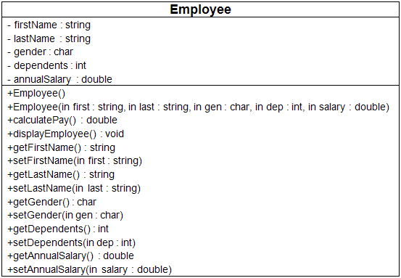

**Pseudocode**

//Program Header

//Program Name: Class Development

//Programmer: Your Name

//CIS247C, Week 2 Lab

//Program Description: PROVIDE A DESCRIPTITON OF THE PROGRAM

**Define class – Employee**

private access specifier

// declare data members

firstName as a string

lastName as a string

gender as a character

dependents as an integer

annualSalary as a double

public access specifier

default constructor Employee()

constructor with parameters Employee(string, string, char, int, double)

declaration calculatePay()

declaration displayEmployee()

declaration getFirstName()

declaration setFirstName(string)

declaration getLastName()

declaration setLastName(string)

declaration getGender()

declaration setGender(char)

declaration getDependents()

declaration setDependents(int)

declaration getAnnualSalary()

declaration setAnnualSalary(double)

**end define class**

**start define constructors/methods**

default constructor Employee()

set the attributes as follows: firstName = "not given", lastName = "not given", gender = "U" (for unknown), dependents = 0, and annualSalary = 20,000.

end constructor

constructor with parameters Employee(string first, string last, char gen, int dep,

double salary)

should initialize all of the attributes using values passed in using its parameter list.

end constructor

procedure calculatePay()

should return the value of annual salary divided by 52 (return annualSalary / 52;).

end procedure

procedure displayEmployee()

should display all the attributes of the Employee object in a well-formatted string with logical labels applied to each attribute. Don't forget to call calculatePay from within the displayEmployee method in order to display the Employee's weekly pay as well!

end procedure

procedure getFirstName()

return value of firstName data member.

end procedure

procedure setFirstName(string first)

assign value to firstName data member using value passed in parameter list.

end procedure

procedure getLastName()

return value of lastName data member.

end procedure

procedure setLastName(string last)

assign value to lastName data member using value passed in parameter list.

end procedure

procedure getGender()

return value of gender data member.

end procedure

procedure setGender(char gen)

assign value to gender data member using value passed in parameter list.

end procedure

procedure getDependents()

return value of dependents data member.

end procedure

procedure setDependents(int dep)

assign value to dependents data member using value passed in parameter list.

end procedure

procedure getAnnualSalary()

return value of annualSalary data member.

end procedure

procedure setAnnualSalary(double salary)

assign value to annualSalary data member using value passed in parameter list.

end procedure

**end define constructors/methods**

**Start main**

Create an Employee object using the default constructor.

Prompt for and then set the first name, last name, gender, dependents, and annual salary. **(Remember that you have to convert gender, dependents, and annual salary from strings to the appropriate data type.)**

Using your code from last week, display a divider that contains the string "Employee Information"

Format the currency using the following formatting services (<iomanip>):

cout << "Annual Salary:\t" << setprecision(2) << showpoint << fixed << annualSalary << "\n";

Display the Employee information.

Create a second Employee object using the multi-argument constructor, setting each of the attributes with appropriate valid values.

Using your code from last week, display a divider that contains the string "Employee Information".

Display the Employee information for the second Employee object.

**end main program**

Week 1 functions.

**procedure DisplayApplicationInformation**

display “Welcome the Basic User Interface Program”

display “CIS247, Week 1 Lab”

display “Name: YOUR NAME”

display “This program accepts user input as a string, then makes the appropriate data conversion”

**end procedure**

**procedure DisplayDivider(string outputTitle)**

display “**************** “ + outputTitle + “****************”

**end procedure**

**function GetInput(string inputType) as string**

strInput as string

display “Enter the “ + inputType

get strInput

return strInput

**end function**

**procedure TerminateApplication**

display “Thank you for using the Basic User Interface program”

exit application

**end procedure**