Interior Permanent Design Motor Design to Improve The Formula-E Team Car’s Performance


Table of Contents
Background: Current Motor Analysis 1
Part A: Framework Definition And Initial Design 1
Part B: Design Validation 1
Electromechanical Analysis 2
Thermal Analysis 2
Mechanical Analysis 2
Appendix 2
DD5-14-10-POW Datasheet 2
Race Analysis Report 2
How Efficient Is The Current Motor? 3
5
Ff 6
Requirements 6

Background: Current Motor Analysis
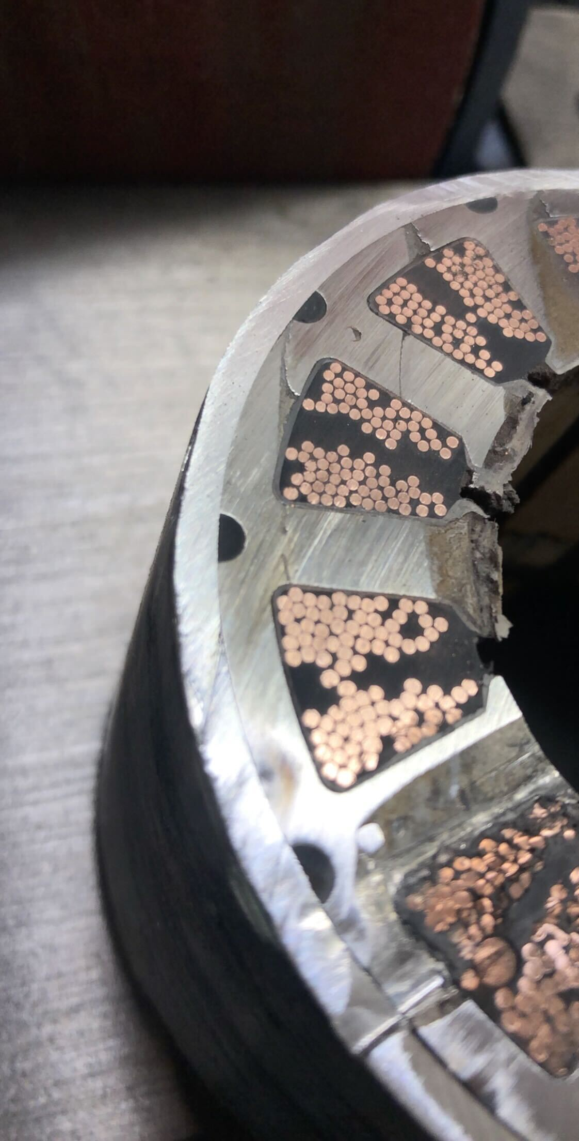Figure 1: Stator traversal cut
The team is currently using the DD5-14-10-POW motor
From the Figure 1 we can get some information; we can see 86 wire ends, which means the total number of turns per tooth is 43.
Notice how, in the data-sheet, and , but we know that in a IPM, usually due the fact that magnets have approximately the same reluctance than the air (check Appendix). This inverse saliency () comes from the fact that magnets could be partially buried with iron shoes or a specific shape of the rotor. This can lead to “negative” reluctance when using the standard control.

Part A: Framework Definition And Initial Design
The purpose of this part is to define the type of motor to be designed, the constraints (such as voltage, current and heat limitations), the requirements (such as speed and torque) and the software to be used.
A surface permanent magnet motor, although simple and cheap, would need a very good glue in order to be able to withstand the 20,000 rpm centrifugal forces. Because of those reasons, we decide to proceed with an IPM Machine design.

Requirements Boundaries

After a discussion within the team, the following target requirements were derived:

The following requirements shall be validated in Part B.
1. Ld shall be less than Lq.
2. The rotor dimensions should not exceed 80mm of diameter and
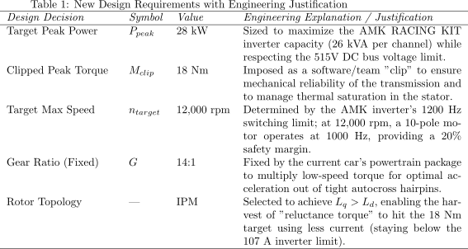

Number Of Slots And Poles
The general size of the motor is defined by:
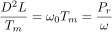
Where:
D: State bore diameter.
L: Stator core length.
T_m: Mechanical torque
P_r: Output Power.
\omega: Rotor Speed.
\omega_0: Coefficient.

Sizing
Ideally, the new design should keep the same dimensions as the previous machine, with the difference that it will be optimized in terms of heat and energy efficiency.
$D^2L$

Part B: Design Validation
Here, using software, we implement the motor designed in Part A and perform electromechanical, thermal and mechanical simulations. The objective of this section is to validate the design in mutiple domains.

Electromechanical Analysis

Thermal Analysis

Mechanical Analysis

Appendix

Surface Permanent Magnet (SPM) Machine
This machine has permanent magnets pasted on the surface of the rotor. As the experiences speed, acceleration and temperature changes, the material used to hold this magnets in place should be really good!

Interior Permanent Magnet (IPM) Machine
The magnets of this machine are “buried” inside the rotor structure.

DD5-14-10-POW Datasheet
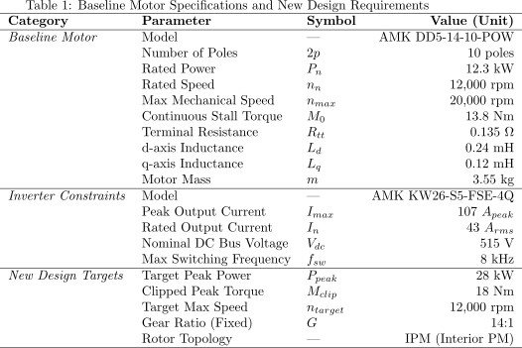
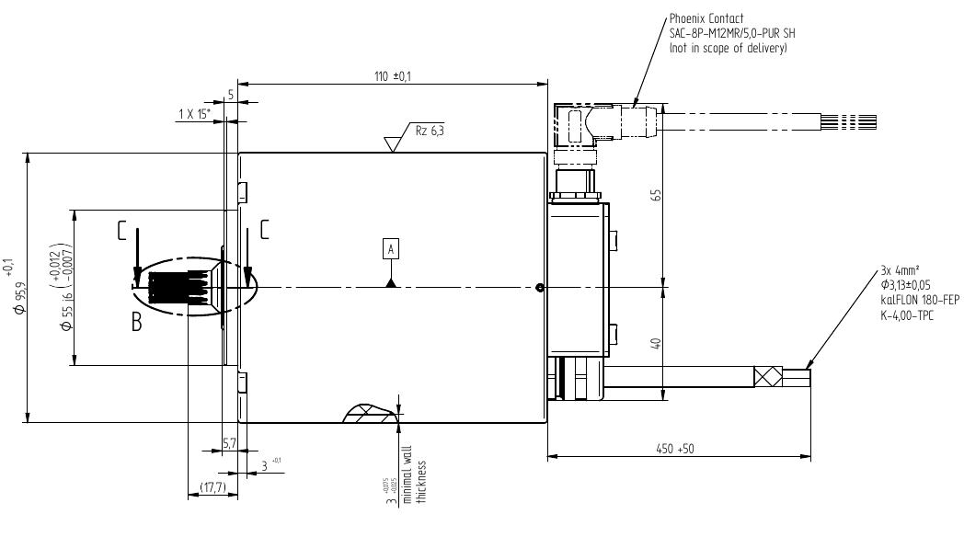
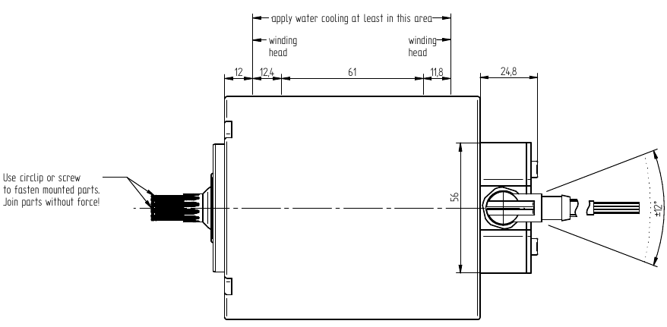

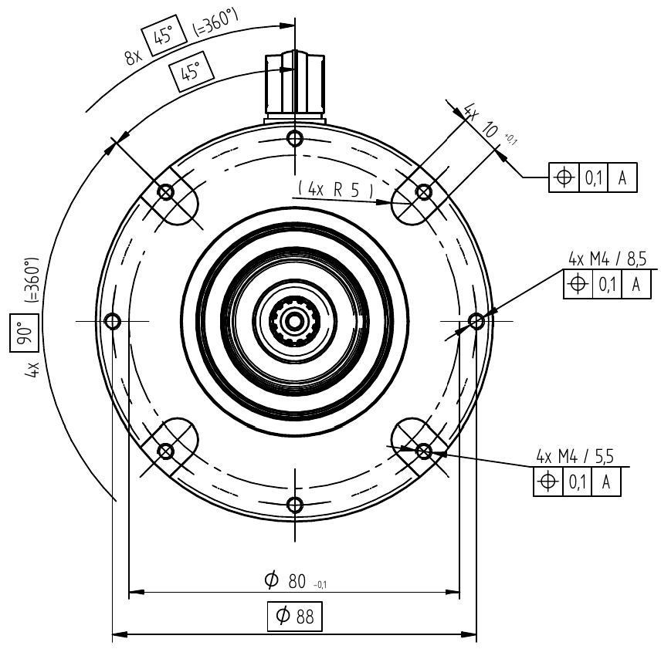
Race Analysis Report

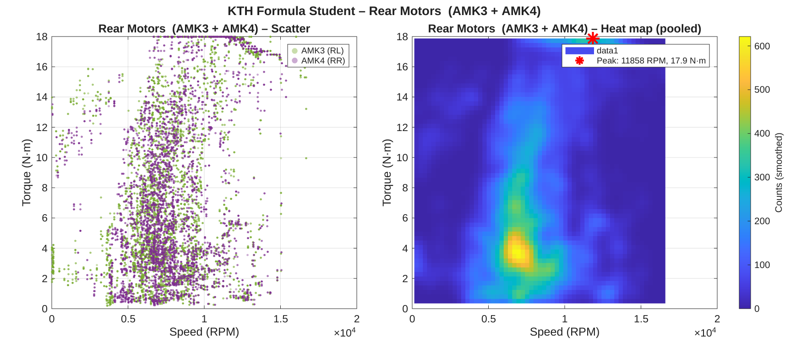
The 3 delimiters:
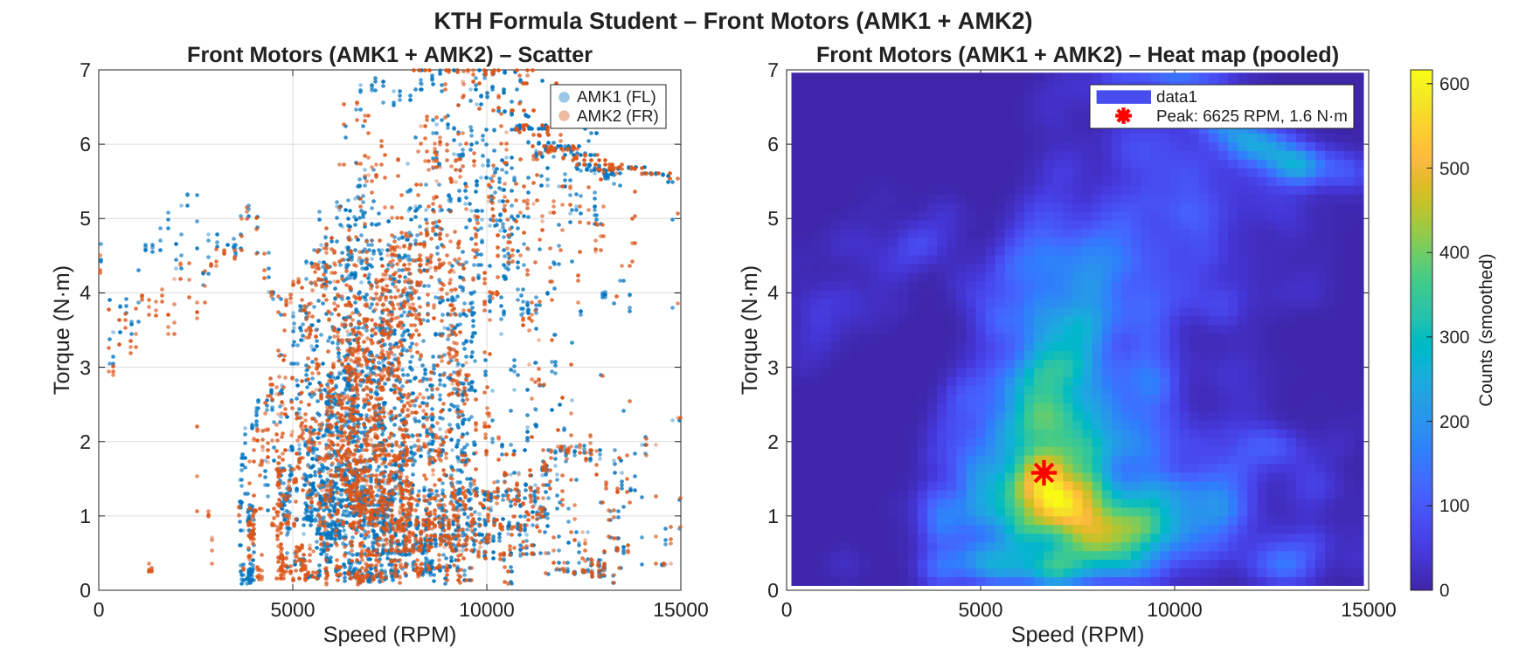
1. A high torque low speed scenario happens always at the beginning of the race (when the car is stationary) or when passing through a steep slope. This scenario has very low back EMF that resists the battery voltage, thus drawing high currents and generating massive heat (P=I^2*R). If the motor will be constantly exposed to this zone, it is key to prioritize for thermal mass and current capacity.
2. A high speed low torque scenario happens when a flat or even a downwards slope is faced, and because the driver’s main objective is always to gain as much speed as possible, the motor’s electromechanical properties can become a limit. If the motor is expected to experience this scenario commonly, the design priorities should be focused on the low iron losses and field-weakening zone.
3. A high speed high torque scenario happens when, although the driver knows that the road conditions are not optimal, attempts to maintain or even gain speed. Even if the car usually spends little time in this zone, it should be considered in the design, as one cannot allow an scenario where the external torque overcomes the motor and the car inevitably de-accelerates. (really shouldn’t this be allowed?)
kthformulastudent.se

How Efficient Is The Current Motor?
The rotor has glued surface-magnets. SPM machine. The motor has 10 poles. This number can be reduced. The electrical frequency would be reduced and higher efficiency would be reached. The inverter tries to achieve up to 1.6 kHz frequency. A lot of lamination losses. This could reduce the acceleration efficiency, but the idea is to find a sweet spot.
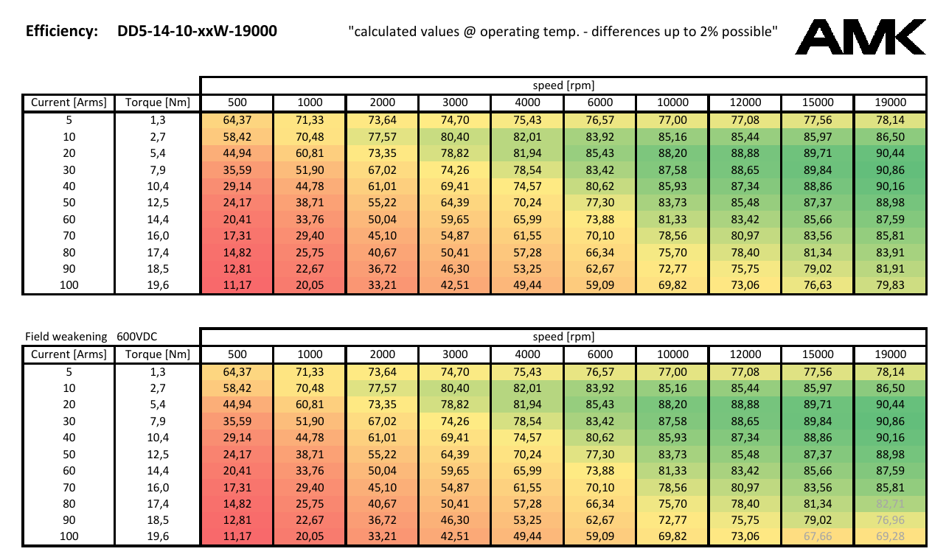
The Ld an Lq values are different () meaning that the motor is slightly anisotropic.
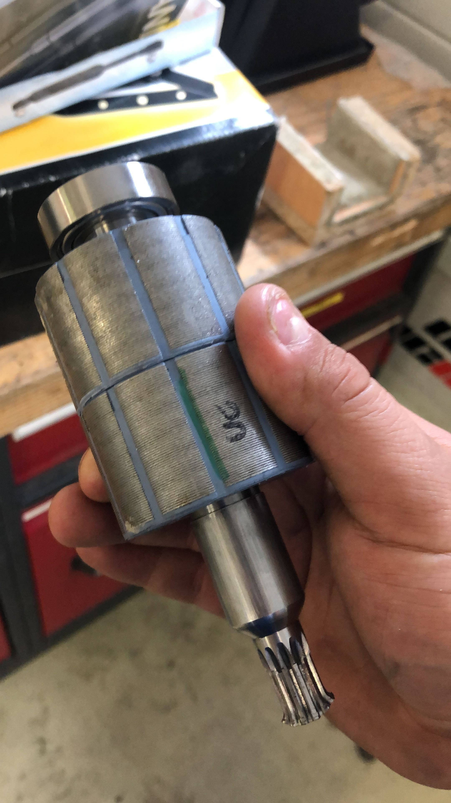
Teeth
Slots
Wire turns per slot: ~46
The power distribution is 70% to the front wheels and 30% to the rear wheels.

Ff

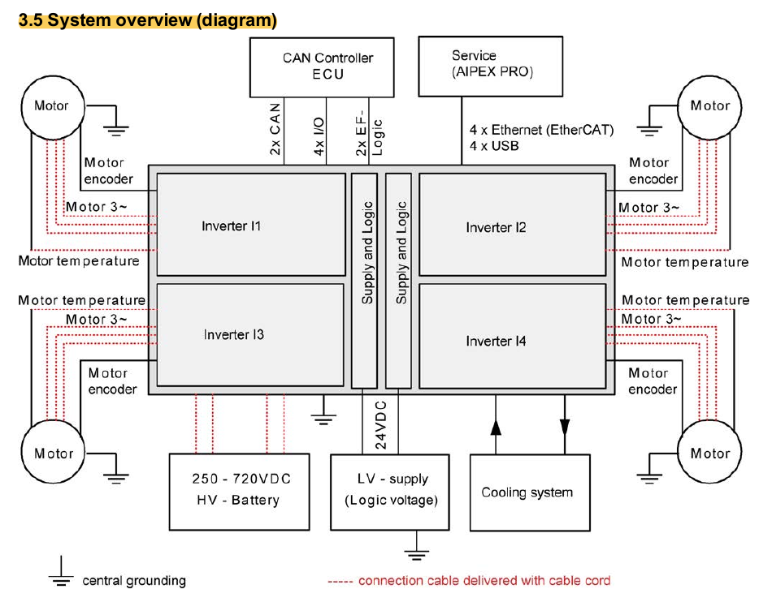
Requirements
1.
2.
2. The maximum power of the system shall not exceed 80 kW.
3. The motor’s maximum power shall be 28 kW.
4. The DC-bus maximum voltage shall be 600V. The nominal voltage should be 515 V.
5. The IP protection level shall be ???.
6. The temperature limit shall be ???.
7. Liquid cooling shall be used. Air could be considered.
2. The motor should operate in field-weakening mode when reaching it’s speed limits.
3. The motor type shall be of the IPM type.
4. The maximum speed without field-weakening mode shall be ??? rpm.
5. The maximum speed shall be 12,000 rpm.
7. The torque-speed curve shall mimic the following example:
8. The power split between front and rear propulsion shall be ???.
9. The maximum dimensions are 120 mm of outer diameter and 110 mm in length. This includes the liquid cooling.
Mechanical power is defined as:
The motor is not 100% efficient, we need to represent the overall efficiency of the motor, gearbox and inverter ($n$).

The previous images show how the torque-speed relationship behaved during an Auto-cross race. The car has a fixed gear ratio, thus we can assume that the road and driver interaction is responsible for this speed-torque variations. The way to interpret this plot is basically observing that the zone that produces more stress on the motor (higher draw of current, heat and mechanical stress) is when the torque and speed are high
(for how long was this data recorded? What was the sampling frequency? Sensors used?)
Requirements Definition
1. They have water cooling, can we get rid of it?
2. If we remove that, we
3. Use less magnets?
4. Use outer dimensions as a constraint.
5. We are going from 24 to 28 kW. We should chose what to “improve”, if we want to keep the same dimensions.
The field weakening range is not so large. In a quick calculation, one can derive 20% is in this region (from 16 to 20 of the speed/Torque graph.
We can consider changing from Surface Magnet to an Interior Permanent Magnet (where the magnets are inside), reducing the magnets and increasing the flux weakening region. Is more robust
The Chasis
The Motors

Design an IPM

