Beachvolley Assist

App and Mission Description

# Mission

The idea is to have a mobile app for supporting beachvolleyball referees or scoring assistents.

* The app should guide through administative tasks

like conducing the toss to decide upon the first service and the sides of the court

* Support the game

current storeline, service order, time-out‘s and so on

# General requirements

The app should be intuitively and also usable for non experienced referees. Helping the users step by step with only minimal required input and using graphic and acoustic support.

By default the app should comply with the official regulations.

See „OFFICIAL BEACH VOLLEYBALL RULES 2013-2016 approved by the 33rd FIVB Congress 2012“ at <http://www.fivb.org/EN/Refereeing-Rules/documents/FIVB-BeachVolleyball_Rules2013-EN_20130531.pdf>

Additionaly it should be possible to change parameters (e.g. no technical time-out, a set up’s only to 15 points).

# Structure of a beach volleyball game from referee view

1. Before the game
   * + - Administrative tasks before starting the game
2. During the game
   * First set
     + Administative tasks at the beginning of the set
     + Operating the set
   * Second set
     + Administative tasks at the beginning of the set
     + Operating the set
   * Optional third set
     + Administative tasks at the beginning of the set
     + Operating the set
3. After the game
   * Administrative tasks after the game

# Structure of the app

Because it is an app for referees it does make sense to construct the app the same way described above.

## Start screen

There is a start screen with app name and logo, an imprint with credits to the app developer and a start button to go on with a new game.

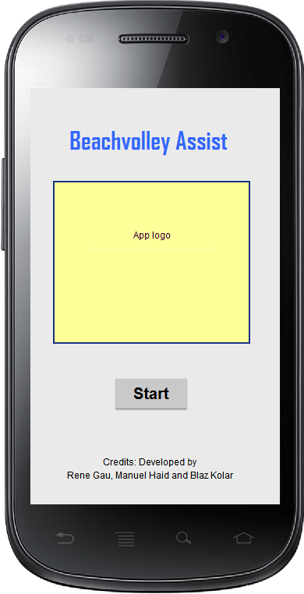

# dfadfadf

dfafadffdaf.

adfaf