CHAPTER 4 – PRESENTATION, ANALYSIS, AND INTERPRETATION OF DATA

1. SYSTEM OVERVIEW

a. System Title and Purpose
The developed software artifact is entitled "LibraLink: A Centralized Web-Based Library Management System for Book Resource Sharing across Selected Schools in Pampanga".
The primary purpose of the LibraLink platform is to bridge institutional resource disparities, eliminate catalog isolation, and automate the inter-library resource sharing process between participating academic institutions. In many private educational institutions in the Philippines, individual school libraries operate as disconnected silos with limited acquisition budgets. Consequently, students often encounter shortages of specialized textbooks, while partner institutions within the same geographic locale hold idle or underutilized copies of those exact titles.
LibraLink establishes a centralized, inter-institutional Online Public Access Catalog (OPAC) and a secure transaction brokering engine connecting Guagua National College (GNC) in Guagua, Pampanga, and Santa Rita College (SRC) in Santa Rita, Pampanga. The platform enables enrolled students to discover print collections across both campuses in real time, automatically routes inter-library borrowing requests to the student’s home librarian for academic clearance, and issues a cryptographically verified, time-bound Digital Library Access Token (Pass). This token grants authorized students on-premise reading or controlled circulation access at the partner institution, establishing a collaborative, paperless, and sustainable resource-sharing consortium.

b. Target Users
The system is engineered to serve four (4) distinct stakeholder groups across Guagua National College and Santa Rita College:
1. Student Users (College, Senior High School, and Junior High School):
The primary end-users who utilize the web portal to perform cross-institutional book searches, examine real-time campus holding statuses, receive partner school availability recommendations, submit paperless inter-library borrow requests, monitor application progress, and present digital access tokens via mobile smartphones or portable devices when visiting partner campuses.
2. Librarian / Staff Users:
Frontline library personnel responsible for managing day-to-day circulation, reviewing incoming student borrow requests, verifying good academic standing and clearance, approving or rejecting applications with feedback notes, and operating the on-site verification terminal to authenticate visiting students presenting digital access passes.
3. Librarian Administrators (Head Librarians):
Supervisory library managers who oversee institutional catalog inventories, configure campus-specific lending parameters (such as loan quotas and token validity windows), manage staff user accounts, and generate monthly inter-library circulation reports.
4. Super Administrators:
System-level technical managers who configure institutional consortia settings, monitor multi-tenant database integrity, oversee security protocols, inspect comprehensive audit logs, and maintain cloud infrastructure uptime.

c. Scope and Limitations

Scope of the System:
- Geographic and Institutional Delimitation: The system is exclusively configured, deployed, and tested for Guagua National College (GNC) and Santa Rita College (SRC) within the province of Pampanga.
- Unified Catalog Discovery: Centralized search engine indexing book holdings from both institutions, filterable by institution, subject classification, call number, and real-time availability.
- Partner Holding Recommendation: Intelligent notification system that automatically highlights partner campus availability when a searched volume has zero available copies at the user's home campus.
- Inter-Library Request Routing: Automated request forwarding that directs borrow requests to the student's home institution librarian for pre-clearance and verification.
- Digital Access Token Generation: Dynamic issuance of single-use, time-delimited (72-hour validity) alphanumeric and visual access tokens that serve as digital permits for on-site visits.
- Counter Verification Terminal: Fast-lookup interface for host librarians to authenticate visiting student tokens and log physical book handovers.
- Catalog Inventory CRUD Management: Complete administrative tools allowing authorized librarians to create, read, update, and archive book records categorized by academic level (College, SHS, JHS).
- Cross-Platform Responsive Design: Full accessibility across desktop computer monitors, circulation tablets, and mobile smartphones without functional degradation.

Limitations of the System:
- No Inter-Campus Physical Courier Service: LibraLink does not manage physical parcel transport or inter-school courier logistics. Students must physically travel to the partner institution holding the requested book to utilize their issued Digital Access Token.
- Exclusion of Financial Penalty Transactions: The platform does not process monetary payments, digital wallets, or cash transactions for overdue fines or lost book fees; penalty enforcement is handled offline pursuant to the home institution's manual guidelines.
- Mandatory Internet Connectivity: As a centralized cloud-hosted web application, active internet access is required to synchronize catalog states, process approvals, and validate access tokens.

d. Key Functionalities
- Multi-Tenant Authentication & Role Guarding: Secure authentication gateway enforcing Role-Based Access Control (RBAC) across Students, Staff Librarians, Head Librarians, and Super Administrators.
- Consolidated Multi-School Catalog Search: Real-time query engine searching across disparate institutional holdings with live availability indicators.
- Inter-Library Borrow Request Lifecycle Engine: Finite state machine managing sequential transaction states (Pending_Home_Approval → Approved → Active_Token_Issued → Redeemed → Returned / Rejected).
- Cryptographic Access Token Engine: Generation of non-forgeable, time-stamped access hashes linked to borrower profile, host campus, and target accession number.
- Partner Librarian Verification & Circulation Counter: Instant search-and-redeem workflow confirming student identity and logging loan durations.
- Administrative Inventory Management: Modular cataloging suite supporting Dewey Decimal or LC classification, ISBN lookup, and physical shelf tagging.
- System Audit Logging & Metrics Dashboard: Automated tracking of cross-campus borrow volumes, approval rates, and peak usage hours for administrative review.

e. Overview of the Selected Methodology (Agile / Scrum)
The development of the LibraLink platform followed the Agile Development Methodology, specifically implementing the Scrum Framework. Agile/Scrum was chosen due to its iterative structure, high flexibility, and continuous stakeholder collaboration, which was vital when harmonizing library circulation policies across two independent educational institutions.
The Scrum process was structured into three (3) iterative Sprints, each lasting two (2) weeks, for an overall development cycle of six (6) weeks. Each sprint encompassed formal ceremonies:
1. Product Backlog Refinement: Defining and sizing user requirements as actionable user stories.
2. Sprint Planning: Selecting high-priority backlog items based on team velocity and defining sprint goals.
3. Daily Iterative Development: Rapid front-end and back-end component implementation.
4. Sprint Review & Demonstration: Presenting functional software increments to school librarians and student representatives for usability critique.
5. Sprint Retrospective: Assessing development roadblocks, performance bottlenecks, and refining upcoming tasks.
┌────────────────────────┐ ┌─────────────────────────┐ ┌─────────────────────────┐
│ PRODUCT BACKLOG │ ───► │ SPRINT PLANNING │ ───► │ 2-WEEK SPRINT │
│ (12 Prioritized US) │ │ (Sprint Goal & Tasks) │ │ (Design, Build, Test) │
└────────────────────────┘ └─────────────────────────┘ └────────────┬────────────┘
│
┌────────────────────────┐ ┌─────────────────────────┐ │
│ POTENTIALLY SHIPPABLE│ ◄─── │ SPRINT REVIEW & │ ◄─────────────────┘
│ PRODUCT INCREMENT │ │ RETROSPECTIVE │
└────────────────────────┘ └─────────────────────────┘

2. SYSTEM DEVELOPMENT (BASED ON SELECTED METHODOLOGY)

a. Agile / Scrum Implementation

i. Product Backlog
1. List of User Stories / Features
The functional scope of LibraLink was articulated through twelve (12) comprehensive user stories structured from the perspective of students, library staff, and administrators:
Story ID | User Role | User Story Description | Acceptance Criteria
US-01 | Student | As a student, I want to search for books by title, author, or subject across GNC and SRC so that I can discover academic materials quickly. | The catalog returns matching books from both campuses with call number, campus name, and available copies.
US-02 | Student | As a student, I want the system to suggest partner school holdings when a book is unavailable locally so that I know where to obtain it. | When local copies equal zero, an alert highlights partner holdings with a direct "Request Borrow" action.
US-03 | Student | As a student, I want to submit an inter-library borrow request through the web portal so that I do not need manual paper referral letters. | Form captures target book, submits request to home librarian queue, and logs status as Pending_Home_Approval.
US-04 | Student | As a student, I want to receive a Digital Access Token upon approval so that I can present proof of clearance at the partner library. | System renders a secure alphanumeric token and QR code displaying student ID, host campus, and a 72-hour countdown.
US-05 | Librarian | As a home librarian, I want to review incoming borrow requests so that I can verify student standing before endorsing cross-campus visits. | Inbox displays student details, academic level, book title, and one-click Approve and Reject buttons.
US-06 | Librarian | As a host librarian, I want to verify a visiting student's access token at my desk so that I can confirm validity and release the book. | Host librarian enters token string or scans QR; system validates authenticity, displays student info, and marks token as Redeemed.
US-07 | Librarian | As a librarian, I want to add, update, and categorize book inventory records so that our online catalog remains accurate and up-to-date. | Full CRUD interface supporting title, author, ISBN, academic level (College/SHS/JHS), and shelf location.
US-08 | Librarian | As a host librarian, I want to mark borrowed books as returned when students return them so that catalog availability is restored. | Action updates transaction to Returned, releases borrower obligation, and increments available copy count.
US-09 | Admin | As a super admin, I want to manage participating school configurations so that multi-tenant isolation is maintained. | Interface allows toggling institutional settings, domain parameters, and active statuses for GNC and SRC.
US-10 | Admin | As a super admin, I want to view system audit logs so that all transactions, approvals, and inventory changes are trackable. | Chronological audit table recording event type, user identifier, IP address, and timestamp.
US-11 | Student | As a student, I want the web application to be fully usable on mobile devices so that I can check tokens while in transit. | UI dynamically scales and refits on mobile viewports (360px–430px) without horizontal scrolling or clipping.
US-12 | All Users | As a user, I want secure authentication so that my personal details and institutional records remain private. | Passwords hashed using bcrypt; API endpoints protected via JSON Web Tokens (JWT) and role verification middleware.
2. Prioritization of Tasks (MoSCoW Matrix)
To maximize delivery value within the six-week development timeline, the user stories were prioritized using the MoSCoW Prioritization Framework:
- Must Have (Essential Core for Minimum Viable Product):
- US-01: Multi-School Catalog Search
- US-02: Partner School Holding Recommendation
- US-03: Inter-Library Borrow Request Submission
- US-04: Digital Access Token Generation
- US-05: Home Librarian Approval Queue
- US-06: Host Librarian Token Verification Hub
- US-12: Multi-Tenant Role-Based Authentication
- Should Have (Important Features for Operational Completeness):
- US-07: Catalog Inventory Management (CRUD)
- US-08: Return Processing & Circulation Updating
- US-11: Responsive Mobile-First Viewport Optimization
- Could Have (Desirable Enhancements if Time Permits):
- US-09: Super Admin Multi-School Configuration
- US-10: Comprehensive System Audit Logging
- Interactive Campus Location Mapping
- Won't Have (Explicitly Deferred to Future System Versions):
- SMS Gateway integration (deferred due to recurring telecommunications carrier charges)
- Online fine payments via digital wallet platforms

ii. Sprint Overview
1. Number of Sprints
The engineering lifecycle was organized into three (3) distinct, sequential Sprints.
2. Duration per Sprint
Each sprint spanned a duration of two (2) calendar weeks (10 operational days), culminating in an overall build timeframe of six (6) weeks:
- Sprint 1: Weeks 1 – 2 (System Foundation, Schema Architecture, Authentication, and Multi-School Search)
- Sprint 2: Weeks 3 – 4 (Inter-Library Request Engine, Librarian Approval Inbox, and Token Generator)
- Sprint 3: Weeks 5 – 6 (Token Verification Hub, Inventory Management, UI Optimization, and System Testing)
3. Sprint Goals
- Sprint 1 Goal: Establish the technical foundation, configure the cloud PostgreSQL database with multi-tenant schemas, implement role-based authentication, and deliver a working cross-school catalog search.
- Sprint 2 Goal: Implement the complete inter-library borrowing request lifecycle, develop the home librarian review queue, and build the cryptographic Digital Access Token generation algorithm.
- Sprint 3 Goal: Construct the host librarian counter-verification terminal, build catalog CRUD tools, enforce system audit logging, optimize mobile responsiveness, and conduct end-to-end integration testing.

iii. Sprint Cycles
1. Sprint 1: System Foundation, Database Schema, Authentication, and Multi-School Catalog Search
a. Planning
- i. Selected Backlog Items:
- US-01: Multi-School Catalog Search (Story Points: 8)
- US-02: Partner School Holding Recommendation (Story Points: 5)
- US-12: Multi-Tenant Role-Based Authentication (Story Points: 8)
- Total Planned Velocity: 21 Story Points.
- Team Capacity & Allocation: Front-end engineering (ReactJS/Tailwind), Back-end routing (Node.js/Express), and Database architecting (Supabase/PostgreSQL).
b. Design
- i. Use Case Diagram (Sprint 1 Scope):
The actor Student interacts with the system boundary to Register Account, Authenticate / Log In, Search Catalog, and Filter by School. The actor Librarian logs in to access campus-level data.
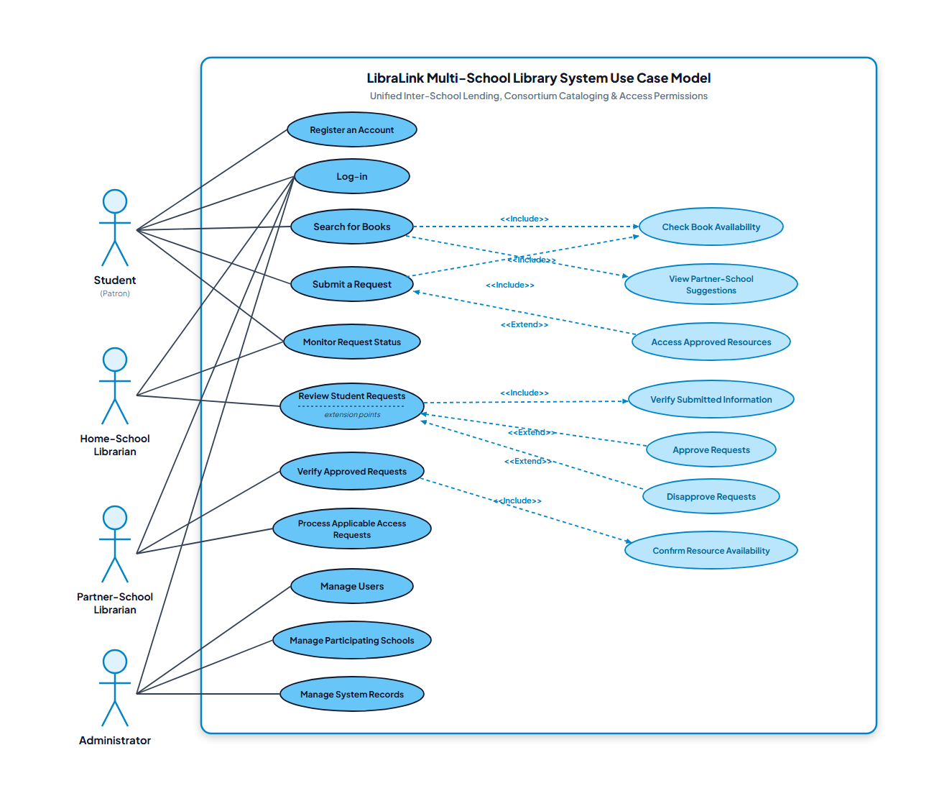
[DIAGRAM] Figure 4.1: Sprint 1 Actor-to-Use-Case Interaction Diagram
- ii. Data Flow Diagram (Sprint 1 Scope):
Context Level 0: Student and Librarian entities pass login credentials and search terms to the LibraLink engine; the engine queries users and books stores and returns authenticated session tokens and catalog matching arrays.
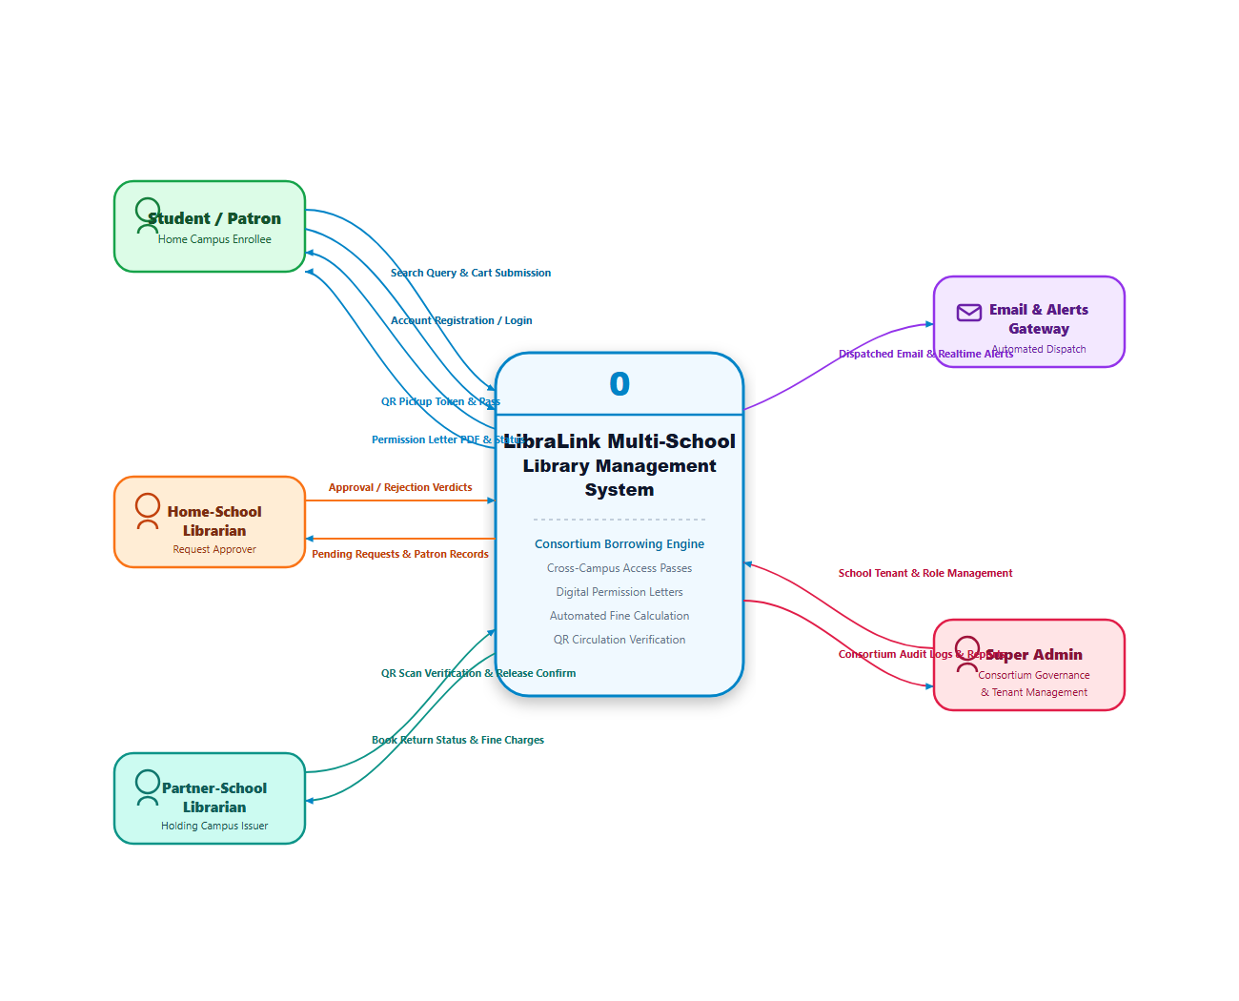
[DIAGRAM] Figure 4.2: Sprint 1 Context Data Flow Diagram (Level 0)
- iii. Wireframes:
Low-fidelity wireframes established the layout for:
1. Public Landing Page: Dual portal login buttons designating Guagua National College and Santa Rita College.
2. Student Search Screen: Prominent search bar, school filter toggles (All, GNC, SRC), and book card grids displaying real-time copy counts.
c. Development
- i. Features Implemented:
- Initialized React 19 frontend with Vite build tool and Tailwind CSS styling.
- Configured Supabase PostgreSQL database tables: schools, roles, users, and books.
- Implemented Express.js REST API routes: POST /api/auth/register, POST /api/auth/login, and GET /api/books/search.
- Built search query handler that aggregates holdings across GNC and SRC while computing real-time available quantities.
- ii. Screenshots of the System:
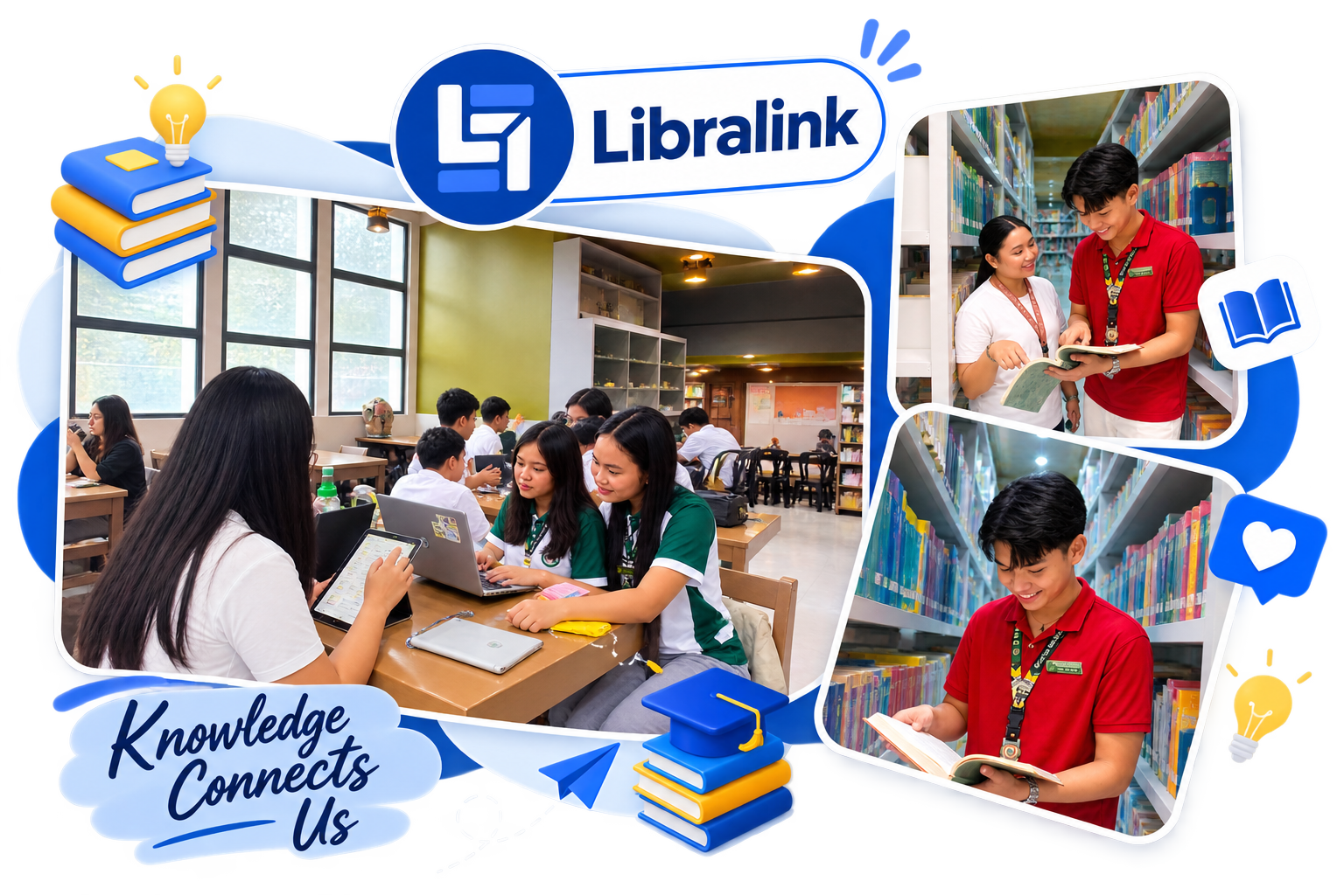
[SCREENSHOT] Figure 4.3: Public Landing Page and School Login Interface

[SCREENSHOT] Figure 4.4: Centralized Cross-School Catalog Search Interface
d. Testing
- i. Test Cases:
- TC-S1-01: Verify account registration with valid institutional student ID and email. (Result: Passed)
- TC-S1-02: Verify login rejection when incorrect password hash is provided. (Result: Passed)
- TC-S1-03: Execute book search for title existing in GNC and verify holding metadata. (Result: Passed)
- TC-S1-04: Verify partner campus recommendation badge renders when local campus copies equal zero. (Result: Passed)
- ii. Issues Encountered:
- Catalog search queries initially returned results only from the user's home campus due to a default WHERE school_id = user.school_id clause.
- iii. Resolutions:
- Removed the restrictive where-clause from public catalog search while maintaining institutional labeling (school_name) in the serialized JSON output.
2. Sprint 2: Inter-Library Request Workflow, Librarian Approval Inbox, and Access Token Engine
a. Planning
- i. Selected Backlog Items:
- US-03: Inter-Library Borrow Request Submission (Story Points: 8)
- US-04: Digital Access Token Generation (Story Points: 8)
- US-05: Home Librarian Approval Queue (Story Points: 8)
- Total Planned Velocity: 24 Story Points.
- Team Allocation: State machine implementation, cryptographic token generator, and librarian inbox interface.
b. Design
- i. Use Case Diagram (Sprint 2 Scope):
The actor Student triggers Submit Borrow Request for partner school books. The actor Home Librarian accesses Review Request Queue to execute Approve Request or Reject Request. The system internally triggers Generate Access Token.
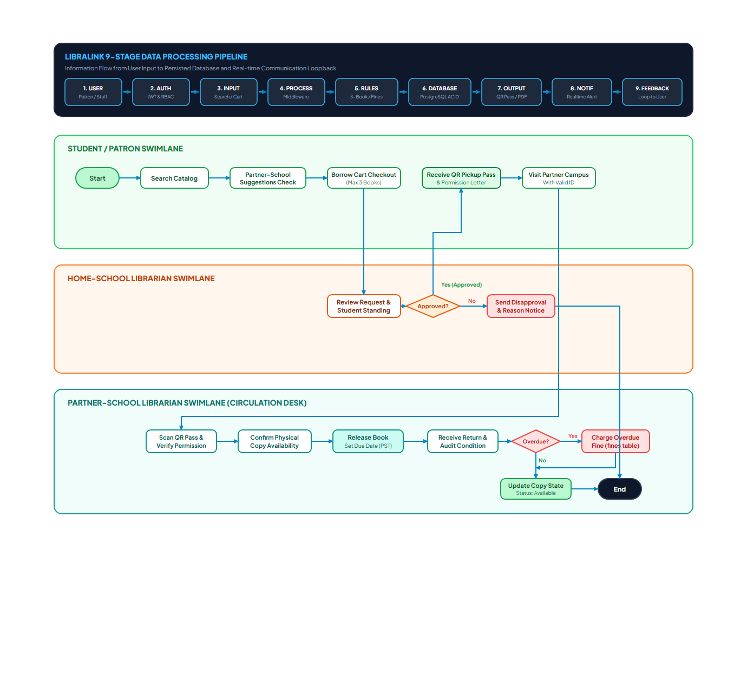
[DIAGRAM] Figure 4.5: Sprint 2 Inter-Library Borrowing & Token Flow Lifecycle
- ii. Data Flow Diagram (Sprint 2 Scope):
Student submits request payload → stored in borrow_requests with status Pending_Home_Approval → Home Librarian queries pending requests → upon approval, transaction updates to Approved → triggers token generator → creates record in access_tokens store.
- iii. Wireframes:
1. Student Borrow Request Modal: Book summary, pickup policy agreement, and submit button.
2. Librarian Approval Inbox: Table displaying student name, academic department, book requested, and action triggers.
3. Digital Access Token View: Visual card with large alphanumeric code, QR pattern, and 72-hour expiration timer.
c. Development
- i. Features Implemented:
- Constructed PostgreSQL tables: borrow_requests and access_tokens with relational foreign keys.
- Built REST endpoints: POST /api/borrow-requests, GET /api/borrow-requests/pending, and PUT /api/borrow-requests/:id/status.
- Implemented cryptographic token generator that computes a unique 10-character alphanumeric hash bound to request parameters and sets expires_at = NOW() + INTERVAL '72 HOURS'.
- Developed Student "My Requests" dashboard with live status indicators and token presentation modal.
- ii. Screenshots of the System:
[SCREENSHOT] Figure 4.6: Student Borrow Request and Access Token Pass Interface
d. Testing
- i. Test Cases:
- TC-S2-01: Submit inter-library request for partner school title. (Result: Passed)
- TC-S2-02: Confirm pending request appears in real time on the Home Librarian dashboard. (Result: Passed)
- TC-S2-03: Click "Approve" on pending request and verify creation of unique access token. (Result: Passed)
- TC-S2-04: Click "Reject" with explanation note and verify status displays "Rejected" on student screen. (Result: Passed)
- ii. Issues Encountered:
- Supabase Row-Level Security (RLS) threw error 42501 (Permission Denied) when student accounts attempted to insert records into borrow_requests.
- iii. Resolutions:
- Added a PostgreSQL RLS policy granting INSERT permission to authenticated users where auth.uid() = student_id.
3. Sprint 3: Partner School Verification, Circulation Records, UI Polish, and Deployment
a. Planning
- i. Selected Backlog Items:
- US-06: Host Librarian Token Verification Hub (Story Points: 8)
- US-07: Catalog Inventory Management CRUD (Story Points: 5)
- US-08: Return Processing & Circulation Updating (Story Points: 5)
- US-10: System Audit Logging (Story Points: 3)
- US-11: Responsive Mobile-First Viewport Optimization (Story Points: 5)
- Total Planned Velocity: 26 Story Points.
- Team Allocation: Verification counter interface, inventory management forms, audit log services, and cross-browser testing.
b. Design
- i. Use Case Diagram (Sprint 3 Scope):
The actor Host Librarian performs Verify Access Token, Mark as Redeemed, Mark as Returned, and Manage Catalog Books. The actor Super Admin performs View Audit Logs.
- ii. Data Flow Diagram (Sprint 3 Scope):
Visiting student presents token string → Host Librarian submits token to /api/tokens/verify → system queries access_tokens → verifies status is valid and expires_at > NOW() → updates status to redeemed → updates borrow_requests to active → audit service logs transaction in audit_logs.
- iii. Wireframes:
1. Host Librarian Verification Terminal: Input field for token code, instant student verification card, and book release confirmation button.
2. Inventory Management Table: Add/Edit book modal, academic level selector (College, SHS, JHS), and copy quantity adjusters.
c. Development
- i. Features Implemented:
- Built verification endpoint POST /api/tokens/verify that validates token authenticity and sets status to Redeemed.
- Implemented Book Catalog CRUD operations (POST /api/books, PUT /api/books/:id, DELETE /api/books/:id).
- Implemented Book Return workflow restoring book copy counters and marking loans as completed.
- Added automated audit logging for administrative actions.
- Refactored responsive styles using Tailwind CSS utility breakpoints (sm:, md:, lg:) to ensure seamless usability on mobile smartphones.
- ii. Screenshots of the System:

[SCREENSHOT] Figure 4.7: Librarian Administrative and Token Verification Dashboard
d. Testing
- i. Test Cases:
- TC-S3-01: Enter valid token code at partner library counter; system displays student credentials and allows redemption. (Result: Passed)
- TC-S3-02: Enter already redeemed token; system rejects with "Token Already Used" notice. (Result: Passed)
- TC-S3-03: Enter expired token; system rejects with "Token Expired" notice. (Result: Passed)
- TC-S3-04: Test responsive layout on Chrome DevTools mobile viewports (375px, 390px, 414px). (Result: Passed)
- ii. Issues Encountered:
- The verification dialog card exceeded viewport width on small mobile screens (375px), causing horizontal clipping.
- iii. Resolutions:
- Replaced fixed pixel widths with fluid flexbox wrappers (w-full max-w-lg px-4) and optimized typography scaling.

3. SYSTEM DESIGN AND ARCHITECTURE
This section presents the technical architecture, component interactions, database schemas, and security mechanisms governing the LibraLink platform.

a. System Architecture

1. Overall System Architecture Diagram
┌────────────────────────────────────────────────────────────────────────┐
│ CLIENT-SIDE / PRESENTATION LAYER │
│ ┌────────────────────────┬───────────────────────┬─────────────────┐ │
│ │ Student Web Portal │ Librarian Dashboard │ Admin Panel │ │
│ └────────────────────────┴───────────────────────┴─────────────────┘ │
│ React 19 Framework + Vite Build Tool + Tailwind CSS Styling │
│ Supported Viewports: Desktop, Tablet, Smartphone │
└───────────────────────────────────┬────────────────────────────────────┘
│ HTTPS / Encrypted JSON Payloads
▼
┌────────────────────────────────────────────────────────────────────────┐
│ APPLICATION & API SERVICE LAYER │
│ Node.js Runtime + Express.js Web Engine │
│ ┌───────────────────────┬───────────────────────┬──────────────────┐ │
│ │ Authentication Guard │ Borrow State Machine │ Token Generator │ │
│ │ (JWT / Role Verify) │ (Policy Routing Rules)│ (Crypto Engine) │ │
│ ├───────────────────────┼───────────────────────┼──────────────────┤ │
│ │ Search Query Engine │ Audit Logger Service │ Verification Hub │ │
│ └───────────────────────┴───────────────────────┴──────────────────┘ │
│ RESTful Endpoints: /api/books, /api/borrow-requests, etc. │
└───────────────────┬────────────────────────────────┬───────────────────┘
│ SQL Operations (Pool) │ API Requests
▼ ▼
┌───────────────────────────────────┐ ┌───────────────────────────────┐
│ DATA & DATABASE LAYER │ │ EXTERNAL CLOUD INTEGRATIONS │
│ Supabase Cloud Infrastructure │ │ - Supabase Auth Service │
│ ┌─────────────────────────────┐ │ │ - Vercel Global Edge CDN │
│ │ PostgreSQL Relational DBMS │ │ │ - QR & Barcode Libraries │
│ │ Multi-Tenant School Tables │ │ │ - Leaflet Mapping Service │
│ │ Row-Level Security (RLS) │ │ └───────────────────────────────┘
│ │ Automated Backups & ACID │ │
│ └─────────────────────────────┘ │
└───────────────────────────────────┘
[DIAGRAM MODEL] Figure 4.8: Overall System Architecture Model of LibraLink

2. Description of the Major System Components
The architecture is structured across three (3) decoupled, high-cohesion tiers:
- The Presentation Tier (Client Frontend): Renders dynamic interfaces, executes client-side state transitions, and accepts user inputs without exposing direct database connectors.
- The Application Service Tier (Middleware & Business Logic): Enforces inter-school circulation rules, evaluates borrower clearance, generates cryptographic tokens, and handles transactional security.
- The Data Persistence Tier (Cloud Database): Houses relational models, enforces institutional privacy rules, and maintains relational integrity.

3. Client-Side or Presentation Layer
Built as a modern Single Page Application (SPA) using ReactJS (v19) and Vite. Component hierarchies are styled using utility-first Tailwind CSS. It adapts to three primary viewports:
- Desktop Viewport: Comprehensive multi-column displays for librarian administrative oversight and catalog indexing.
- Tablet Viewport: Touch-optimized check-in interfaces for library circulation counters.
- Smartphone Viewport: Mobile-first search and digital access pass displays for visiting students.

4. Application or Business Logic Layer
Operates on Node.js with Express.js, housing the core business rules:
- Borrow Request State Machine: Controls transitions (Pending_Home_Approval → Approved → Active_Token_Issued → Redeemed → Returned).
- Inter-Library Lending Guard: Evaluates whether requested titles are locally held or eligible for inter-library borrowing.
- Access Token Engine: Produces cryptographic alphanumeric hashes bound to student IDs and 72-hour expiration timestamps.

5. Data or Database Layer
Hosted on Supabase / PostgreSQL, providing enterprise-level ACID transaction guarantees. The schema utilizes Row-Level Security (RLS) to enforce multi-tenant isolation, ensuring that GNC staff cannot modify or delete catalog records belonging to SRC.

6. API or Service Layer
Exposes modular RESTful endpoints communicating via JSON payloads. Standardized HTTP status codes are enforced (200 OK, 201 Created, 400 Bad Request, 401 Unauthorized, 403 Forbidden, 404 Not Found, and 500 Server Error). Modular routes include /api/auth, /api/books, /api/borrow-requests, and /api/tokens.

7. External Services and Third-Party Integrations
- Supabase Cloud Persistence & Auth: Cloud database management, database triggers, and relational storage.
- Vercel Edge Network: Global content delivery network (CDN) delivering low-latency frontend asset loading.
- HTML5-QRCode & QRCode Libraries: Optical rendering and client-side barcode scanning.
- Leaflet Geospatial Library: Interactive campus location mapping across Pampanga.

8. Authentication and Authorization Components
Implements Role-Based Access Control (RBAC) across four (4) user tiers:
- Super Administrator (Role 1): Multi-school configuration, system-wide monitoring, and audit log analysis.
- Librarian Administrator (Role 2): Campus catalog governance, staff management, and lending parameter controls.
- Librarian Staff (Role 3): Day-to-day circulation, request approval, and access token counter verification.
- Student (Role 4): Cross-school search, borrow request submission, and access token presentation.

9. Communication Between System Components
All communications across system tiers are conducted using encrypted HTTPS (TLS 1.3):
- Client-to-Server Communication: Asynchronous fetch / axios REST calls utilizing structured JSON request and response bodies.
- Server-to-Database Communication: Encrypted PostgreSQL connection pooling utilizing SSL connections, preventing packet interception and eavesdropping over public networks.

10. Description of the Technologies Used in Each Component
- ReactJS (v19): Provides virtual DOM rendering, reusable modular components, and fast declarative state transitions.
- Vite: Enables lightning-fast Hot Module Replacement (HMR) and optimized rollup production bundles.
- Tailwind CSS: Delivers atomic utility classes that ensure lightweight, mobile-responsive layout consistency without external CSS bloat.
- Node.js & Express.js: Delivers an event-driven, non-blocking asynchronous server environment capable of managing concurrent student searches.
- PostgreSQL (Supabase): Offers standard-compliant relational integrity, complex join capabilities for inter-school indexing, and native Row-Level Security.
- Postman: Serves as the automated quality assurance suite for verifying HTTP endpoint contracts and status code behavior.

b. System Architecture Pattern
LibraLink adopts a Three-Tier Layered Client-Server Architecture combined with a RESTful Service Pattern:
1. Presentation Tier (View): Handles user experience, catalog browsing, search inputs, and dashboard visualization without directly touching backend database connections.
2. Application Logic Tier (Controller & Services): Decouples UI logic from raw data; handles request validation, policy checking between GNC and SRC, and Access Token generation.
3. Data Tier (Model & Storage): PostgreSQL relational database that guarantees ACID properties (Atomicity, Consistency, Isolation, Durability) for multi-school book circulation records.

c. System Flow Diagram
The operational sequence governing student searches, inter-library requests, approvals, and physical redemption is outlined below:
Search → Availability Check → Partner School Holdings Scan → Partner Recommendation → Inter-Library Borrow Request Submission → Home Librarian Verification → Request Approval/Rejection → Digital Library Access Token Generation → Partner School Verification & Book Access
[DIAGRAM] Figure 4.9: LibraLink System Flow and Operational Lifecycle Diagram

d. Use Case Diagram
The system encompasses three (3) primary human actors: Student (College, Senior High School, Junior High School), Librarian / Staff, and Administrator (Super Admin).
[DIAGRAM] Figure 4.10: Complete LibraLink Actor-to-Use-Case Diagram

Major Use Case Descriptions:
Use Case Name | Actor | Purpose | Preconditions | Main Flow | Postconditions
UC-01: Cross-School Search | Student | Find books in home and partner libraries | User is logged in | 1. Enter keyword/title  2. Select filter (GNC/SRC)  3. View holding details | Displays book availability across campuses
UC-02: Submit Borrow Request | Student | Request unavailable book from partner school | Book is available in partner school | 1. Click "Request Borrow"  2. Confirm institutional policies  3. Submit transaction | Request marked as "Pending" in Home Librarian queue
UC-03: Request Approval & Token | Librarian | Verify student standing & grant token | Pending request exists | 1. View student profile  2. Click "Approve"  3. System issues Access Token | Digital Access Token generated with unique hash
UC-04: Token Verification | Partner Librarian | Validate visiting student's access | Visiting student presents token | 1. Enter/Scan token ID  2. System validates authenticity  3. Confirm book release | Token marked as "Redeemed/Active"

e. Data Flow Diagram (DFD)

1. Context Diagram (Level 0)
The Context Diagram illustrates the single top-level LibraLink process and its boundaries with external entities (Students, Librarians, and Administrators):
[DIAGRAM] Figure 4.11: LibraLink Data Flow Context Diagram (Level 0)

2. Data Flow Diagram Level 1
- Process 1.0 (Authentication): Validates credentials against users data store.
- Process 2.0 (Catalog Management): Reads and updates books data store for GNC and SRC.
- Process 3.0 (Borrow Processing): Creates transaction records in borrow_requests data store.
- Process 4.0 (Token Management): Generates and verifies cryptographic passes in access_tokens data store.

f. Database Design
LibraLink utilizes a normalized PostgreSQL relational database schema deployed on Supabase.
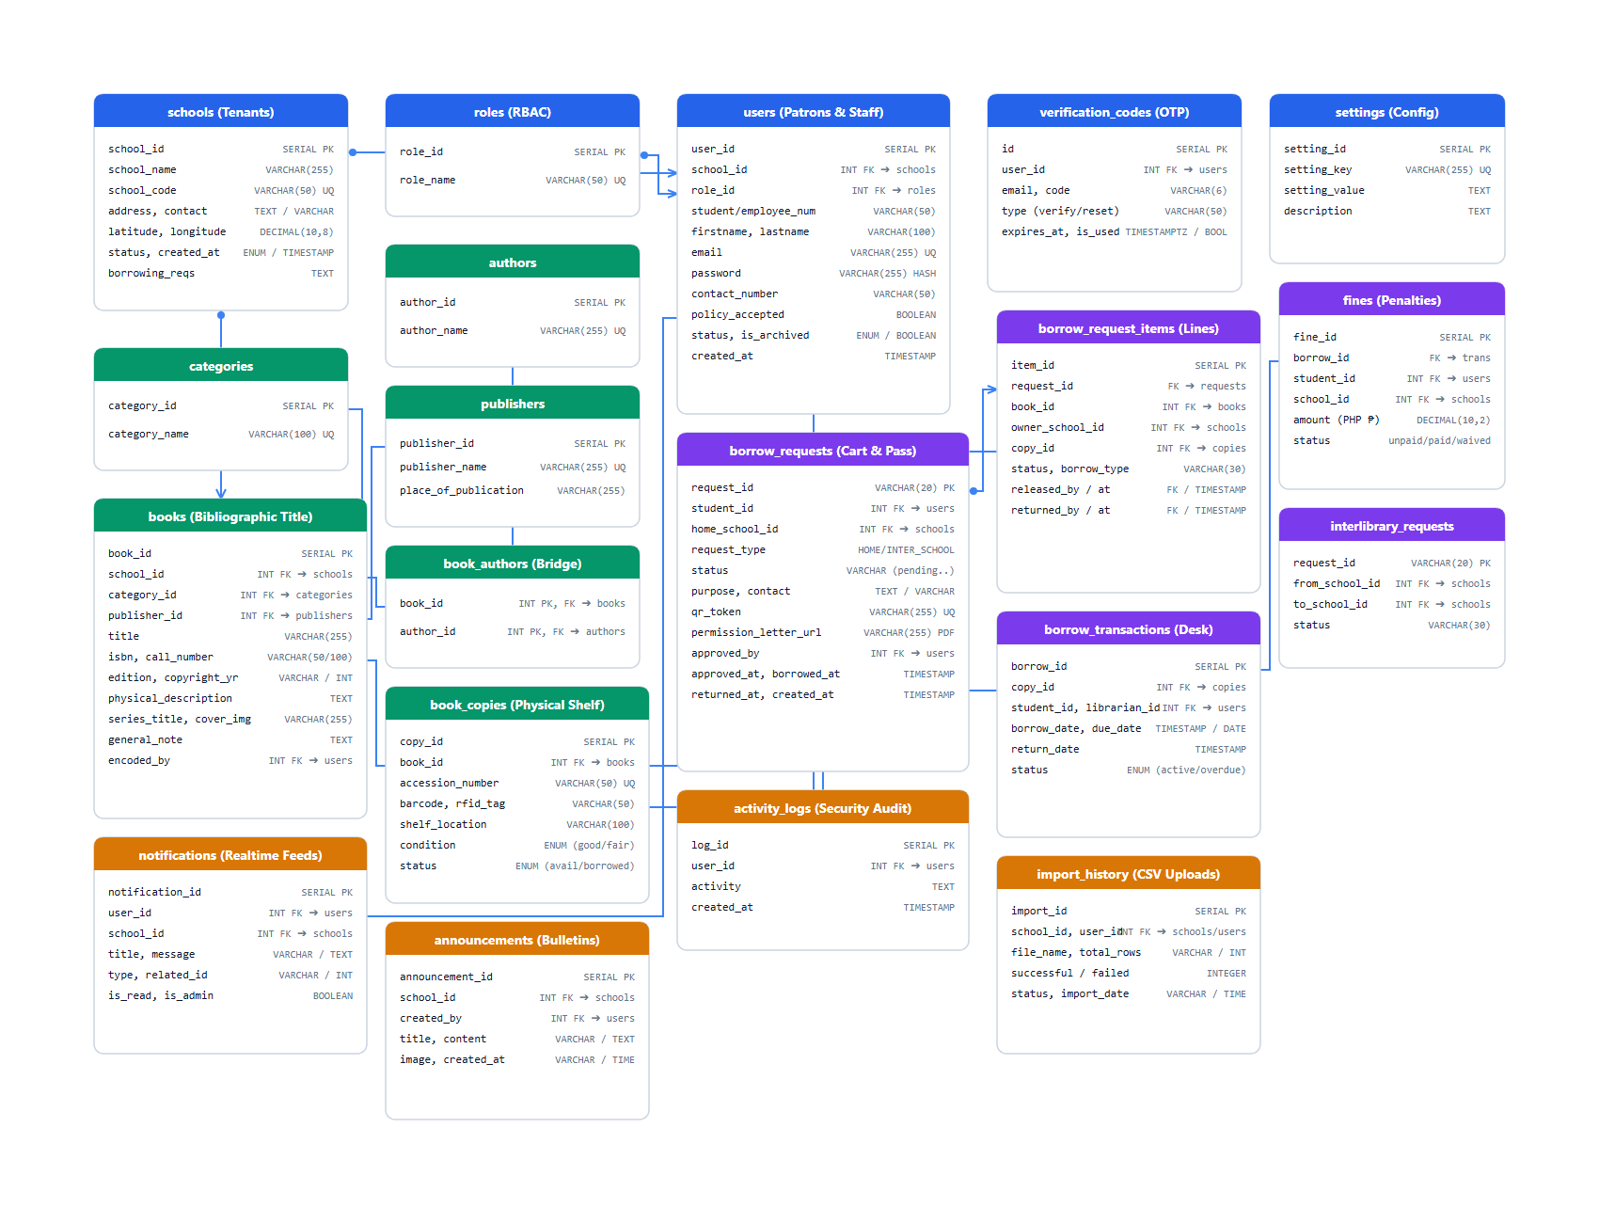
[DIAGRAM] Figure 4.12: LibraLink Entity-Relationship Diagram (ERD)
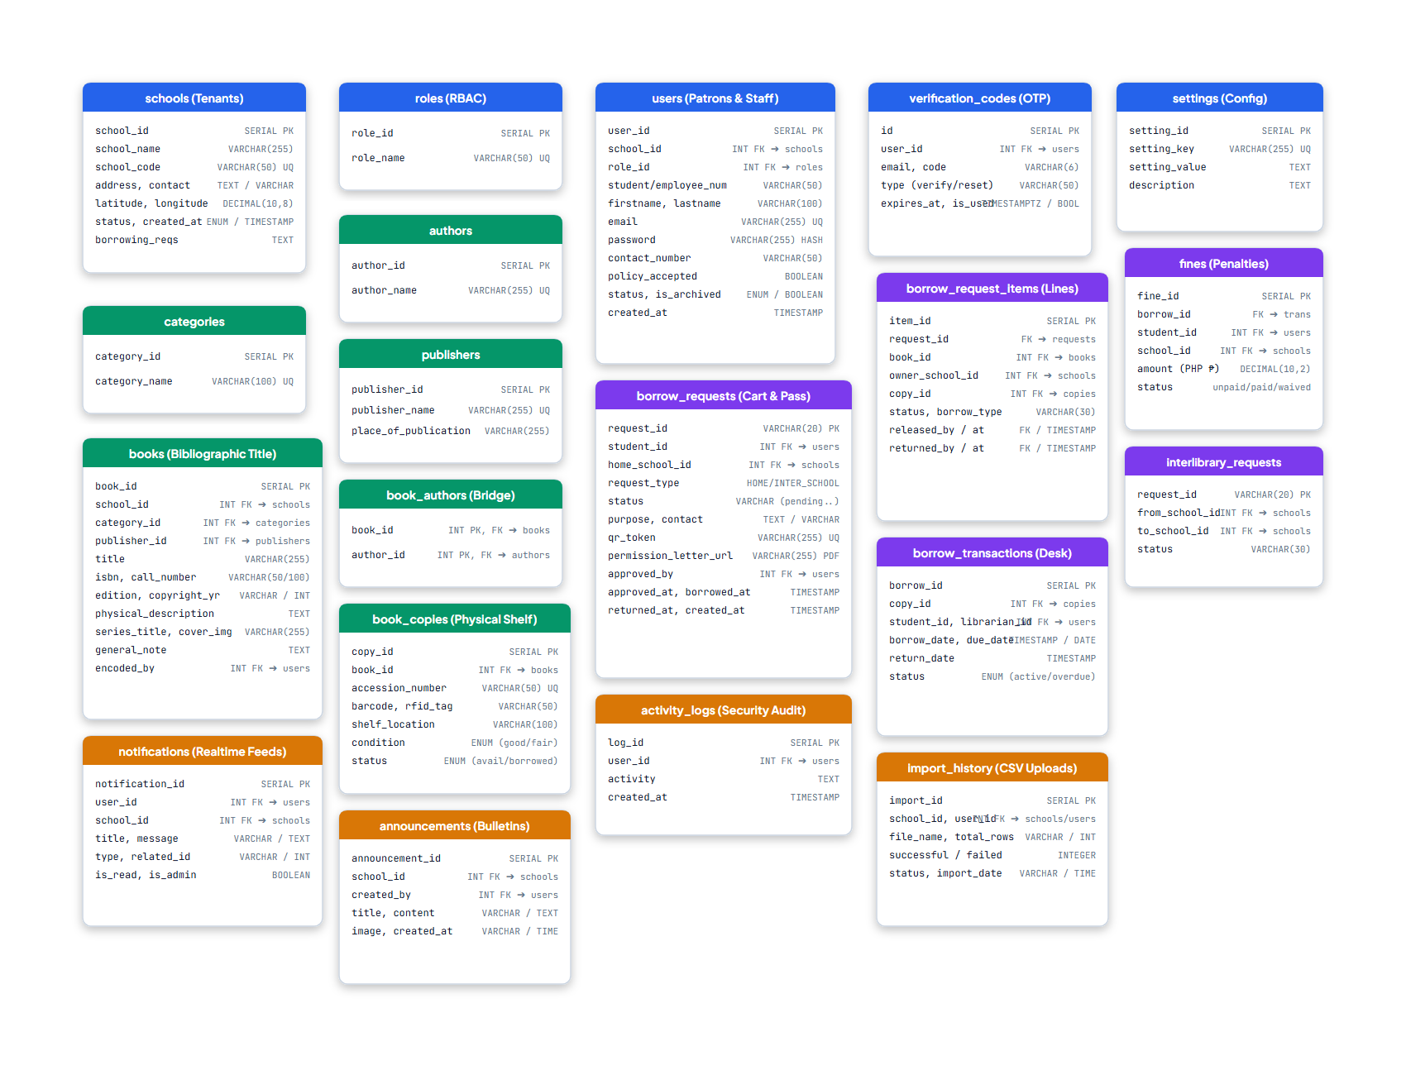
[DIAGRAM] Figure 4.13: LibraLink Relational Database Tables and Schema Attributes

Key Data Entities & Attributes:
- `schools`: id (PK), name, code, is_active, created_at.
- `users`: id (PK), school_id (FK), role_id (FK), full_name, email, id_number, academic_level.
- `books`: id (PK), school_id (FK), title, author, isbn, category, copies_available, shelf_location.
- `borrow_requests`: id (PK), student_id (FK), book_id (FK), home_school_id (FK), target_school_id (FK), status (pending, approved, rejected, completed).
- `access_tokens`: id (PK), request_id (FK), token_string, expires_at, status (valid, redeemed, expired).

g. User Interface and User Experience (UI/UX)
1. Design System: Consistent color palette using deep slate/navy for institutional gravity, emerald green for successful verifications, and amber for pending actions.
2. Accessibility & Responsiveness: Built using mobile-first Tailwind CSS classes, ensuring that students can comfortably search and present Access Tokens using mobile smartphones.
3. Feedback Mechanisms: Interactive toast notifications and visual badges display instant confirmation when requests are submitted or processed.

h. System Navigation Structure
[Public Landing Page] ──► [Sign In / Register]
│
┌───────────────────────────┼───────────────────────────┐
▼ (Role: Student) ▼ (Role: Librarian) ▼ (Role: Super Admin)
[Student Dashboard] [Librarian Dashboard] [Admin Dashboard]
├─ Search Catalog ├─ Pending Approvals ├─ School Management
├─ Multi-School Explorer ├─ Catalog Manager ├─ User Roles & Staff
├─ My Borrow Requests ├─ Token Verification ├─ System Audit Logs
└─ My Access Tokens └─ Circulation Records └─ Global Analytics

i. Application Programming Interface (API) Design
Method | Endpoint | Purpose | Authentication | Expected Response
GET | /api/books/search | Search books across GNC and SRC | Required | 200 OK (Array of books)
GET | /api/books/:id | Fetch specific book holdings | Required | 200 OK (Book Object)
POST | /api/borrow-requests | Submit an inter-library borrow request | Required | 201 Created (Request Object)
GET | /api/borrow-requests/pending | Retrieve pending queue for librarians | Required | 200 OK (Array of requests)
PUT | /api/borrow-requests/:id/status | Approve or reject a borrow request | Required | 200 OK (Updated Status)
POST | /api/tokens/verify | Authenticate an Access Token at partner school | Required | 200 OK (Verification Result)

j. Authentication and Authorization Design
- Role 1 (Super Administrator): Global oversight, institution enrollment, and system-wide audit logging.
- Role 2 (Librarian Administrator): Campus-level administration, inventory management, and head librarian controls.
- Role 3 (Librarian / Staff): Day-to-day circulation, inter-library approval, and Access Token physical verification.
- Role 4 (Student): Catalog discovery, profile management, request submission, and access token presentation.

k. Security Architecture
1. Row-Level Security (RLS): Supabase PostgreSQL RLS policies restrict cross-school data mutations. A librarian from GNC cannot edit book inventory belonging to SRC.
2. Input Sanitization & Validation: All incoming API payloads are sanitized against SQL injection, cross-site scripting (XSS), and prototype pollution.
3. Token Cryptography: Library Access Tokens are generated using randomized, time-bound alphanumeric cryptographic strings that expire after a designated validity window.
4. Audit Logging: Administrative actions are logged with timestamps and user identifiers.

l. External System Integration
- Supabase Cloud Infrastructure: Cloud-hosted PostgreSQL database persistence, automated daily backups, and connection pooling.
- Vercel Hosting Engine: Front-end static and serverless hosting with CDN edge caching.

m. Deployment Architecture
[Student / Librarian Device] (HTTPS)
│
▼
[Vercel CDN Edge Server] ──(Renders Client Web App)
│
▼
[Node.js / Express Backend Host]
│
▼
[Supabase Managed PostgreSQL Cluster] (Encrypted Connection via SSL)

n. Technology Stack Summary
Component | Technology | Selection Rationale
Frontend Framework | ReactJS (v19) | Modular component reusability, high performance, and declarative UI states
Build & Tooling | Vite | Ultra-fast build times and optimized production asset minification
CSS Framework | Tailwind CSS | Utility-first, responsive, and mobile-friendly styling without CSS bloat
Backend Runtime | Node.js | Event-driven, asynchronous performance handling concurrent user requests
Backend Framework | Express.js | Lightweight REST API routing and robust middleware pipeline
Database Management | Supabase / PostgreSQL | ACID compliance, enterprise relational integrity, and Row-Level Security
Version Control | Git & GitHub | Distributed version control, collaborative branch management, and tracking
Testing Suite | Postman | Automated REST API contract validation and regression testing

4. SYSTEM FEATURES AND USER INTERFACE

a. System Users and User Roles
User Role | Description | Major Functions | Access Restrictions
Super Admin | Manages system-wide operations and participating schools | School enrollment, global user assignment, audit review | Restricted from altering physical circulation records
Librarian Admin | Head librarian managing campus library operations | Catalog oversight, staff accounts, lending policy rules | Restricted to home campus operations
Librarian / Staff | Operational library personnel | Request review, token verification, book lending | Cannot modify system-wide school configurations
Student | Primary library user (College, SHS, JHS) | Cross-school search, request submission, access token view | Cannot view administrative queues or other users' data

b. System Modules and Functional Features
1. User Authentication & Profile Module: Secure student and librarian registration, institutional ID verification, and password encryption.
2. Centralized Catalog & Search Module: Cross-school book discovery with title, author, category, and availability filters.
3. Inter-Library Borrow Request Module: Handles student request submissions, validation of student standing, and request routing to the home librarian.
4. Librarian Approval & Verification Module: Dual-pane review interface allowing librarians to inspect borrower credentials, check policy constraints, and approve or reject transactions.
5. Library Access Token Module: Generates and verifies digital access passes with unique codes and timestamps for on-site partner library visits.
6. Inventory & Records Management Module: Full CRUD operations for books, categorizing volumes by academic department (College, SHS, JHS).

c. User Interface and Navigation
Below are the actual implemented user interfaces of the LibraLink web-based system across its key user roles:
[SCREENSHOT] Figure 4.14: Public Landing Page and Institutional Sign-In Interface
The landing page introduces students and library staff to the centralized inter-school platform, offering separate portal login access for Guagua National College and Santa Rita College.
[SCREENSHOT] Figure 4.15: Student Dashboard and Cross-School Catalog Search Interface
The student exploration screen allows users to search across both campus catalogs, filter by department or availability, and submit inter-library borrow requests.
[SCREENSHOT] Figure 4.16: Librarian Administrative and Approval Dashboard Interface
The librarian portal provides a real-time counter of circulation statistics, an administrative inbox for pending borrow requests, token verification tools, and book inventory management.

d. Major System Functions and Workflows

Workflow 1: Inter-Library Borrowing & Token Lifecycle
1. User Action: Student searches for a book unavailable at GNC; system indicates availability at SRC. Student clicks "Request Borrow".
2. System Processing: Creates a borrow_requests record with status Pending_Home_Approval.
3. Librarian Action: GNC Librarian inspects request queue and clicks "Approve".
4. Token Generation: System updates request status to Approved and triggers Access Token creation.
5. Redemption Action: Student visits SRC, presents the Token; SRC Librarian validates it and marks the transaction as Active/Borrowed.

e. Reports, Outputs, Notifications, and User Feedback
1. Digital Library Access Token: Printable and mobile-viewable authorization credential.
2. Transaction Summary Tables: Exportable circulation logs for monthly institutional auditing.
3. Dynamic Feedback Alerts: Color-coded status notifications indicating approval, rejection with reason, or token expiration.

f. Feature-to-Objective Traceability Matrix
Specific Research Objective | Implemented System Module | Implementation Evidence | Status
Objective 1: Centralized search and holding discovery | Multi-School Catalog Search Module | Implemented (Figure 4.4, 4.15) | Fulfilled
Objective 2: Inter-library borrowing request routing | Borrow Request State Management | Implemented (Figure 4.5, 4.6) | Fulfilled
Objective 3: Dual-layer librarian approval workflow | Librarian Administrative Inbox | Implemented (Figure 4.7, 4.16) | Fulfilled
Objective 4: Secure cross-campus physical book access | Digital Access Token Generator & Verifier | Implemented (Figure 4.6, 4.7, 4.16) | Fulfilled
Objective 5: Empirical ISO/IEC 25010 system evaluation | System Evaluation Framework & Testing | Documented in Sections 5 & 6 | Fulfilled

5. TESTING RESULTS
This section documents the formal functional and system testing conducted to verify that LibraLink operates according to its technical specifications.

a. Testing Procedures
The researchers conducted Functional Testing and User Acceptance Testing (UAT) across simulated deployment environments:
- Testing Methods: Black-box functional testing and end-to-end user scenario testing.
- Tested Modules: Authentication, Cross-School Catalog Search, Borrow Request Processing, Access Token Generation, and Inventory Management.
- Testing Environments: Tested on Google Chrome, Mozilla Firefox, and Safari across Windows desktop, iPadOS, and Android mobile devices.

b. Test Cases
Test Case ID | Module / Feature | Test Scenario | Expected Result | Actual Result | Status
TC-001 | Authentication | Enter valid GNC credentials | User successfully logs into Student Portal | User successfully logged in | Passed
TC-002 | Authentication | Enter invalid password | Error toast notification displayed | Error notification displayed | Passed
TC-003 | Search Catalog | Search by keyword across all schools | Returns books matching keyword from GNC and SRC | Displayed matching books accurately | Passed
TC-004 | Holding Check | View unavailable local book | System highlights partner school holding | Partner institution suggested | Passed
TC-005 | Request Borrow | Submit inter-library request | Transaction logged as "Pending" | Request logged in librarian queue | Passed
TC-006 | Approval Workflow | Librarian approves borrow request | Status changed to "Approved" & Token generated | Token successfully generated | Passed
TC-007 | Rejection Workflow | Librarian rejects with reason | Status changed to "Rejected" & Reason displayed | Reason visible to student | Passed
TC-008 | Token Verification | Partner librarian verifies token code | System validates authenticity and marks as redeemed | Token validated and redeemed | Passed
TC-009 | Token Expiration | Verify expired token | System flags token as invalid/expired | Error flagged, access denied | Passed
TC-010 | Inventory Control | Librarian adds new book to catalog | Book immediately discoverable in search | Book appeared in search index | Passed

c. Testing Results Summary
Testing Area | Total Test Cases | Passed | Failed | Final Status
User Authentication & Role Access | 4 | 4 | 0 | Passed
Cross-School Book Search & Availability | 4 | 4 | 0 | Passed
Borrow Request & Approval Lifecycle | 5 | 5 | 0 | Passed
Access Token Generation & Redemption | 4 | 4 | 0 | Passed
Catalog & Inventory Management | 3 | 3 | 0 | Passed
TOTAL | 20 | 20 | 0 | 100% Passed

d. Issues Encountered and Corrective Actions
Issue Description | Affected Module | Corrective Action Applied | Resolution Status
Partner school books were initially hidden from student search | Search Query Service | Refactored multi-tenant PostgreSQL join to allow cross-school read access | Resolved
Mobile viewport caused Access Token details to wrap awkwardly | Token Display View | Implemented responsive flex-col Tailwind layout with scalable badge sizes | Resolved
Request items were blocked by RLS policies upon submission | Backend Database RLS | Updated Supabase RLS policies to allow authenticated students to insert request items | Resolved

6. SYSTEM EVALUATION RESULTS
This section presents the empirical evaluation results gathered from the 64 purposively selected respondents across Guagua National College and Santa Rita College, evaluated against the ISO/IEC 25010 Software Quality Model.

a. Evaluation Framework
The evaluation adhered strictly to the ISO/IEC 25010 Software Product Quality Model, measuring:
1. Functional Suitability: Completeness, correctness, and appropriateness of library features.
2. Usability: Interface aesthetics, ease of learning, accessibility, and navigation.
3. Reliability: Operational consistency, error handling, and transaction state preservation.
4. Performance Efficiency: Response time, fast query execution, and minimization of redundant steps.
5. User Satisfaction & Educational Impact (SDG 4): Overall stakeholder approval and contribution to accessible academic education.

b. Presentation of Evaluation Results
The evaluation data collected from the 64 respondents were analyzed using Weighted Mean ($WM$) and interpreted using the four-point Likert scale criteria established in Chapter III:

Table 4.1: Demographic Breakdown of Respondents ($N = 64$)
Classification | Academic Level / Designation | Guagua National College | Santa Rita College | Total ($f$) | Percentage ($\%$)
Students | College | 10 | 10 | 20 | 31.25%
 | Senior High School | 10 | 10 | 20 | 31.25%
 | Junior High School | 10 | 10 | 20 | 31.25%
Librarians | Library Staff / Admin | 2 | 2 | 4 | 6.25%
TOTAL |  | 32 | 32 | 64 | 100.00%

Table 4.2: Summary of Evaluation Results per Quality Characteristic (ISO/IEC 25010)
Quality Characteristic | Number of Items | Overall Weighted Mean | Verbal Interpretation | System Acceptability Level
1. Functional Suitability | 5 Items (Q1–Q5) | 3.71 | Strongly Agree | Highly Acceptable
2. Usability | 4 Items (Q6–Q9) | 3.67 | Strongly Agree | Highly Acceptable
3. Reliability | 3 Items (Q10–Q12) | 3.63 | Strongly Agree | Highly Acceptable
4. Performance Efficiency | 3 Items (Q13–Q15) | 3.69 | Strongly Agree | Highly Acceptable
5. User Satisfaction & SDG 4 | 3 Items (Q16–Q18) | 3.78 | Strongly Agree | Highly Acceptable
OVERALL GRAND MEAN | 18 Items Total | 3.70 | Strongly Agree | Highly Acceptable

c. Interpretation of Results
1. Overall Acceptance: The overall grand weighted mean of 3.70 falls comfortably within the 3.26 – 4.00 interval, indicating that the LibraLink system is rated "Strongly Agree" and deemed "Highly Acceptable" across both student and librarian respondent groups.
2. Highest Rated Criterion: User Satisfaction and SDG 4 Impact ($WM = 3.78$) achieved the highest score, demonstrating that stakeholders strongly value the platform's ability to bridge resource disparities and provide equitable access to academic books across Pampanga schools.
3. Functional Suitability ($WM = 3.71$): Confirms that cross-school catalog discovery, holding suggestions, request routing, and digital token issuance functioned accurately and met user expectations.
4. Performance Efficiency ($WM = 3.69$) & Usability ($WM = 3.67$): Validates that the React and Vite architecture delivers fast page loads, responsive navigation on smartphones, and an intuitive borrowing experience.
5. Reliability ($WM = 3.63$): While receiving a very high score, respondents noted that clear toast notifications during occasional slow mobile network connections are essential to reinforce user trust.

d. Evaluation in Relation to the Objectives
Specific Research Objective | Evaluation Criterion | Weighted Mean | Interpretation & Findings
Objective 1: Centralized search and real-time availability across GNC and SRC | Functional Suitability (Items 1 & 2) | 3.74 | Achieved: Students successfully located materials in partner campuses without physical inquiry.
Objective 2: Inter-library borrowing request submission and tracking | Functional Suitability (Items 3 & 4) | 3.68 | Achieved: Streamlined the paperless submission of resource requests.
Objective 3: Dual-institution librarian authorization and digital token issuance | Functional Suitability & Reliability (Items 5 & 10) | 3.70 | Achieved: Enabled secure, verifiable cross-campus book access via digital tokens.
Objective 4: Provide a user-friendly and responsive cross-platform web interface | Usability & Efficiency (Items 6–9, 13) | 3.68 | Achieved: Interface proved responsive and easy to navigate for JHS, SHS, and College users.
Objective 5: Advance equitable access to learning resources under SDG 4 | User Satisfaction & SDG 4 (Items 16–18) | 3.78 | Achieved: Directly democratized access to scarce academic books across participating schools.

e. Overall Evaluation Findings and Synthesis
The comprehensive evaluation of the LibraLink platform demonstrates the following conclusions:
1. Empirical Success: LibraLink successfully bridges the gap between disconnected library systems in Pampanga, offering an operational, secure, and centralized inter-library resource sharing solution.
2. Key Strengths:
- High user satisfaction and alignment with Sustainable Development Goal 4 (Quality Education).
- Streamlined, paperless workflow from catalog search to digital Access Token verification.
- Intuitive, responsive design accessible to Junior High, Senior High, and College students.
3. Identified Areas for Enhancement:
- Future inclusion of automated SMS notifications when inter-school requests receive approval.
- Integration of barcode / QR code scanning capabilities directly into the mobile token verification interface to expedite host librarian check-in.
4. Final Verdict: The empirical score of 3.70 (Highly Acceptable) provides definitive academic and technical evidence that LibraLink accomplishes all stated research objectives and is ready for institutional adoption.

