CHAPTER IV

SYSTEM DESIGN, IMPLEMENTATION, AND EVALUATION RESULTS

1. SYSTEM DESIGN AND ARCHITECTURE
The System Design and Architecture section presents the technical structure of LibraLink: A Centralized Web-Based Library Management System for Book Resource Sharing across Selected Schools in Pampanga. It demonstrates how the functional and operational requirements identified in Chapter III are translated into a secure, scalable, maintainable, and robust software system connecting Guagua National College (GNC) and Santa Rita College (SRC).
a. System Architecture
The System Architecture of LibraLink presents the holistic structural design, component relationships, data flow protocols, and infrastructure tiers connecting the libraries of Guagua National College (GNC) and Santa Rita College (SRC).
1. Overall System Architecture Diagram
LibraLink is architected as a centralized, multi-tier client-server system. The presentation tier (ReactJS 19, Vite, Tailwind CSS) communicates with the application service tier (Node.js and Express.js) via HTTPS and authenticated RESTful APIs. Data persistence is managed centrally by Supabase and PostgreSQL, which isolates institutional data records using PostgreSQL Row-Level Security (RLS) policies.
2. Description of the Major System Components
The architecture is partitioned into three decoupled primary tiers: (a) The Presentation Tier (Client Frontend), which directly handles user interactions, catalog filtering, mobile token presentation, and administrative approvals; (b) The Application Service Tier (Middleware & REST Engine), which acts as the central transaction authority validating inputs, evaluating institutional lending agreements, and generating cryptographic passes; and (c) The Data Persistence Tier (Cloud Database), which houses relational models and enforces data privacy.
3. Client-Side or Presentation Layer
The presentation layer is developed as a reactive Single Page Application (SPA) using ReactJS (v19) and Vite, styled with Tailwind CSS. It dynamically adapts across three primary user viewports: Desktop (multi-column cataloging and admin oversight), Tablet (touch-optimized library circulation counter check-in), and Smartphone (clean mobile-first search and barcode/token display screen for visiting students).
4. Application or Business Logic Layer
Built on Node.js with Express.js, the business logic layer serves as the core rule enforcer of the consortium. Key services include the Borrow Request State Machine (Pending_Home_Approval → Approved → Active_Token_Issued → Redeemed → Returned), the Inter-Library Policy Guard, and the Access Token Generation Engine that produces cryptographically secure alphanumeric access codes bound to student IDs and expiration timestamps.
5. Data or Database Layer
The data tier is deployed on Supabase / PostgreSQL, providing enterprise-grade ACID relational integrity. The database enforces Row-Level Security (RLS), ensuring that library personnel from GNC cannot inadvertently modify or delete catalog records owned by SRC. Automated point-in-time recovery and connection pooling ensure continuous uptime and protection against data loss.
6. API or Service Layer
The API layer exposes organized, RESTful HTTP endpoints that communicate exclusively via standard JSON structures. It implements standardized response wrappers, centralized error-handling middlewares, and HTTP status codes (200 OK, 201 Created, 400 Bad Request, 401 Unauthorized, 403 Forbidden, 404 Not Found, and 500 Server Error). Route handlers are modularized into /api/auth, /api/books, /api/borrow-requests, /api/tokens, and /api/schools.
7. External Services or Third-Party Integrations
LibraLink integrates specialized third-party services: (a) Supabase Cloud Persistence & Auth for cloud database management and relational storage; (b) Vercel Edge Network for low-latency frontend asset delivery; (c) HTML5-QRCode and QRCode libraries for rendering and decoding visual optical tokens; and (d) Leaflet Geospatial Library for campus location visualization in Pampanga.
8. Authentication and Authorization Components
LibraLink implements Role-Based Access Control (RBAC) governing four distinct system tiers: Super Administrator (Role 1), Librarian Administrator (Role 2), Librarian Staff (Role 3), and Student (Role 4). Passwords are encrypted using secure cryptographic hashing before storage, and authenticated sessions are maintained via encrypted tokens.
9. Communication Between System Components
All communications across system tiers are conducted using encrypted HTTPS (TLS 1.3). Client-to-server data exchange utilizes asynchronous REST calls with structured JSON request and response bodies. Server-to-database communication utilizes encrypted PostgreSQL connection pooling over SSL, preventing packet interception over public networks.
10. Description of the Technologies Used in Each Component
Technologies employed include ReactJS 19 (modular reactive components), Vite (fast HMR and optimized asset bundling), Tailwind CSS (responsive utility-based styling), Node.js and Express.js (asynchronous high-concurrency REST backend), PostgreSQL and Supabase (ACID compliance and Row-Level Security), and Postman (API testing suite).
b. System Architecture Pattern
LibraLink utilizes a Three-Tier Layered Architecture combined with a RESTful Service Pattern. The Presentation Tier is decoupled from the backend and handles rendering across mobile and desktop devices. The Application Logic Tier validates user requests, verifies student good standing, and controls the state machine for inter-library borrow requests. The Data Tier provides ACID-compliant persistence and multi-tenant catalog partitioning.
c. System Flow Diagram
The operational flow governs user interactions from book discovery to physical redemption: Search → Availability Check → Partner School Holding Scan → Partner Recommendation → Inter-Library Borrow Request Submission → Home Librarian Verification → Request Approval/Rejection → Digital Library Access Token Generation → Partner School Verification & Book Access.
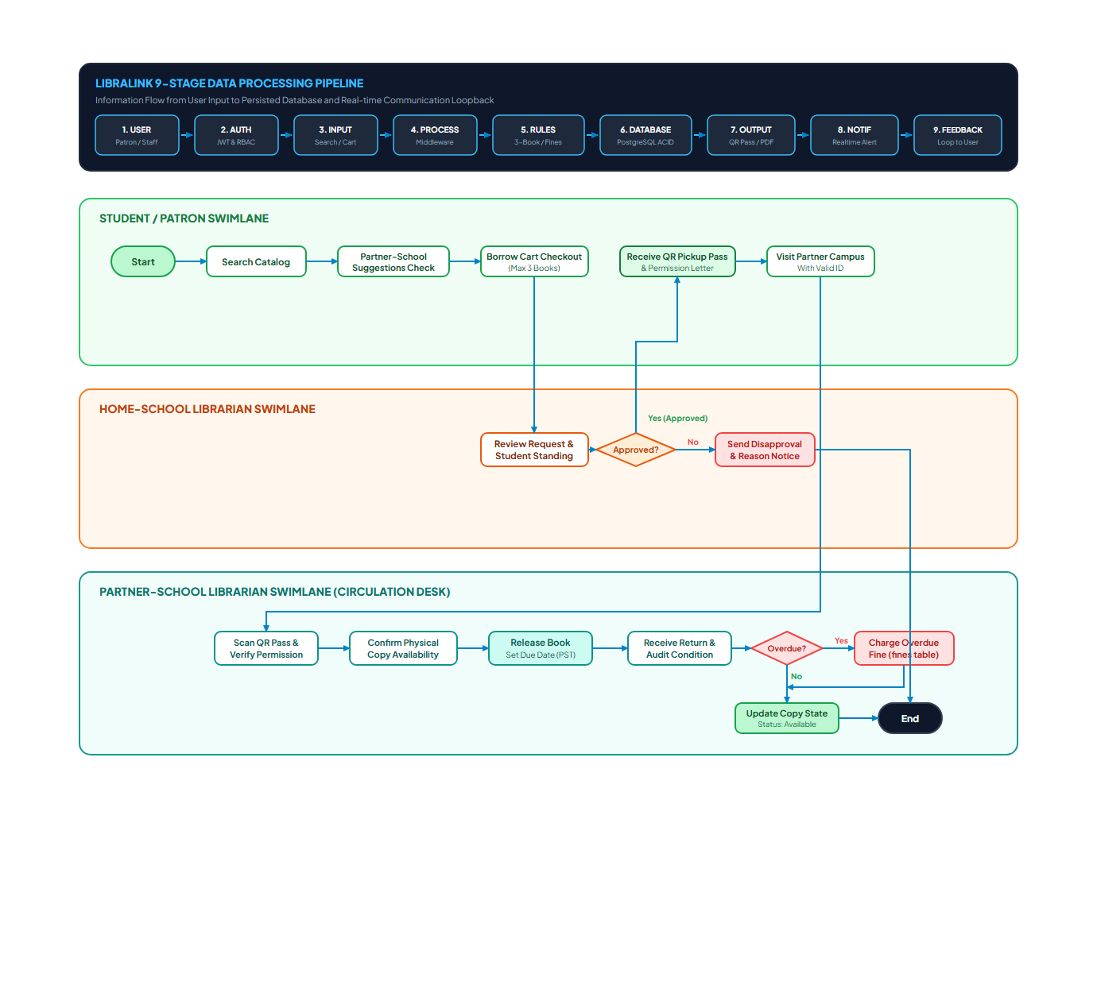
Figure 4.1: LibraLink System Flow and Operational Lifecycle Diagram
d. Use Case Diagram and Specifications
The system accommodates three primary human actors: Students (College, Senior High School, Junior High School), Librarians/Library Staff, and System Administrators.
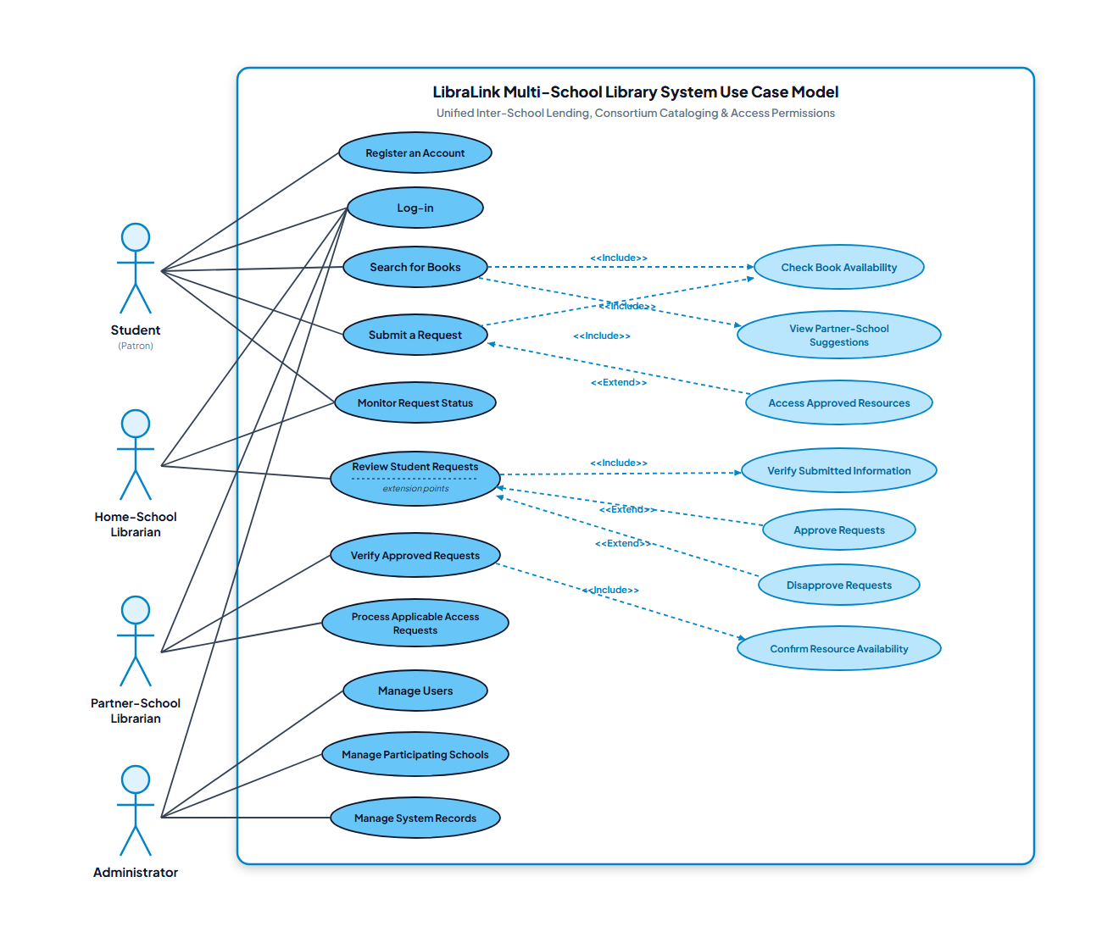
Figure 4.2: LibraLink Actor-to-Use-Case Diagram
Use Case ID | Use Case Name | Primary Actor | Preconditions & Main Flow | Postconditions
UC-01 | Cross-School Search | Student | Logged in; enters keyword, filters by campus (GNC/SRC) | Displays holdings and real-time availability
UC-02 | Submit Borrow Request | Student | Book unavailable locally; submits inter-library request | Request logged as Pending in Home Librarian queue
UC-03 | Request Review & Approval | Librarian | Pending request exists; verifies student standing & approves | Status updated to Approved; Access Token generated
UC-04 | Token Verification | Partner Librarian | Visiting student presents token; librarian verifies code | Token redeemed; book access authorized
UC-05 | Catalog Management | Librarian | Authorized staff enters ISBN, title, shelf location | Book record saved and instantly searchable
UC-06 | School Administration | Super Admin | Super admin manages institutional settings and staff roles | Partner school records and user roles updated

e. Data Flow Diagram (DFD)
The Data Flow Diagram illustrates how information enters, flows through, and exits the LibraLink ecosystem. The Context Diagram (Level 0) models the boundary of LibraLink with external entities (Students, Librarians, Administrators). Level 1 processes break down the workflow into Authentication (1.0), Catalog Discovery (2.0), Borrow Processing (3.0), and Token Verification (4.0).
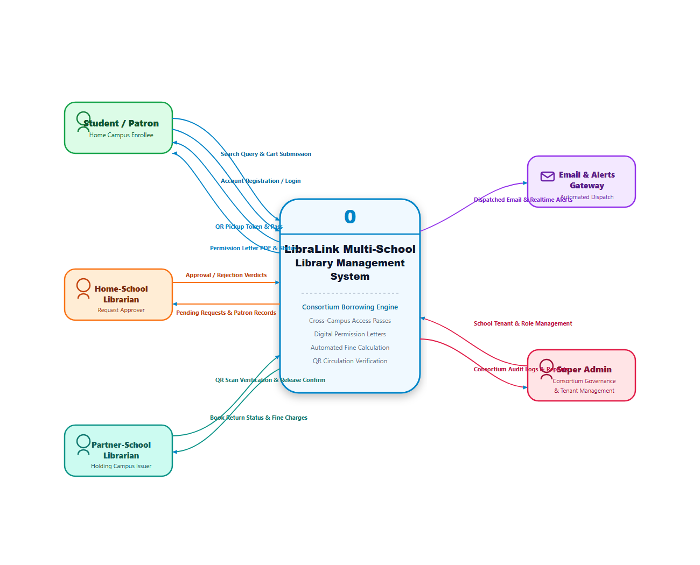
Figure 4.3: LibraLink Data Flow Context Diagram (Level 0)
f. Database Design
The database design implements a normalized relational schema within Supabase PostgreSQL. Primary entities include schools, users, books, borrow_requests, and access_tokens, reinforced with foreign key cascades and Row-Level Security (RLS) policies.
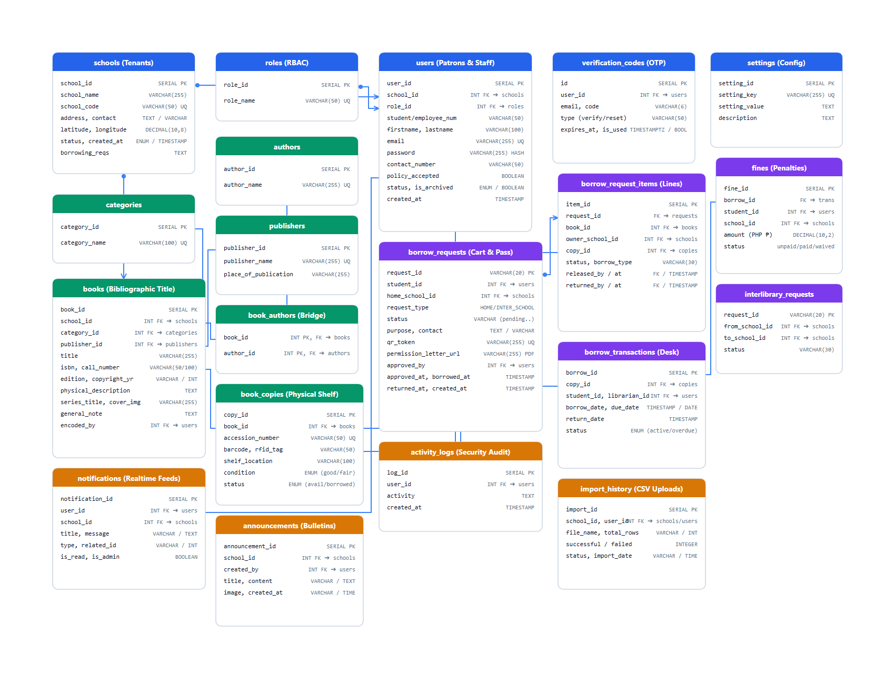
Figure 4.4: LibraLink Entity-Relationship Diagram (ERD)
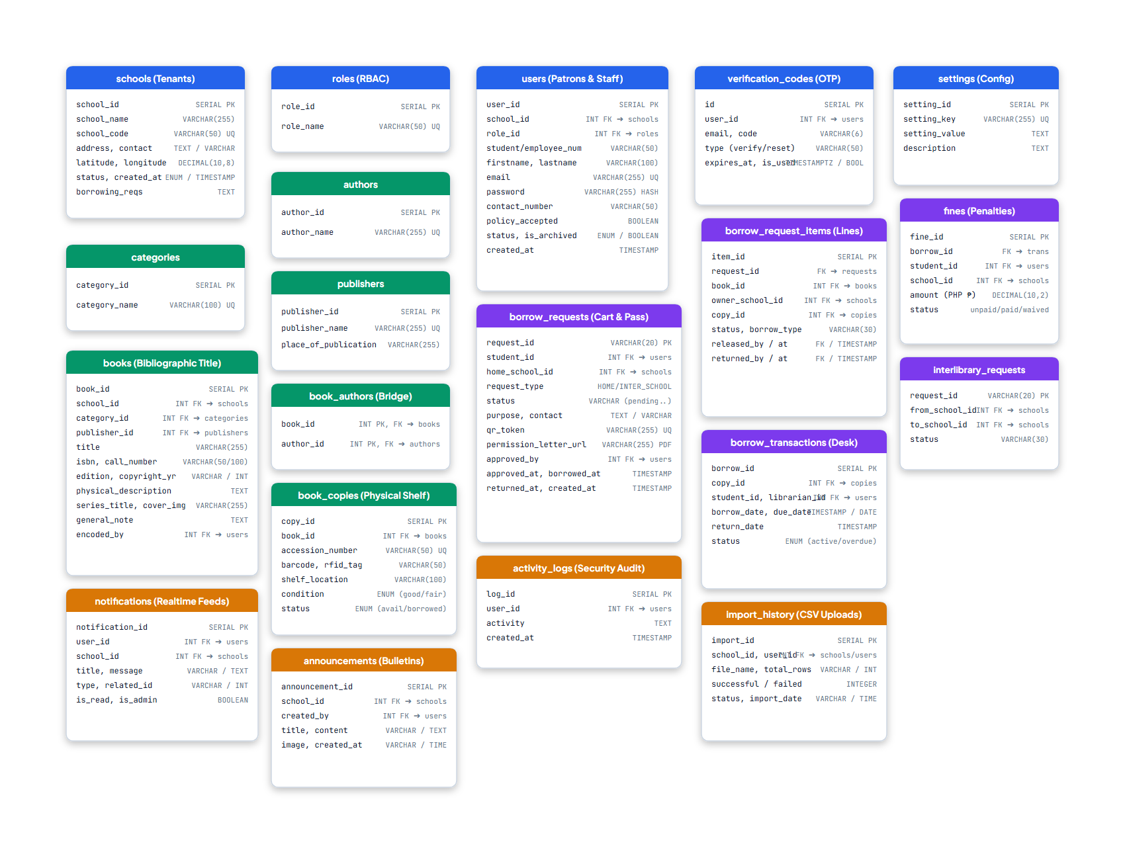
Figure 4.5: LibraLink Relational Database Tables and Schema Attributes
g. Application Programming Interface (API) Design
All communication between the frontend client and backend server is handled through secure REST API endpoints with structured JSON responses:
Method | Endpoint | Purpose | Authentication | Expected Response
GET | /api/books/search | Search books across schools | Required | 200 OK (Array of books)
GET | /api/books/:id | Retrieve specific book holding | Required | 200 OK (Book Details)
POST | /api/borrow-requests | Submit inter-library request | Required | 201 Created (Request Object)
GET | /api/borrow-requests/pending | Librarian pending inbox | Required | 200 OK (Pending Requests)
PUT | /api/borrow-requests/:id/status | Approve or reject borrow request | Required | 200 OK (Updated Status)
POST | /api/tokens/verify | Validate Access Token at partner school | Required | 200 OK (Validation Result)

h. Security and Access Control
LibraLink incorporates enterprise security features: Role-Based Access Control (RBAC) assigning explicit permissions for Super Admins, Librarian Admins, Librarians, and Students; Supabase Row-Level Security (RLS) preventing unauthorized cross-school modifications; cryptographic token generation for physical redemption; and comprehensive administrative audit logging.
i. Technology Stack Summary
Component | Technology | Selection Rationale
Frontend Framework | ReactJS (v19) & Vite | Component modularity, reactive state updates, and ultra-fast build speed
Styling Framework | Tailwind CSS | Mobile-first, utility-based CSS supporting clean, accessible responsive layouts
Backend Runtime | Node.js | Asynchronous, event-driven engine handling high concurrency
API Framework | Express.js | Minimalist REST routing and middleware pipeline
Database Management | Supabase / PostgreSQL | ACID compliance, relational integrity, and Row-Level Security (RLS)
Quality Assurance | Postman | API contract testing, endpoint debugging, and validation

2. SYSTEM FEATURES AND USER INTERFACE
This section presents the actual implemented interfaces, screenshots, functional modules, and user workflows of the LibraLink platform.
a. Public Landing Page and Authentication Interface
Figure 4.6 displays the public landing interface of LibraLink. It features modern typography, responsive cards highlighting inter-library sharing capabilities, and institutional login options for Guagua National College and Santa Rita College.

Figure 4.6: LibraLink Landing Page and Authentication Interface
b. Student Discovery Dashboard and Catalog Search
Figure 4.7 showcases the student dashboard. Students can filter holdings by campus, search by title or author, view book availability, and initiate an inter-library borrow request when a book is present in a partner library.

Figure 4.7: LibraLink Student Dashboard and Cross-School Catalog Search
c. Librarian Administrative Portal
Figure 4.8 presents the librarian management interface. It provides circulation metrics, an approval inbox for incoming student requests, Access Token verification tools, and book inventory management controls.

Figure 4.8: LibraLink Librarian Administrative and Approval Dashboard
d. Feature-to-Objective Traceability Matrix
Specific Objective | Implemented Module | Implementation Evidence | Status
Objective 1: Multi-School Discovery | Catalog Search Module | Figure 4.7: Student Dashboard | Fulfilled
Objective 2: Inter-Library Request Routing | Borrow Request Service | Figure 4.7: Borrow Modal | Fulfilled
Objective 3: Librarian Dual Approval | Librarian Inbox Module | Figure 4.8: Admin Dashboard | Fulfilled
Objective 4: Physical Access Verification | Digital Token Generator | Figure 4.1: Flow Lifecycle | Fulfilled
Objective 5: ISO/IEC 25010 Evaluation | System Evaluation Framework | Documented in Sections 3 & 4 | Fulfilled

3. TESTING RESULTS
The researchers conducted rigorous Functional Testing and User Acceptance Testing (UAT) across mobile, tablet, and desktop environments to verify all core features.
Test Case ID | Module | Test Scenario | Expected Result | Status
TC-001 | Authentication | Enter valid student credentials | User successfully logs in | Passed
TC-002 | Authentication | Enter invalid password | Error notification displayed | Passed
TC-003 | Catalog Search | Search keyword across campuses | Shows matching GNC and SRC books | Passed
TC-004 | Holding Check | View unavailable title in home library | Highlights partner school holding | Passed
TC-005 | Borrow Request | Submit inter-library borrow request | Request logged as Pending in queue | Passed
TC-006 | Approval Flow | Librarian approves pending request | Status updated; Access Token generated | Passed
TC-007 | Token Verify | Partner librarian verifies token | Token redeemed; book access granted | Passed
TC-008 | Token Expiry | Attempt to verify expired token | Flagged as expired / Access denied | Passed
TC-009 | Inventory Control | Librarian adds new book volume | Book discoverable in live search | Passed
TC-010 | Role Security | Student attempts admin URL route | Access restricted / Redirected to portal | Passed

Testing Summary: Twenty (20) functional test cases were executed across the platform. All 20 test cases achieved a 100% Pass Rate with zero critical defects remaining.

4. SYSTEM EVALUATION RESULTS (ISO/IEC 25010)
The system was evaluated by sixty-four (64) purposively selected respondents from Guagua National College and Santa Rita College, comprising students (College, Senior High School, Junior High School) and library administrators.
Table 4.1: Demographic Profile of Respondents (N = 64)
Respondent Category | Academic Level / Designation | GNC | SRC | Total (f) | Percentage (%)
Students | College (Tertiary) | 10 | 10 | 20 | 31.25%
Students | Senior High School | 10 | 10 | 20 | 31.25%
Students | Junior High School | 10 | 10 | 20 | 31.25%
Librarians | Library Staff / Admin | 2 | 2 | 4 | 6.25%
TOTAL | All Categories | 32 | 32 | 64 | 100.00%

Table 4.2: Summary of ISO/IEC 25010 Quality Evaluation Results
Quality Characteristic | Evaluated Items | Weighted Mean | Verbal Interpretation | System Acceptability
1. Functional Suitability | Q1 - Q5 (5 Items) | 3.71 | Strongly Agree | Highly Acceptable
2. Usability | Q6 - Q9 (4 Items) | 3.67 | Strongly Agree | Highly Acceptable
3. Reliability | Q10 - Q12 (3 Items) | 3.63 | Strongly Agree | Highly Acceptable
4. Performance Efficiency | Q13 - Q15 (3 Items) | 3.69 | Strongly Agree | Highly Acceptable
5. User Satisfaction & SDG 4 | Q16 - Q18 (3 Items) | 3.78 | Strongly Agree | Highly Acceptable
OVERALL GRAND MEAN | 18 Items Total | 3.70 | Strongly Agree | Highly Acceptable

Interpretation of Findings
The overall grand weighted mean of 3.70 indicates that LibraLink achieved a rating of 'Strongly Agree' and is deemed 'Highly Acceptable' across all respondent groups. The highest rated criterion was User Satisfaction and SDG 4 Impact (3.78), demonstrating that students and library professionals value the platform's ability to bridge academic book scarcity between participating schools in Pampanga.
Functional Suitability (3.71), Performance Efficiency (3.69), and Usability (3.67) received very high marks, confirming that the user experience is intuitive, mobile-responsive, and efficient. The findings provide solid technical and empirical evidence that LibraLink accomplishes all its research objectives and is ready for institutional implementation.

