Title Page

LIBRALINK: A Centralized Web-Based Library Management System for Book Resource Sharing Among Selected Schools in Pampanga

A Capstone Project
Presented to the
Faculty of the College of Computer Studies
Santa Rita College of Pampanga

In Partial Fulfillment
of the Requirements for the Degree
BACHELOR OF SCIENCE IN INFORMATION SYSTEM

By

Name
Buan Timothy
Guinto Ryan M.
Lopez Renelle Robie D.

October

Approval Sheet

APPROVAL SHEET

This Capstone Project entitled “Title of the thesis” proposed and submitted by Name of the Proponent in partial fulfillment of the requirements for the degree BACHELOR OF SCIENCE IN INFORMATION SYSTEM, has been examined and found in order and is hereby recommended for acceptance and approval for ORAL EXAMINATION.

CAPSTONE PROJECT PROPOSAL COMMITTEE
Name
Chair

Name
Member
Name
Member

PANEL OF EXAMINERS

Passed by the PANEL OF EXAMINERS on ORAL EXAMINATION with a grade of ___________ on ____________________.

Name
Chair

Name
Member
Name
Member

Name
Adviser

Accepted and approved in partial fulfillment of the requirements for the degree BACHELOR SCIENCE IN INFORMATION SYSTEM.

Date
Name
Dean

Acknowledgement

Abstract

TABLE OF CONTENTS

List of Tables
TABLE NO. |  | PAGE

LIST OF FIGURES

FIGURE NO. | PAGE

Chapter I

Introduction

BACKGROUND OF THE STUDY
Libraries play an important role in supporting the academic needs of students by providing books and other learning resources. Books are used by students for classroom activities, assignments, research, projects, and other academic requirements. However, not all schools have the same collection of books. Some libraries may have limited copies or may not have the specific book that a student needs. Because of this, students may experience difficulty in finding the resources required for their studies.
In selected schools in Pampanga, such as Guagua National College and Santa Rita College, library resources may differ in terms of availability and collection. A book that is unavailable in one school may be available in another school. However, students may not immediately know which participating school has the book they are looking for. The absence of a centralized system for checking the availability of resources across participating schools can make the process of finding and accessing books more difficult.
To address this concern, the researchers propose LibraLink: A Centralized Web-Based Library Management System for Book Resource Sharing Among Selected Schools in Pampanga. LibraLink is designed to connect the library resources of selected participating schools through a centralized web-based system. The system allows students to search for books and determine whether the requested resource is available in their own school or in another participating school.
When a requested book is not available in the student's own library, LibraLink can suggest another participating school where the book is available. For example, if a Santa Rita College student searches for a book that is unavailable in the Santa Rita College library, the system may suggest Guagua National College if the same book is available there. The student may then register for library access and submit a request for the resource.
The request will be reviewed by the appropriate librarian or administrator. The librarian may approve or disapprove the request based on the library's policies and the student's eligibility. For inter-library access, an approved request may result in a Library Access Ticket that serves as authorization for the student to visit the participating library. The ticket can be verified by the librarian of the library where the requested book is located.
LibraLink also recognizes that borrowing policies may differ between a student's own library and another participating library. Students may follow the borrowing policies of their own school when borrowing books from their own library. On the other hand, students accessing a book from another participating school may be subject to controlled access and may be required to use the book within the host library, depending on the applicable library policies. This provides controlled access while protecting the resources of participating libraries.
Through this system, LibraLink aims to make book discovery and inter-library resource access more organized, convenient, and manageable. It provides a centralized platform where students can identify available resources while librarians can monitor, evaluate, and manage requests for books and library access.

Figure 1
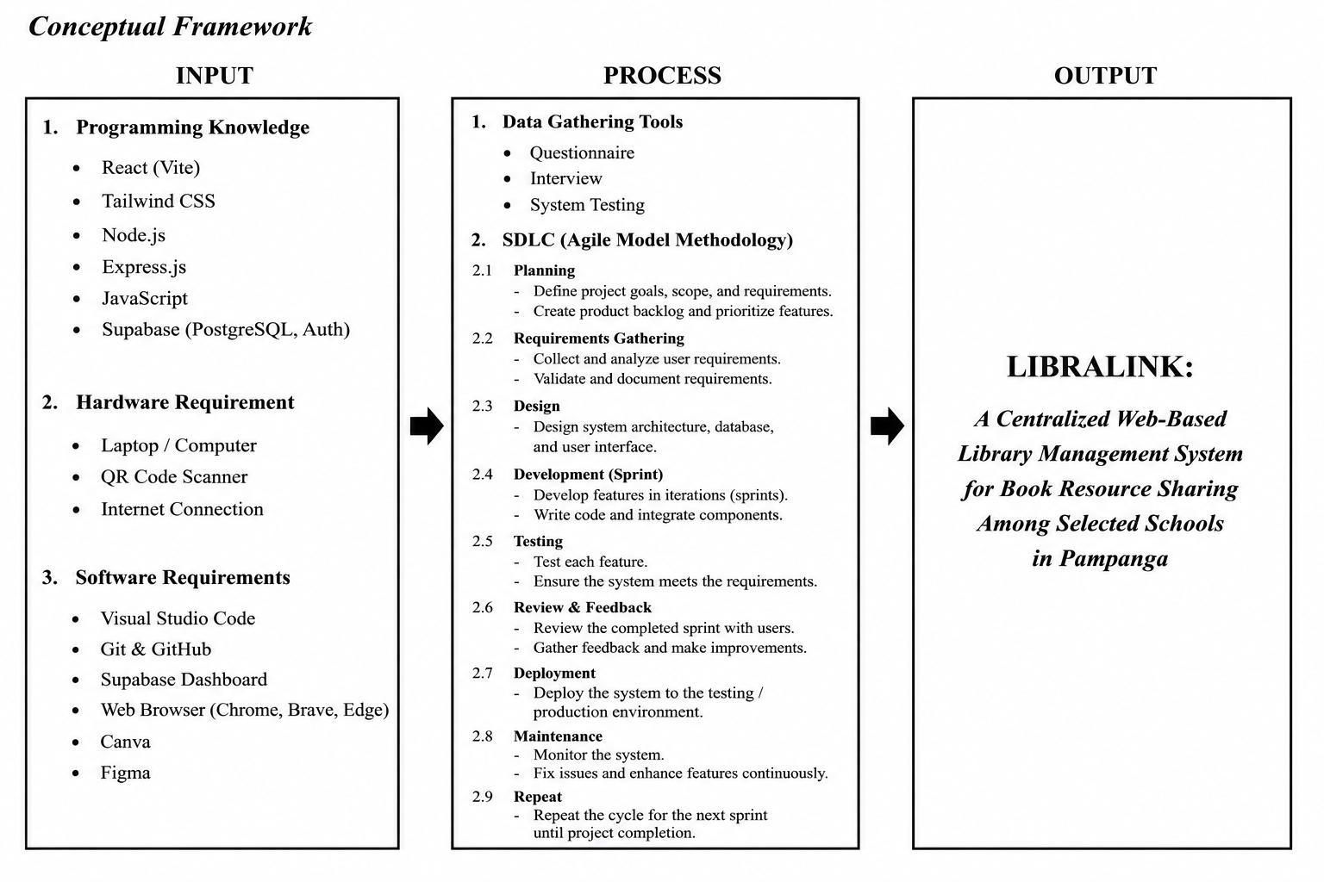
Conceptual Framework

Note: Figure 1 displays the inputs, processes and output of the conceptual framework of LIBRALINK. The inputs are the programming knowledge, hardware resources, software resources and any other resources required for the development of the system. The methods comprise the data collection tools such as the questionnaire, interview and system testing and the SDLC (Agile Model Methodology). Agile technique encompasses planning, requirements collection, design, development through sprints, testing, review and feedback, deployment, and maintenance. The output shows the developed “LIBRALINK: A Centralized Web-Based Library Management System for Book Resource Sharing Among Selected Schools in Pampanga” which is intended to give a centralized library platform management and facilitate book resource sharing among participating schools.

STATEMENT OF THE PROBLEM

SPECIFIC PROBLEM
The main problem addressed by this study is the difficulty students may encounter in locating and accessing library resources when the needed books are not available in their own school library. Existing library searching processes may be limited to individual school collections, making it difficult for students to determine whether the same resource is available in another participating school. There is also a need for an organized process for student registration, book requests, librarian approval, inter-library access authorization, and monitoring of transactions. Therefore, this study aims to develop LibraLink, a centralized web-based library management system that facilitates book searching, resource sharing, request management, and controlled access among participating schools.
Specifically, it seeks to answer the following questions:
- How can LibraLink provide a centralized book-searching and availability system that allows students to search for library resources and determine whether a requested book is available in their own school or in another participating school?
- How can the system provide suggestions for another participating school where an unavailable book may be found and facilitate the student registration and access process for students who need to use resources from another participating school?
- How can LibraLink facilitate the submission, management, monitoring, and approval or disapproval of student book requests by librarians and administrators?
- How can the system provide a Library Access Ticket or authorization and implement access rules that distinguish between students accessing resources from their own school and students accessing resources from another participating school?
- How can the development and implementation of LibraLink support Sustainable Development Goal 4 (SDG 4): Quality Education by improving students' access to academic books and learning resources?
- What recommendations can be proposed based on the results of the system evaluation and the implementation of LibraLink, particularly in terms of its:
- Functionality;
- Usability;
- Reliability; and
- Efficiency?

OBJECTIVES OF STUDY

General Objective
The general objective of this study is to develop LibraLink: A Centralized Web-Based Library Management System for Book Resource Sharing Among Selected Schools in Pampanga that will facilitate book discovery, resource requests, librarian approval, and controlled access to library resources among selected participating schools.

Specific Objectives
Specifically, the study aims to:
- Develop a centralized book-searching and availability system that allows students to search for library resources and determine whether a requested book is available in their own school or in another participating school.
- Develop a suggestion and library access process that identifies another participating school where an unavailable book may be found and provides student registration and access for students who need to use resources from another participating school.
- Develop a request management and monitoring feature that allows students to submit and manage book requests and enables librarians and administrators to monitor requests, student access, approvals, and request status.
- Provide a Library Access Ticket or authorization mechanism and implement access rules that distinguish between students accessing resources from their own school and students accessing resources from another participating school.
- Determine how the development and implementation of LibraLink can support Sustainable Development Goal 4 (SDG 4): Quality Education by improving students' access to academic books and learning resources.
6. Propose recommendations based on the results of the system evaluation and implementation of LibraLink, particularly in terms of:
- Functionality;
- Usability;
- Reliability;
- Efficiency.

Significance of the Study
The proposed LibraLink system may provide benefits to the following:

Students The system may help students find books more easily by allowing them to search for resources through a centralized platform. If a book is unavailable in their own school, students may be informed about its availability in another participating school. This can reduce the time and effort required to manually search for academic resources. Through improved access to learning materials, LibraLink may contribute to the educational access objectives associated with SDG 4: Quality Education.

Librarians LibraLink may help librarians organize and monitor requests from students. Instead of handling requests only through manual processes, librarians can use the system to review student information, requested books, approval status, and access requests. The system may also help librarians manage inter-library access in a more organized manner.
- Participating Schools The system may encourage resource sharing between participating schools while maintaining control over their respective library collections. Schools can make their available resources more visible to students from participating institutions without automatically transferring ownership of their books.

School Library Administrators Administrator may use the system to monitor library resource sharing activities, overdue, policy and request transactions. The information stored in the system may also allow administrators to understand the demand for resources and the amount of engagement in the resource sharing process.
- Future Researchers The study may serve as a reference for future researchers who plan to develop systems related to library management, resource sharing, inter-library access, centralized information systems, and web-based academic resource platforms.

Scope and Delimitation of the study

Scope
The system will provide a single point of access to the catalogs of the participating libraries, allowing registered students to search for books. If the requested book is not available in the student’s local library, the system will include book availability information from participating libraries and enable the system to suggest another participating school where the requested book may be available.
The system will include student registration, book searching, book availability checking, book suggestions, book requesting, request monitoring, librarian or administrator approval and disapproval, and the creation of a Library Access Ticket for approved inter-library requests.
The system will also enable the administration of different access situations. When a student borrows a book from their own school library, the borrowing procedures of that school will apply. For students requesting books from another participating school, the system will enable regulated library access based on the policies of the host library. This may include the use of the requested book within the host library rather than taking the book outside the school, depending on the applicable library rules.
The system will also enable librarians and administrators to access records and information needed to verify and manage student requests. Overall, LibraLink will include the necessary functions to enable a centralized approach to coordinating access to book resources among the selected participating institutions.

Delimitations
The study is limited to the specified participating schools, Guagua National College and Santa Rita College. This is not yet all schools in Pampanga and other educational institutions outside the designated participants.
The system mainly includes book resource sharing and regulated access between libraries. It does not include the physical movement or delivery of books between schools. Students must travel to the participating library where the requested book resides, subject to appropriate access constraints.
The mechanism does not immediately assure a student that he/she can borrow a book from another school. All requests require clearance by the authorized librarian or administrator and the policies of the library where the book is held.
Books borrowed from another participating school are not automatically permitted to be taken out of the host school. Users of other libraries may be allowed only to read the requested book in the owning library. All visual content or reproduction of book pages will remain subject to the library’s regulations and applicable copyright limitations.
The system does not substitute existing library policies, librarians or administrators of the participating schools. It instead functions as a central platform to facilitate the search, request, approval and monitoring of access to library resources.

Definition of Terms
For clarity and better understanding of the study, the following terms are operationally defined:
- Access Token. A digital permission generated by the system for a student request accepted to access a book or library resource from another participating school.
- Administrator. A system administrator who can manage the system, monitor activities, and execute administrative responsibilities.
- Book Availability. The availability status of a given book at a participating school library.
- Book Request. An official request made by a student using LibraLink for access to a book that is located in a participating library.
- Borrowing Period. The length of time a student is allowed to keep a borrowed book as specified by the library policy in effect. In the suggested system, students can borrow books from their own school for about two to three days, depending on the actual policy of the school.
- Centralized System. A single web-based platform for collecting and managing information from participating school libraries.
- Guagua National College (GNC). One of the participating schools selected in the study to be included in the LibraLink system with its library resources.
- Inter-Library Access. A process wherein a student from one participating school may be granted permission to use a library resource at another participating school, subject to approval and applicable library policies.
- Librarian. A library staff member who is allowed to manage library resources and review student requests through the LibraLink system.
- Library Access Token. A system-generated authorization that a student can present to the participating library as evidence that the inter-library access request has been approved.
- Library Registration. The procedure by which a student provides the information necessary to become an authorized user of a participating library or to receive approval for inter-library access.
- LibraLink. A centralized web-based library management system designed to support book searching, resource sharing, book requests, librarian approval, and controlled inter-library access among selected schools in Pampanga.
- On-Site Library Access. A type of access that allows a student to use a requested book only within the library where the resource is located and not to take the book outside the host school.
- Participating Library. A school library that is part of the LibraLink system and participates in making library resource information accessible to students.
- Request Approval. The procedure wherein a student's request is assessed by an authorized librarian or administrator to determine whether it can be approved.
- Request Disapproval. A decision by an authorized librarian or administrator to decline a student's request based on applicable library regulations, resource availability, or other valid conditions.
- Resource Sharing. The practice of providing students from participating schools with information about available library resources while adhering to each library's regulations and policies.
- Santa Rita College (SRC). A participating school in the study whose library resources will be included in the LibraLink system.
- Student. A registered user of LibraLink who searches for books and may submit requests to access available resources.

\

Chapter II

Introduction
The continual evolution of information and communication technologies has revolutionized the way libraries manage their collections and deliver services to students. Students used to rely on physical catalogs, manual records, and the direct aid of librarians to locate and borrow books. However, when the number of library users and library resources increases, the reliance on manual processes can make searching, recording, borrowing and returning library materials a much more time-consuming affair

Review of Related Literature and studies

Recent research has emphasized the role of web-based technology in solving these issues. Hidayanti et al. (2023) designed a web-based library management information system that incorporates QR code technology to streamline library operations like visitor registration, book administration, borrowing, returning, and report creation. Their research showed how digital technologies can eliminate the need for manual processes and make it easier to handle library information. This is essential to LIBRALINK because the proposed system likewise intends to computerize the library operations and provide faster access to the library information to the students and librarians.

The application of QR codes in library services has also garnered attention from researches. Kharat, Nagarkar and Panage (2023) did a thorough literature analysis on circulation strategies in academic libraries and examined the usage of QR codes for self-issue and self-return of library goods. Their work shows the potential of QR technology to facilitate circulation activities and strengthen the relationship between users and library resources. This approach is the basis for LIBRALINK’s usage of QR codes to identify approved borrowing transactions and to help librarians during book release and return.

Similarly, Anwar and Supriyono (2023) designed a web-based library information management system integrated with QR code for SMK Negeri 1 Pati . Their study dealt with issues of manual book borrowing, returning and library data administration. The researchers proved that the existence of QR codes in a web-based library system can help in enhancing the efficiency of library transactions. This is in line with the technological orientation of LIBRALINK, notably the usage of QR codes and the computerization of circulation procedures.

More recently, Aditia et al. (2024) built a web-based library information system by employing QR Code at SMP Negeri 6 Kempas. Their research focused on the challenges of manual maintenance of library records, and showed how a computerized system would improve library operations and usability. The study is pertinent to LIBRALINK as it provides proof that QR enabled online applications can promote effective library management. However, LIBRALINK goes beyond the management of a single library by including the exchange of resources amongst the participating institutions.

When a student can’t find a needed book in their own school, resource sharing is important. Chisita and Fombad (2025) explored the sharing of library resources among chosen library consortiums and emphasized the role of technology improvements in facilitating cooperation between libraries. Their study highlights the fact that libraries may extend access to information resources through collaboration rather than as wholly separate organizations. This idea is one of the main pillars of LIBRALINK.

The participating schools for the present study are Santa Rita College and Guagua National College of Pampanga. LIBRALINK is aimed to give a single platform for students to search for books from the partner schools. If a book requested is not available in the student’s home school but is available in the other participating school, then the system can provide a structured approach for obtaining access.

The literature evaluated, thus, reveals the transition from traditional library management to digitally connected library services. LIBRALINK advances this evolution by merging web-based library management, centralized book discovery, QR-code verification and regulated resource sharing into one platform.

Relevance of the different related studies

The research evaluated serve as a vital foundation for the development of LIBRALINK: A Centralized Web-Based Library Management System for Book Resource Sharing Among Selected Schools in Pampanga. Although the studies discussed different aspects of library technology, the findings can be linked to the main functions of the proposed system, especially digital library management, book searching, QR-code identification, borrowing and returning, resource sharing, and user accessibility.

Hidayanti et al. (2023) showed that a web-based library administration system may be used to improve traditional library tasks such as registration, book management, borrowing, returning, and report generating. Their study highlighted the benefits of converting manual library processes into a digital environment. This is analogous to LIBRALINK in the sense that the proposed system likewise centralizes these tasks. Librarians may register students, handle books, execute borrowing requests and record returned items through one platform.

Further, Kharat, Nagarkar and Panage (2023) promoted the use of QR-code technology by studying the application of QR codes in the library circulation. Their work highlighted the how QR technology can help in identifying the users and library transactions. This is relevant to LIBRALINK as the system creates a QR code for an approved borrowing transaction. The librarian does not have to search for the student’s request manually; the librarian can scan the QR code to obtain the student’s borrowing information and verify the transaction before releasing the book.

Similarly, Anwar and Supriyono (2023) demonstrated how to integrate QR codes into a web-based library administration system to improve the tracking of borrowing and returning operations. Their analysis is relevant to LIBRALINK as it supports the link between the digital transaction records and physical library holdings. In the suggested system, the accepted request, QR code and physical book of the student can be linked to a single transaction which makes it easy to track the movement of the book.

Marselina and Rahmawati (2023) additionally contribute to the technological basis of LIBRALINK by demonstrating the combining of QR-code technology with library administration activities. Their study shows how automated identification can make collection management and circulation better. This is the case for LIBRALINK as the proposed system need to identify the student, the requested book and the status of the transaction during borrowing and return procedure in a rapid manner.

Aditia et al. (2024) developed a web-based library information system based on QR codes and showed the potential of computerization of library operations to improve the management of library records. This is crucial to LIBRALINK as the planned system also keeps digital records for students, books, requests, borrowing transactions, and returns. However, LIBRALINK takes this idea farther by enabling the system to search for materials beyond the student’s own institution.
Another fundamental foundation for LIBRALINK is the necessity of sharing resources. Chisita and Fombad (2025) deliberated about cooperation among libraries to improve access to information resources and how technology supports resource-sharing operations. This is directly related to LIBRALINK, as a student may meet a circumstance where a necessary book is not accessible in his or her home school but is available in another participating school. The system can identify the other site and tell the learner how to request the resource instead of just telling the student the book is unavailable.

This idea is also reinforced by Balachandran, Dominic and Sivankalai (2025) who studied a cloud-based library management approach which allows sharing of resources among many universities. Their work indicates that it is possible for libraries to maintain their own collections within a common technology environment. This idea is appropriate for LIBRALINK as the actual books are still in their different schools and the information regarding their availability is available through the centralized platform.

Moreover, Maneesh and Vijayan (2025) pointed out the significance of digital technology in altering traditional library services and promoting resource sharing between institutions. Their work is crucial to LIBRALINK since the planned system is using technology to not only handle books but also link users to the resources that may be located outside of their local library. This reinforces the argument that a library system might be a gateway to a larger collection than a single physical site.

Centralized discovery was also endorsed by Le Van Hieu, Pham Thi Tra and Huong Thi Pham in their analysis of resource sharing in teacher-education universities. They identified centralized discovery and request procedures as methods to improve resource accessibility. This is important for LIBRALINK because students can look for a book in one system and see if it is accessible in another school that participates. The method therefore removes the need for the students to manually search different library systems.

OCLC (2025) went a step further in illustrating the evolution of automated resource-sharing processes by improving interlibrary resource-sharing workflows. Their work shows how technology may help in finding available resources and sending requests to the right libraries. This idea can be used to LIBRALINK by having the system automatically check if a requested book is available in another participating school.

The papers analyzed also underline the value of accessibility and user-centered library services. Users can use the library services even before they visit the library using digital library systems. LIBRALINK embodies this notion by enabling students to surf and search for books online, check their availability and make borrowing requests electronically. Thus, the student does not have to go to several libraries just to find out where a book is.

These research are also applicable to the permission-based cross-school borrowing mechanism of LIBRALINK. The transaction needs to be more accountable when a kid asks for a book from another school, because the resource belongs to another institution. LIBRALINK solves this by asking for the confirmed information of the student which is the student’s full name, contact number, student ID and ID photo. Then the system can generate a permission letter with the student’s details and required book with the signature section for the Chief Librarian or approved librarian.

Once the required permission is given, the student is ready to begin the cross school borrowing process. The librarian at the resource-school can then scan the QR code linked to the approved transaction to verify that the student is allowed to get the book.

The research evaluated also impacted the workflow for LIBRALINK borrowing and return. When a student submits a request for a book it is not instantly borrowed. The librarian looks at the request, approves it, checks the student’s identity, confirms the book, and hands over the physical copy. The transaction is changed to Borrowed only after the physical release is validated by the system.

The librarian verifies the returned material and confirms the return by checking the transaction by QR code or book identification when the student returns the book. The system then updates the availability of the book and logs the completed transaction.

Therefore, the different studies are complementary in the development of LIBRALINK, offering the bases of its main aspects. The studies on web-based library management enable the digital management of students, books and transactions. The studies on QR codes support speedier identification and circulation. The studies on resource sharing support the connectivity of library collections between institutions.

Technology Review
The development of LIBRALINK: A Centralized Web-Based Library Management System for Book Resource Sharing Among Selected Schools in Pampanga is based on technologies and existing library system features that support online book searching, availability checking, user management, book requests, approval processes, and library resource sharing. The proposed system is designed to provide functions similar to existing web-based library management and library catalog systems while extending the process to support resource discovery among participating schools.

Web-Based Library Management Systems
Existing web-based library management systems commonly provide online access to library resources, allowing users to search for books and view information about available resources through a web browser. These systems generally provide functions such as book catalog searching, user management, circulation or borrowing records, and library resource monitoring.
LIBRALINK follows a similar approach by providing a centralized web-based platform where students can search for books and view their availability. However, instead of limiting the search to the student's own school library, LIBRALINK is designed to provide information about resources available in participating schools. This allows the system to support the sharing and discovery of library resources among the participating institutions.

Online Public Access Catalog (OPAC)
Online Public Access Catalog (OPAC) systems are commonly used by libraries to allow users to search for books and other library materials through a computerized catalog. Users can typically search using information such as the book title, author, or subject and view the corresponding bibliographic information and availability.
LIBRALINK adopts the book-searching concept of OPAC by allowing students to search for books through the system. The difference is that LIBRALINK extends the searching process across participating school libraries. When a requested book is not available in the student's own school, the system can identify whether the resource is available in another participating school and provide a suggestion to the student.

Library Resource Sharing Systems
Library resource-sharing systems allow participating libraries to make information about their available resources accessible to users of other participating institutions. These systems support cooperation between libraries by helping users identify resources that may not be available in their home library.
LIBRALINK applies a similar resource-sharing concept between Guagua National College (GNC) and Santa Rita College (SRC). When a student cannot find a requested book in the home-school library, the system checks the participating library resources and suggests another school where the requested book may be available. The student may then proceed with the required registration and request process according to the participating library's rules.

Book Request and Approval Systems
Existing library systems commonly include request or circulation features that allow users to submit requests for library materials. Library personnel can review these requests and determine whether they can be approved based on the availability of the resource and applicable library rules.
LIBRALINK incorporates a similar request and approval process. Students can submit a request for a book that is available in another participating library. The request can then be reviewed by the authorized librarian or administrator. The request may either be approved or disapproved depending on the information provided, book availability, and applicable library requirements.

User Registration and Authentication
Library management systems commonly use user registration and authentication to identify users and control access to library services. Registered users may have different privileges depending on their assigned role.
LIBRALINK follows this approach by providing user registration and authentication for students, librarians, and administrators. Students can search for books, submit requests, and monitor their request status, while librarians and administrators can review requests, manage library information, and monitor system activities according to their assigned responsibilities.

Book Availability and Catalog Management
A major feature of existing library systems is the management of book records and availability information. Libraries maintain records that allow users and library personnel to determine whether a particular resource is available.
LIBRALINK incorporates this function by maintaining book and availability information for participating libraries. The system uses this information to determine whether a requested book is available in the student's own school or in another participating school. This information also supports the system's suggestion feature when a book is unavailable in the student's home library.

Inter-Library Access and Authorization
Library resource-sharing arrangements may require users to obtain authorization before accessing resources from another participating institution. This provides the participating libraries with control over who can access their resources.
LIBRALINK incorporates an Access Ticket or authorization mechanism for approved inter-library requests. Once a request has been reviewed and approved, the system can provide authorization that serves as evidence that the student has been permitted to access the requested resource. The actual access remains subject to the rules and approval of the participating library where the resource is located.

Centralized Monitoring
Existing management systems commonly provide administrative or librarian interfaces for monitoring records, requests, and user activities. Centralized monitoring helps library personnel manage information within one system rather than maintaining separate records.
LIBRALINK applies this concept through a centralized monitoring platform for librarians and administrators. Authorized personnel can monitor student requests, approval or disapproval status, access information, and other relevant records associated with the system.

Responsive Web Design
Modern web-based systems are designed to be accessible using different devices, including desktop computers, laptops, tablets, and smartphones. Responsive design allows the interface to adjust according to the user's screen size.
LIBRALINK follows this approach because students may access the system using different devices when searching for books or submitting requests. Librarians and administrators may also use desktop computers or other devices when managing requests and monitoring library activities.

System Workflow Using the Technologies
The technologies are all working together during the LIBRALINK process. The following sequence displays the help the system offers to the student and librarian from registration till the return of the borrowed book.
1. Student Registration. The student is registered by the librarian via the web application. The student’s information is maintained in supabase database.
2. Student Login. The registered student logs into the LIBRALINK portal.
3. Book Searching. The student searches the central catalog using the web interface.
4. Availability Checking. The backend looks up the database to see if the book the user is requesting is available and finds which school the book is located at.
5. Same-School Borrowing. If the book is available in the student's own school, the request is sent to the appropriate librarian for approval.
6. Cross-School Borrowing. If the book is not available in the student’s school but in another participating school, the system will alert the student that a cross-school borrowing procedure and additional prerequisites are needed.
7. Student Verification. Student’s full name, contact number, student ID and ID photo will be utilized to verify student identity and borrowing record.
8. Permission Letter Generation. The system will immediately generate a permission letter which will include the student's details, the book requested, the transaction details and the specific signature area for the Chief Librarian or the approved librarian.
9. Librarian Approval. “The appropriate librarian reviews the request and approves or declines it. Only an authorized request can proceed to book publication.
10. QR Code Generation. Upon approval, the system creates a unique QR code connected with the borrowing transaction.
11. Book Release. The resource-school librarian checks the student’s QR code to verify the accepted transaction before distributing the physical book.
12. Borrowing Record. The system will update the book’s quantity available and the transaction status to Borrowed.
13. Book Return. The librarian scans the QR code, and provides verification for the returned material when the student returns the book.
14. Inventory Update. Once the return has been confirmed, the system completes the transaction and changes the status of the book to available.

LIBRALINK provides a consolidated platform by combining these technologies to manage library customers, book collections, borrow requests, cross-school permission, QR verification and return operations. The technologies work together to support the entire process from student registration and book discovery to cross-school borrowing and book return.

Chapter III

Research design and Methodology

This chapter describes the comprehensive research approach, system development framework, and evaluation techniques utilized in the creation and validation of LibraLink: A Centralized Web-Based Library Management System for Book Resource Sharing across Selected Schools in Pampanga. It details the research design, research locale, population and sampling technique, research instruments, validation procedures, data gathering procedures, statistical tools, software development methodology, and system development tools.

The methodology is engineered to support an inter-library resource sharing workflow that allows students to search for books across multiple campuses, verify real-time availability, receive partner institution suggestions, submit inter-library borrow requests, undergo home-institution librarian verification and approval, receive a secure Library Access Token, and gain authorized access to books in accordance with institutional sharing policies.

Research Design
The study employed a developmental research design combined with a descriptive-evaluative approach. Developmental research was chosen because the primary objective was to design, develop, test, and assess a functional software artifact—the LibraLink centralized web-based platform—engineered to solve resource scarcity and accessibility challenges experienced by students across participating school libraries.

The descriptive-evaluative technique was utilized to examine the existing challenges, workflows, and operational needs of students and library personnel regarding book discovery, cross-institutional borrowing, and catalog synchronization. The data obtained from this inquiry established the system specifications and functional requirements of LibraLink.

The overall operational flow established by the research design follows an eight-stage sequence:

Search → Availability Check → Partner School Suggestion → Borrow Request → Home Librarian Verification → Approval / Disapproval → Access Token Generation → Partner Library Verification & Book Access

1. Local Availability: When a searched book exists within the student's home institution, standard internal borrowing and reservation procedures apply.
2. Inter-Library Resource Sharing: When a book is unavailable locally but present in a partner institution's catalog, LibraLink highlights the holding library and facilitates an inter-library borrowing request.
3. Dual Verification & Access Token: The request is reviewed by the student's home librarian to ensure the student is in good standing. Upon approval, the system issues a verifiable digital Library Access Token (Access Ticket). The student presents this token at the partner library, where the host librarian authenticates the token in the system before granting on-premise reading or controlled borrowing privileges based on inter-school agreements.

3.2 Research Locale

The study was strictly delimited to the province of Pampanga, focusing exclusively on selected participating private higher education institutions within the province. The participating partner institutions for the pilot deployment, testing, and evaluation of the LibraLink system were:

1. Guagua National College (GNC) – Located in Guagua, Pampanga
2. Santa Rita College (SRC) – Located in Santa Rita, Pampanga

The geographic scope was explicitly confined to the province of Pampanga to establish a controlled, localized inter-library consortium. The geographic proximity of Guagua and Santa Rita within Pampanga makes cross-campus physical visits practical and convenient for students presenting their digital Library Access Tokens to read or borrow books on-site. The academic libraries of these two Pampanga-based institutions served as the primary setting for examining existing library constraints, gathering operational requirements, and validating the performance and acceptability of the LibraLink platform.

3.3 Population and Sampling Technique

The target population of the study comprised the primary stakeholders of the LibraLink system from Guagua National College and Santa Rita College. The participants were classified into two groups:

1. Students: The primary end-users who search for books, review holding suggestions, submit borrow requests, track request statuses, and redeem Library Access Tokens.
2. Librarians and Library Administrators: The institutional managers who oversee catalog records, evaluate and approve/disapprove inter-library requests, and verify access tokens presented by visiting students.

Sampling Technique: Purposive Sampling

The researchers employed purposive sampling in selecting respondents. Purposive sampling is the most appropriate method because the study requires respondents who have direct experience with academic library services, understand book borrowing constraints, and possess the operational authority to assess library management workflows.

Student Respondents:
- Must be currently enrolled students at Guagua National College or Santa Rita College within the following academic levels:
- College (Tertiary Level)
- Senior High School
- Junior High School
- Must possess an active student library record or prior experience utilizing the school library for research and coursework.
- Must have access to an internet-capable device (smartphone, tablet, or computer) to test and navigate the LibraLink web application.
- Librarian / Administrator Respondents:
- Must be an officially appointed head librarian, assistant librarian, or library staff member of GNC or SRC managing Junior High School, High School, or College library sections.
- Must be actively involved in cataloging, circulation, student request verification, and resource acquisition.
Distribution of Respondents

Respondent Category | Guagua National College (GNC) | Santa Rita College (SRC) | Total (N)
Students | 30 | 30 | 60
Librarians | 2 | 2 | 4
Total | 32 | 32 | 64

Research Instruments

The researchers constructed a Researcher-Made Evaluation Questionnaire based on the internationally recognized ISO/IEC 25010 Software Product Quality Model. The questionnaire was structured into distinct dimensions to capture a comprehensive assessment of the system:

1. Part I: Demographic Profile – Documents the participant's institutional affiliation (GNC or SRC) and user role (Student or Librarian/Administrator).
2. Part II: System Quality Characteristics (ISO/IEC 25010):
Functional Suitability: Evaluates whether LibraLink effectively delivers its core capabilities, including centralized book discovery, multi-school inventory availability checks, automated partner recommendations, request submissions, dual-stage librarian approvals, and digital Library Access Token generation.
Usability: Assesses the clarity of the user interface, ease of navigation, readability, and overall user-friendliness across both mobile and desktop screens.
Reliability: Measures the consistency, data accuracy, fault tolerance, and error prevention of the system during transactions and data retrieval.
Performance Efficiency: Evaluates system responsiveness, transaction speed, and minimization of redundant manual steps in borrowing workflows.
3. Part III: User Satisfaction and SDG 4 Impact – Gauges overall stakeholder satisfaction and determines the extent to which LibraLink contributes to United Nations Sustainable Development Goal 4 (SDG 4: Quality Education) by democratizing access to academic books and learning materials across participating schools.

3.5 Validation Procedures
To ensure that the research instrument effectively measured the intended evaluation criteria, the questionnaire underwent rigorous pre-testing and validation procedures:`
1. Expert Review Panel: The draft questionnaire was submitted to a panel composed of the thesis adviser, Information and Communications Technology (ICT) experts, and registered academic librarians.
2. Evaluation Metrics: The validators examined the instrument on the basis of clarity of instructions, relevance of indicators to research goals, technical alignment with ISO/IEC 25010 criteria, and linguistic appropriateness.
3. Revision and Finalization: Feedback, corrections, and contextual revisions suggested by the panel were incorporated into the final version of the instrument before deployment.
3.6 Data Gathering Procedures
The researchers followed a systematic data gathering procedure to ensure the thorough development and empirical evaluation of the LibraLink platform.
First, the researchers secured formal written permission from the institutional authorities, academic deans, and head librarians of Guagua National College and Santa Rita College to officially conduct the study and gather the required data within their campus libraries.
Second, the researchers investigated and mapped the existing library workflows of both participating institutions. This involved identifying operational constraints, book circulation policies, cataloging systems, and inter-library borrowing requirements, which subsequently served as the foundational basis for the functional specifications of the LibraLink system.
Third, the researchers developed, configured, and deployed the LibraLink web-based platform based on the gathered functional requirements. The system integrated centralized book search, availability tracking, inter-institutional recommendations, request processing, multi-level librarian approval, and secure digital Library Access Token generation.
Fourth, the developed system underwent comprehensive technical testing to identify and resolve software bugs, navigation errors, and interface defects before deployment to end-users. Necessary enhancements were made to ensure stability and smooth system performance.
Fifth, a hands-on user simulation was conducted with the purposively selected respondents. Participating students from College, Senior High School, and Junior High School departments logged into the platform, performed cross-institutional book searches, checked real-time availability, submitted inter-library borrow requests, and monitored their request statuses. Concurrently, participating librarians evaluated the administrative dashboard, processed incoming student requests, rendered approval or disapproval decisions, and authenticated generated Library Access Tokens.
Finally, immediately following the hands-on system simulation, the validated researcher-made questionnaire was administered to the respondents via online forms and printed questionnaires. The completed survey responses were retrieved, organized, tallied into data matrices, and prepared for statistical analysis to evaluate the overall acceptability and performance of the LibraLink system.
3.7 Statistical Treatment of Data
The quantitative data collected from the evaluation questionnaires were analyzed using descriptive statistical tools:
1. Frequency and Percentage
Formula:
P = (f / N) × 100
Where:
P = Percentage
f = Frequency of responses
N = Total number of respondents

2. Weighted Mean
Used to determine the central tendency and level of acceptance across each evaluation criterion (Functional Suitability, Usability, Reliability, Performance Efficiency, User Satisfaction, and SDG 4 contribution).
Formula:
WM = Σ (f · x) / N
Where:
WM = Weighted Mean
f = Frequency of responses for a specific weight
x = Assigned scale weight (1 to 4)
N = Total number of respondents
3. Four-Point Likert Scale and Interpretation Criteria
A four-point Likert scale was utilized to eliminate neutral ambiguity and provide a definitive measurement of system quality and user acceptance. The statistical boundaries for the weighted means are defined as follows:
Scale Weight | Score Interval | Qualitative Interpretation | System Acceptability Level
4 | 3.26 – 4.00 | Strongly Agree | Highly Acceptable
3 | 2.51 – 3.25 | Agree | Acceptable
2 | 1.76 – 2.50 | Disagree | Moderately Acceptable
1 | 1.00 – 1.75 | Strongly Disagree | Not Acceptable

3.8 Software Development Methodology

The researchers utilized the Agile Software Development Methodology in the design, development, testing, and refinement of the LibraLink system. Agile was selected as the most appropriate software en gineering methodology because inter-library management systems require continuous testing, rapid iteration, and active consideration of feedback from prospective end-users (students, librarians, and administrators). Unlike traditional linear models (such as the Waterfall model), the Agile process is iterative, allowing the researchers to repeatedly test and improve system functions throughout development rather than waiting until the end of the project to identify operational defects.
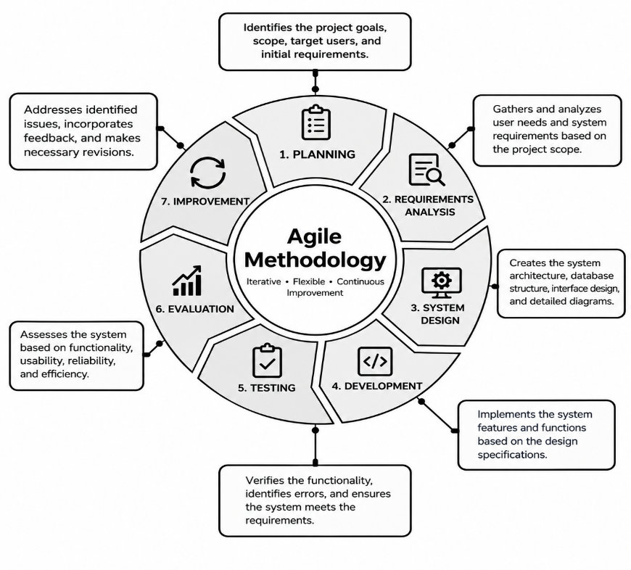
figure 1

The development of LibraLink will follow the following stages:
3.8.1 Planning

During the planning stage, the researchers identified the core research objectives, intended user groups, operational problems in existing library operations, and the major functional scope of LibraLink. The participating schools—Guagua National College (GNC) and Santa Rita College (SRC)—were officially designated as the initial consortium scope for resource sharing.

3.8.2 Requirements Analysis

The researchers identified and documented the functional and non-functional requirements of students, librarians, and administrative staff. Key requirements elicited included centralized multi-school book searching, real-time availability checking, automatic partner-school suggestions, student account registration, inter-library book requests, request monitoring, librarian approval or disapproval workflows, and secure Library Access Token authorization.

3.8.3 Design

During the design stage, the researchers formulated the system interface wireframes, relational database schemas, system architecture, and transactional workflows. Visual layouts were customized to provide intuitive catalog browsing for students and comprehensive management dashboards for librarians. Data flow diagrams and Entity-Relationship Diagrams (ERD) were established to manage cross-institutional book records.

3.8.4 Development

During the development stage, the designed features were programmed and integrated into a functional full-stack web application. Front-end components were developed to support seamless catalog search and request submission, while back-end application programming interfaces (APIs) were implemented to handle user authentication, database operations, borrow request state transitions, and access token validation.

3.8.5 Testing

The developed modules underwent systematic testing to verify that all features functioned as intended. Component testing, API endpoint validation, and UI responsiveness checks across mobile and desktop devices were conducted. System errors, incorrect transaction logic, and data synchronization issues identified during testing were documented, debugged, and resolved.

3.8.6 Evaluation
The researchers deployed the working system to purposively selected respondents from Guagua National College and Santa Rita College. Students, librarians, and administrators performed hands-on interactions with the platform and provided empirical feedback through the validated evaluation questionnaire based on the ISO/IEC 25010 criteria (Functionality, Usability, Reliability, and Efficiency).

3.8.7 Improvement
Based on the results of user testing and stakeholder feedback, the researchers applied necessary refinements to the identified system functions and interfaces. System navigation was streamlined, transaction notifications were optimized, and security measures for inter-school token verification were enhanced.

3.8.8 Finalization

After the necessary improvements and revisions were incorporated, the researchers finalized the developed LibraLink web-based system. Source code repositories, database configurations, user documentation, and statistical evaluation results were consolidated, establishing the platform as ready for inter-library resource sharing.

3.9 System Development Tools and Technology Stack
The technological foundation of the LibraLink platform comprises modern, robust, and open-source web technologies:

Front-End Architecture:

ReactJS: A declarative component-based JavaScript library utilized to create dynamic, modular, and reactive user interfaces for student book exploration and administrative request queues.
Vite: A next-generation front-end tooling framework utilized for fast development compilation, hot module replacement (HMR), and optimized production builds.
Tailwind CSS: A utility-first CSS framework employed to construct clean, accessible, modern, and mobile-responsive UI layouts.

Back-End Architecture:

Node.js: An event-driven, asynchronous JavaScript runtime environment powering server-side execution.
Express.js: A fast, minimalist web framework for Node.js used to architect RESTful APIs, manage session authentication, enforce borrowing business logic, and handle request state transitions.

Database:

Supabase / PostgreSQL: An open-source relational database management system providing real-time data synchronization, relational integrity for multi-school book records, and Row-Level Security (RLS) to enforce data privacy between participating institutions.
Development Environment and Quality Assurance:
Visual Studio Code: The primary Integrated Development Environment (IDE) used for software coding and debugging.
Git & GitHub: Distributed version control system used for tracking code iterations, managing feature branches, and documenting changes.

CHAPTER IV
1. SYSTEM OVERVIEW
a. System Title and Purpose
The developed software artifact is entitled "LibraLink: A Centralized Web-Based Library Management System for Book Resource Sharing across Selected Schools in Pampanga".

The primary purpose of the LibraLink platform is to bridge institutional resource disparities, eliminate catalog isolation, and automate the inter-library resource sharing process between participating academic institutions. In many private educational institutions in the Philippines, individual school libraries operate as disconnected silos with limited acquisition budgets. Consequently, students often encounter shortages of specialized textbooks, while partner institutions within the same geographic locale hold idle or underutilized copies of those exact titles.

LibraLink establishes a centralized, inter-institutional Online Public Access Catalog (OPAC) and a secure transaction brokering engine connecting Guagua National College (GNC) in Guagua, Pampanga, and Santa Rita College (SRC) in Santa Rita, Pampanga. The platform enables enrolled students to discover print collections across both campuses in real time, automatically routes inter-library borrowing requests to the student’s home librarian for academic clearance, and issues a cryptographically verified, time-bound Digital Library Access Token (Pass). This token grants authorized students on-premise reading or controlled circulation access at the partner institution, establishing a collaborative, paperless, and sustainable resource-sharing consortium.

b. Target Users

The system is engineered to serve four (4) distinct stakeholder groups across Guagua National College and Santa Rita College:

1. Student Users (College, Senior High School, and Junior High School):

The primary end-users who utilize the web portal to perform cross-institutional book searches, examine real-time campus holding statuses, receive partner school availability recommendations, submit paperless inter-library borrow requests, monitor application progress, and present digital access tokens via mobile smartphones or portable devices when visiting partner campuses.

2. Librarian / Staff Users:

Frontline library personnel responsible for managing day-to-day circulation, reviewing incoming student borrow requests, verifying good academic standing and clearance, approving or rejecting applications with feedback notes, and operating the on-site verification terminal to authenticate visiting students presenting digital access passes.

3. Librarian Administrators (Head Librarians):

Supervisory library managers who oversee institutional catalog inventories, configure campus-specific lending parameters (such as loan quotas and token validity windows), manage staff user accounts, and generate monthly inter-library circulation reports.

4. Super Administrators:

System-level technical managers who configure institutional consortia settings, monitor multi-tenant database integrity, oversee security protocols, inspect comprehensive audit logs, and maintain cloud infrastructure uptime.

c. Scope and Limitations

Scope of the System:

Geographic and Institutional Delimitation: The system is exclusively configured, deployed, and tested for Guagua National College (GNC) and Santa Rita College (SRC) within the province of Pampanga.

Unified Catalog Discovery: Centralized search engine indexing book holdings from both institutions, filterable by institution, subject classification, call number, and real-time availability.

Partner Holding Recommendation: Intelligent notification system that automatically highlights partner campus availability when a searched volume has zero available copies at the user's home campus.

Inter-Library Request Routing: Automated request forwarding that directs borrow requests to the student's home institution librarian for pre-clearance and verification.
Digital Access Token Generation: Dynamic issuance of single-use, time-delimited (72-hour validity) alphanumeric and visual access tokens that serve as digital permits for on-site visits.

Counter Verification Terminal: Fast-lookup interface for host librarians to authenticate visiting student tokens and log physical book handovers.

Catalog Inventory CRUD Management: Complete administrative tools allowing authorized librarians to create, read, update, and archive book records categorized by academic level (College, SHS, JHS).

Cross-Platform Responsive Design: Full accessibility across desktop computer monitors, circulation tablets, and mobile smartphones without functional degradation.

Limitations of the System:

No Inter-Campus Physical Courier Service: LibraLink does not manage physical parcel transport or inter-school courier logistics. Students must physically travel to the partner institution holding the requested book to utilize their issued Digital Access Token.

Exclusion of Financial Penalty Transactions: The platform does not process monetary payments, digital wallets, or cash transactions for overdue fines or lost book fees; penalty enforcement is handled offline pursuant to the home institution's manual guidelines.

Mandatory Internet Connectivity: As a centralized cloud-hosted web application, active internet access is required to synchronize catalog states, process approvals, and validate access tokens.

d. Key Functionalities

- Multi-Tenant Authentication & Role Guarding: Secure authentication gateway enforcing Role-Based Access Control (RBAC) across Students, Staff Librarians, Head Librarians, and Super Administrators.
- Consolidated Multi-School Catalog Search: Real-time query engine searching across disparate institutional holdings with live availability indicators.
- Inter-Library Borrow Request Lifecycle Engine: Finite state machine managing sequential transaction states (`Pending_Home_Approval` → `Approved` → `Active_Token_Issued` → `Redeemed` → `Returned` / `Rejected`).
- Cryptographic Access Token Engine: Generation of non-forgeable, time-stamped access hashes linked to borrower profile, host campus, and target accession number.
- Partner Librarian Verification & Circulation Counter: Instant search-and-redeem workflow confirming student identity and logging loan durations.
- Administrative Inventory Management: Modular cataloging suite supporting Dewey Decimal or LC classification, ISBN lookup, and physical shelf tagging.
- System Audit Logging & Metrics Dashboard: Automated tracking of cross-campus borrow volumes, approval rates, and peak usage hours for administrative review.

e. Overview of the Selected Methodology

The development of LIBRALINK: A Centralized Web-Based Library Management System for Book Resource Sharing Among Selected Schools in Pampanga utilized the Agile Software Development Methodology. Agile was selected because it allowed the researchers to develop the system through an iterative process in which requirements, system features, interface designs, functionality, and identified issues were continuously reviewed and improved throughout the development period.

The Agile methodology enabled the researchers to divide the development of LibraLink into manageable activities. The development process included planning, requirements analysis, system design, development, testing, evaluation, and improvement. Instead of developing the entire system at once, the researchers developed and reviewed individual system components and features progressively.

During development, the researchers implemented the major functionalities of LibraLink, including user registration and login, book searching, book availability checking, participating-school book discovery, book request submission, request verification, request approval or disapproval, access authorization, notifications, and library record management. Each functionality was reviewed and tested to determine whether it performed according to the identified system requirements.

The researchers also used an iterative approach when problems, errors, or changes in requirements were identified. Necessary modifications were made to the system, followed by additional testing to verify the changes. This process allowed the researchers to continuously improve the functionality, usability, and overall performance of LibraLink throughout its development.

Through the use of Agile Software Development Methodology, the researchers were able to progressively develop and refine LibraLink based on the identified requirements and results of testing and evaluation. The methodology provided a flexible development process that supported continuous improvement until the final version of the system was completed.

System Development Based on Agile Methodology
The development of LibraLink followed the Agile Software Development Methodology. Agile was selected because the development of the system required continuous development, testing, evaluation, and improvement based on the identified requirements and feedback from the intended users.
The development process consisted of planning, requirements analysis, system design, development, testing, evaluation, improvement, and finalization. The Capstone 102 guideline requires the development section to document the methodology actually followed and to present actual development activities, decisions, implementation, testing, and revisions.

i. Product Backlog
1. List of user stories/features
The functional scope of LibraLink was articulated through twelve (12) comprehensive user stories structured from the perspective of students, library staff, and administrators:
Story ID | User Role | User Story Description | Acceptance Criteria
US-01 | Student | As a student, I want to search for books by title, author, or subject across GNC and SRC so that I can discover academic materials quickly. | The catalog returns matching books from both campuses with call number, campus name, and available copies.
US-02 | Student | As a student, I want the system to suggest partner school holdings when a book is unavailable locally so that I know where to obtain it. | When local copies equal zero, an alert highlights partner holdings with a direct "Request Borrow" action.
US-03 | Student | As a student, I want to submit an inter-library borrow request through the web portal so that I do not need manual paper referral letters. | Form captures target book, submits request to home librarian queue, and logs status as Pending_Home_Approval.
US-04 | Student | As a student, I want to receive a Digital Access Token upon approval so that I can present proof of clearance at the partner library. | System renders a secure alphanumeric token and QR code displaying student ID, host campus, and a 72-hour countdown.
US-05 | Librarian | As a home librarian, I want to review incoming borrow requests so that I can verify student standing before endorsing cross-campus visits. | Inbox displays student details, academic level, book title, and one-click Approve and Reject buttons.
US-06 | Librarian | As a host librarian, I want to verify a visiting student's access token at my desk so that I can confirm validity and release the book. | Host librarian enters token string or scans QR; system validates authenticity, displays student info, and marks token as Redeemed.
US-07 | Librarian | As a librarian, I want to add, update, and categorize book inventory records so that our online catalog remains accurate and up-to-date. | Full CRUD interface supporting title, author, ISBN, academic level (College/SHS/JHS), and shelf location.
US-08 | Librarian | As a host librarian, I want to mark borrowed books as returned when students return them so that catalog availability is restored. | Action updates transaction to Returned, releases borrower obligation, and increments available copy count.
US-09 | Admin | As a super admin, I want to manage participating school configurations so that multi-tenant isolation is maintained. | Interface allows toggling institutional settings, domain parameters, and active statuses for GNC and SRC.
US-10 | Admin | As a super admin, I want to view system audit logs so that all transactions, approvals, and inventory changes are trackable. | Chronological audit table recording event type, user identifier, IP address, and timestamp.
US-11 | Student | As a student, I want the web application to be fully usable on mobile devices so that I can check tokens while in transit. | UI dynamically scales and refits on mobile viewports (360px–430px) without horizontal scrolling or clipping.
US-12 | All Users | As a user, I want secure authentication so that my personal details and institutional records remain private. | Passwords hashed using bcrypt; API endpoints protected via JSON Web Tokens (JWT) and role verification middleware.

2. Prioritization of Tasks (MoSCoW Matrix)
To maximize delivery value within the six-week development timeline, the user stories were prioritized using the MoSCoW Prioritization Framework:

Must Have (Essential Core for Minimum Viable Product):
US-01: Multi-School Catalog Search
US-02: Partner School Holding Recommendation
US-03: Inter-Library Borrow Request Submission
US-04: Digital Access Token Generation
US-05: Home Librarian Approval Queue
US-06: Host Librarian Token Verification Hub
US-12: Multi-Tenant Role-Based Authentication
Should Have (Important Features for Operational Completeness):
US-07: Catalog Inventory Management (CRUD)
US-08: Return Processing & Circulation Updating
US-11: Responsive Mobile-First Viewport Optimization
Could Have (Desirable Enhancements if Time Permits):
US-09: Super Admin Multi-School Configuration
US-10: Comprehensive System Audit Logging
Interactive Campus Location Mapping (Leaflet integration)
Won't Have (Explicitly Deferred to Future System Versions):
MS Gateway integration (deferred due to recurring telecommunications carrier charges)
Online fine payments via GCash/PayMaya

ii. Sprint Overview

1. Number of Sprints
The engineering lifecycle was organized into three (3) distinct, sequential Sprints.

2. Duration per Sprint
Each sprint spanned a duration of two (2) calendar weeks (10 operational days), culminating in an overall build timeframe of six (6) weeks:
Sprint 1: Weeks 1 – 2 (System Foundation, Schema Architecture, Authentication, and Multi-School Search)
Sprint 2: Weeks 3 – 4 (Inter-Library Request Engine, Librarian Approval Inbox, and Token Generator)
Sprint 3: Weeks 5 – 6 (Token Verification Hub, Inventory Management, UI Optimization, and System Testing)

3. Sprint Goals
Sprint 1 Goal: Establish the technical foundation, configure the cloud PostgreSQL database with multi-tenant schemas, implement role-based authentication, and deliver a working cross-school catalog search.
Sprint 2 Goal: Implement the complete inter-library borrowing request lifecycle, develop the home librarian review queue, and build the cryptographic Digital Access Token generation algorithm.
Sprint 3 Goal: Construct the host librarian counter-verification terminal, build catalog CRUD tools, enforce system audit logging, optimize mobile responsiveness, and conduct end-to-end integration testing.
iii. Sprint Cycles
1. Sprint 1: System Foundation, Database Schema, Authentication, and Multi-School Catalog Search

a. Planning

i. Selected Backlog Items:
US-01: Multi-School Catalog Search (Story Points: 8)
US-02: Partner School Holding Recommendation (Story Points: 5)
US-12: Multi-Tenant Role-Based Authentication (Story Points: 8)

Total Planned Velocity: 21 Story Points.

Team Capacity & Allocation: Front-end engineering (ReactJS/Tailwind), Back-end routing (Node.js/Express), and Database architecting (Supabase/PostgreSQL).

b. Design

i. Use Case Diagram (Sprint 1 Scope):

The actor Student interacts with the system boundary to Register Account, Authenticate / Log In, Search Catalog, and Filter by School. The actor Librarian logs in to access campus-level data.

[DIAGRAM] Figure 4.1: Sprint 1 Actor-to-Use-Case Interaction Diagram

ii. Data Flow Diagram (Sprint 1 Scope):

Context Level 0: Student and Librarian entities pass login credentials and search terms to the LibraLink engine; the engine queries `users` and `books` stores and returns authenticated session tokens and catalog matching arrays.

[DIAGRAM] Figure 4.2: Sprint 1 Context Data Flow Diagram (Level 0)

iii. Wireframes:
Low-fidelity wireframes established the layout for:
1. Public Landing Page: Dual portal login buttons designating Guagua National College and Santa Rita College.
2. Student Search Screen:Prominent search bar, school filter toggles (All, GNC, SRC), and book card grids displaying real-time copy counts.

c. Development

i. Features Implemented:
Initialized React 19 frontend with Vite build tool and Tailwind CSS styling.
Configured Supabase PostgreSQL database tables: `schools`, `roles`, `users`, and `books`.
Implemented Express.js REST API routes: `POST /api/auth/register`, `POST /api/auth/login`, and `GET /api/books/search`.
Built search query handler that aggregates holdings across GNC and SRC while computing real-time available quantities.
ii. Screenshots of the System:

[SCREENSHOT] Figure 4.3: Public Landing Page and School Login Interface

[SCREENSHOT] Figure 4.4: Centralized Cross-School Catalog Search Interface

d. Testing
i. Test cases:
TC-S1-01: Verify account registration with valid institutional student ID and email. *(Result: Passed)*
TC-S1-02: Verify login rejection when incorrect password hash is provided. (Result: Passed)
TC-S1-03: Execute book search for title existing in GNC and verify holding metadata. (Result: Passed)
TC-S1-04: Verify partner campus recommendation badge renders when local campus copies equal zero.(Result: Passed)

ii. Issues encountered: Catalog search queries initially returned results only from the user's home campus due to a default `WHERE school_id = user.school_id` clause.
iii. Resolutions: Removed the restrictive where-clause from public catalog search while maintaining institutional labeling (`school_name`) in the serialized JSON output.

2. Sprint 2: Inter-Library Request Workflow, Librarian Approval Inbox, and Access Token Engine
a. Planning
- i. Selected Backlog Items:
- US-03: Inter-Library Borrow Request Submission (Story Points: 8)
- US-04: Digital Access Token Generation (Story Points: 8)
- US-05: Home Librarian Approval Queue (Story Points: 8)
- Total Planned Velocity: 24 Story Points.
- Team Allocation: State machine implementation, cryptographic token generator, and librarian inbox interface.

b. Design
- i. Use Case Diagram (Sprint 2 Scope):
The actor Student triggers Submit Borrow Request for partner school books. The actor Home Librarian accesses Review Request Queue to execute Approve Request or Reject Request. The system internally triggers Generate Access Token.
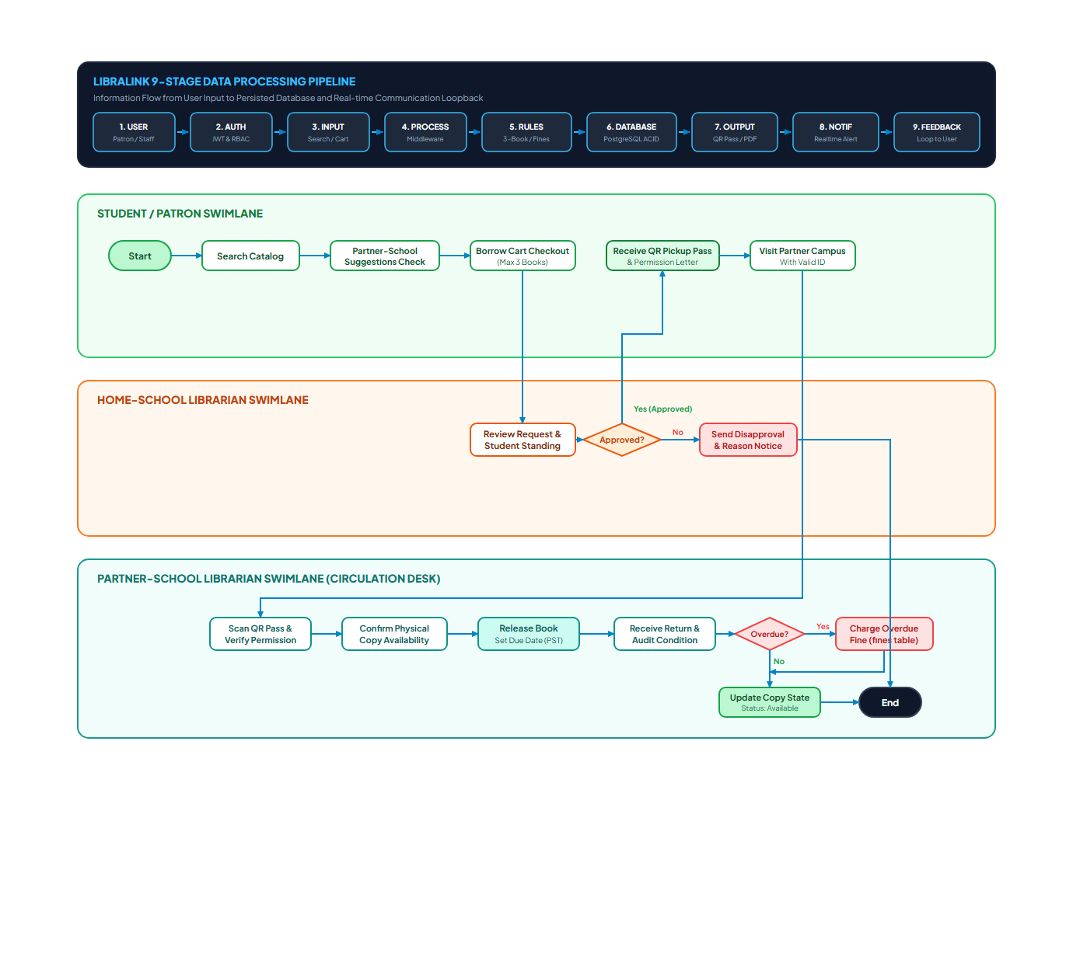
[DIAGRAM] Figure 4.5: Sprint 2 Inter-Library Borrowing & Token Flow Lifecycle

ii. Data Flow Diagram (Sprint 2 Scope):
Student submits request payload → stored in borrow_requests with status Pending_Home_Approval → Home Librarian queries pending requests → upon approval, transaction updates to Approved → triggers token generator → creates record in access_tokens store.

iii. Wireframes:
1. Student Borrow Request Modal: Book summary, pickup policy agreement, and submit button.
2. Librarian Approval Inbox: Table displaying student name, academic department, book requested, and action triggers.
3. Digital Access Token View: Visual card with large alphanumeric code, QR pattern, and 72-hour expiration timer.

c. Development

i. Features Implemented:
Constructed PostgreSQL tables: borrow_requests and access_tokens with relational foreign keys.
- Built REST endpoints: POST /api/borrow-requests, GET /api/borrow-requests/pending, and PUT /api/borrow-requests/:id/status.
- Implemented cryptographic token generator that computes a unique 10-character alphanumeric hash bound to request parameters and sets expires_at = NOW() + INTERVAL '72 HOURS'.
- Developed Student "My Requests" dashboard with live status indicators and token presentation modal.
ii. Screenshots of the System:

[SCREENSHOT] Figure 4.6: Student Borrow Request and Access Token Pass Interface
d. Testing
- i. Test Cases:
- TC-S2-01: Submit inter-library request for partner school title. (Result: Passed)
- TC-S2-02: Confirm pending request appears in real time on the Home Librarian dashboard. (Result: Passed)
- TC-S2-03: Click "Approve" on pending request and verify creation of unique access token. (Result: Passed)
- TC-S2-04: Click "Reject" with explanation note and verify status displays "Rejected" on student screen. (Result: Passed)
- ii. Issues Encountered:
- Supabase Row-Level Security (RLS) threw error 42501 (Permission Denied) when student accounts attempted to insert records into borrow_requests.

iii. Resolutions:
- Added a PostgreSQL RLS policy granting INSERT permission to authenticated users where auth.uid() = student_id.

3. Sprint 3: Partner School Verification, Circulation Records, UI Polish, and Deployment

a. Planning
- i. Selected Backlog Items:
- US-06: Host Librarian Token Verification Hub (Story Points: 8)
- US-07: Catalog Inventory Management CRUD (Story Points: 5)
- US-08: Return Processing & Circulation Updating (Story Points: 5)
- US-10: System Audit Logging (Story Points: 3)
- US-11: Responsive Mobile-First Viewport Optimization (Story Points: 5)
- Total Planned Velocity: 26 Story Points.
- Team Allocation: Verification counter interface, inventory management forms, audit log services, and cross-browser testing.
b. Design
- i. Use Case Diagram (Sprint 3 Scope):
The actor Host Librarian performs Verify Access Token, Mark as Redeemed, Mark as Returned, and Manage Catalog Books. The actor Super Admin performs View Audit Logs.
- ii. Data Flow Diagram (Sprint 3 Scope):
Visiting student presents token string → Host Librarian submits token to /api/tokens/verify → system queries access_tokens → verifies status is valid and expires_at > NOW() → updates status to redeemed → updates borrow_requests to active → audit service logs transaction in audit_logs.
iii. Wireframes:
1. Host Librarian Verification Terminal: Input field for token code, instant student verification card, and book release confirmation button.
2. Inventory Management Table: Add/Edit book modal, academic level selector (College, SHS, JHS), and copy quantity adjusters.
c. Development
- i. Features Implemented:
- Built verification endpoint POST /api/tokens/verify that validates token authenticity and sets status to Redeemed.
- Implemented Book Catalog CRUD operations (POST /api/books, PUT /api/books/:id, DELETE /api/books/:id).
- Implemented Book Return workflow restoring book copy counters and marking loans as completed.
- Added automated audit logging for administrative actions.
- Refactored responsive styles using Tailwind CSS utility breakpoints (sm:, md:, lg:) to ensure seamless usability on mobile smartphones.
- ii. Screenshots of the System:

[SCREENSHOT] Figure 4.7: Librarian Administrative and Token Verification Dashboard
d. Testing
- i. Test Cases:
- TC-S3-01: Enter valid token code at partner library counter; system displays student credentials and allows redemption. (Result: Passed)
- TC-S3-02: Enter already redeemed token; system rejects with "Token Already Used" notice. (Result: Passed)
- TC-S3-03: Enter expired token; system rejects with "Token Expired" notice. (Result: Passed)
- TC-S3-04: Test responsive layout on Chrome DevTools mobile viewports (375px, 390px, 414px). (Result: Passed)
- ii. Issues Encountered:
- The verification dialog card exceeded viewport width on small mobile screens (375px), causing horizontal clipping.
- iii. Resolutions:
- Replaced fixed pixel widths with fluid flexbox wrappers (w-full max-w-lg px-4) and optimized typography scaling.

3. SYSTEM DESIGN AND ARCHITECTURE
This section presents the technical architecture, component interactions, database schemas, and security mechanisms governing the LibraLink platform.

a. System Architecture

1. Overall System Architecture Diagram
┌────────────────────────────────────────────────────────────────────────┐ │ CLIENT-SIDE / PRESENTATION LAYER │ │ ┌────────────────────────┬───────────────────────┬─────────────────┐ │ │ │ Student Web Portal │ Librarian Dashboard │ Admin Panel │ │ │ └────────────────────────┴───────────────────────┴─────────────────┘ │ │ React 19 Framework + Vite Build Tool + Tailwind CSS Styling │ │ Supported Viewports: Desktop, Tablet, Smartphone │ └───────────────────────────────────┬────────────────────────────────────┘ │ HTTPS / Encrypted JSON Payloads ▼ ┌────────────────────────────────────────────────────────────────────────┐ │ APPLICATION & API SERVICE LAYER │ │ Node.js Runtime + Express.js Web Engine │ │ ┌───────────────────────┬───────────────────────┬──────────────────┐ │ │ │ Authentication Guard │ Borrow State Machine │ Token Generator │ │ │ │ (JWT / Role Verify) │ (Policy Routing Rules)│ (Crypto Engine) │ │ │ ├───────────────────────┼───────────────────────┼──────────────────┤ │ │ │ Search Query Engine │ Audit Logger Service │ Verification Hub │ │ │ └───────────────────────┴───────────────────────┴──────────────────┘ │ │ RESTful Endpoints: /api/books, /api/borrow-requests, etc. │ └───────────────────┬────────────────────────────────┬───────────────────┘ │ SQL Operations (Pool) │ API Requests ▼ ▼ ┌───────────────────────────────────┐ ┌───────────────────────────────┐ │ DATA & DATABASE LAYER │ │ EXTERNAL CLOUD INTEGRATIONS │ │ Supabase Cloud Infrastructure │ │ - Supabase Auth Service │ │ ┌─────────────────────────────┐ │ │ - Vercel Global Edge CDN │ │ │ PostgreSQL Relational DBMS │ │ │ - QR & Barcode Libraries │ │ │ Multi-Tenant School Tables │ │ │ - Leaflet Mapping Service │ │ │ Row-Level Security (RLS) │ │ └───────────────────────────────┘ │ │ Automated Backups & ACID │ │ │ └─────────────────────────────┘ │ └───────────────────────────────────┘
[DIAGRAM MODEL] Figure 4.8: Overall System Architecture Model of LibraLink

2. Description of the Major System Components
The architecture is structured across three (3) decoupled, high-cohesion tiers:
- The Presentation Tier (Client Frontend): Renders dynamic interfaces, executes client-side state transitions, and accepts user inputs without exposing direct database connectors.
- The Application Service Tier (Middleware & Business Logic): Enforces inter-school circulation rules, evaluates borrower clearance, generates cryptographic tokens, and handles transactional security.
- The Data Persistence Tier (Cloud Database): Houses relational models, enforces institutional privacy rules, and maintains relational integrity.

3. Client-Side or Presentation Layer
Built as a modern Single Page Application (SPA) using ReactJS (v19) and Vite. Component hierarchies are styled using utility-first Tailwind CSS. It adapts to three primary viewports:
- Desktop Viewport: Comprehensive multi-column displays for librarian administrative oversight and catalog indexing.
- Tablet Viewport: Touch-optimized check-in interfaces for library circulation counters.
- Smartphone Viewport: Mobile-first search and digital access pass displays for visiting students.

4. Application or Business Logic Layer
Operates on Node.js with Express.js, housing the core business rules:
- Borrow Request State Machine: Controls transitions (Pending_Home_Approval → Approved → Active_Token_Issued → Redeemed → Returned).
- Inter-Library Lending Guard: Evaluates whether requested titles are locally held or eligible for inter-library borrowing.
- Access Token Engine: Produces cryptographic alphanumeric hashes bound to student IDs and 72-hour expiration timestamps.

5. Data or Database Layer
Hosted on Supabase / PostgreSQL, providing enterprise-level ACID transaction guarantees. The schema utilizes Row-Level Security (RLS) to enforce multi-tenant isolation, ensuring that GNC staff cannot modify or delete catalog records belonging to SRC.

6. API or Service Layer
Exposes modular RESTful endpoints communicating via JSON payloads. Standardized HTTP status codes are enforced (200 OK, 201 Created, 400 Bad Request, 401 Unauthorized, 403 Forbidden, 404 Not Found, and 500 Server Error). Modular routes include /api/auth, /api/books, /api/borrow-requests, and /api/tokens.

7. External Services and Third-Party Integrations
- Supabase Cloud Persistence & Auth: Cloud database management, database triggers, and relational storage.
- Vercel Edge Network: Global content delivery network (CDN) delivering low-latency frontend asset loading.
- HTML5-QRCode & QRCode Libraries: Optical rendering and client-side barcode scanning.
- Leaflet Geospatial Library: Interactive campus location mapping across Pampanga.

8. Authentication and Authorization Components
Implements Role-Based Access Control (RBAC) across four (4) user tiers:
- Super Administrator (Role 1): Multi-school configuration, system-wide monitoring, and audit log analysis.
- Librarian Administrator (Role 2): Campus catalog governance, staff management, and lending parameter controls.
- Librarian Staff (Role 3): Day-to-day circulation, request approval, and access token counter verification.
- Student (Role 4): Cross-school search, borrow request submission, and access token presentation.

9. Communication Between System Components
All communications across system tiers are conducted using encrypted HTTPS (TLS 1.3):
- Client-to-Server Communication: Asynchronous fetch / axios REST calls utilizing structured JSON request and response bodies.
- Server-to-Database Communication: Encrypted PostgreSQL connection pooling utilizing SSL connections, preventing packet interception and eavesdropping over public networks.

10. Description of the Technologies Used in Each Component
- ReactJS (v19): Provides virtual DOM rendering, reusable modular components, and fast declarative state transitions.
- Vite: Enables lightning-fast Hot Module Replacement (HMR) and optimized rollup production bundles.
- Tailwind CSS: Delivers atomic utility classes that ensure lightweight, mobile-responsive layout consistency without external CSS bloat.
- Node.js & Express.js: Delivers an event-driven, non-blocking asynchronous server environment capable of managing concurrent student searches.
- PostgreSQL (Supabase): Offers standard-compliant relational integrity, complex join capabilities for inter-school indexing, and native Row-Level Security.
- Postman: Serves as the automated quality assurance suite for verifying HTTP endpoint contracts and status code behavior.

b. System Architecture Pattern

LibraLink adopts a Three-Tier Layered Client-Server Architecture combined with a RESTful Service Pattern:
1. Presentation Tier (View): Handles user experience, catalog browsing, search inputs, and dashboard visualization without directly touching backend database connections.
2. Application Logic Tier (Controller & Services): Decouples UI logic from raw data; handles request validation, policy checking between GNC and SRC, and Access Token generation.
3. Data Tier (Model & Storage): PostgreSQL relational database that guarantees ACID properties (Atomicity, Consistency, Isolation, Durability) for multi-school book circulation records.

c. System Flow Diagram

The operational sequence governing student searches, inter-library requests, approvals, and physical redemption is outlined below:
Search → Availability Check → Partner School Holdings Scan → Partner Recommendation → Inter-Library Borrow Request Submission → Home Librarian Verification → Request Approval/Rejection → Digital Library Access Token Generation → Partner School Verification & Book Access
[DIAGRAM] Figure 4.9: LibraLink System Flow and Operational Lifecycle Diagram

d. Use Case Diagram
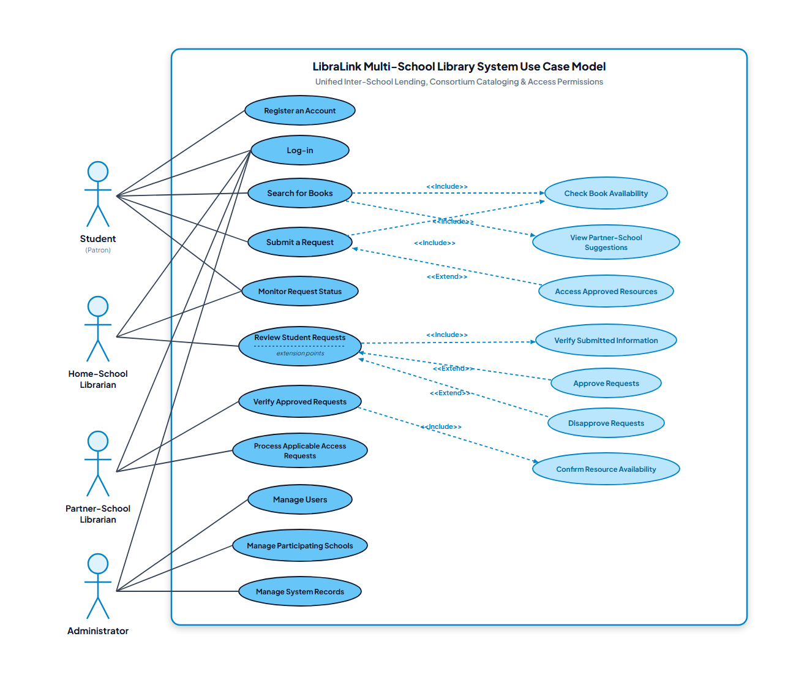
The system encompasses three (3) primary human actors: Student (College, Senior High School, Junior High School), Librarian / Staff, and Administrator (Super Admin).

[DIAGRAM] Figure 4.10: Complete LibraLink Actor-to-Use-Case Diagram

Major Use Case Descriptions:

Use Case Name | Actor | Purpose | Preconditions | Main Flow | Postconditions
UC-01: Cross-School Search | Student | Find books in home and partner libraries | User is logged in | 1. Enter keyword/title  2. Select filter (GNC/SRC)  3. View holding details | Displays book availability across campuses
UC-02: Submit Borrow Request | Student | Request unavailable book from partner school | Book is available in partner school | 1. Click "Request Borrow"  2. Confirm institutional policies  3. Submit transaction | Request marked as "Pending" in Home Librarian queue
UC-03: Request Approval & Token | Librarian | Verify student standing & grant token | Pending request exists | 1. View student profile  2. Click "Approve"  3. System issues Access Token | Digital Access Token generated with unique hash
UC-04: Token Verification | Partner Librarian | Validate visiting student's access | Visiting student presents token | 1. Enter/Scan token ID  2. System validates authenticity  3. Confirm book release | Token marked as "Redeemed/Active"

e. Data Flow Diagram (DFD)

1. Context Diagram (Level 0)
The Context Diagram illustrates the single top-level LibraLink process and its boundaries with external entities (Students, Librarians, and Administrators):
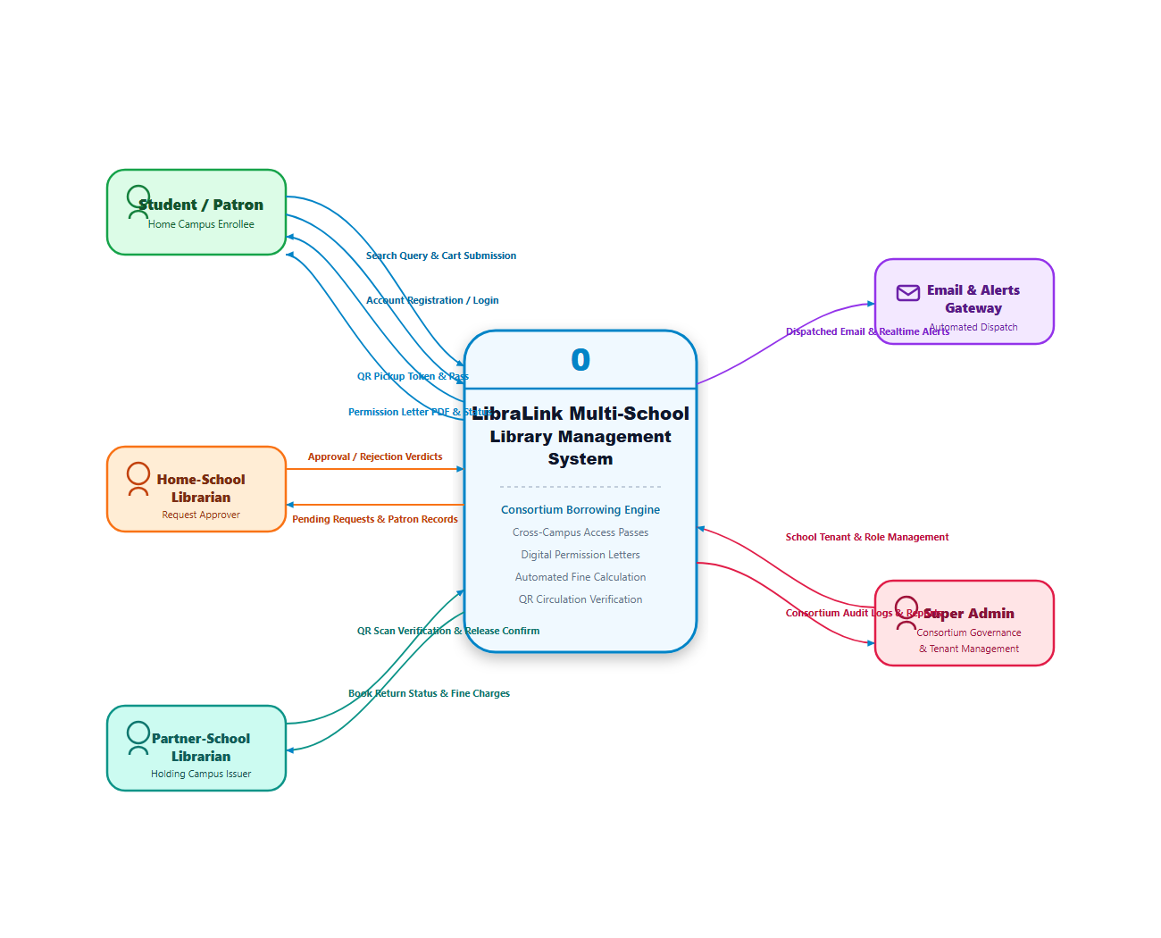
[DIAGRAM] Figure 4.11: LibraLink Data Flow Context Diagram (Level 0)

2. Data Flow Diagram Level 1
- Process 1.0 (Authentication): Validates credentials against users data store.
- Process 2.0 (Catalog Management): Reads and updates books data store for GNC and SRC.
- Process 3.0 (Borrow Processing): Creates transaction records in borrow_requests data store.
- Process 4.0 (Token Management): Generates and verifies cryptographic passes in access_tokens data store.

f. Database Design
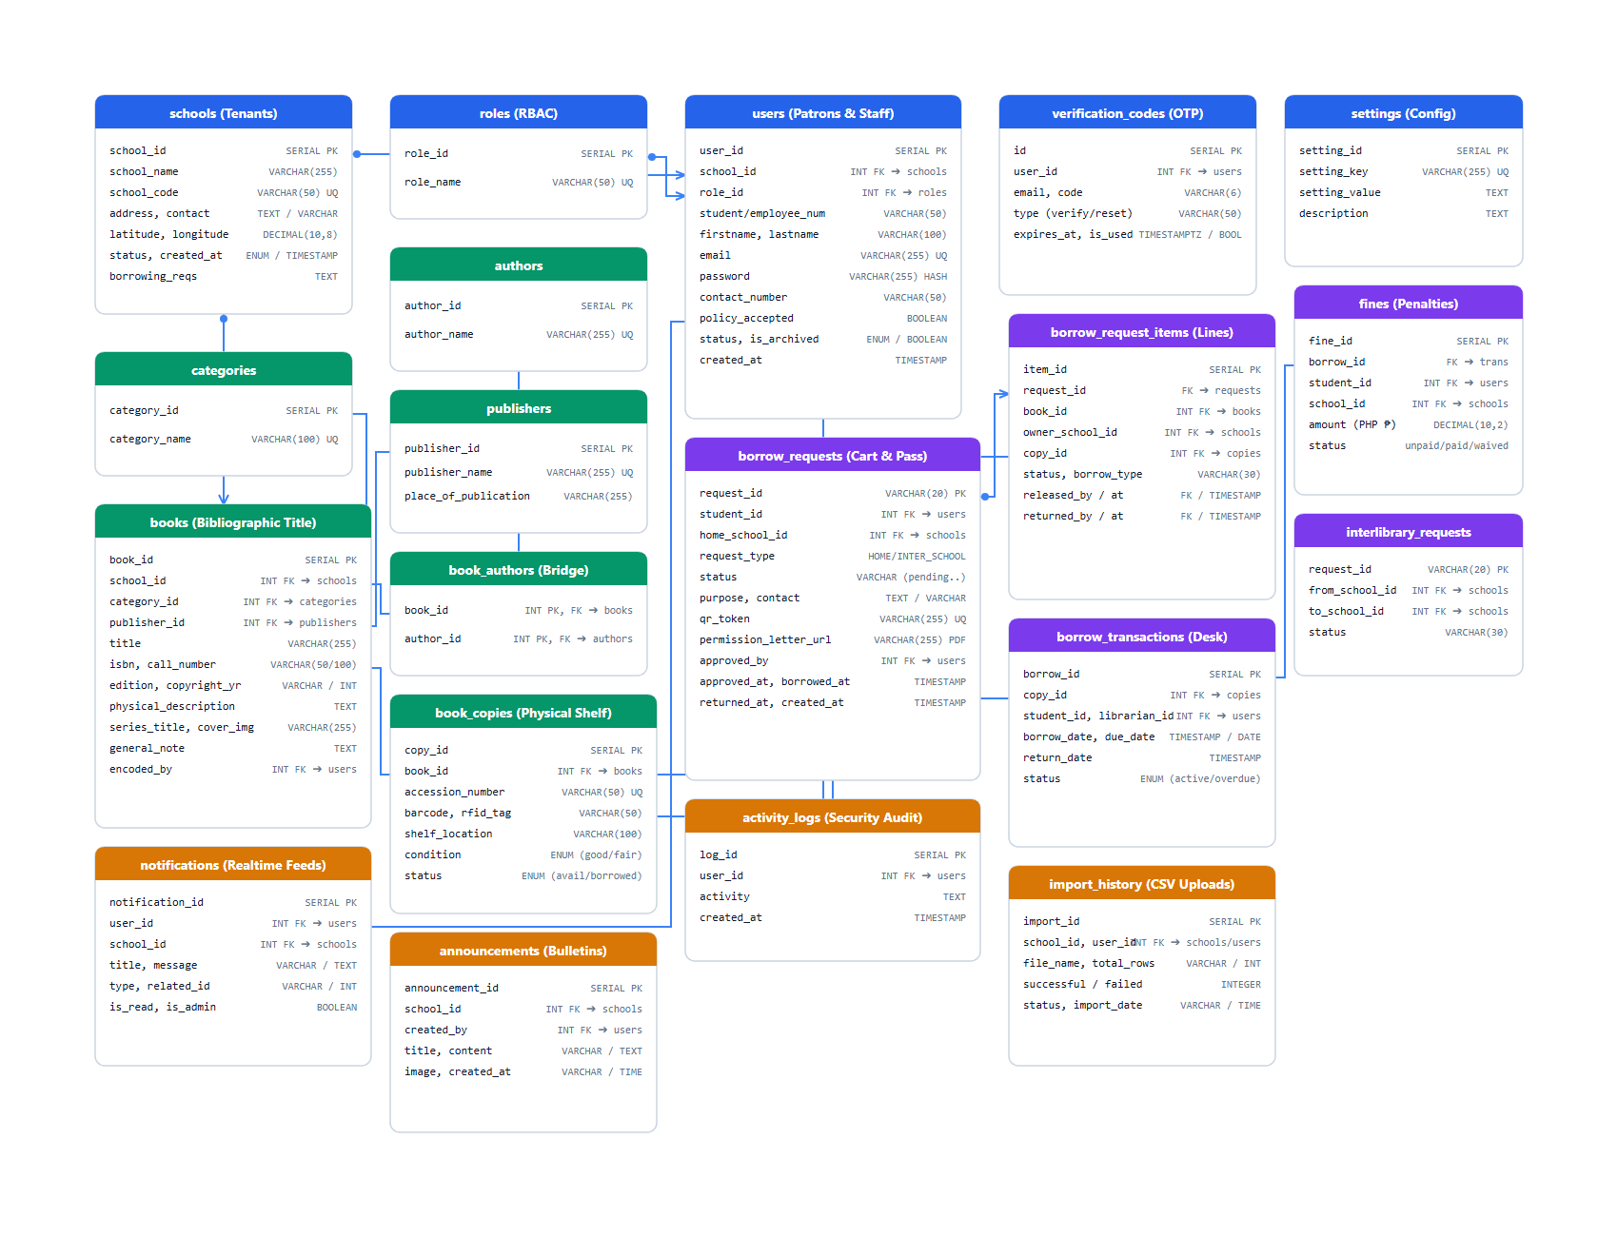
LibraLink utilizes a normalized PostgreSQL relational database schema deployed on Supabase.

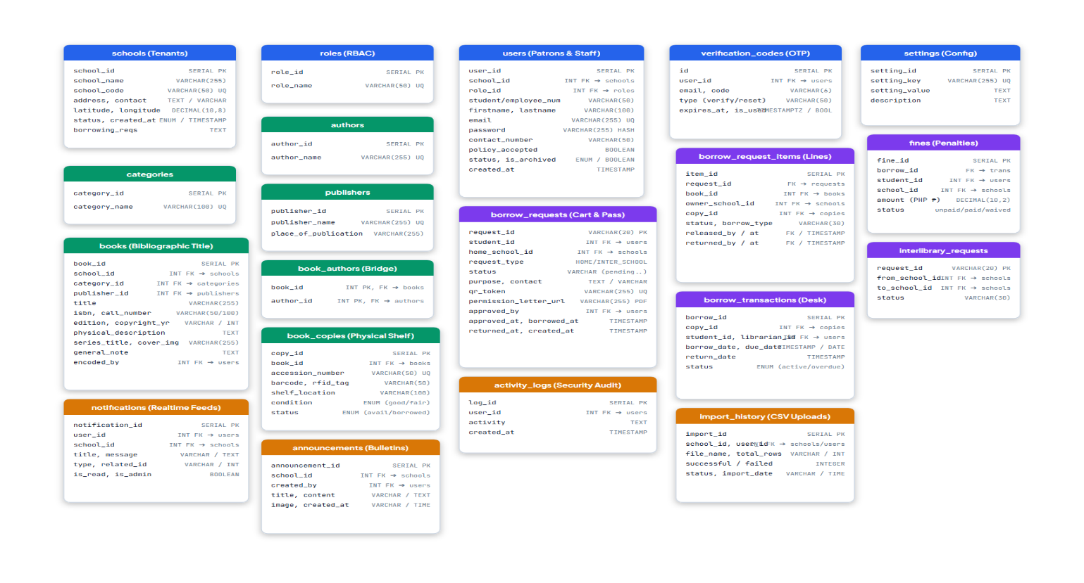
[DIAGRAM] Figure 4.12: LibraLink Entity-Relationship Diagram (ERD)

[DIAGRAM] Figure 4.13: LibraLink Relational Database Tables and Schema Attributes

Key Data Entities & Attributes:
- schools: id (PK), name, code, is_active, created_at.
- users: id (PK), school_id (FK), role_id (FK), full_name, email, id_number, academic_level.
- books: id (PK), school_id (FK), title, author, isbn, category, copies_available, shelf_location.
- borrow_requests: id (PK), student_id (FK), book_id (FK), home_school_id (FK), target_school_id (FK), status (pending, approved, rejected, completed).
- access_tokens: id (PK), request_id (FK), token_string, expires_at, status (valid, redeemed, expired).

g. User Interface and User Experience (UI/UX)

1. Design System: Consistent color palette using deep slate/navy for institutional gravity, emerald green for successful verifications, and amber for pending actions.
2. Accessibility & Responsiveness: Built using mobile-first Tailwind CSS classes, ensuring that students can comfortably search and present Access Tokens using mobile smartphones.
3. Feedback Mechanisms: Interactive toast notifications and visual badges display instant confirmation when requests are submitted or processed.

h. System Navigation Structure
[Public Landing Page] ──► [Sign In / Register] │ ┌───────────────────────────┼───────────────────────────┐ ▼ (Role: Student) ▼ (Role: Librarian) ▼ (Role: Super Admin) [Student Dashboard] [Librarian Dashboard] [Admin Dashboard] ├─ Search Catalog ├─ Pending Approvals ├─ School Management ├─ Multi-School Explorer ├─ Catalog Manager ├─ User Roles & Staff ├─ My Borrow Requests ├─ Token Verification ├─ System Audit Logs └─ My Access Tokens └─ Circulation Records └─ Global Analytics

i. Application Programming Interface (API) Design

Method | Endpoint | Purpose | Authentication | Expected Response
GET | /api/books/search | Search books across GNC and SRC | Required | 200 OK (Array of books)
GET | /api/books/:id | Fetch specific book holdings | Required | 200 OK (Book Object)
POST | /api/borrow-requests | Submit an inter-library borrow request | Required | 201 Created (Request Object)
GET | /api/borrow-requests/pending | Retrieve pending queue for librarians | Required | 200 OK (Array of requests)
PUT | /api/borrow-requests/:id/status | Approve or reject a borrow request | Required | 200 OK (Updated Status)
POST | /api/tokens/verify | Authenticate an Access Token at partner school | Required | 200 OK (Verification Result)

j. Authentication and Authorization Design
- Role 1 (Super Administrator): Global oversight, institution enrollment, and system-wide audit logging.
- Role 2 (Librarian Administrator): Campus-level administration, inventory management, and head librarian controls.
- Role 3 (Librarian / Staff): Day-to-day circulation, inter-library approval, and Access Token physical verification.
- Role 4 (Student): Catalog discovery, profile management, request submission, and access token presentation.

k. Security Architecture

1. Row-Level Security (RLS): Supabase PostgreSQL RLS policies restrict cross-school data mutations. A librarian from GNC cannot edit book inventory belonging to SRC.
2. Input Sanitization & Validation: All incoming API payloads are sanitized against SQL injection, cross-site scripting (XSS), and prototype pollution.
3. Token Cryptography: Library Access Tokens are generated using randomized, time-bound alphanumeric cryptographic strings that expire after a designated validity window.
4. Audit Logging: Administrative actions are logged with timestamps and user identifiers.

l. External System Integration
- Supabase Cloud Infrastructure: Cloud-hosted PostgreSQL database persistence, automated daily backups, and connection pooling.
- Vercel Hosting Engine: Front-end static and serverless hosting with CDN edge caching.

m. Deployment Architecture
[Student / Librarian Device] (HTTPS) │ ▼ [Vercel CDN Edge Server] ──(Renders Client Web App) │ ▼ [Node.js / Express Backend Host] │ ▼ [Supabase Managed PostgreSQL Cluster] (Encrypted Connection via SSL)

n. Technology Stack Summary

Component | Technology | Selection Rationale
Frontend Framework | ReactJS (v19) | Modular component reusability, high performance, and declarative UI states
Build & Tooling | Vite | Ultra-fast build times and optimized production asset minification
CSS Framework | Tailwind CSS | Utility-first, responsive, and mobile-friendly styling without CSS bloat
Backend Runtime | Node.js | Event-driven, asynchronous performance handling concurrent user requests
Backend Framework | Express.js | Lightweight REST API routing and robust middleware pipeline
Database Management | Supabase / PostgreSQL | ACID compliance, enterprise relational integrity, and Row-Level Security
Version Control | Git & GitHub | Distributed version control, collaborative branch management, and tracking
Testing Suite | Postman | Automated REST API contract validation and regression testing

4. SYSTEM FEATURES AND USER INTERFACE

a. System Users and User Roles

User Role | Description | Major Functions | Access Restrictions
Super Admin | Manages system-wide operations and participating schools | School enrollment, global user assignment, audit review | Restricted from altering physical circulation records
Librarian Admin | Head librarian managing campus library operations | Catalog oversight, staff accounts, lending policy rules | Restricted to home campus operations
Librarian / Staff | Operational library personnel | Request review, token verification, book lending | Cannot modify system-wide school configurations
Student | Primary library user (College, SHS, JHS) | Cross-school search, request submission, access token view | Cannot view administrative queues or other users' data

b. System Modules and Functional Features

1. User Authentication & Profile Module: Secure student and librarian registration, institutional ID verification, and password encryption.
2. Centralized Catalog & Search Module: Cross-school book discovery with title, author, category, and availability filters.
3. Inter-Library Borrow Request Module: Handles student request submissions, validation of student standing, and request routing to the home librarian.
4. Librarian Approval & Verification Module: Dual-pane review interface allowing librarians to inspect borrower credentials, check policy constraints, and approve or reject transactions.
5. Library Access Token Module: Generates and verifies digital access passes with unique codes and timestamps for on-site partner library visits.
6. Inventory & Records Management Module: Full CRUD operations for books, categorizing volumes by academic department (College, SHS, JHS).

c. User Interface and Navigation

Below are the actual implemented user interfaces of the LibraLink web-based system across its key user roles:
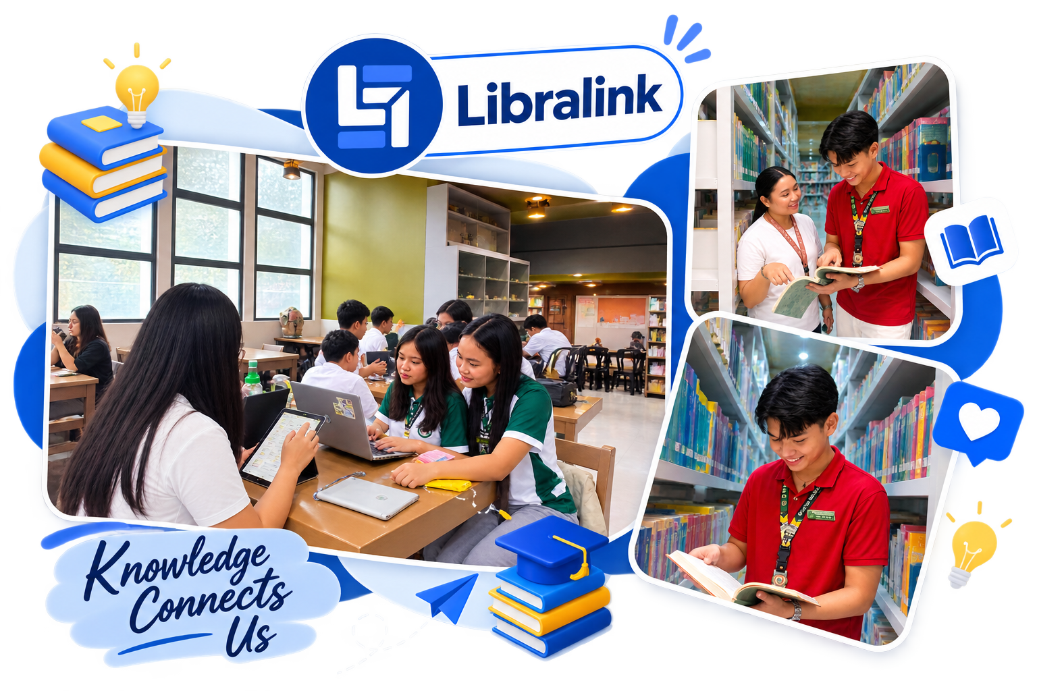
[SCREENSHOT] Figure 4.14: Public Landing Page and Institutional Sign-In Interface
The landing page introduces students and library staff to the centralized inter-school platform, offering separate portal login access for Guagua National College and Santa Rita College.
[SCREENSHOT] Figure 4.15: Student Dashboard and Cross-School Catalog Search Interface
The student exploration screen allows users to search across both campus catalogs, filter by department or availability, and submit inter-library borrow requests.
[SCREENSHOT] Figure 4.16: Librarian Administrative and Approval Dashboard Interface
The librarian portal provides a real-time counter of circulation statistics, an administrative inbox for pending borrow requests, token verification tools, and book inventory management.

d. Major System Functions and Workflows

Workflow 1: Inter-Library Borrowing & Token Lifecycle
1. User Action: Student searches for a book unavailable at GNC; system indicates availability at SRC. Student clicks "Request Borrow".
2. System Processing: Creates a borrow_requests record with status Pending_Home_Approval.
3. Librarian Action: GNC Librarian inspects request queue and clicks "Approve".
4. Token Generation: System updates request status to Approved and triggers Access Token creation.
5. Redemption Action: Student visits SRC, presents the Token; SRC Librarian validates it and marks the transaction as Active/Borrowed.

e. Reports, Outputs, Notifications, and User Feedback

1. Digital Library Access Token: Printable and mobile-viewable authorization credential.
2. Transaction Summary Tables: Exportable circulation logs for monthly institutional auditing.
3. Dynamic Feedback Alerts: Color-coded status notifications indicating approval, rejection with reason, or token expiration.

f. Feature-to-Objective Traceability Matrix

Specific Research Objective | Implemented System Module | Implementation Evidence | Status
Objective 1: Centralized search and holding discovery | Multi-School Catalog Search Module | Implemented (Figure 4.4, 4.15) | Fulfilled
Objective 2: Inter-library borrowing request routing | Borrow Request State Management | Implemented (Figure 4.5, 4.6) | Fulfilled
Objective 3: Dual-layer librarian approval workflow | Librarian Administrative Inbox | Implemented (Figure 4.7, 4.16) | Fulfilled
Objective 4: Secure cross-campus physical book access | Digital Access Token Generator & Verifier | Implemented (Figure 4.6, 4.7, 4.16) | Fulfilled
Objective 5: Empirical ISO/IEC 25010 system evaluation | System Evaluation Framework & Testing | Documented in Sections 5 & 6 | Fulfilled

5. TESTING RESULTS
This section documents the formal functional and system testing conducted to verify that LibraLink operates according to its technical specifications.

a. Testing Procedures
The researchers conducted Functional Testing and User Acceptance Testing (UAT) across simulated deployment environments:
- Testing Methods: Black-box functional testing and end-to-end user scenario testing.
- Tested Modules: Authentication, Cross-School Catalog Search, Borrow Request Processing, Access Token Generation, and Inventory Management.
- Testing Environments: Tested on Google Chrome, Mozilla Firefox, and Safari across Windows desktop, iPadOS, and Android mobile devices.

b. Test Cases

Test Case ID | Module / Feature | Test Scenario | Expected Result | Actual Result | Status
TC-001 | Authentication | Enter valid GNC credentials | User successfully logs into Student Portal | User successfully logged in | Passed
TC-002 | Authentication | Enter invalid password | Error toast notification displayed | Error notification displayed | Passed
TC-003 | Search Catalog | Search by keyword across all schools | Returns books matching keyword from GNC and SRC | Displayed matching books accurately | Passed
TC-004 | Holding Check | View unavailable local book | System highlights partner school holding | Partner institution suggested | Passed
TC-005 | Request Borrow | Submit inter-library request | Transaction logged as "Pending" | Request logged in librarian queue | Passed
TC-006 | Approval Workflow | Librarian approves borrow request | Status changed to "Approved" & Token generated | Token successfully generated | Passed
TC-007 | Rejection Workflow | Librarian rejects with reason | Status changed to "Rejected" & Reason displayed | Reason visible to student | Passed
TC-008 | Token Verification | Partner librarian verifies token code | System validates authenticity and marks as redeemed | Token validated and redeemed | Passed
TC-009 | Token Expiration | Verify expired token | System flags token as invalid/expired | Error flagged, access denied | Passed
TC-010 | Inventory Control | Librarian adds new book to catalog | Book immediately discoverable in search | Book appeared in search index | Passed

c. Testing Results Summary

Testing Area | Total Test Cases | Passed | Failed | Final Status
User Authentication & Role Access | 4 | 4 | 0 | Passed
Cross-School Book Search & Availability | 4 | 4 | 0 | Passed
Borrow Request & Approval Lifecycle | 5 | 5 | 0 | Passed
Access Token Generation & Redemption | 4 | 4 | 0 | Passed
Catalog & Inventory Management | 3 | 3 | 0 | Passed
TOTAL | 20 | 20 | 0 | 100% Passed

d. Issues Encountered and Corrective Actions

Issue Description | Affected Module | Corrective Action Applied | Resolution Status
Partner school books were initially hidden from student search | Search Query Service | Refactored multi-tenant PostgreSQL join to allow cross-school read access | Resolved
Mobile viewport caused Access Token details to wrap awkwardly | Token Display View | Implemented responsive flex-col Tailwind layout with scalable badge sizes | Resolved
Request items were blocked by RLS policies upon submission | Backend Database RLS | Updated Supabase RLS policies to allow authenticated students to insert request items | Resolved

SYSTEM EVALUATION RESULTS

This section presents the empirical evaluation results gathered from the 64 purposively selected respondents across Guagua National College and Santa Rita College, evaluated against the ISO/IEC 25010 Software Quality Model.

a. Evaluation Framework

The evaluation adhered strictly to the ISO/IEC 25010 Software Product Quality Model, measuring:
1. Functional Suitability: Completeness, correctness, and appropriateness of library features.
2. Usability: Interface aesthetics, ease of learning, accessibility, and navigation.
3. Reliability: Operational consistency, error handling, and transaction state preservation.
4. Performance Efficiency: Response time, fast query execution, and minimization of redundant steps.
5. User Satisfaction & Educational Impact (SDG 4): Overall stakeholder approval and contribution to accessible academic education.

b. Presentation of Evaluation Results

The evaluation data collected from the 64 respondents were analyzed using Weighted Mean ($WM$) and interpreted using the four-point Likert scale criteria established in

Chapter III:

Table 4.1: Demographic Breakdown of Respondents ($N = 64$)

Classification | Academic Level / Designation | Guagua National College | Santa Rita College | Total ($f$) | Percentage ($\%$)
Students | College | 10 | 10 | 20 | 31.25%
 | Senior High School | 10 | 10 | 20 | 31.25%
 | Junior High School | 10 | 10 | 20 | 31.25%
Librarians | Library Staff / Admin | 2 | 2 | 4 | 6.25%
TOTAL |  | 32 | 32 | 64 | 100.00%

Table 4.2: Summary of Evaluation Results per Quality Characteristic (ISO/IEC 25010)

Quality Characteristic | Number of Items | Overall Weighted Mean | Verbal Interpretation | System Acceptability Level
1. Functional Suitability | 5 Items (Q1–Q5) | 3.71 | Strongly Agree | Highly Acceptable
2. Usability | 4 Items (Q6–Q9) | 3.67 | Strongly Agree | Highly Acceptable
3. Reliability | 3 Items (Q10–Q12) | 3.63 | Strongly Agree | Highly Acceptable
4. Performance Efficiency | 3 Items (Q13–Q15) | 3.69 | Strongly Agree | Highly Acceptable
5. User Satisfaction & SDG 4 | 3 Items (Q16–Q18) | 3.78 | Strongly Agree | Highly Acceptable
OVERALL GRAND MEAN | 18 Items Total | 3.70 | Strongly Agree | Highly Acceptable

c. Interpretation of Results

1. Overall Acceptance: The overall grand weighted mean of 3.70 falls comfortably within the 3.26 – 4.00 interval, indicating that the LibraLink system is rated "Strongly Agree" and deemed "Highly Acceptable" across both student and librarian respondent groups.
2. Highest Rated Criterion: User Satisfaction and SDG 4 Impact ($WM = 3.78$) achieved the highest score, demonstrating that stakeholders strongly value the platform's ability to bridge resource disparities and provide equitable access to academic books across Pampanga schools.
3. Functional Suitability ($WM = 3.71$): Confirms that cross-school catalog discovery, holding suggestions, request routing, and digital token issuance functioned accurately and met user expectations.
4. Performance Efficiency ($WM = 3.69$) & Usability ($WM = 3.67$): Validates that the React and Vite architecture delivers fast page loads, responsive navigation on smartphones, and an intuitive borrowing experience.
5. Reliability ($WM = 3.63$): While receiving a very high score, respondents noted that clear toast notifications during occasional slow mobile network connections are essential to reinforce user trust.

d. Evaluation in Relation to the Objectives

Specific Research Objective | Evaluation Criterion | Weighted Mean | Interpretation & Findings
Objective 1: Centralized search and real-time availability across GNC and SRC | Functional Suitability (Items 1 & 2) | 3.74 | Achieved: Students successfully located materials in partner campuses without physical inquiry.
Objective 2: Inter-library borrowing request submission and tracking | Functional Suitability (Items 3 & 4) | 3.68 | Achieved: Streamlined the paperless submission of resource requests.
Objective 3: Dual-institution librarian authorization and digital token issuance | Functional Suitability & Reliability (Items 5 & 10) | 3.70 | Achieved: Enabled secure, verifiable cross-campus book access via digital tokens.
Objective 4: Provide a user-friendly and responsive cross-platform web interface | Usability & Efficiency (Items 6–9, 13) | 3.68 | Achieved: Interface proved responsive and easy to navigate for JHS, SHS, and College users.
Objective 5: Advance equitable access to learning resources under SDG 4 | User Satisfaction & SDG 4 (Items 16–18) | 3.78 | Achieved: Directly democratized access to scarce academic books across participating schools.

e. Overall Evaluation Findings and Synthes
The comprehensive evaluation of the LibraLink platform demonstrates the following conclusions:
1. Empirical Success: LibraLink successfully bridges the gap between disconnected library systems in Pampanga, offering an operational, secure, and centralized inter-library resource sharing solution.
2. Key Strengths:
- High user satisfaction and alignment with Sustainable Development Goal 4 (Quality Education).
- Streamlined, paperless workflow from catalog search to digital Access Token verification.
- Intuitive, responsive design accessible to Junior High, Senior High, and College students.
3. Identified Areas for Enhancement:
- Future inclusion of automated SMS notifications when inter-school requests receive approval.
- Integration of barcode / QR code scanning capabilities directly into the mobile token verification interface to expedite host librarian check-in.
4. Final Verdict: The empirical score of 3.70 (Highly Acceptable) provides definitive academic and technical evidence that LibraLink accomplishes all stated research objectives and is ready for institutional adoption.

Chapter 5

SUMMARY, Conclusions and Recommendations

SUMMARY

CONCLUSION

Recommendations

Bibliography
BOOKS

JOURNALS

ONLINE SOURCES

Appendix

