Os mais vendidos:
select
f.product_id,
pr.product_name,
sum(f.quantity) as quantity_sold
from
fato_sales_items f
inner join
dim_products pr on f.product_id = pr.product_id
inner join
dim_date dt on f.date_id = dt.date_id
where
dt.year = 2022
group by
f.product_id, pr.product_name
order by
quantity_sold desc
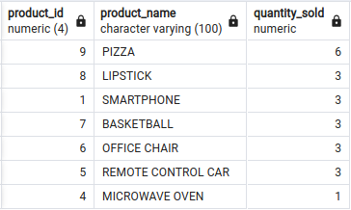

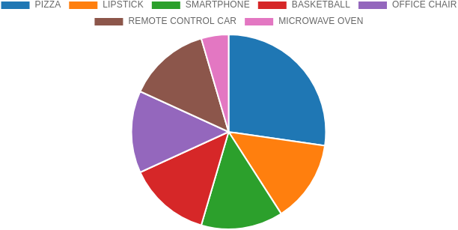

2023
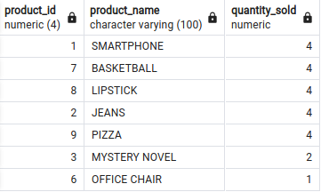

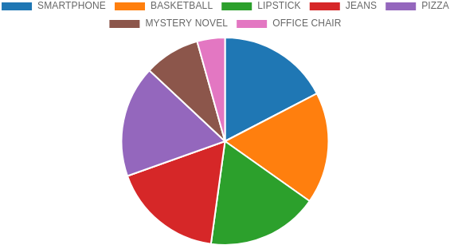

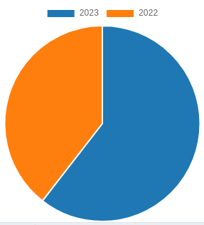
Faturamento total por ano
select distinct
dt.year,
sum(f.sub_total)
from
fato_sales_items f
inner join
dim_date dt on f.date_id = dt.date_id
group by
dt.year
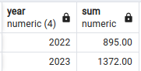

Maiores commissões de vendedores por ano
select distinct
f.sales_id,
f.total_price,
se.seller_name,
se.tx_commission,
sum(sub_total * se.tx_commission / 100) as commission
from
fato_sales_items f
inner join
dim_date dt on f.date_id = dt.date_id
inner join
dim_sellers se on se.seller_id = f.seller_id
where
dt.year = 2022 and dt.month between
group by
f.sales_id, f.total_price, se.seller_name, se.tx_commission
order by
commission desc
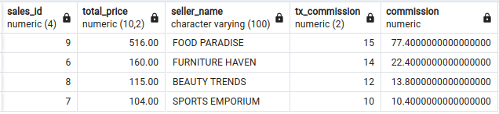

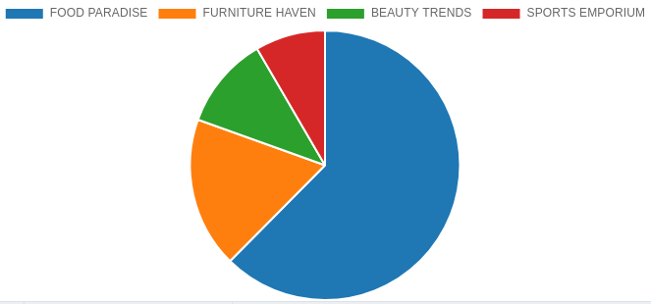
2023
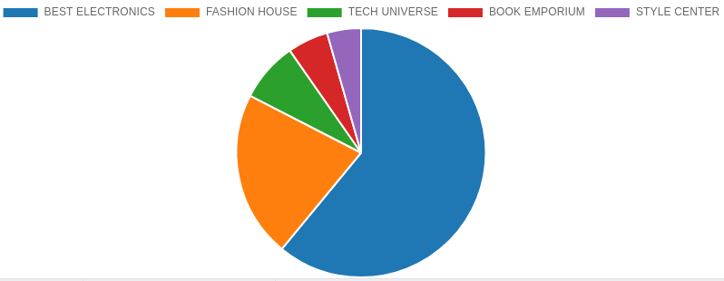
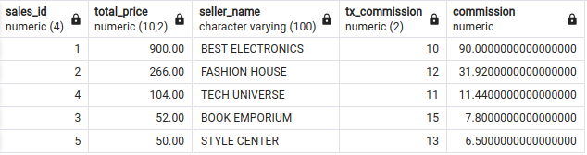
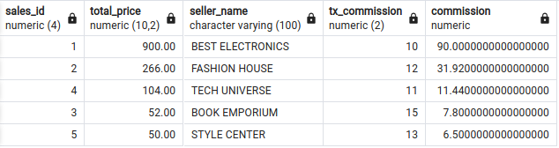
Quantidade de fornecedores por estado
select
st.state_name,
count(f.state_id) as suppliers_per_state
from
fato_sales_items f
inner join
dim_suppliers su on f.supplier_id = su.supplier_id
inner join
dim_states st on st.state_id = f.state_id
inner join
dim_date dt on f.date_id = dt.date_id
where
dt.year = 2022
group by
st.state_name
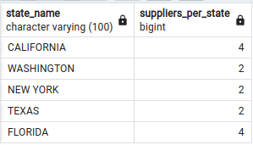

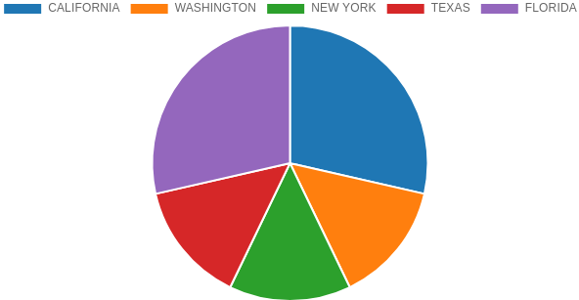
2023
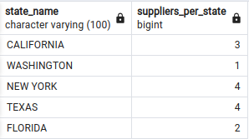

Quantidade de clientes por estado por ano
select
st.state_name,
count(f.customer_id) as customers_per_state
from
fato_sales_items f
inner join
dim_customers cu on f.customer_id = cu.customer_id
inner join
dim_states st on st.state_id = cu.state_id
inner join
dim_date dt on f.date_id = dt.date_id
where
dt.year = 2022
group by
st.state_name
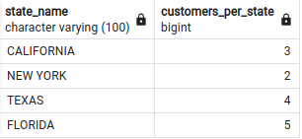

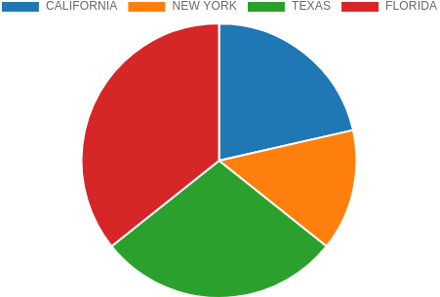

2023
