The National Focal Point survey as evidence for the RespiCast review
A reading of the 2024 NFP survey against the review’s least-cost test — what it does and does not license.
Provenance and scope (read first). Instrument: the 2024 ECDC survey of National Focal Points (NFPs) for respiratory viruses, designed to evaluate RespiCompass and read across here to RespiCast — which bounds what can be asked of it. Vintage: fielded in 2024, when RespiCast was ~1 year old; it informs a late-2026 decision, so its engagement figures are ~2 years old and cannot be read as current use. Population: 19 of ~30 NFPs replied — national surveillance / public-health consumers, giving one collective institutional position per country (the respondent need never have opened a forecast). They are not the contributor modelling network (~9 teams / 28 models) and not the website-user survey (results due November); those three must not be conflated. Non-response: 19 of ~30 is not random — the absent ~11 plausibly skew less engaged, so the engagement figures here are, if anything, optimistic; every share also moves ~5 points per country and subgroup counts below are single digits. The governing question: the review asks not only what value RespiCast has and could have, but whether that value could be had more cheaply. A benefit counts toward continuation only where the survey gives reason to think a cheaper route would not deliver it.
1. What the survey licenses — and the gap where the cost sits. The strongest finding is a need: 13 of 19 institutes (68%) have no in-house mathematical modeller, and only one has a team above five (Figure 1). That is clear evidence ECDC should provide some central forecast. It is silent on the question that carries the cost — whether that forecast must be a ~28-model community ensemble on a hubverse platform rather than a single centrally-run model. The survey cannot compare the two, and that silence is itself decision-relevant. It sharpens against the stated use: the activity NFPs most expect modelling to inform is situational awareness (surveillance, 58% “likely”), while the demanding forecasting use case — healthcare-capacity planning — is the one they expect least (16% “likely”; 42% “unlikely”). An undemanding use case is one a much simpler product might serve adequately. What a multi-model ensemble buys over a simple central forecast, for situational awareness, the survey cannot say — and should not be read to.
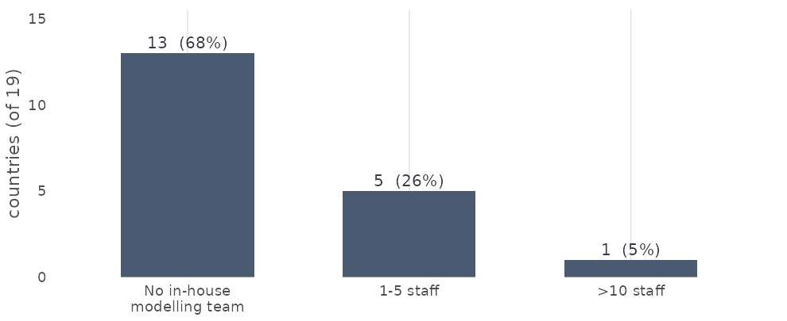
Figure 1. In-house mathematical-modelling staff at the national institute (2024 NFP survey, 19 countries). Source: code/05_figures/fig_respicast_decision.R.
2. Does the need convert into demand? Read straight. Engagement with RespiCast averages 2.1 / 5 (18 countries), but the average hides the structure that matters. Separating awareness from use: countries with a team engage at 2.2 (n = 5); the no-modeller countries average 2.1 (n = 13) — but that includes three that were unaware (score 0), and the ten aware no-modeller countries engage at 2.7 (n = 10), the highest of any group and level with the mature-forecast ceiling (§3). Two readings were possible in principle — that value is merely latent, or the more troubling one that the absence of capacity is not converting into demand. The review’s discriminator — do the RespiCast-unaware cluster among the no-modeller countries? — resolves it, at small n, toward the first: all three “not aware” responses come from no-modeller countries; every country with any in-house capacity was aware. So the low average is largely an awareness / distribution gap among the highest-need countries — cheap to close, favouring continuation-evolved; where the product is known, the need does appear to convert into demand. This rests on three unaware and ten aware responses: indicative, not robust.
3. But the ceiling is modest. Those aware no-modeller users sit at ~2.7 — which is also where the COVID-19 Forecast Hub, three years in service, sits (guidance documents reach 3.9). Forecasts as a class engage below guidance; the mature-forecast ceiling looks ≈ 2.7. So closing the awareness gap would lift the average toward ~2.7, not toward high use — even a fully-reached rollout of this product class plateaus at moderate engagement. With the 2024 vintage, 2.1 is an early and probably optimistic reading, and ~2.7 is the realistic ceiling.
4. The realised-value ceiling: a route into decisions. Independent of the product, only 9 of 19 institutes (48%) report a clear mechanism to integrate modelling into public-health decisions; 6 (32%) disagree (Figure 2). This caps what any forecast can achieve nationally. Whether ECDC helping to close it is cheap or a cost carried elsewhere is a cost question (§6), not free upside.
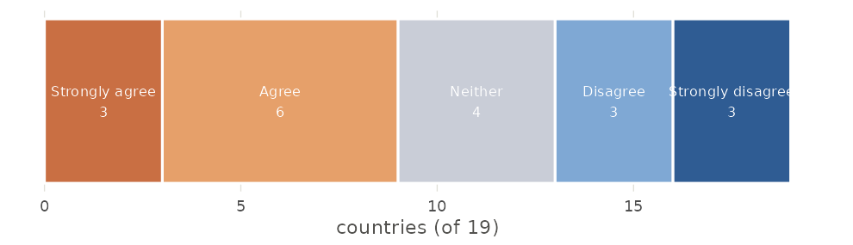
Figure 2. “There is a clear, consistent mechanism to integrate modelling outputs into public-health decisions at my institute” (2024 NFP survey, 19 countries). Source: code/05_figures/fig_respicast_decision.R.
5. The beneficiaries’ own ask is a rival for the budget. The clearest single open comment is not a request to improve RespiCast but to fund national capacity: “An ECDC recommendation for MSs to have adequately resourced and funded national-level modelling capacity … A sustainable European funding mechanism … Supranational modelling is useful, but national-level capacity is required to respond to the needs of each MS.” In least-cost terms this is a challenger to the hub for the same money, and it is the beneficiaries’ stated preference. If 68%-no-modeller is the strongest survey argument for a central forecast, this is the strongest survey argument that the same budget might buy more capability by funding national capacity. Both come from this survey; both belong before the decision.
6. The improvement levers are cost lines, not free upside. The changes the survey points to are “continuation-evolved” levers, each with an owner and non-trivial effort — costs the least-cost test must weigh, not benefits:
Lever the survey points to | Owner | Order-of-magnitude effort / where costed
Plain-language, interpretable outputs for non-modellers | ECDC (hub / comms) | Low–med; recurring editorial
Short training for NFP consumers | ECDC + NFPs | Med; recurring
Published skill / accuracy track-record | ECDC + contributor teams | Med; needs an evaluation pipeline — not a survey deliverable
A mechanism to use forecasts in national decisions | Member states | Med–high; largely a national process cost
National modelling capacity + funding | Member states / EU | High; budget-scale — a strategic alternative (§5), costed elsewhere
7. What this evidence does not speak to. Internal ECDC value (the ERVISS-integration interviews); surge / emergency-response capacity; forecast accuracy or skill (this is stated need and perception, not performance); the contributor community (~9 teams / 28 models — a different population); the hub-versus-simple-forecast cost question (§1); and anything after 2024.
8. Mapping onto the review’s options (considerations, not a recommendation).
- Continuation, as-is — supported only for a central forecast, not specifically for the multi-model hub; engagement modest and possibly near a ~2.7 class ceiling.
- Continuation, evolved — the cheapest well-evidenced lever is closing the awareness/distribution gap among no-modeller countries; interpretability and a decision pathway follow, at cost (§6).
- Descoping (core / modularise / caretaker / transfer) — consistent with the undemanding stated use case (situational awareness; capacity-planning only 16%): a lighter product might serve it. The survey neither rules this in nor out — it does not compare the hub against a simpler forecast.
- Termination — not supported: 68%-no-modeller is a clear need for some central forecast; but “some forecast” is not “this hub”.
- Rival use of funds — the beneficiaries’ own funding ask (§5) is a live alternative for the same budget.
All figures and numbers are generated from the de-identified survey by code/05_figures/fig_respicast_decision.R. Subgroup counts are single digits; percentages are indicative (±~5 points per country) and, given non-response, likely optimistic. A companion comparison — that more NFPs expect both ECDC products to be useful than either alone, with open comments favouring forecasts as more reliable and actionable than long-horizon scenarios — is drawn from a RespiCompass-designed instrument and is not relied on here.

