The National Focal Point survey as evidence for the RespiCast review
A reading of the 2024 NFP survey against the review’s least-cost test — what it does and does not license.
Provenance and scope (read first). Instrument: the 2024 ECDC survey of National Focal Points (NFPs) for respiratory viruses, run by the ECDC Respiratory Viruses & Legionella group and the Modelling team to learn whether and how countries use mathematical modelling to interpret surveillance data and inform decisions, and which outputs they would prefer from ECDC modelling tools; results were presented to the network in October 2024. It is a general modelling survey — not a RespiCast- or RespiCompass-specific evaluation — so the output-preference question (§2a) is in scope, but the instrument reports stated awareness and preference, not measured use. Vintage: fielded in 2024, when RespiCast was ~1 year old; it informs a late-2026 decision, so its figures are ~2 years old. Population: 19 of ~30 NFPs replied — national surveillance / public-health consumers, giving one collective institutional position per country (the respondent need never have opened a forecast). They are not the contributor modelling network (~9 teams / 28 models) and not the website-user survey (results due November); those three must not be conflated. Non-response: 19 of ~30 is not random — the absent ~11 plausibly skew less aware/engaged, so the figures here are, if anything, optimistic; every share moves ~5 points per country and subgroup counts below are single digits. The governing question: the review asks not only what value RespiCast has and could have, but whether that value could be had more cheaply. A benefit counts toward continuation only where the survey gives reason to think a cheaper route would not deliver it.
1. What the survey licenses — and the gap where the cost sits. The strongest finding is a need: 13 of 19 institutes (68%) have no in-house mathematical modeller, and only one has a team above five (Figure 1). That is clear evidence ECDC should provide some central forecast. It is silent on the question that carries the cost — whether that forecast must be a ~28-model community ensemble on a hubverse platform rather than a single centrally-run model. The survey cannot compare the two, and that silence is itself decision-relevant. It sharpens against the stated use: the activity NFPs most expect modelling to inform is situational awareness (surveillance, 58% “likely”), while the demanding forecasting use case — healthcare-capacity planning — is the one they expect least (16% “likely”; 42% “unlikely”). An undemanding use case is one a much simpler product might serve adequately. What a multi-model ensemble buys over a simple central forecast, for situational awareness, the survey cannot say — and should not be read to.
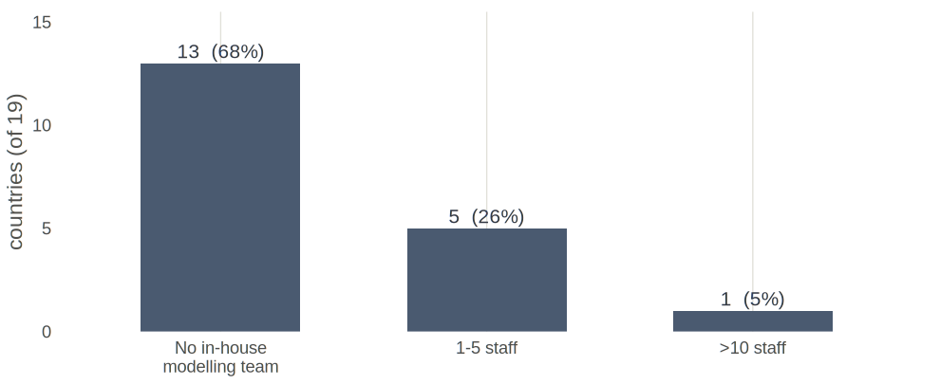
Figure 1. In-house mathematical-modelling staff at the national institute (2024 NFP survey, 19 countries). Source: code/05_figures/fig_respicast_decision.R.
2. Awareness — not use — and it is thinnest where the need is greatest. Q5 asked “how aware are you of respiratory virus burden modelling work done at ECDC?”, rated 0–5 on a slider per output. It measures awareness, not use — a distinction the first draft of this note blurred and this version corrects. Awareness of RespiCast averages 2.1 / 5 (18 countries) and is not higher where in-house capacity is absent: no-modeller countries average 2.08 (n = 13), those with a team 2.2 (n = 5). The review’s discriminator — do the RespiCast-unaware cluster among the no-modeller countries? — lands cleanly, at small n: all three institutes entirely unaware of RespiCast have no modelling team; every country with any in-house capacity was aware. So the awareness gap sits exactly where the need is greatest — a distribution / communications gap, cheap to close, favouring continuation-evolved. What the survey cannot say is whether closing it converts into use: Q5 is awareness only, and the sole evidence on actual use is the open text (§5), where several institutes state they have not yet used the outputs. Awareness is a necessary, not a sufficient, condition for value.
2a. The preference question (in scope, this time). The survey explicitly asked which outputs NFPs would prefer, so the forecasts-vs-scenarios comparison is a legitimate finding, not a by-product: 15 of 19 (79%) expect RespiCast to be useful, and among those who chose a single output, forecasts were preferred to scenarios 5:1. In least-cost terms this supports ECDC providing a central forecast in preference to a scenario product — it says nothing about whether that forecast must be the multi-model hub.
3. The low score is largely recency. Awareness tracks how long an output has been in circulation: guidance documents (since 2020) sit at 3.9, the COVID-era hubs at ~2.7, RespiCast (2023) at 2.1 and RespiCompass (2024) at 1.35 — newest, least known. So RespiCast’s low awareness is substantially a recency and communication-reach effect, not a signal about its value or use; closing the gap (cheap comms) would move it toward the level of the older, better-known outputs. Even this awareness reading is ~2 years stale.
4. The realised-value ceiling: a route into decisions. Independent of the product, only 9 of 19 institutes (48%) report a clear mechanism to integrate modelling into public-health decisions; 6 (32%) disagree (Figure 2). This caps what any forecast can achieve nationally. Whether ECDC helping to close it is cheap or a cost carried elsewhere is a cost question (§6), not free upside.
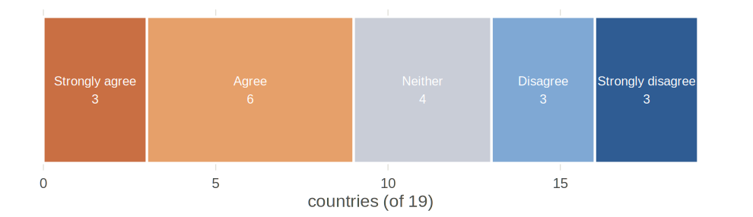
Figure 2. “There is a clear, consistent mechanism to integrate modelling outputs into public-health decisions at my institute” (2024 NFP survey, 19 countries). Source: code/05_figures/fig_respicast_decision.R.
5. The beneficiaries’ own ask is a rival for the budget. The clearest single open comment is not a request to improve RespiCast but to fund national capacity: “An ECDC recommendation for MSs to have adequately resourced and funded national-level modelling capacity … A sustainable European funding mechanism … Supranational modelling is useful, but national-level capacity is required to respond to the needs of each MS.” In least-cost terms this is a challenger to the hub for the same money, and it is the beneficiaries’ stated preference. If 68%-no-modeller is the strongest survey argument for a central forecast, this is the strongest survey argument that the same budget might buy more capability by funding national capacity. Both come from this survey; both belong before the decision.
6. The improvement levers are cost lines, not free upside. The changes the survey points to are “continuation-evolved” levers, each with an owner and non-trivial effort — costs the least-cost test must weigh, not benefits:
Lever the survey points to | Owner | Order-of-magnitude effort / where costed
Plain-language, interpretable outputs for non-modellers | ECDC (hub / comms) | Low–med; recurring editorial
Short training for NFP consumers | ECDC + NFPs | Med; recurring
Published skill / accuracy track-record | ECDC + contributor teams | Med; needs an evaluation pipeline — not a survey deliverable
A mechanism to use forecasts in national decisions | Member states | Med–high; largely a national process cost
National modelling capacity + funding | Member states / EU | High; budget-scale — a strategic alternative (§5), costed elsewhere
7. What this evidence does not speak to. Actual use / uptake (Q5 is awareness; only the open text touches use); internal ECDC value (the ERVISS-integration interviews); surge / emergency-response capacity; forecast accuracy or skill (this is stated awareness, need and preference, not performance); the contributor community (~9 teams / 28 models — a different population); the hub-versus-simple-forecast cost question (§1); and anything after 2024.
8. Mapping onto the review’s options (considerations, not a recommendation).
- Continuation, as-is — supported only for a central forecast, not specifically for the multi-model hub; awareness modest and, given recency, likely to rise only toward the ~2.7 level of the older outputs.
- Continuation, evolved — the cheapest well-evidenced lever is closing the awareness/distribution gap among no-modeller countries; interpretability and a decision pathway follow, at cost (§6).
- Descoping (core / modularise / caretaker / transfer) — consistent with the undemanding stated use case (situational awareness; capacity-planning only 16%): a lighter product might serve it. The survey neither rules this in nor out — it does not compare the hub against a simpler forecast.
- Termination — not supported: 68%-no-modeller is a clear need for some central forecast; but “some forecast” is not “this hub”.
- Rival use of funds — the beneficiaries’ own funding ask (§5) is a live alternative for the same budget.
All figures and numbers are generated from the de-identified survey by code/05_figures/fig_respicast_decision.R. Subgroup counts are single digits; percentages are indicative (±~5 points per country) and, given non-response, likely optimistic. The open comments add that forecasts are seen as more reliable and actionable than long-horizon scenarios — consistent with the §2a preference — but remain qualitative signal, not measured use.

