*DKE Self-assessment reflection form*

This self-assessment reflection form is focused on the team-dynamics processes in your second project-team period (March-June), with regard to both your individual (part A) and your teams’ experiences (Part B & C). These last few months have been a very special period characterized by a worldwide lockdown in which most of you went back home. Adapting to these new circumstances, next to not being able to physically meet as a team, dealing with bad internet, different time zones or even governmental restrictions are some huge extra challenges for your team, next to the usual dynamics in communicating and collaborating together to get things done.

Please, *reflect and fill out Part A, the individual part*, and *bring it with you* to the online team dynamics skill class”in June 2020*.* You can use this form to answer the questions, or use a separate document.

This is an important exercise for yourself to reflect on what you have learned and experienced and where there is room for improvement in your behaviour, communication or collaboration skills in future projects. It is also important to be able to reflect on your individual experiences with your group, which we will do in the online skill class. Therefore, please prepare this well. Note that coming unprepared is not only disrespectful to others, but also to yourself. As we feel this is a really important part of drawing lessons from this project period, not preparing means risking your attendance requirement for this skills class.

In the online skills class you will share and reflect on your individual answers (part A) with your team members in a breakout room. Then you will reflect and discuss on Part B & C together and write up your answers. You also prepare a short 3-minute pitch about the main lessons learned by the team as a whole (Part C). When we come back to the main room, all teams will give their 3 minute pitch to each other.

*After the online meeting, each team sends their answers of Part B & C to their project tutor* that very day.

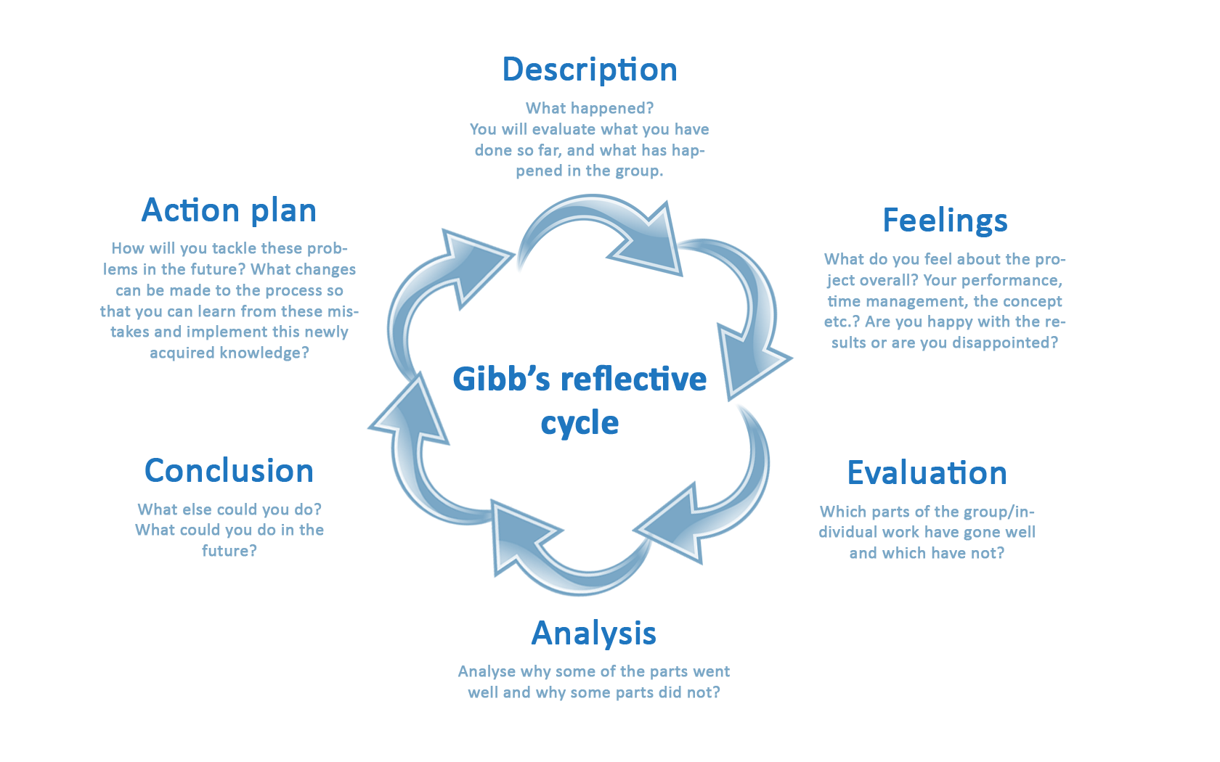This form is based on Gibb’s reflective cycle to help you explore, reflect and analyse your individual and team experiences in DKEs projects.

|  |  |
| --- | --- |
|  | **PART B. Team** |
| **Description** | 2. How have these special circumstances affected your  a) team motivation  b) team cooperation  c) team communication processes so far? |
| a) We were less motivated, since we had a lot of work and couldn’t come together. We had to do the numerical mathematics course which also worsened our motivation, partially because of the amount of work and stress it caused.  b) Team cooperation was still pretty good, even tough we couldn’t meet in real life, we still communicated online. It was less efficient than it would have otherwise been, but still decent.  c) Team communication was still pretty good, even tough we couldn’t meet in real life, we still communicated online. It was less efficient than it would have otherwise been, but still decent. |
| **Feelings** | 4. How do you feel about  a) the teams overall performance?  b) the collaboration in the team?  c) the communication in the team? |
| a) It was decent, but we didn’t always stick to the planning. This caused some of the work to be discontinued and some features to be half-baked.  b) It had a few problems, since we didn’t always stick to the planning. Because of this we couldn’t always work on the things that were planned, because the dependencies weren’t finished.  c) The communication was reasonably good. We had fun during the meetings, while still communicating about our progress and difficulties. However the group wasn’t always informed about delays in time. |
| **Evaluation** | 6. Which parts of the group work have gone well and which have not? |
| a) Communication mostly went well, but some work was done late. When someone was having trouble, they communicated it properly. The main problem was that we couldn’t spent enough time on the project, causing delays. |
| **Analysis** | 8. What is your analysis on *why* certain parts of the group a) collaboration, b) work and c) communication went well, and other parts didn’t? |
| They were very interlinked and had the same problems. There isn’t really a sizeable difference in how well they went. |
| **Conclusion** | 10. a) What *could* have been done by your team in order to prevent what did not go well?  b) What kind of support from within the team would have been helpful in this?  c) What kind of support of your tutor would have been helpful in this? |
| a) Stick to the planning more and for some to notify the group earlier when something is behind schedule.  b) The teammates that didn’t stick to the planning could stick to the planning more.  c) Ask more questions to people who were responsible for tasks that weren’t completed in time (and hold them more accountable). |
| **Action plan/Lessons learned/ ‘take aways’ from this experience** | 12.What are the three most important things that you learned as a team from this experience?  a) Everyone should stick to the planning  b) Everyone who is behind on the planning should notify the team ASAP  c) DKE is messed up |
|  |

ADDITIONAL NOTES

Because we had a course that took a lot of time and had very poor explanation/classes, we didn’t have enough time to work on the project. This combined with Corona caused us to have a way harder time trying to complete the project than what would be reasonable. We feel like DKE could have helped us more, possibly by reducing the amount of work for phase 3 of the project or giving us more time (instead of even less).