Minutes for meeting on 17-03-2020

Project: 1-2 Crazy Putting

Date: 17/03/2020

Group number: 4

Group members: René Steeman, Aaron Schapira, Ivan Poliakov, Jean Janssen, Matthijs Kusters, Hoaran Luan

Attendants: René Steeman, Aaron Schapira, Ivan Poliakov, Jean Janssen, Matthijs Kusters, Hoaran Luan

Chair: Aaron Schapira

Secretary: Matthijs Kusters

1. Opening at 10:14.
2. State of the project:
3. Completed tasks/milestones since last project meeting.

Finished: basic terrain, 3D ball and flag, main menu.

In progress: improved terrain, function parser, physics, in-game UI, resetting the ball after hitting water, course input-output module, game modes, course designer.

1. Planning:
2. improved terrain, function parser, physics, in-game UI, resetting the ball after hitting water, course input-output module, game modes, course designer.
3. Everyday we ‘meet’ at 9:00 to talk about what we’ll do that day and the progress so far and there’ll also be a short meeting at 19:00 about our progress that day.
4. Planning of the complete phase:

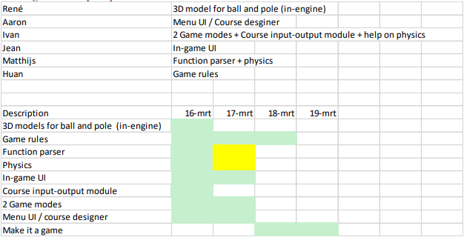

1. Any other business:
   1. Q1: What is being meant by game rule 2?

A1: Reference [1]: picture of rules ([usga.org/content/usga/home-page/rules/rules-2019/rules-of-golf/rules-and-interpretations.html#!ruletype=pe&section=rule&rulenum=17](https://www.usga.org/content/usga/home-page/rules/rules-2019/rules-of-golf/rules-and-interpretations.html#!ruletype=pe&section=rule&rulenum=17))

Q2: Clarification of the course input:

A2: Follow structure of example-course. More specification of file? Examiners: “Specify API, then it’s fine.”

Q3: Are we allowed to use a very small ‘dx’

A3: See literature. Can use small ‘dx’. Be aware that it’s an approximation, thus it’s an error and should be explained.

Q4: Ball always slides on top of the terrain.

A4: IRL ball rolls, but now it slides over the terrain without rolling. We don’t have to consider these motions of the ball.

* 1. From tutor *(remark: you do not need to fill this section out, reserve 3 minutes for that)*
* Presentation: 10 minutes to present, 5 minutes questions, 5 minutes buffer time.
* Talk with each other who is going to host the presentation; manage when person has to click, etc.
* To share presentation:
  + Blackboard room: share content 🡪 screenshare.
* Planning of each phase at the beginning of each phase, starting from phase 2.
  + No grading for phase 2, but feedback.
  + Planning of phase 3 is held account for grading.

1. Chair/Secretary for the next meeting. Chair: René Steeman; Secretary: Jean Janssen.
2. Closing at 10:39