Integrating Jurisdictions, Dividing Workers: Consolidation, Labor Markets, and the Migrant-Local Wage Gap in China
____________________________________________________________
研究人员基于中国流动人口动态调查的个体数据，使用差分中的差分方法，研究了中国的市县合并如何重塑地方劳动力市场。研究发现：市县合并使本地居民工资增加10.4%（P8-"increased the wages of local residents by a substantial 10.4%"）；外来务工人员工资增加3.1%（P8-"migrant workers rose by only 3.1%"）。合并改革还导致了经济增长和实际工资的增加（P8-"reforms led to local economic growth and real wage increases"）。机制上，合并后地方经济通过改善连接性、增强税收执法和扩大服务获取得到加强（P2-"connectivity improved, tax enforcement became more effective, and access to local services expanded"）。

附录：提取的图表/图片
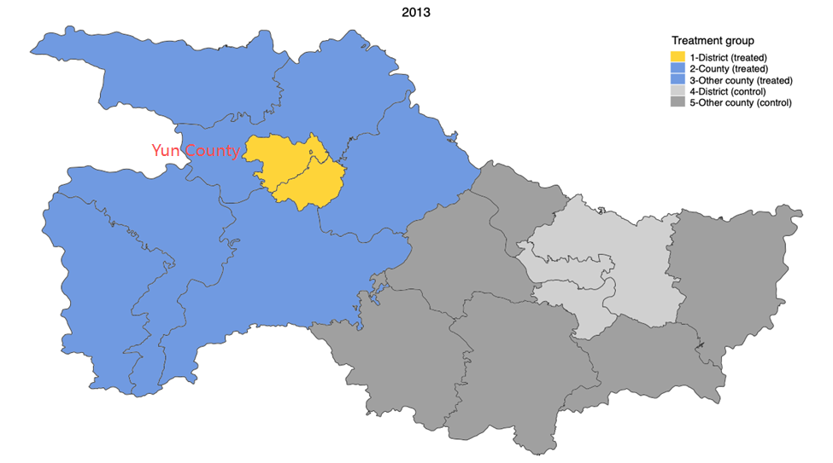
文件: img_60d6d4523079.png

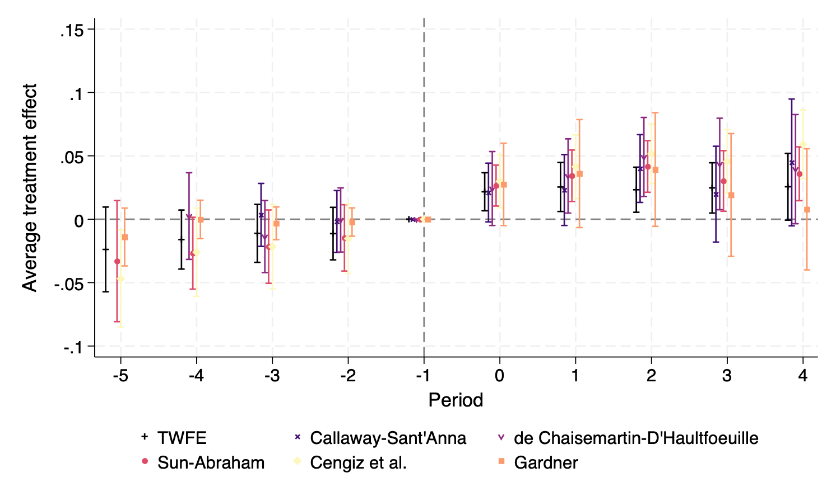
文件: img_ba633b3f5416.png

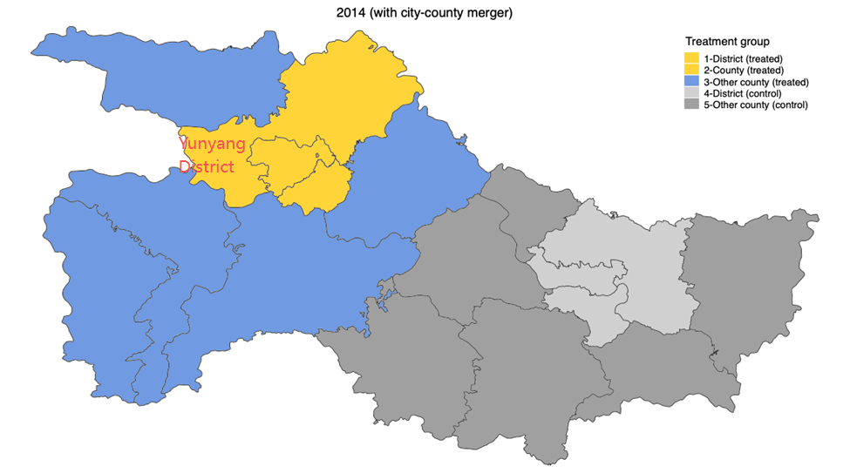
文件: img_05c70a53196f.png

