# Connectors

## Sense & Supply Module <-> Raspberry Pi 3

Sense & Supply Module ist am auf der linken Seite des Gehäuses und der Rasperry Pi auf der rechten Seite (direkter Anschluss für USB, Ethernet). Beide Boards warden durch ein 40 Pin Flachbandkabel verbunden. (Achtung 50pin stecker) <https://www.te.com/deu-de/product-1-5103311-0.html>

<https://www.raspberrypi.org/documentation/usage/gpio/README.md>

Pinseite Bohrloch

|  |  |  |  |
| --- | --- | --- | --- |
| 1 | 3.3V | 5V | 2 |
| 3 | GPIO2 (Data) | 5V | 4 |
| 5 | GPIO3 (Clock) | GND | 6 |
| 7 | GPIO4 | GPIO14 (TX) | 8 |
| 9 | GND | GPIO15 (RX) | 10 |
| 11 | GPIO17 | GPIO18 | 12 |
| 13 | GPIO27 | GND | 14 |
| 15 | GPIO22 | GPIO23 | 16 |
| 17 | 3.3V | GPIO24 | 18 |
| 19 | GPIO10 (MOSI) | GND | 20 |
| 21 | GPIO9 (MISO) | GPIO25 | 22 |
| 23 | GPIO11 (SCLK) | GPIO8 (CE0) | 24 |
| 25 | GND | GPIO7 (CE1) | 26 |
| 27 | ID EEPROM | ID EEPROM | 28 |
| 29 | GPIO5 | GND | 30 |
| 31 | GPIO6 | GPIO12 | 32 |
| 33 | GPIO13 | GND | 34 |
| 35 | GPIO19 | GPIO16 | 36 |
| 37 | GPIO26 | GPIO20 | 38 |
| 39 | GND | GPIO21 | 40 |

## PULP module <-> Sense & Supply Module

Auf der linken Seite einfach einstecken.

1. Leiterplatte-an-Leiterplatte

<https://www.te.com/deu-de/product-1734099-6.html>

Stabil genug?

1. Header Stecker wie bei Rasperry Pi

Stiftleiste gewinkelt am Sense & Supply Module

Buchse am PULP Module

## ON/OFF <-> PiJuice HAT

Wie stellt man den PiJuice HAT ab?

## PiJuice HAT <-> Raspberry Pi 3 <-> Touchscreen

Vorgegebene Stecker

## JTAG??

USB -> USB-OCD -> Sense Module

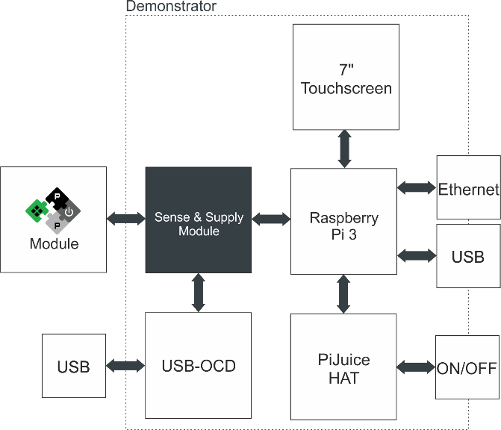

Fig. 1 Block diagram PULP demonstrator

# Sense & Supply Module

## Pinbelegung Stecker zu Rasperry Pi

|  |  |  |  |
| --- | --- | --- | --- |
| 1 | 3.3V | 5V | 2 |
| 3 | SDA | 5V | 4 |
| 5 | SCL | GND | 6 |
| 7 | GPIO4 | GPIO14 (TX) | 8 |
| 9 | GND | GPIO15 (RX) | 10 |
| 11 | GPIO17 | GPIO18 | 12 |
| 13 | GPIO27 | GND | 14 |
| 15 | GPIO22 | GPIO23 | 16 |
| 17 | 3.3V | GPIO24 | 18 |
| 19 | MOSI | GND | 20 |
| 21 | MISO | GPIO25 | 22 |
| 23 | SCLK | CE0 | 24 |
| 25 | GND | CE1 | 26 |
| 27 | NC | NC | 28 |
| 29 | GPIO5 | GND | 30 |
| 31 | GPIO6 | GPIO12 | 32 |
| 33 | GPIO13 | GND | 34 |
| 35 | GPIO19 | GPIO16 | 36 |
| 37 | GPIO26 | GPIO20 | 38 |
| 39 | GND | GPIO21 | 40 |

I2C

JTAG?

## Pinbelegung Stecker zu PULPModule

Versorgungsspannungen: Obere Pins

Spannungsmessung, Strommessungen: mittlere Pins

JTAG, ID: untere Pins

Weshalb MUX bei I2C? → **replace mux with bidirectional i2c level shifter such as PCA9306, allows to use pulp or rpi as a master…. Good job, Philipp**

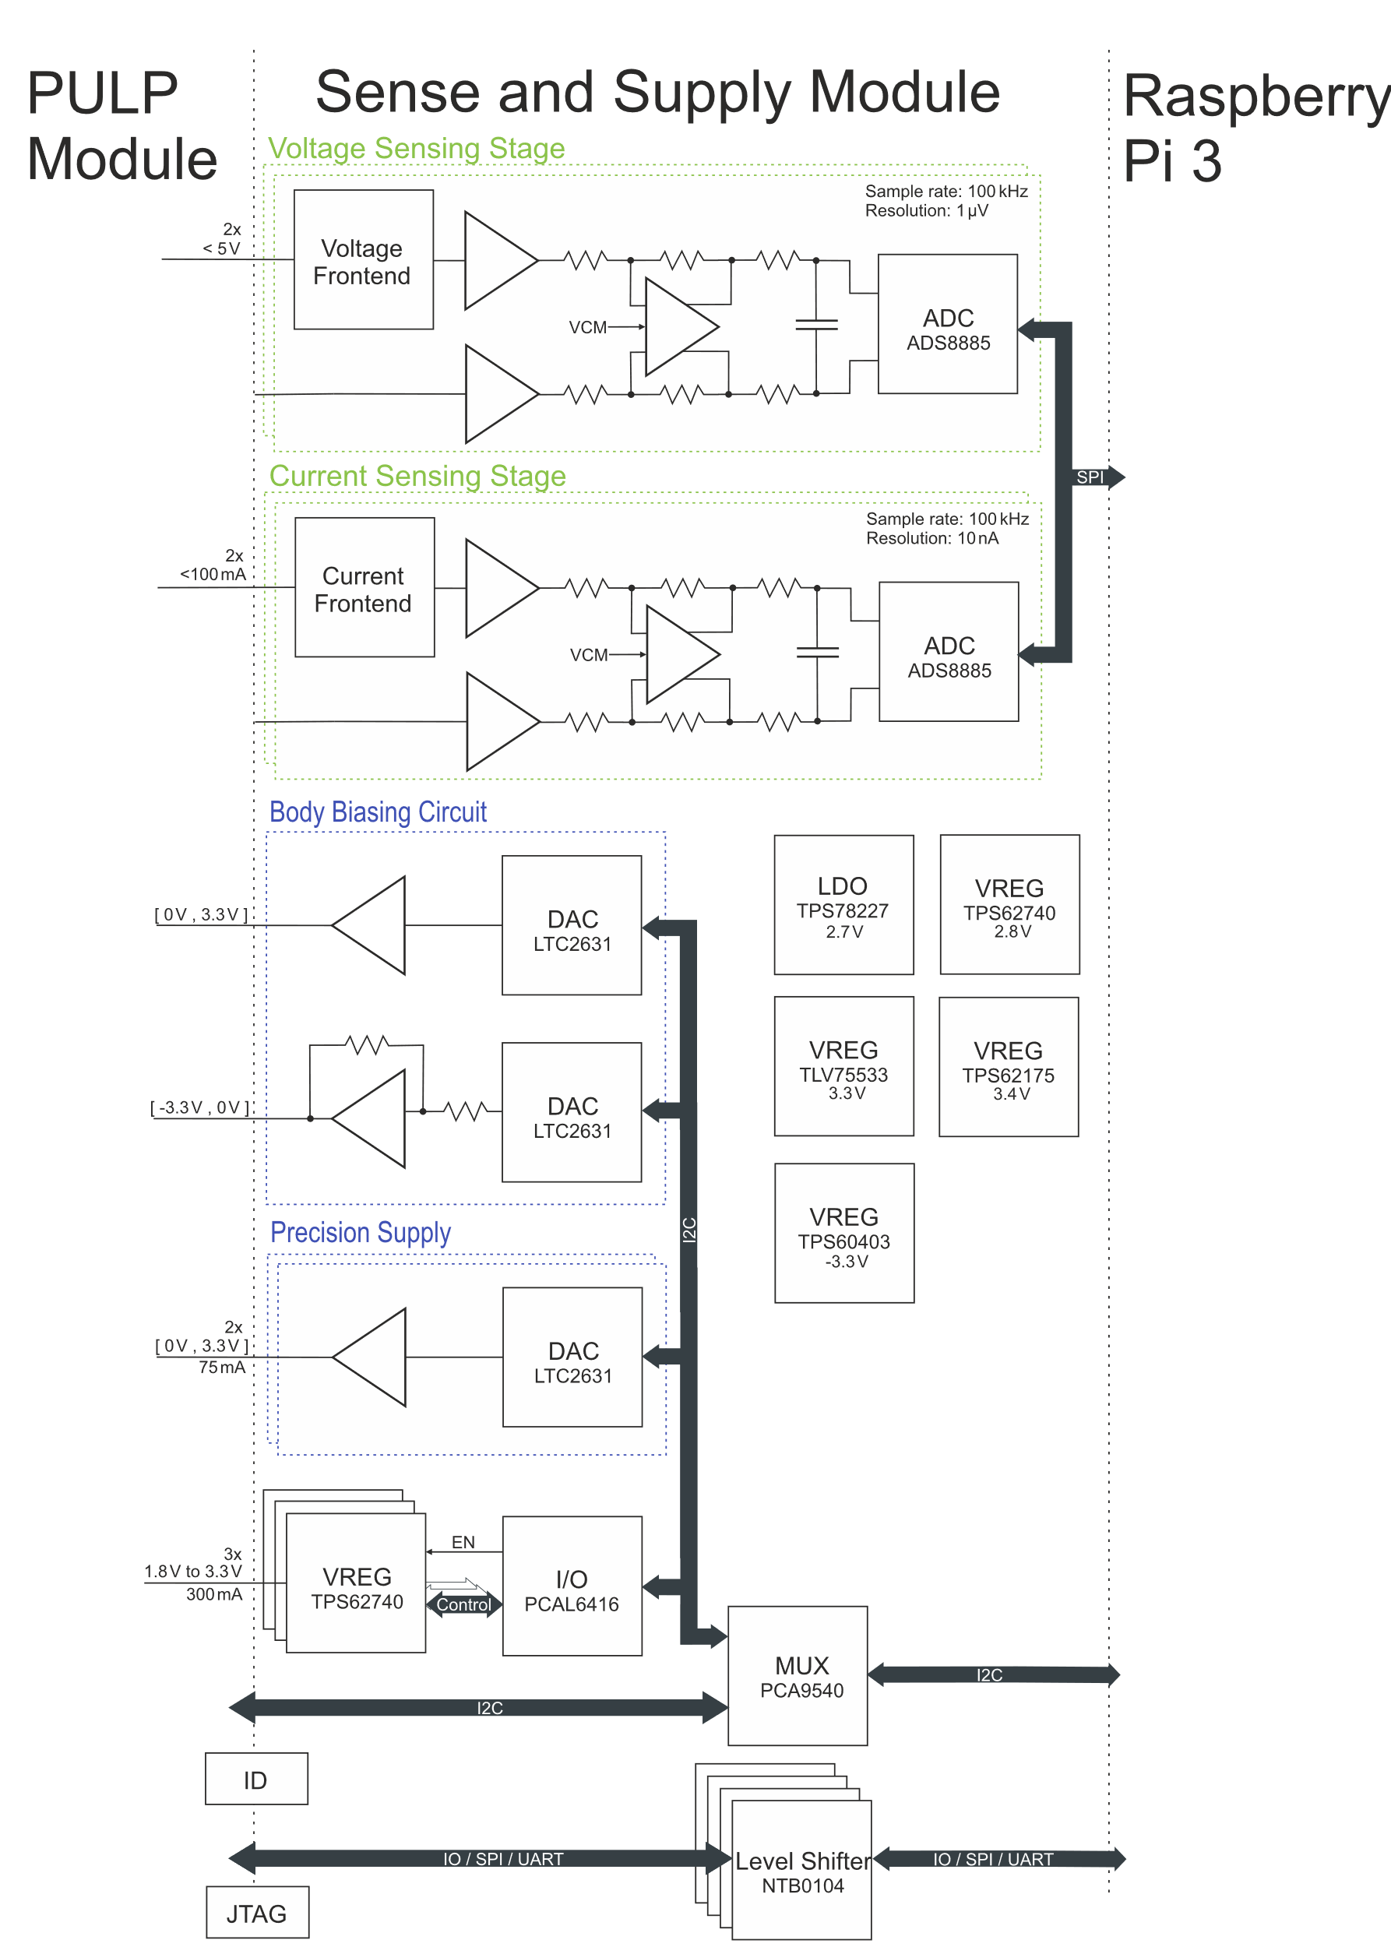

Fig. 2 Block diagram Sense and Supply module.

# Voltage Front End

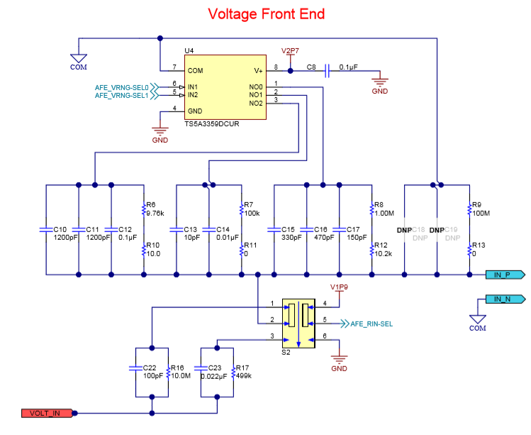Beim TIDA-01012 kann man zwischen vier verschiedenen Ranges auswaehlen: 50V, 5V, 500mV und 50mV. Mit dem TS5A3359 wird die Range eingestellt.

VOLT_IN wird mit einem Spannungsteiler skaliert, sodass IN_P auf ca. 50mV ist. Fuer 50mV wird der Strang mit 100MOhm gewaehlt. Fuer 500mV die Straenge mit 100MOhm und 1.0102MOhm in parallel.

Die 50mV werden mit dem fullz differential amplifier THS4531 um 44.2 verstaerkt. So wird die Referenzspannung des ADC 50mV*44.2 ~= 2.2V erreicht.

# ADC

## Anti aliasing filter

## 

# LTC2631

FSE

|  |  |  |  |  |  |  |
| --- | --- | --- | --- | --- | --- | --- |
| Symbol | Parameter | Conditions | LTC2631-12 | | |  |
|  |  |  | MIN | TYP | MAX | UNITS |
| FSE | Full-Scale Error | Vcc=3V, Internal Ref. (Note 14) |  | +- 0.08 | +-0.4 | %FSR |

Note 14: Full-scale error is determined using the reference voltage measured at the REF pin.

Similarly, limiting can occur near full-scale when the REF pin is tied to VCC. If VREF = VCC and the DAC full-scale error (FSE) is positive, the output for the highest codes limits at VCC, as shown in Figure 5c. No full-scale limiting can occur if VREF is less than VCC – FSE.

# ADS8885

## Digital Interface

The ADS8885 can work either in a 3- or 4-wire interface. There is a busy indicator which allows the ADS8885 to indicate a new datatransmition.

## 4-Wire CS Mode Without a Busy Indicator

As the datasheet says: This interface option is useful when one or more ADCs are connected to an SPI-compatible digital host.

# Raspberrry Pi

## SPI

There are multiple chips connected as slaves to the master. To provide proper data transmission one has to select the appropriate chip. This can be done by the Pins CE0 and CE1. Unfortunately, there are more then to SPI slaves to select therefore GPIO Pins will be used to select the appropriate chip by setting the Pin to low before doing the transmittion.

# References

Datasheet ADS8885 05.03.2019 <http://www.ti.com/lit/ds/symlink/ads8885.pdf>

SPI Docum Raspberry PI 05.03.2019 <https://www.raspberrypi.org/documentation/hardware/raspberrypi/spi/README.md>

LTC2631CTS8-LZ12#TRMPBF