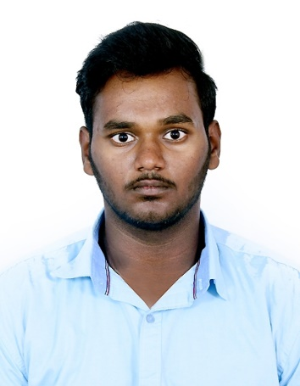

**RENGASAMY B**

**+91 6382665198**

E-mail Id:ranganaveen@gmail.com

# LinkedIn ID: https://www.linkedin.com/in/rengasamy-b-1435a2249/

**SUMMARY:**

I'm pursuing B.TECH-Artificial Intelligence & Data Science at Karpagam Academy Of Higher Education .I'm curious to develop my skills in Data Science and it's branches .It’s a field where insides are predicted with analyzation of data for a particular problem

**SKILL HIGHLIGHTS:**

* Front end development

HTML,CSS

* Computer programming
* Data Visualisation Tools

Tableau

# INTERNSHIP:

# Python Period of 30 days (June ,2022)

**Pantech e learning PVT LTD , Chennai.**

Python is a popular Object Oriented Programming Language .Python plays huge role in the Data Science field for analysis of data . High level programming language with Dynamic Semantics.

# +EDUCATION QUALIFICATION:

|  |  |  |  |  |
| --- | --- | --- | --- | --- |
| **DEGREE** | **DISCIPLINE** | **INSTITUTION** | **COUNTRY** | **YEAR OF PASSING/PERCENTAGE** |
| B. Tech | AI&DS | Karpagam  Academy of Higher Education | INDIA | 2025  (pursuing)  CGPA-7.83 |
| HSC | Bio-Maths | Sivakasi Hindu Nadar  Victoria  Higher Secondary  School | INDIA | 2021  78.3% |
| SSLC | __ | Sivakasi Hindu Nadar  Victoria  Higher Secondary  School | INDIA | 2019  69.8% |

# CERTIFICATE:

* Certified in ‘Data Analysis using Python’ from Infosys Springboard in 2022
* Certified in ‘Tableau’, Data visualization tool for attending from Karpagam Academy of Higher Education

* Certified in ‘Python’ from Pantech e learning PVT LTD
* Certified in ‘Cloud Computing’ from NPTEL Online Certification
* Certified in ‘Warehouse Management’ from Infosys Springboard in 2022
* Certified in ‘Exel Basics for Data Analysis’from Infosys Springboard in 2022
* Certified in ‘Introduction of C’ from Solo learn in 2023
* Certified in ‘Learning C’ from Linked in

# AREA OF INTEREST:

* Data Analysis
* Data Scientist
* Data Visualization
* Programming

# TECHNICAL SKILLS:

* C(Basic)
* Python(Basic)
* SQL(Basic)

# SOFT SKILLS:

* Leadership
* Decision Making
* Punctual
* Communication
* Adaptability

# LANGUAGES KNOWN:

* English
* Tamil

# PERSONAL DETAILS:

Address : 3/19 E.S.I Street Pernayakanpatti,Sivakasi-626189

Father’s Name : BABU S

Date of Birth : 10/ 06/ 2004

# DECLARATION:

I hereby declare that all above mentioned information is in accordance with factor truth upto my knowledge.

Rengasamy B