Multi-Agentic AI System
MSIG Exercise - Project Summary
Repository: github.com/rengan76/multi-agentic-ai
Date: June 3, 2026

1. Project Overview
We built a multi-agent AI workflow system that demonstrates how AI agents can collaborate following a structured rulebook to automatically generate full-stack applications. The system showcases the concept behind MSIG's "Nebula" framework — where AI agents take on specific roles (Product Manager, Architect, Developer, QA) and follow a gated pipeline to produce software.
Key Concept: Instead of manually guiding AI through the same workflow every session, we define the workflow ONCE as code. Agents follow rules, produce artifacts, and pass quality gates before the next step begins.

2. What We Built

2.1 Agent Workflow Engine
A Node.js/Express system with 4 AI agents working in sequence:
Product Manager → 🚪 Gate → Architect → 🚪 Gate → Developer → 🚪 Gate → QA → ✅ Done
Agent Role | Responsibility | Produces | Cannot Do
Product Manager | Define WHAT to build | requirements.json, stories.json | Write code, pick technology
Architect | Design HOW to build it | api-design.json, data-model.json | Change requirements, write code
Developer | Write the actual code | routes, controllers, models | Change requirements/architecture
QA | Test everything works | test-results.json | Change code or requirements

2.2 The Rulebook
A configuration file that defines:
- Roles — What each agent can and cannot do
- Workflow — The ordered steps (1→2→3→4)
- Gates — Quality checkpoints between each step

2.3 Generated Application
When the agent pipeline runs, it automatically generates:
- tasks-routes.js — A fully functional Express REST API (GET, POST, DELETE)
- server.js — Express server with CORS and API endpoints
- build-summary.json — Metadata showing what was built and why

2.4 React Frontend (Viewer UI)
A React + Vite frontend with 3 tabs:
Tab | Purpose
Rulebook & Workflow | Visual pipeline diagram, agent roles, gates
Tasks Manager (Live) | Live CRUD interface against the Express API
Build Summary | User stories, endpoints, generated files, test results

3. Project Architecture
msig-exercise/
├── mini-app/
│ ├── rulebook.js ← Agent roles, workflow, gates
│ ├── agents.js ← Agent implementations
│ ├── run.js ← Workflow runner
│ ├── frontend/ ← React + Vite UI
│ │ └── src/components/ ← RulebookView, TasksManager, BuildSummary
│ └── generated-app/ ← Output from agent pipeline
│ ├── server.js
│ ├── tasks-routes.js
│ └── build-summary.json

4. Screenshots
(Insert your screenshots below each heading)

4.1 Rulebook & Workflow View
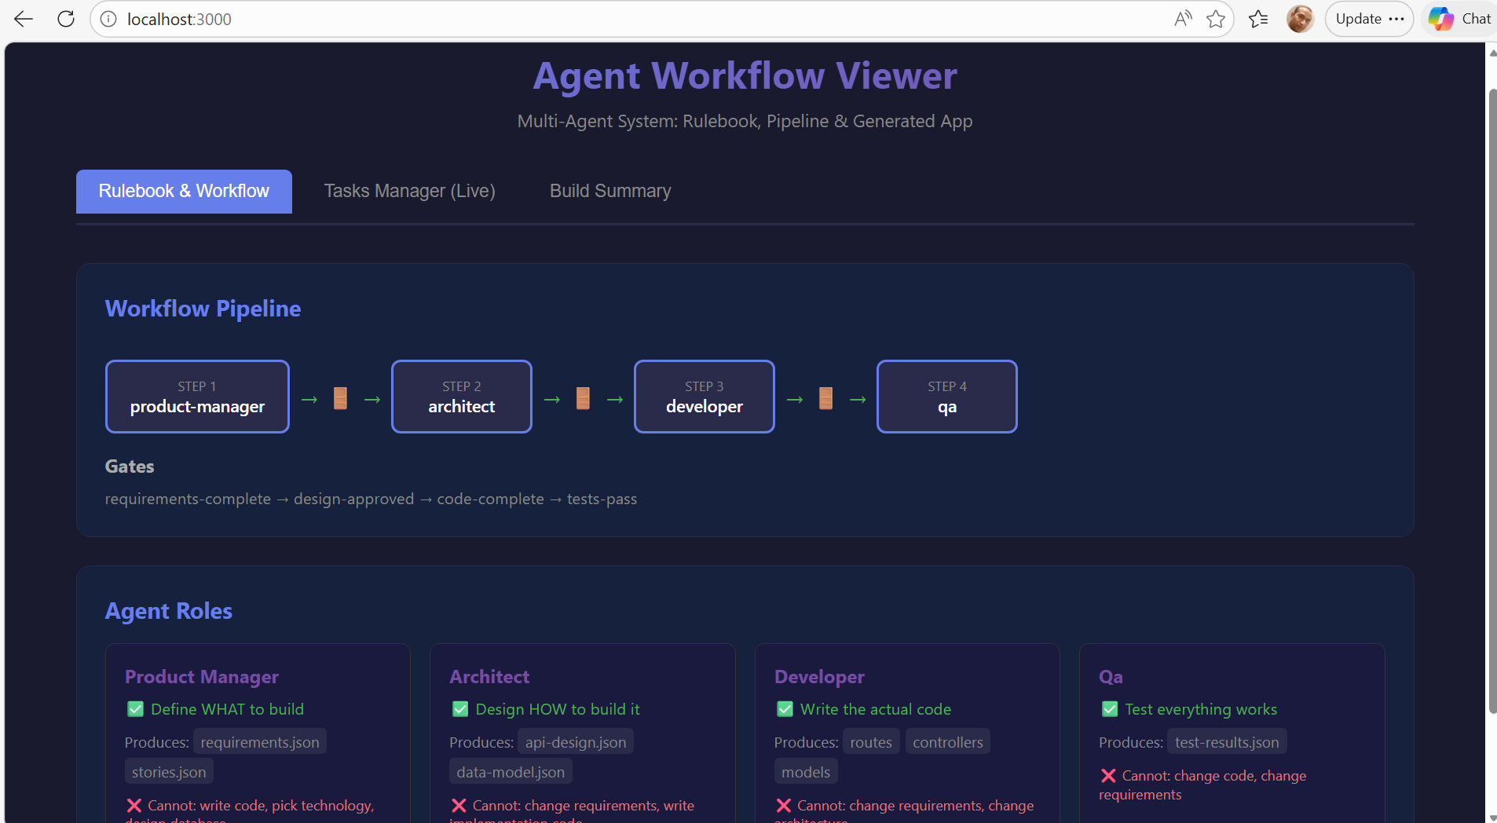

4.2 Tasks Manager (Live CRUD)
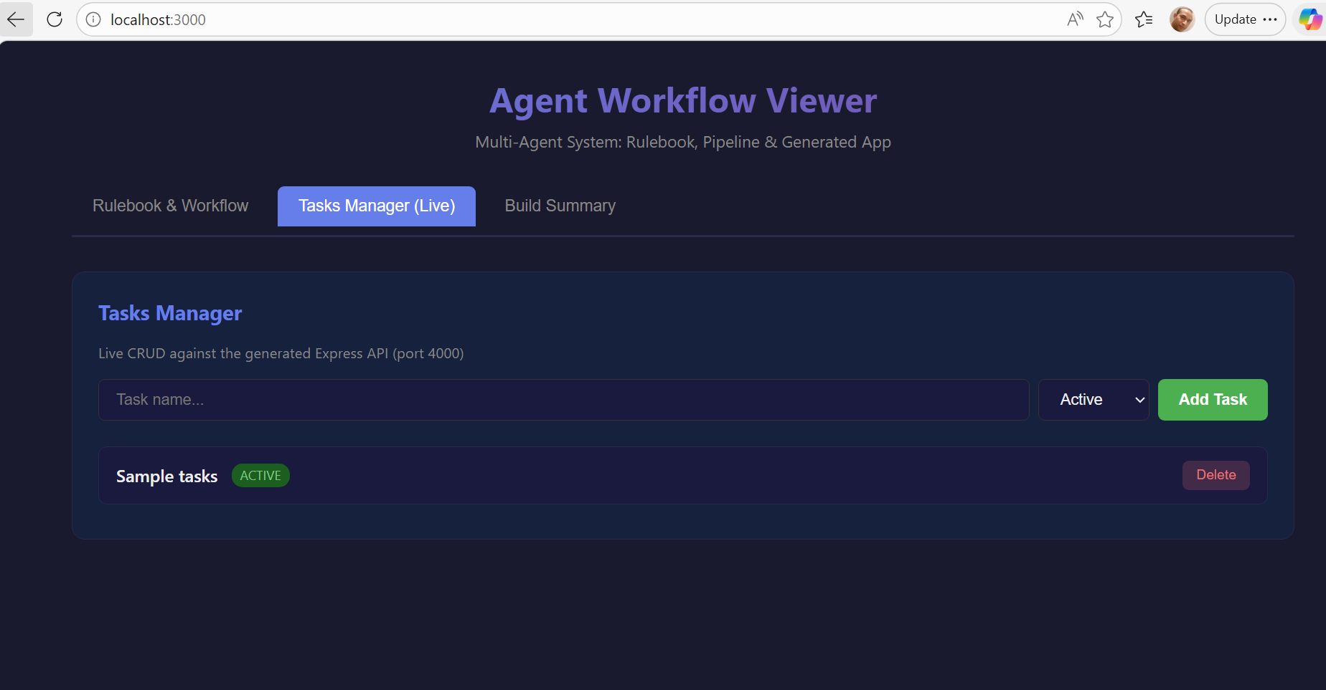

4.3 Build Summary

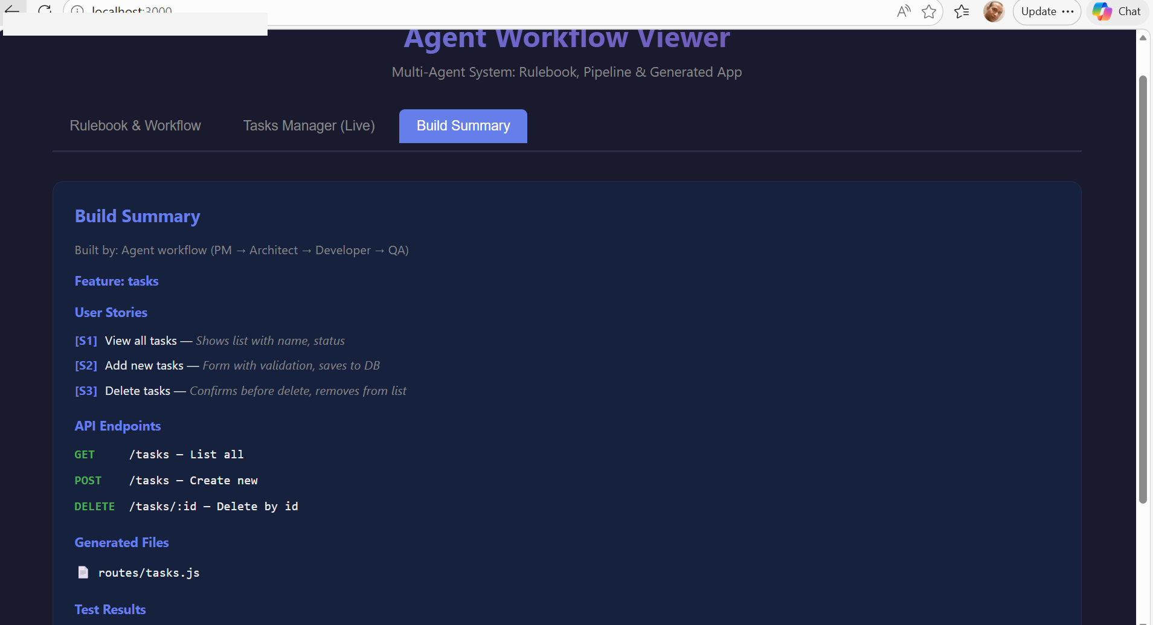

5. How to Run
# 1. Clone the repo
git clone https://github.com/rengan76/multi-agentic-ai.git
cd multi-agentic-ai/msig-exercise/mini-app

# 2. Run the agent pipeline
node run.js

# 3. Start the backend
cd generated-app && node server.js # → http://localhost:4000

# 4. Start the frontend (new terminal)
cd ../frontend && npm install && npx vite # → http://localhost:3000

6. Key Takeaways
- Why agents? Eliminates repetitive AI sessions; workflow is codified once and reused
- Why gates? Prevents coordination failures (code that compiles but doesn't match the spec)
- Why role boundaries? Each agent can ONLY do its job — ensures separation of concerns
- Real-world basis: Based on MSIG's Nebula framework for enterprise software delivery

7. Technologies Used
Node.js • Express • React 18 • Vite • JavaScript

