1. Write a program that will count the most used word in a file. It should accept the name of a file to read from and print out the word that was most common along with the number of times that word appeared in the file.
2. Write a program that will accepts a zipfile and prints out all of the file names and the their sizes. For example, if I were to zip the directory “Dropbox” and give the name to the program it should print out the following:

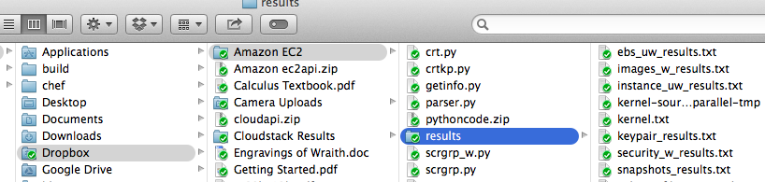

Calculus Textbook.pdf 869 bytes

cloudapi.zip 2.4MB

Engravings of Wraith.doc 4.2MB

Getting Started.pdf 2.3MB

Crt.py 3.2KB

Crtkp.py 3.2KB

Getinfo.py 3.9KB

….

Ebs_uw_results.txt 5.2KB

Images_w_results.txt 1.2KB

Instance_uw_results.txt 2.2KB

….

Snapshots_results.txt 1.2KB

1. Write a program that takes in a decimal whole number and returns the number in hex and binary.
2. Write a program that accepts a file input and assigns a numerical value position to a letter in the alphabet (ignoring case) and adds up the total of each letter in a sentence, printing out the sentence and value with the highest numerical value. It should ignore any numbers, spaces, and special characters (‘$’, ‘!’, ‘-‘). For example, the word “green” would have the values of 7+18+5+5+14= 49. And given the following paragraph:
   1. The car is green. The nightingale sang in N.Y.C. but not in Chicago in 2015. Let’s talk about the zucchini.

The first sentence would have a value of 165, the second is 627, and the third is 912. Therefore the program would print out the last sentence and 912.

***NOTE*** : All programs should be able to run from a command line.