Beryl Sin

PeopleSoft ID: 4522433

02/05/2024

Problem Set 3

1. a) See ps3.py for code

b) See ps3-1-b.png for scatter plot

c) See ps3.py for code

d) See sigmoid.py for sigmoid function code, ps3-1-c.png for sigmoid plot



Sigmoid output reaches 0.1 at around z = -2.2

e) See costFunction.py and gradFunction.py for cost and gradient implementations, ps3.py for other code

Cost J for toy data set:



f) See ps3.py for code

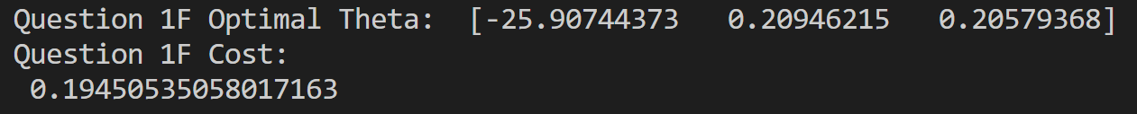

g) See ps3-1-f.png for scatter plot + learned line, ps3.py for code

h) See ps3.py for code

i) See ps3.py for code



Decision: Admitted ^

2. a) See ps3.py for code

b) See ps3-2-b.png for plot, and ps3.py for code

