Aluno: Renildo Gonzaga de Sousa Júnior 2016.1.0120.0011-3

**ISO/IEC 25010**

The quality model is the cornerstone of a product quality evaluation system. The quality model determines which quality characteristics will be taken into account when evaluating the properties of a software product.

The quality of a system is the degree to which the system satisfies the stated and implied needs of its various stakeholders, and thus provides value. Those stakeholders' needs (functionality, performance, security, maintainability, etc.) are precisely what is represented in the quality model, which categorizes the product quality into characteristics and sub-characteristics.

The product quality model defined in ISO/IEC 25010 comprises the eight quality characteristics shown in the following figure:

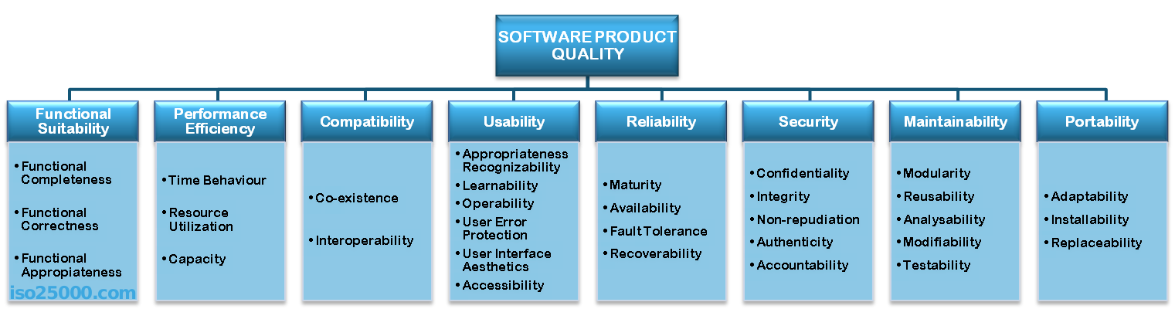

Portability

Degree of effectiveness and efficiency with which a system, product or component can be transferred from one hardware, software or other operational or usage environment to another. This characteristic is composed of the following subcharacteristics:

Adaptability. Degree to which a product or system can effectively and efficiently be adapted for different or evolving hardware, software or other operational or usage environments.

Installability. Degree of effectiveness and efficiency with which a product or system can be successfully installed and/or uninstalled in a specified environment.

Replaceability. Degree to which a product can replace another specified software product for the same purpose in the same environment.