Requirement Intelligence Assistant (RIA)
Complete End-to-End User Flow & Operations Walkthrough Guide
Application Name: | Requirement Intelligence Assistant (RIA)
Target Roles: | Business Analysts, Product Owners, QA Engineers, Enterprise Architects
Documentation Scope: | End-to-End Workflow: Ingestion → AI Analysis → Review → Stories & Tests → Export
Walkthrough Video: | ria_walkthrough_video.webm (Full resolution application recording included)

1. Executive Summary & Solution Architecture
The Requirement Intelligence Assistant (RIA) transforms raw and often conflicting business inputs—such as meeting audio/video transcripts, preliminary BRDs, Jira tickets, and regulatory policy PDFs—into structured, production-ready agile requirements. It automates cross-document contradiction detection, synthesizes atomic functional requirements, writes 4-section user stories with Gherkin acceptance criteria, and produces comprehensive test scenario matrices and multi-format exports.
📌 CORE VALUE PROPOSITION: RIA runs entirely with local determinism, PII privacy scrubbing, and flexible LLM backends (xAI Grok, Ollama, OpenAI-compatible endpoints). Spoken meeting decisions are reconciled directly against written specifications to eliminate discrepancy risk before sprint kickoff.

Video Walkthrough
A full live-action walkthrough recording has been generated to accompany this guide. It demonstrates every page transition, button click, review action, and export deliverable:
🎬 Video File: docs/videos/ria_walkthrough_video.webm
(Direct path: c:\Users\nvishwakarma\Downloads\1\requirement-intelligence-assistant-co\docs\videos\ria_walkthrough_video.webm)

2. Home Dashboard & Session Workspace
The Home Dashboard serves as the central control room for RIA. From this screen, team members manage working sessions, switch contexts between different product releases, and track historical analysis runs.
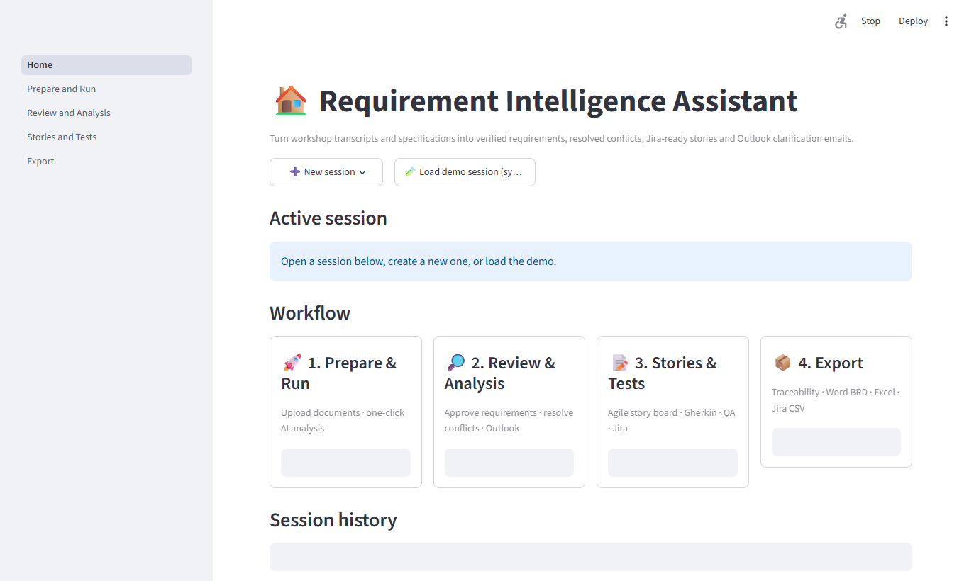
Figure: Home Dashboard displaying Active Session status, Quick Navigation cards, and Session Management table.
Key Features & Capabilities:
- Active Session Banner: Displays current session ID and timestamp with direct navigation cards into the workflow.
- Session Switcher: Quickly toggle between active sprint backlogs and client requirement packages.
- Session History & Administration: Create fresh sessions, duplicate previous baselines for delta comparisons, or purge completed runs with safety confirmations.
- De-cluttered Interface: Telemetry and backend AI configuration details are cleanly abstracted away to keep team focus on business analysis.

3. Document Ingestion (Prepare & Run)
The Prepare & Run screen handles the ingestion and staging of raw project documentation. RIA supports heterogeneous inputs across text, markdown, Word documents, PDF manuals, and meeting subtitle tracks.
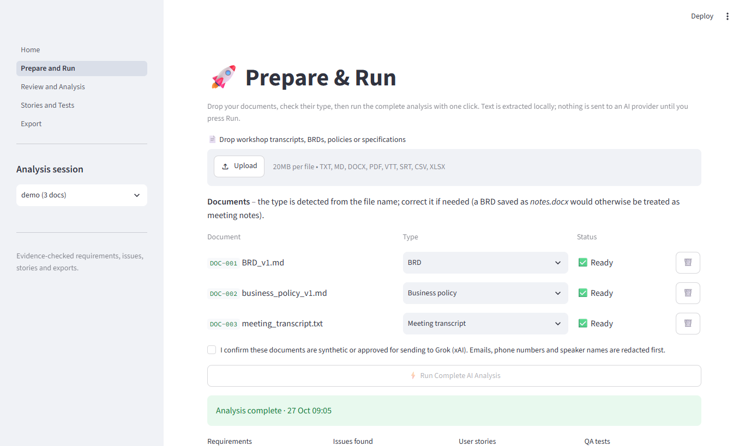
Figure: Prepare & Run Document Ingestion showing multi-format document staging, categorization, and parsing status.
Ingestion Architecture:
- Multi-Format Parsing: Accepts .txt, .md, .docx, .pdf, .vtt, .srt, and .csv files seamlessly.
- Document Classification: Categorize files as Meeting Transcript, BRD / PRD, Business Policy, or Architecture Spec.
- Automated PII Redaction: Sensitive names, emails, phone numbers, and financial details are anonymized before LLM transmission.
- Document Inventory: Clean table tracking Document ID (DOC-001), filenames, file sizes, and parsing status.

4. AI Pipeline Execution (Prepare & Run)
Once source documents are staged, the user configures the reconciliation mode and triggers the automated AI pipeline. The system processes the materials deterministically through five sequential analysis stages.
Figure: Analysis Configuration options and one-click execution trigger on Prepare & Run screen.
📌 PIPELINE AUTOMATION FLOW: Pipeline Stages: 1) Statements Extraction → 2) Requirements Deduction → 3) Cross-Document Conflict & Gap Detection → 4) Agile User Story Formulation → 5) Acceptance Criteria & QA Test Derivation.

5. Review & Analysis Workbench
The Review & Analysis screen gives Business Analysts complete governance over generated requirements. Metric summary cards provide real-time status counts, led by the newly configured 'Confirm Requirement' card.
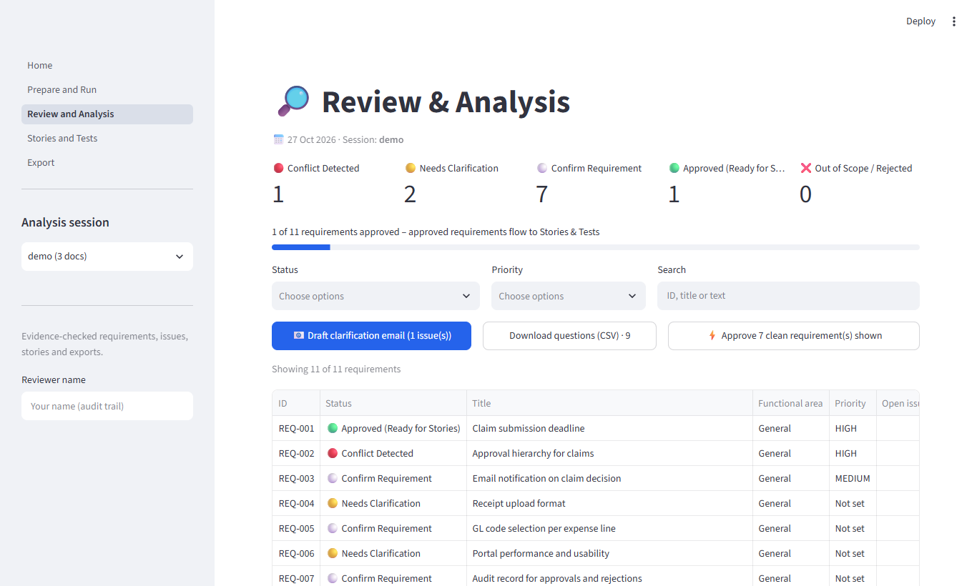
Figure: Review & Analysis Workbench highlighting the 'Confirm Requirement' card and interactive requirements table.
- Confirm Requirement Card: Instantly highlights requirements designated as confirmed and ready for sprint execution.
- Status Lifecycle: Track Pending Review, Approved (Ready for Stories), Needs Clarification, Conflict Detected, and Rejected.
- Requirements Catalog: Examines Requirement ID (REQ-001), category (Functional, Non-Functional, Security), title, and sources.
- Inline Action Controls: Approve, flag, request changes, or reject individual items with full audit trail logging.

6. Stakeholder Clarification Email
When contradictions between spoken meetings and written BRDs are detected, RIA synthesizes an executive clarification email. All findings are consolidated into a single unified Conflicting Requirements table.
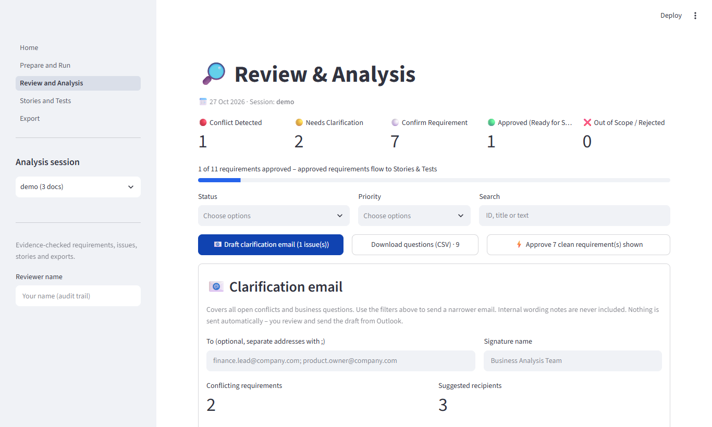
Figure: Clarification Email Panel featuring consolidated Conflicting Requirements table and direct Outlook dispatch.
- Consolidated Conflicting Requirements Table: Eliminates duplicate tables; combines conflict title, impact, meeting evidence, BRD text, and clarifying question.
- Direct Outlook COM Integration: Click '🚀 Open Directly in Outlook' to spawn a formatted draft email via Windows Outlook COM.
- Auto-Subject & Recipients: Pre-fills relevant project tags and formatted HTML tables ready for executive review.

7. Agile Stories & QA Test Scenarios
The Stories & Tests module translates approved requirements into structured engineering backlogs. Every story follows the strict 4-section architecture specified by development leads.
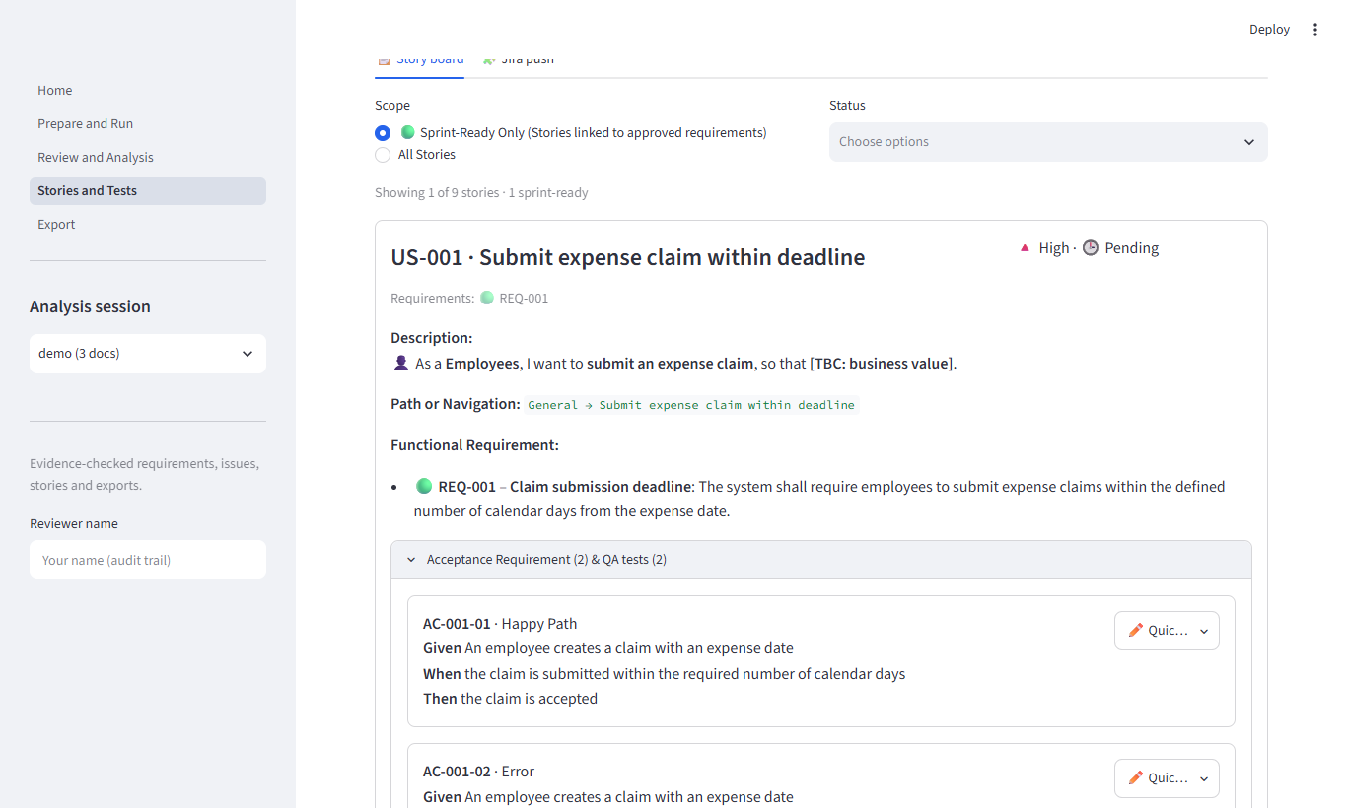
Figure: Stories & Tests Board illustrating the 4-section layout with complete Functional Requirement text.
The 4-Section User Story Architecture:
- 1. Description: Standard agile narrative ('As a [User], I want to [Action], so that [Benefit]').
- 2. Path or Navigation: Explicit system navigation route (e.g. 'Customer Portal → Claims → Settlement Details').
- 3. Functional Requirement: The unabridged, complete text of the underlying requirement specifications.
- 4. Acceptance Requirement & QA Tests: Gherkin Given-When-Then criteria with inline edit popovers, paired with positive Happy Path and negative Edge Case QA test scenarios.

8. Direct Jira Integration
The built-in Jira Workbench allows engineering teams to push sprint-ready stories and QA scenarios directly into Jira Cloud or Server with zero manual re-entry.
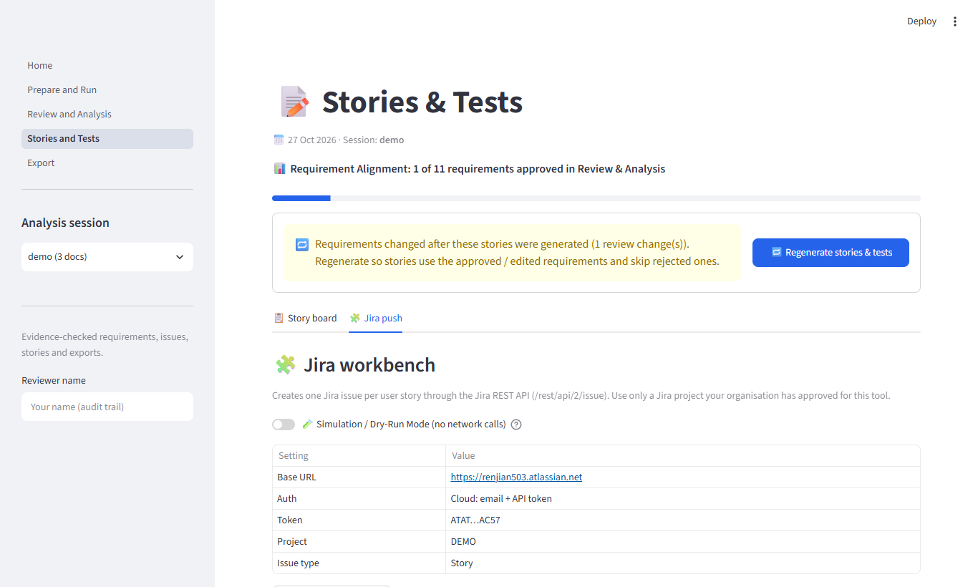
Figure: Jira Push tab showing live API connection test, project configuration, and export settings.
- Direct REST API Sync: Connects directly via secure API tokens to Jira Cloud / Data Center.
- Connection Test Tool: Instant feedback verifying Jira project key accessibility and issue creation permissions.
- Issue Mapping: Maps descriptions, acceptance criteria, test cases, and priority tags into Jira fields.
- Hyperlinked Backlog: Captures created Jira keys (e.g. PROJ-102) with direct clickable links into Jira boards.

9. Multi-Format Export Center
The Export Center packages all validated requirements, stories, tests, and conflict logs into official project artifacts. The top summary displays requirement and user story counts, followed by download buttons for each format.
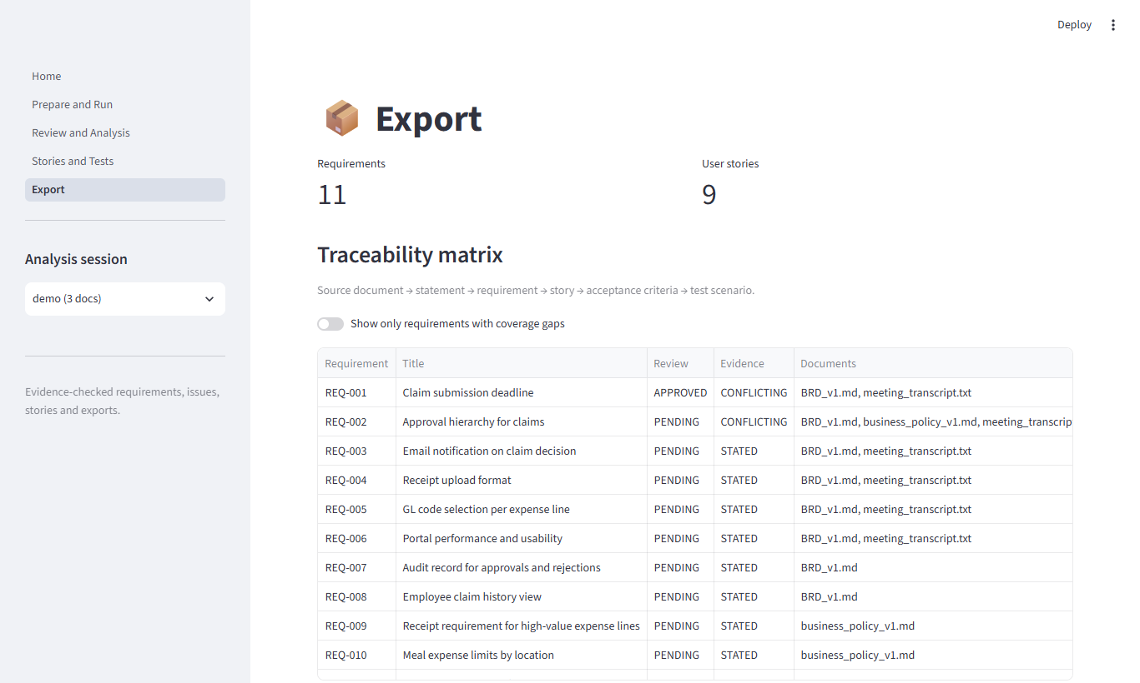
Figure: Export Center displaying Requirement & User Story metric cards and multi-format download options.
Format | File Type | Content & Structure
Excel Workbook | .xlsx | Summary sheet with dynamic count formulas, Requirements sheet, unified Findings & Questions sheet, User Stories sheet, and Test Scenarios sheet.
Word BRD | .docx | Formatted Business Requirements Document with executive summary, atomic requirement definitions, conflict resolution log, and stakeholder sign-off section.
Jira CSV | .csv | Pre-formatted standard CSV ready for bulk backlog import into Jira Cloud, Server, or Azure DevOps.
Summary Checklist for Product Teams:
Phase | Activity | RIA Screen
1. Ingestion | Upload transcripts, PRDs, and policy docs | Prepare & Run
2. Analysis | Run cross-document AI reconciliation | Prepare & Run
3. Governance | Validate requirements & verify Confirm Requirement | Review & Analysis
4. Clarification | Review merged conflicts & open draft in Outlook | Review & Analysis
5. Backlog & Export | Inspect 4-section stories, push Jira & export | Stories & Tests / Export

