德邦物流

导出差错统计结果失败问题修复需求详细设计说明书

文档控制

|  |  |
| --- | --- |
| **文档名称** | **导出差错统计结果失败问题修复需求详细设计说明书** |
| **文档全称** | **DP-IT-导出差错统计结果失败问题修复需求详细设计说明书V1.0** |
| **文档描述** | **导出差错统计结果失败问题修复需求详细设计说明书** |

**版本信息**

|  |  |  |  |
| --- | --- | --- | --- |
| **修改日期** | **版本** | **描述** | **作者** |
| **2013-06-09** | **V1.0** | **制定** | **李水清** |
|  |  |  |  |
|  |  |  |  |
|  |  |  |  |

…… …… ……

**目录**

1. 引言 - 4 -

1.1 编写目的 - 4 -

1.2 文档范围 - 4 -

2. 系统结构设计及子系统划分 - 4 -

3. 设计说明 - 4 -

3.1导出差错统计结果失败问题需求修复 - 4 -

3.1.1 处理行政处罚失败修复规则 - 4 -

3.1.2 类图 - 4 -

3.1.3 流程图 - 5 -

3.1.4时序图（可选） - 5 -

3.1.5 接口设计（可选） - 5 -

3.1.6 数据库设计 - 5 -

3.1.6.1逻辑设计 - 5 -

3.1.6.2 物理设计 - 6 -

**3.1.6.2.1表设计** - 6 -

**3.1.6.2.2 索引及序列** - 6 -

**3.1.6.2.3 视图** - 6 -

**3.1.6.2.4 过程** - 6 -

**3.1.6.2.5 触发器** - 6 -

**3.1.6.2.6 函数** - 6 -

**3.1.6.2.7 Job** - 6 -

**3.1.6.2.8其他(例如同义词,物化视图等等,有则加上)** - 6 -

3.1.6.3建表脚本 - 6 -

3.1.7界面设计 - 7 -

3.1.8关键算法（可选） - 7 -

3.1.9 程序代码 - 7 -

3.1.10性能 - 10 -

3.1.11尚未解决的问题(可选) - 10 -

# 

# 引言

## 编写目的

修复导出差错统计结果失败问题

## 文档范围

修复导出差错统计结果失败问题

# 系统结构设计及子系统划分

|  |  |  |
| --- | --- | --- |
| **工作流系统** | | |
| 模块名称 | 功能简述 | 需求编号 |
| 修复导出差错统计结果失败问题 | 可以正常导出差错结果，并且显示对象工号为人员id。 | *SUBBUG-934* |
|  |  |  |
|  |  |  |
|  |  |  |

# 设计说明

## 3.1导出差错统计结果失败问题需求修复

### 3.1.1 导出差错统计结果失败问题修复规则

|  |  |
| --- | --- |
| 序号 | 描述 |
| RULE-A1 | 可以正常导出差错统计结果 |
|  |  |
|  |  |

### 3.1.2 类图

/DIP/dip.integrateportal.businessManagement/src/dip/integrateportal/businessManagement/errors/QueryErrorsInfo.java

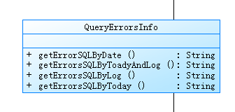

### 3.1.3 流程图

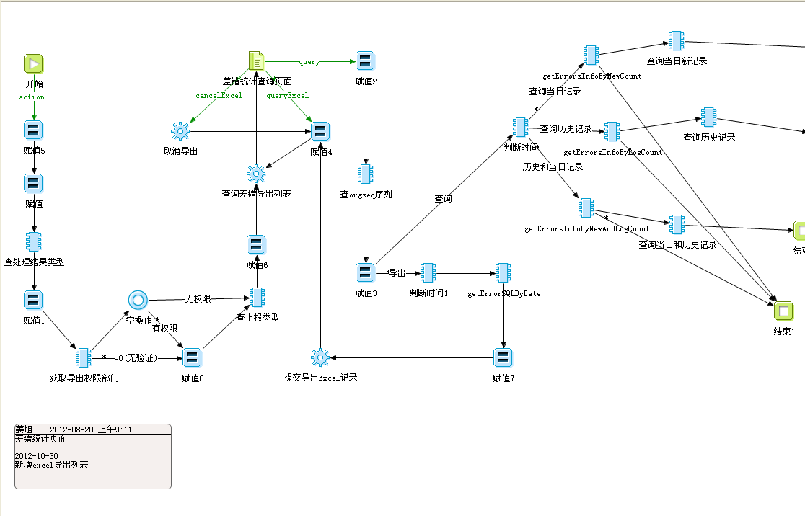

### 3.1.4时序图（可选）

无 原因：没有涉及。

### 3.1.5 接口设计（可选）

### 3.1.6 数据库设计

#### 3.1.6.1逻辑设计

无 没有涉及数据库

#### 3.1.6.2 物理设计

##### **3.1.6.2.1表设计**

无 没有涉及数据库

##### **3.1.6.2.2 索引及序列**

*名称,如何访问,使用频率,功能描述*

|  |  |  |  |  |
| --- | --- | --- | --- | --- |
| ***编号*** | ***名称*** | ***如何访问*** | ***使用频率*** | ***功能描述*** |
|  |  |  |  |  |

##### **3.1.6.2.3 视图**

*名称,如何访问,使用频率,功能描述*

|  |  |  |  |  |
| --- | --- | --- | --- | --- |
| ***编号*** | ***名称*** | ***如何访问*** | ***使用频率*** | ***功能描述*** |
|  |  |  |  |  |

##### **3.1.6.2.4 过程**

*名称,如何访问,使用频率,功能描述*

|  |  |  |  |  |
| --- | --- | --- | --- | --- |
| ***编号*** | ***名称*** | ***如何访问*** | ***使用频率*** | ***功能描述*** |
|  |  |  |  |  |

##### **3.1.6.2.5 触发器**

*名称,如何访问,使用频率,功能描述*

|  |  |  |  |  |
| --- | --- | --- | --- | --- |
| ***编号*** | ***名称*** | ***如何访问*** | ***使用频率*** | ***功能描述*** |
|  |  |  |  |  |

##### **3.1.6.2.6 函数**

*名称,如何访问,使用频率,功能描述*

|  |  |  |  |  |
| --- | --- | --- | --- | --- |
| ***编号*** | ***名称*** | ***如何访问*** | ***使用频率*** | ***功能描述*** |
|  |  |  |  |  |

##### **3.1.6.2.7 Job**

*名称,如何访问,使用频率,功能描述*

|  |  |  |  |  |
| --- | --- | --- | --- | --- |
| ***编号*** | ***名称*** | ***如何访问*** | ***使用频率*** | ***功能描述*** |
|  |  |  |  |  |

##### **3.1.6.2.8其他(例如同义词,物化视图等等,有则加上)**

|  |  |  |  |  |
| --- | --- | --- | --- | --- |
| ***编号*** | ***名称*** | ***如何访问*** | ***使用频率*** | ***功能描述*** |
|  |  |  |  |  |

#### 3.1.6.3建表脚本

无 没有涉及数据库

### 3.1.7界面设计

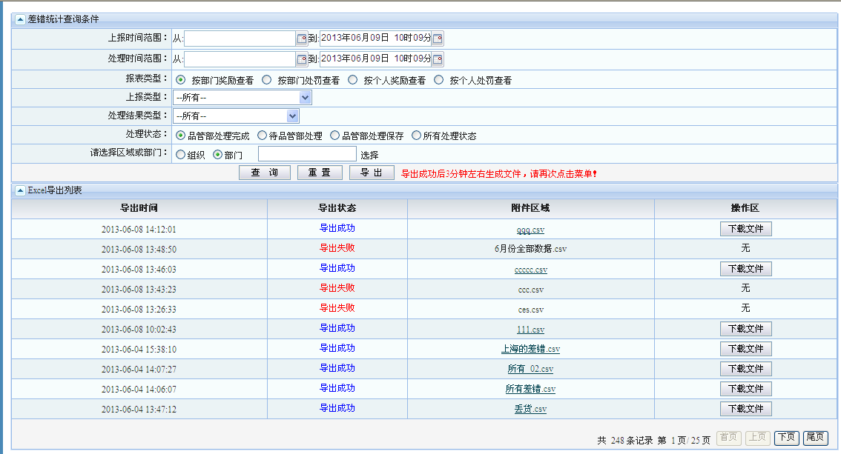

### 3.1.8关键算法（可选）

**无**

### 3.1.9 程序代码

/**

* 查看今天的主表信息.

* **@param** paraObj

* **@return**

*/

**public** String initSqlByErrorsmaintb(Object paraObj) {

Map map = (Map) paraObj;

String str = **null**;

**if** ("1".equals((String) map.get("bblx"))

|| "2".equals((String) map.get("bblx"))) {

str = "a.code";

} **else** **if** ("3".equals((String) map.get("bblx"))

|| "4".equals((String) map.get("bblx"))) {

str = "r.userid";

}

//获取查询条件

StringBuffer sb = **new** StringBuffer(

" select '\" '||replace(b.handlingid,'null','')||'\",\"'||replace(d.typename,'null','')||'\",\"'||replace(b.operatorname,'null','')||'\",\"'||replace(b.operatorworkid,'null','')||'\",\"'||replace(b.orgname,'null','')||'\",\"'||to_char(b.reporttime,'yyyy-mm-dd hh24:mi:ss')||");

sb

.append(

"'\",\"'||decode(b.state,'1','待文化部处理','2','文化部退回','3','文化部处理完成','4','待品管部处理','5','品管部退回','6','品管部处理保存','7','品管部处理完成','')||")

.append(

"'\",\" '||replace(b.waybillid,'null','')||'\",\"'||replace(b.transporttype,'null','')||'\",\"'||replace(b.returnbilltype,'null','')||'\",\"'||replace(b.shipper,'null','')||'\",\"'||replace(b.transportproduct,'null','')||'\",\"'||''||'\",\"'||replace(b.receivertel,'null','')||")

.append(

"'\",\"'||replace(b.groupsendflag,'null','')||'\",\"'||replace(b.remark,'null','')||'\",\"'||replace(b.weight,'null','')||'\",\"'||replace(b.volume,'null','')||'\",\"'||replace(b.quantity,'null','')||'\",\"'||replace(b.goods,'null','')||'\",\"'||b.sendtime||")

.append(

"'\",\"'||replace(b.destination,'null','')||'\",\"'||replace(b.receivingddept,'null','')||'\",\"'||replace(b.receiver,'null','')||'\",\"'||replace(b.paytype,'null','')||'\",\"'||replace(b.insurancemoney,'null','')||'\",\"'||replace(b.goodspacking,'null','')||'\",\"'||replace(b.total,'null','')||")

.append(

"'\",\"'||replace(b.eventreport,'\"','\"\"')||'\",\"'||replace(b.surveycontent,'\"','\"\"')||'\",\"'||replace(e.resultname,'null','')||'\",\"'||replace(q.orgname,'null','')||")

.append("'\",\"'||a.code||'\",\"'||a.objectname||'\",\"'||a.result||")

.append(

"'\",\"'||decode(a.type,'0','奖励','1','负激励','2','赔偿损失','3','入费用','4','质损','5','警告','6','严重警告','7','记过','8','解除劳动合同','')||")

.append(

"'\",\"'||a.money||'\",\"'||replace(a.operator,'null','')||'\",\"'||to_char(a.operatortime,'yyyy-mm-dd hh24:mi:ss')||")

.append(

"'\",\"'||replace(kk.previouscldept,'null','')||' '||replace(kk.unloaddept,'null','')||' '||replace(kk.responsibledept,'null','')||'\",\"'||replace(kk.nogoodscount,'null','')||'\",\"'||replace(j.weight,'null','')||'\",\"'||replace(j.volume,'null','')||")

.append(

"'\",\"'||replace(ll.replaybill,'null','')||'\",\"'||replace(replace(ll.carnumber,'\"','\"\"'),'null','')||'\",\"'||replace(kk.replaybill,'null','')||'\",\"'||replace(replace(kk.carnumber,'\"','\"\"'),'null','')||'\",\"'||replace(nn.safetype,'null','')")

.append("||'\",\"'||replace(LL.responsibledept,'null','')||'\",\"'||replace(LL.moregoodtype,'null','')||'\",\"'||replace(FQCC.cartype,'null','')||'\",\"'||replace(FQCC.resDriverUserName,'null','')||")

.append("'\",\"'||replace(FQCC.resDriverDept,'null','')||'\",\"'||replace(FQCC.resOutDriverUserName,'null','')||'\",\"'||replace(FQCC.resOutDriverDept,'null','')||'\",\"'||replace(FQCC.sliptype,'null','')||'\",\"'||replace(FQCC.carno,'null','')||'\",\"'")

.append("||replace(WBQ.nolabelwaybill,'null','')||'\",\"'||replace(WBQ.nolabelserail,'null','')||'\"' SQLSTR")

.append(initErrorsmaintByCria(paraObj));

System.*out*.println("new:" + sb.toString());

**return** sb.toString();

}

/**

* 返回查询记录表记录数的查询语句.

* **@param** paraObj

* **@return**

*/

**public** String initSqlByLogRecord(Object paraObj) {

Map map = (Map) paraObj;

String str = **null**;

**if** ("1".equals((String) map.get("bblx"))

|| "2".equals((String) map.get("bblx"))) {

str = "b.code";

} **else** **if** ("3".equals((String) map.get("bblx"))

|| "4".equals((String) map.get("bblx"))) {

str = "e.userid";

}

//获取查询条件

StringBuffer sb = **new** StringBuffer(

" select '\" '||replace(a.handlingid,'null','')||'\",\"'||replace(d.typename,'null','')||'\",\"'||replace(a.operatorname,'null','')||'\",\"'||replace(a.operatorworkid,'null','')||");

sb

.append("'\",\"'||replace(a.orgname,'null','')||'\",\"'||to_char(a.reporttime,'yyyy-mm-dd hh24:mi:ss')||");

sb

.append("'\",\"'||decode(a.state,'1','待文化部处理','2','文化部退回','3','文化部处理完成','4','待品管部处理','5','品管部退回','6','品管部处理保存','7','品管部处理完成','')||");

sb

.append("'\",\" '||a.waybillid||'\",\"'||replace(a.transporttype,'null','')||'\",\"'||replace(a.returnbilltype,'null','')||");

sb

.append("'\",\"'||replace(a.shipper,'null','')||'\",\"'||replace(a.transportproduct,'null','')||'\",\"'||''||'\",\"'||replace(a.receivertel,'null','')||");

sb

.append("'\",\"'||replace(a.groupsendflag,'null','')||'\",\"'||replace(a.remark,'null','')||'\",\"'||replace(a.weight,'null','')||'\",\"'||replace(a.volume,'null','')||");

sb

.append("'\",\"'||replace(a.quantity,'null','')||'\",\"'||replace(a.goods,'null','')||'\",\"'||a.sendtime||'\",\"'||replace(a.destination,'null','')||");

sb

.append("'\",\"'||replace(a.receivingddept,'null','')||'\",\"'||replace(a.receiver,'null','')||'\",\"'||replace(a.paytype,'null','')||'\",\"'||replace(a.insurancemoney,'null','')||");

sb

.append("'\",\"'||replace(a.goodspacking,'null','')||'\",\"'||replace(a.total,'null','')||'\",\"'||replace(a.eventreport,'\"','\"\"')||'\",\"'||replace(a.surveycontent,'\"','\"\"')||");

sb

.append("'\",\"'||replace(c.resultname,'null','')||'\",\"'||replace(o.orgname,'null','')||'\",\"'||replace(b.code,'null','')||'\",\"'||replace(b.objectname,'null','')||'\",\"'||replace(b.result,'null','')||");

sb

.append("'\",\"'||decode(b.type,'0','奖励','1','负激励','2','赔偿损失','3','入费用','4','质损','5','警告','6','严重警告','7','记过','8','解除劳动合同','')||");

sb

.append("'\",\"'||replace(b.money,'null','')||'\",\"'||replace(b.operator,'null','')||'\",\"'||to_char(b.operatortime,'yyyy-mm-dd hh24:mi:ss')||'\",\"'||a.f_previouscldept||");

sb

.append("' '||replace(a.f_unloaddept,'null','')||' '||replace(a.f_responsibledept,'null','')||'\",\"'||replace(a.f_nogoodscount,'null','')||'\",\"'||replace(a.d_weight,'null','')||");

sb

.append("'\",\"'||replace(a.d_volume,'null','')||'\",\"'||replace(a.e_replaybill,'null','')||'\",\"'||replace(a.e_carnumber,'null','')||'\",\"'||replace(a.f_replaybill,'null','')||");

sb.append("'\",\"'||replace(a.f_carnumber,'null','')||'\",\"'||replace(a.a_safetype,'null','') ||'\",\"'|| replace(a.e_responsibledept,'null','') ||'\",\"'|| replace(a.e_moregoodtype ,'null','')" );

sb.append("||'\",\"'||replace( a.r_cartype,'null','') ||'\",\"'|| replace(a.r_resdriverusername,'null','') ||'\",\"'|| replace(a.r_resdriverdept,'null','') ||'\",\"'|| replace(a.r_resoutdriverusername,'null','') ||'\",\"'|| a.r_resoutdriverdept ||'\",\"'|| a.R_SLIPTYPE ||'\",\"'|| a.r_carno ||'\",\"'|| a.c_nolabelwaybill ||'\",\"'|| a.c_nolabelserail ||'\"' SQLSTR ");

sb.append(initSqlTotalRecordByCria(paraObj));

//sb.append(" order by a.id");

System.*out*.println("old:" + sb.toString());

**return** sb.toString();

}

### 3.1.10性能

|  |  |  |  |
| --- | --- | --- | --- |
| **编号** | **功能点（可能产生问题的功能点）** | **原因分析** | **解决方案分析** |
|  |  |  |  |
|  |  |  |  |
|  |  |  |  |
|  |  |  |  |

### 3.1.11尚未解决的问题(可选)

**无**