Renjith Madhavan

MDS-535

Activity - 5

Contents

Create Hive table 2

Import Data into Hive 2

Select data from Hive 2

Using “Where”, “LIKE” and other sql commands 2

Creating Hive External Table 6

Using in JOIN in Hive 6

Creating VIEW 7

Exporting HIVE data 8

# Create Hive table

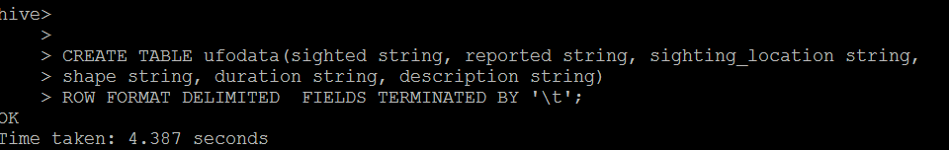

# Import Data into Hive

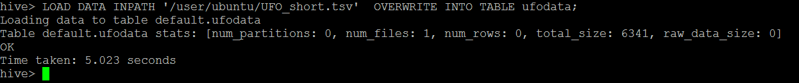

# Select data from Hive

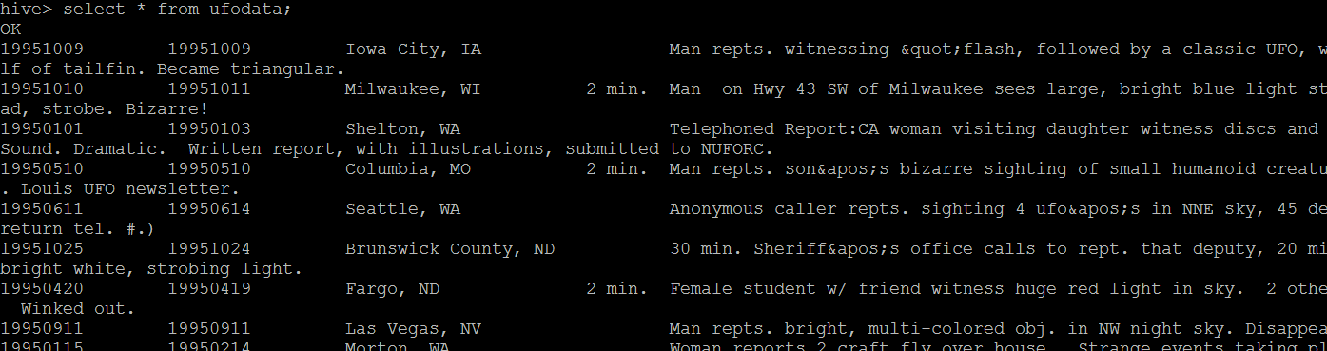

# Using “Where”, “LIKE” and other sql commands

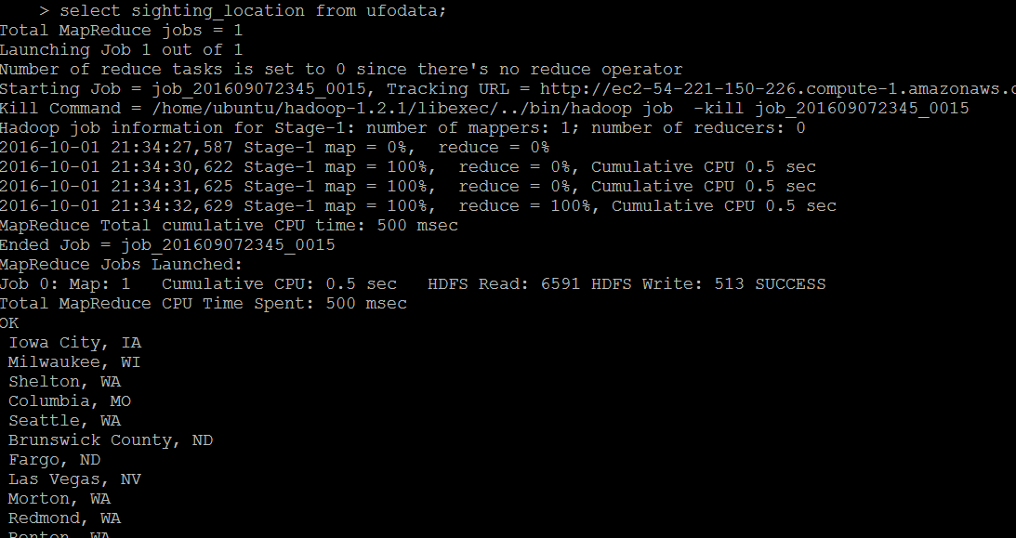

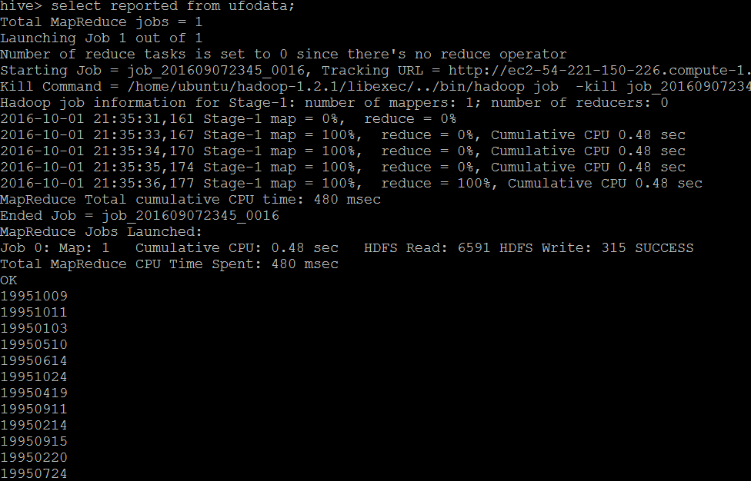

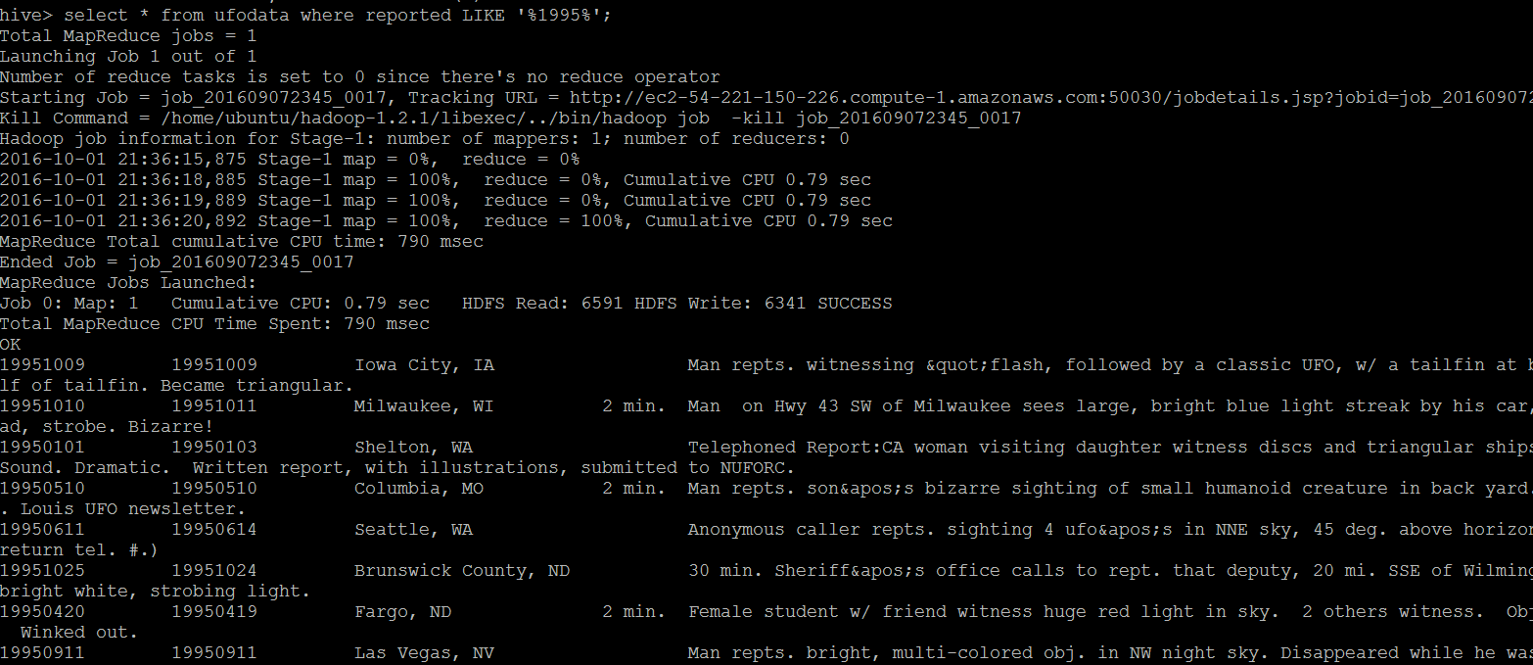

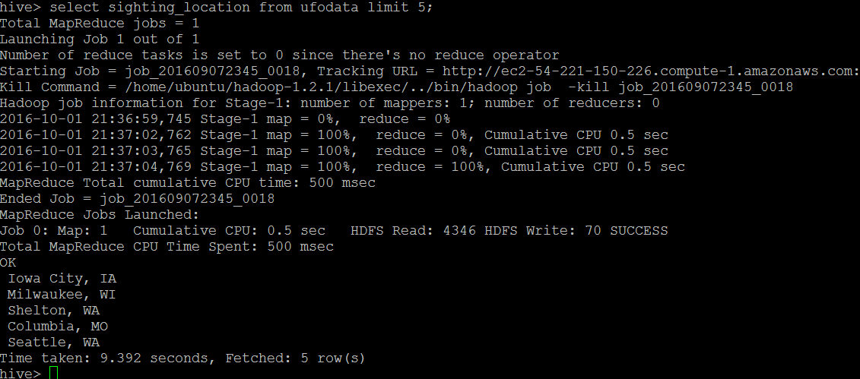

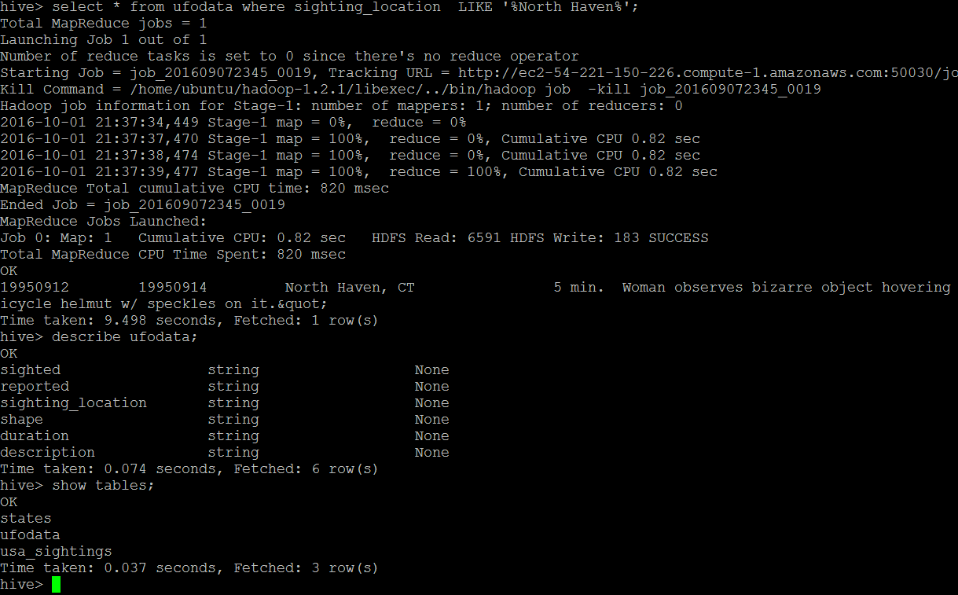

# Creating Hive External Table

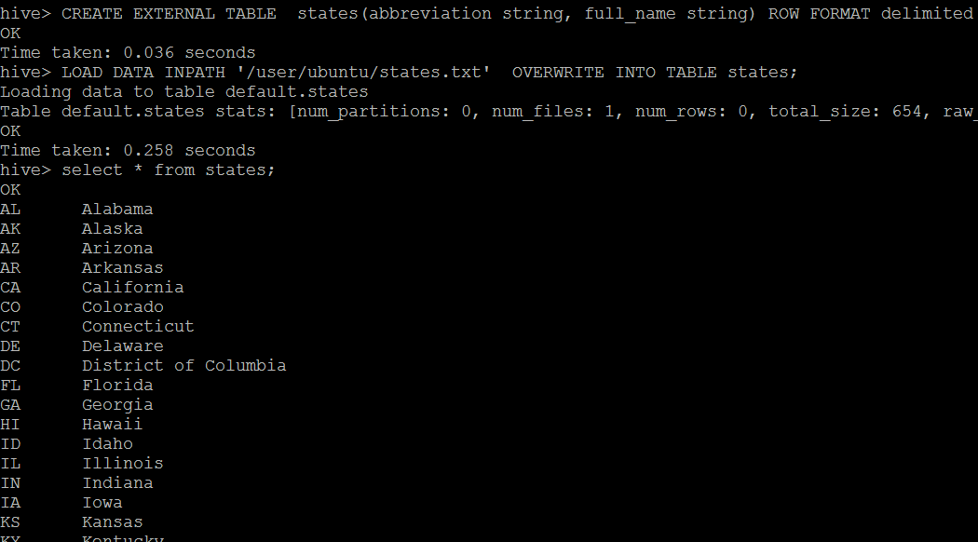

# Using in JOIN in Hive

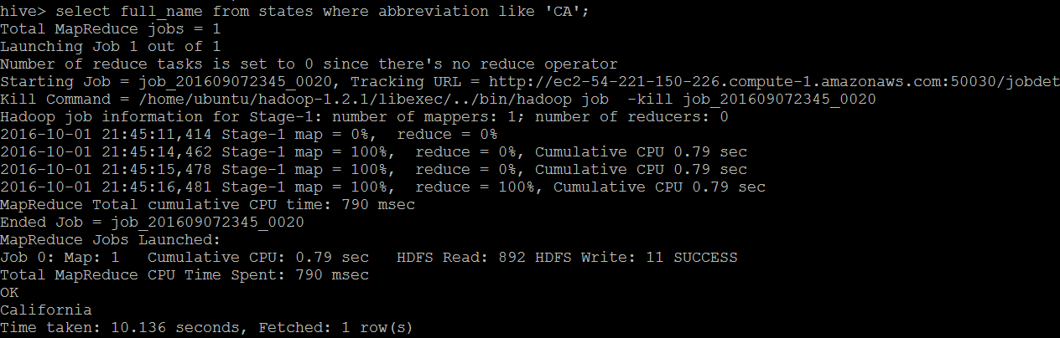

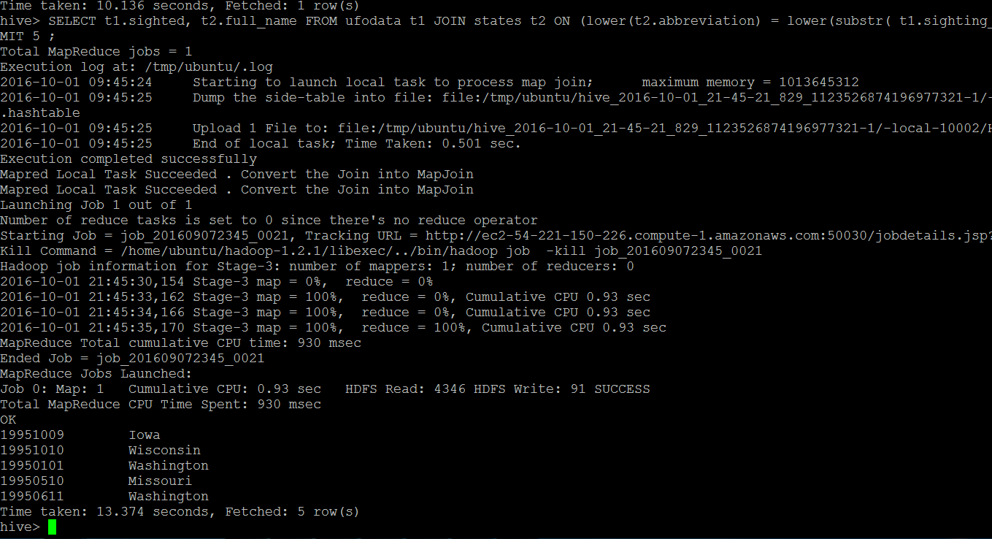

# Creating VIEW

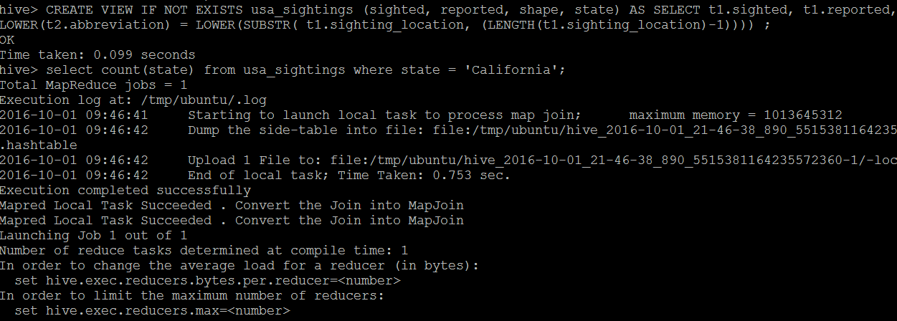

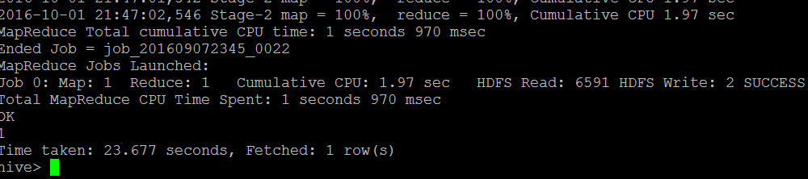

# Exporting HIVE data

