Renjith Madhavan

MDS-535

Activity - 8

Contents

Installing sbt 2

Standalone applications in spark 2

Build, compile and package using SBT 2

Run the spark job 2

Contents of the part file 3

Spark Streaming 3

Compile and package using sbt 3

Start the server terminal 3

Start the Client Terminal 4

Spark Streaming in Action 4

Spark / MLIB 5

Kmeans 5

Linear Regression with stochastic gradient descent 6

Decision tree example 6

Spark GraphX 8

RemoveBrokenlinks 8

averageAge.txt 9

singleSourceShortestPath.txt 10

# Installing sbt

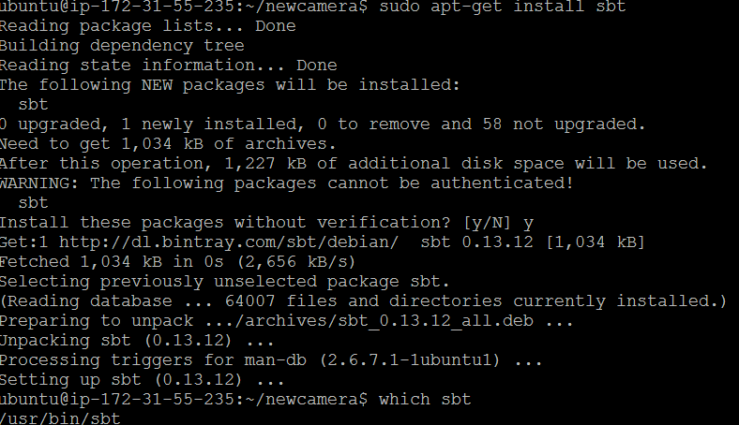

# Standalone applications in spark

## Build, compile and package using SBT

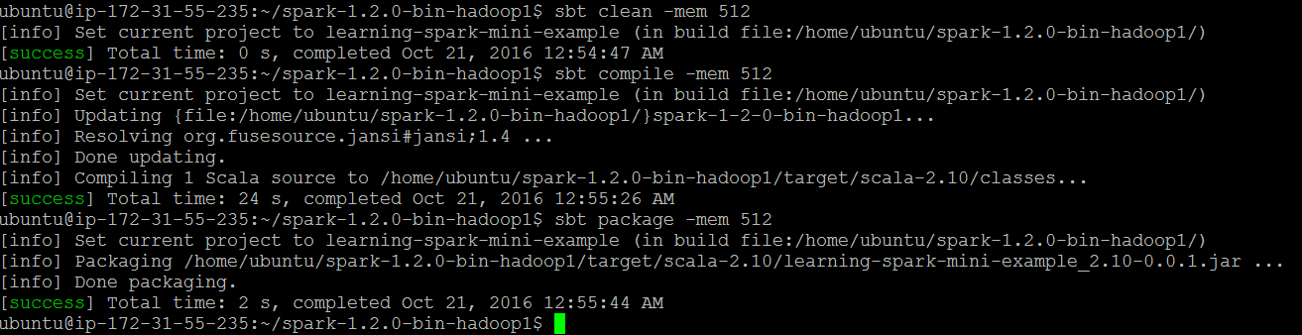

## Run the spark job

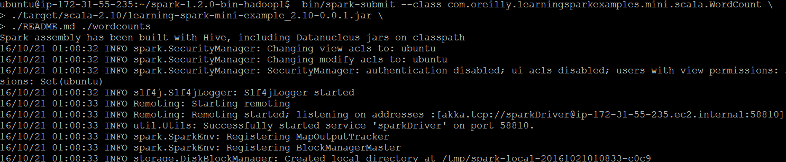

## Contents of the part file

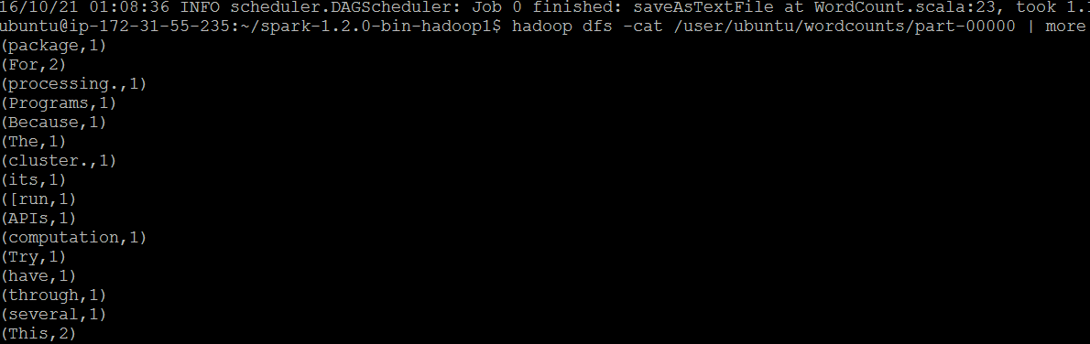

# Spark Streaming

## Compile and package using sbt

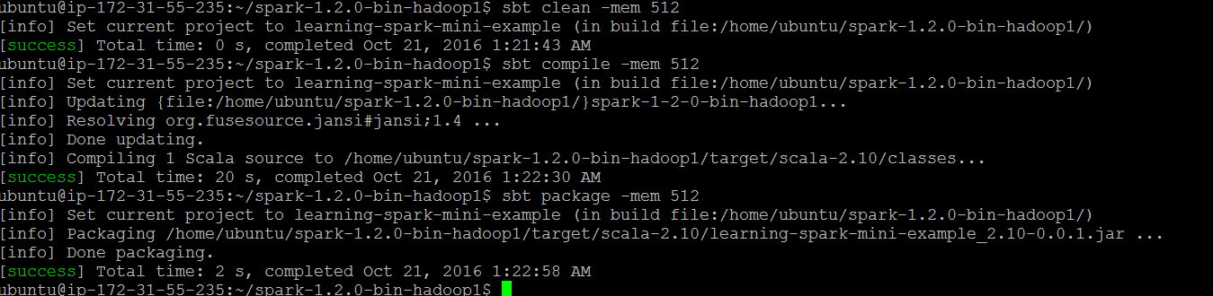

## Start the server terminal

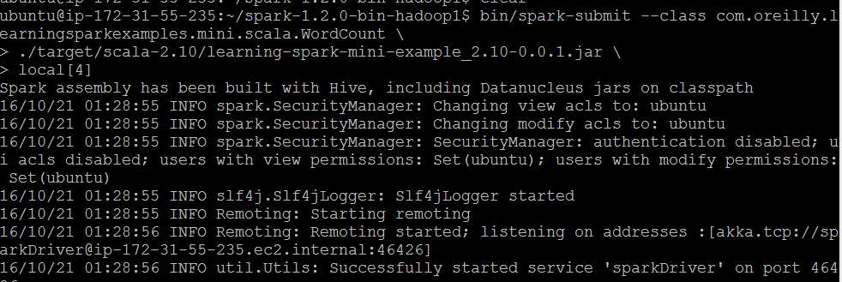

## Start the Client Terminal

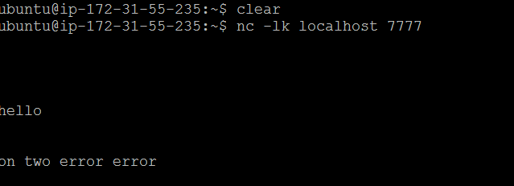

## Spark Streaming in Action

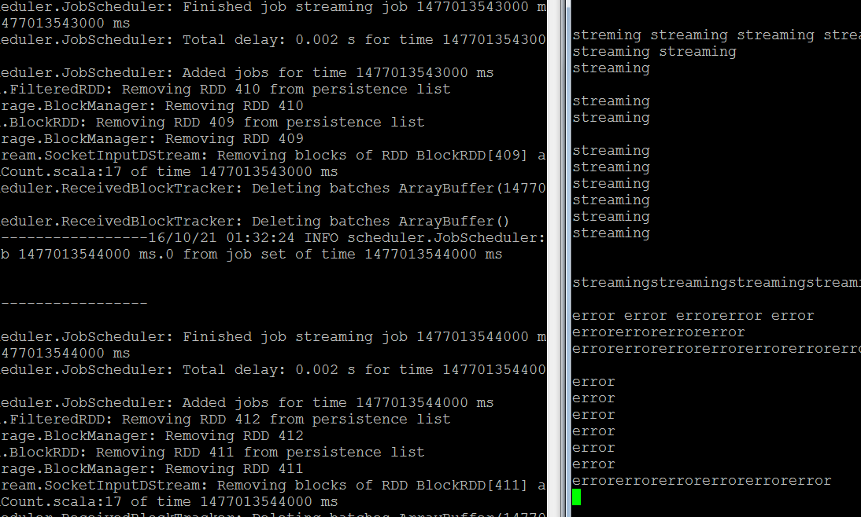

# Spark / MLIB

## Kmeans

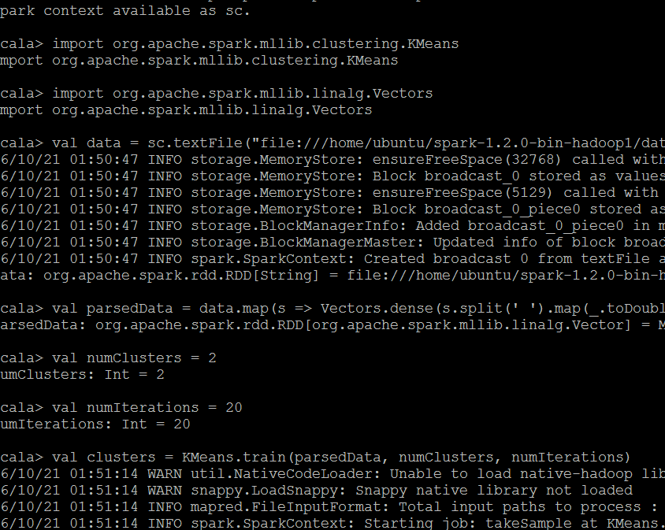

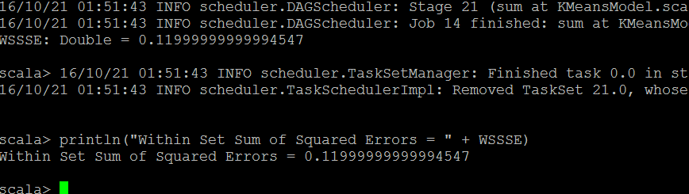

## Linear Regression with stochastic gradient descent

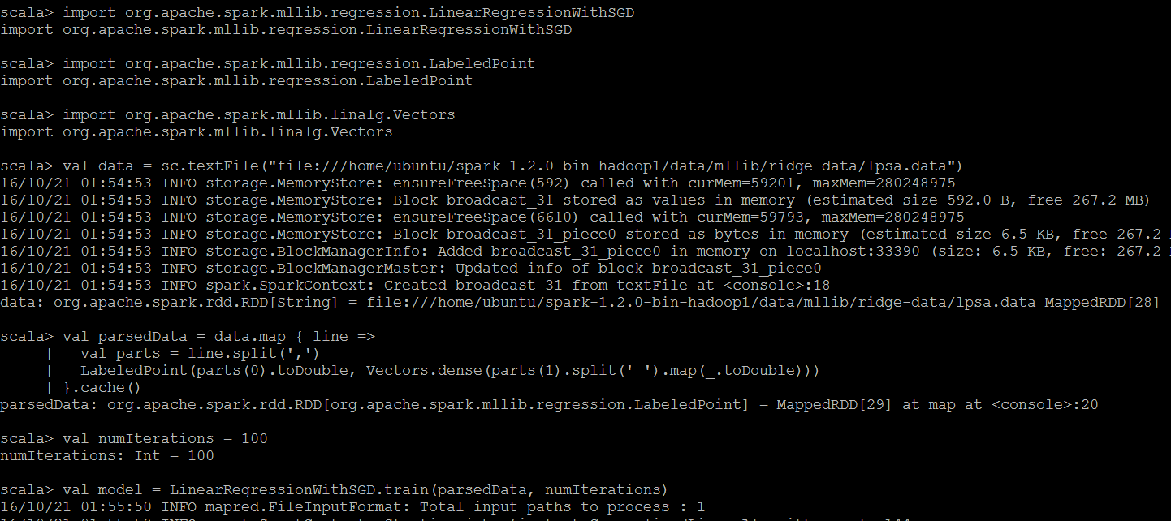

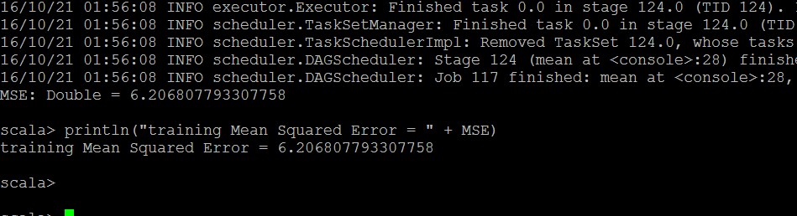

## Decision tree example

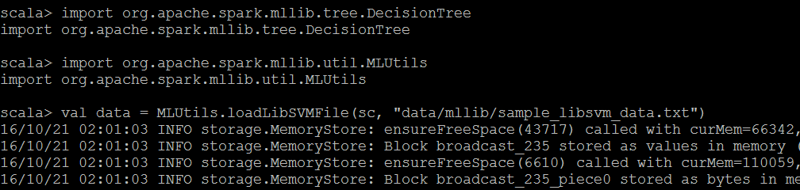

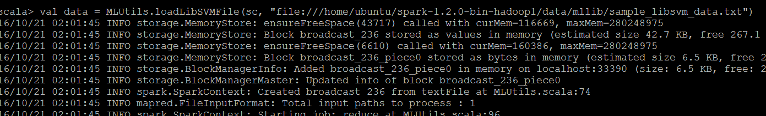

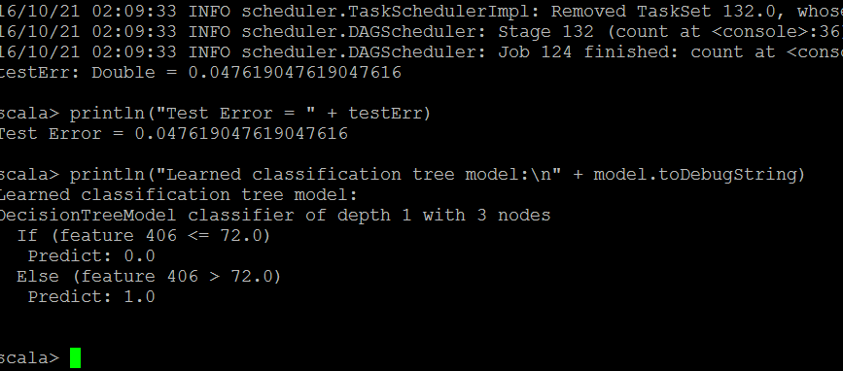

# Spark GraphX

## RemoveBrokenlinks

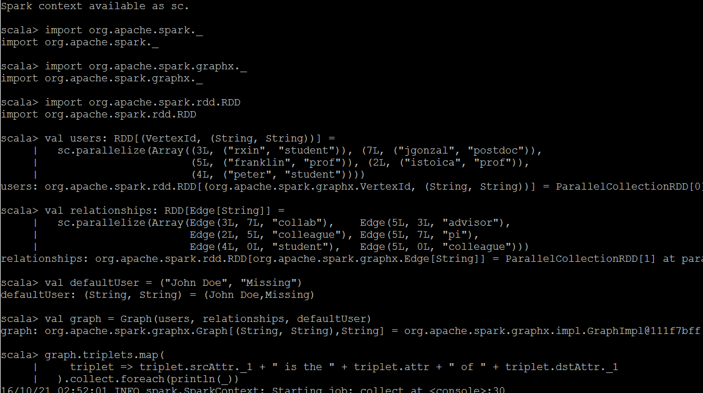

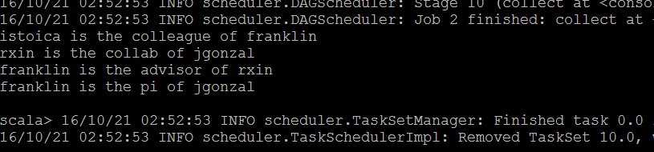

## averageAge.txt

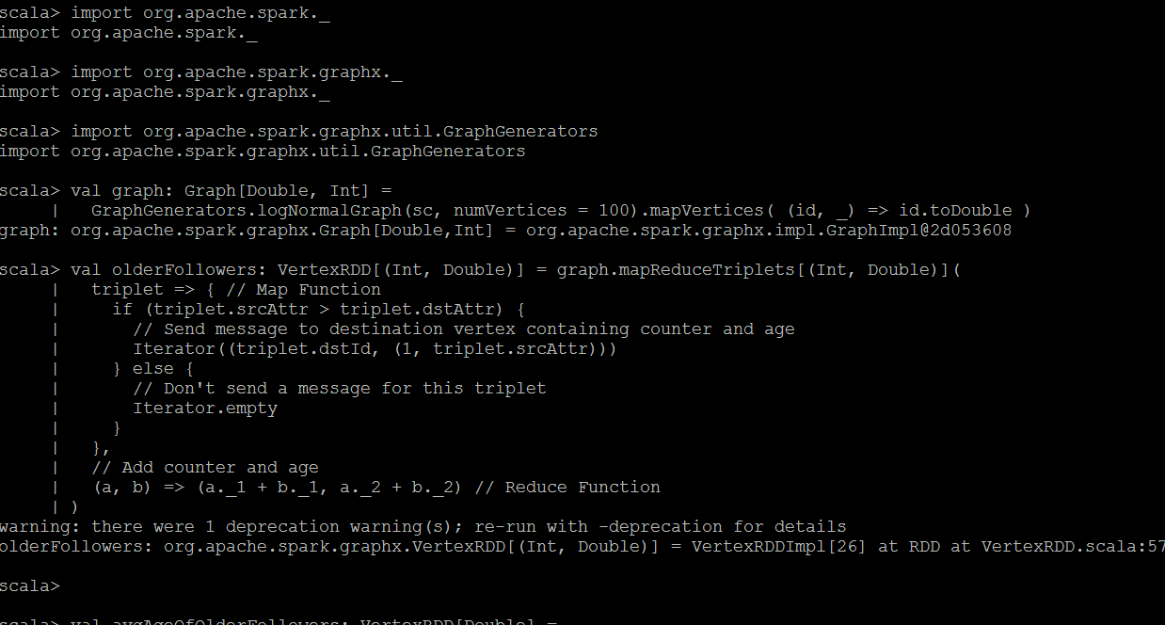

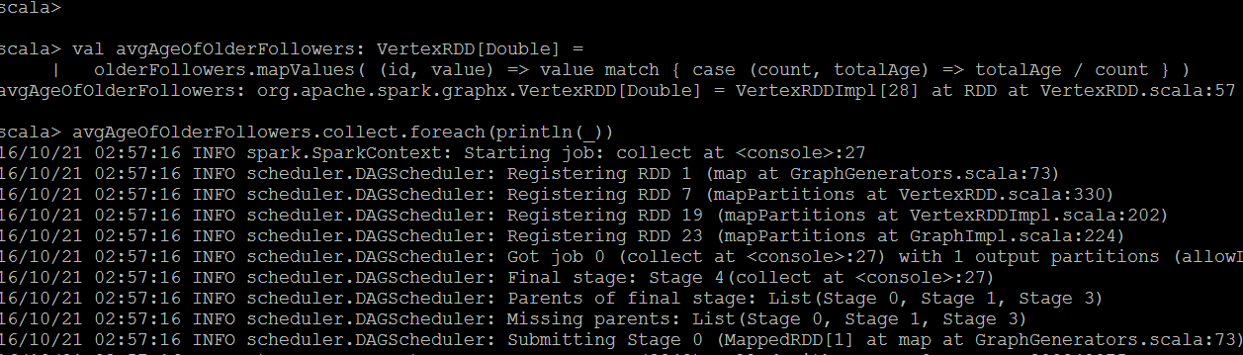

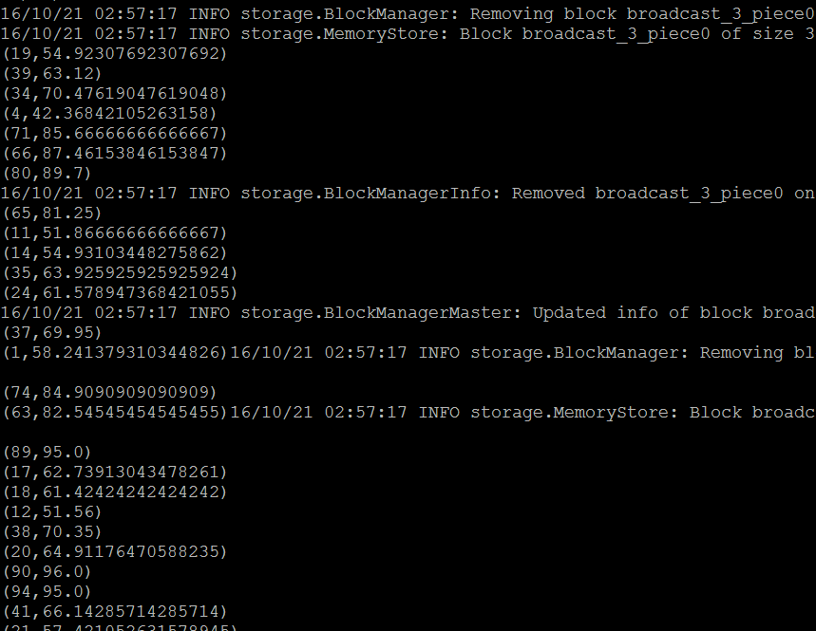

## singleSourceShortestPath.txt

