Renjith Madhavan

MDS-535

Activity - 1

Contents

Overview and Task Summary 2

AWS User Account Creation 3

Creating and setting up an AWS Instance 5

AWS Management Console Screenshot 8

Installing dos2unix 10

Invoking “java” 11

Invoking “Hadoop” 12

Errors 12

# Overview and Task Summary

This is my first experience to install and setup an AWS instance for Hadoop. The how to setup document with instruction was very easy to follow with screenshots. I also captured my screenshots during installation and the final console. Once the setup was complete I copied the environment files env.sh and bashScript24.sh to the AWS instance. Also installed dos2unix and changed permissions for the files.

While sourcing the env.sh, there were error messages for directory exists but that can be ignored as those directories were already created as part of the bashScript24.sh.

Finally I was able to invoke java and Hadoop commands without errors confirming that the setup worked as intended.

# AWS User Account Creation

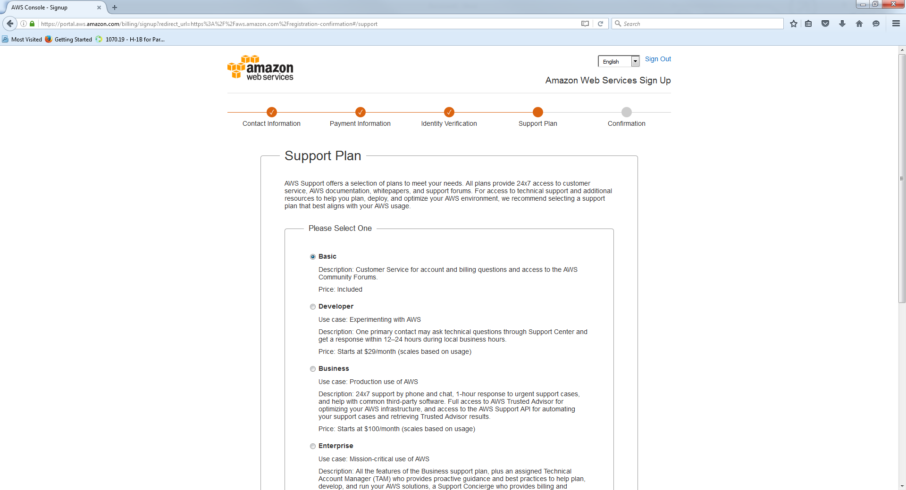



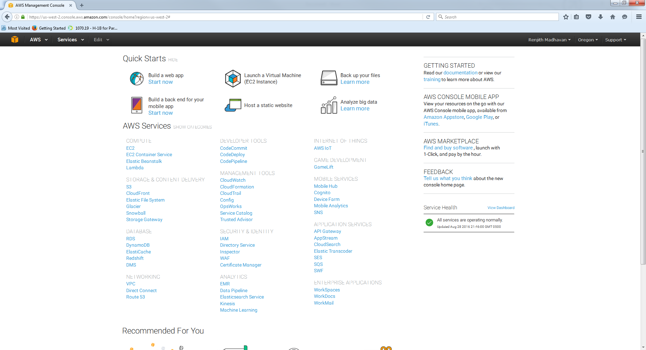

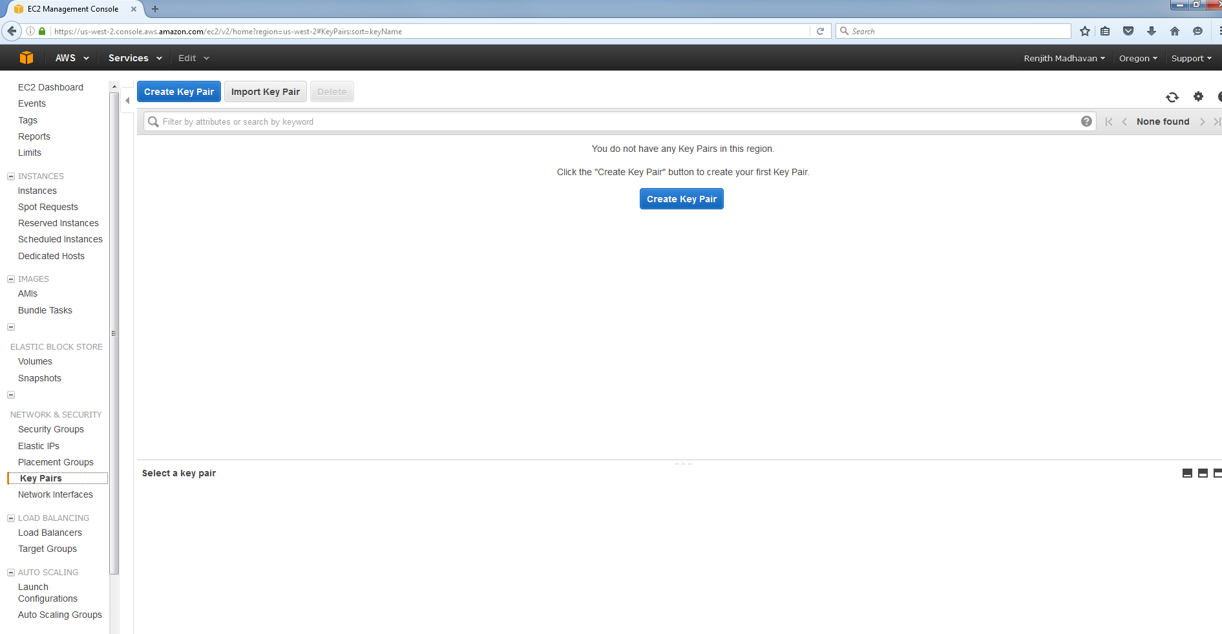

# Creating and setting up an AWS Instance

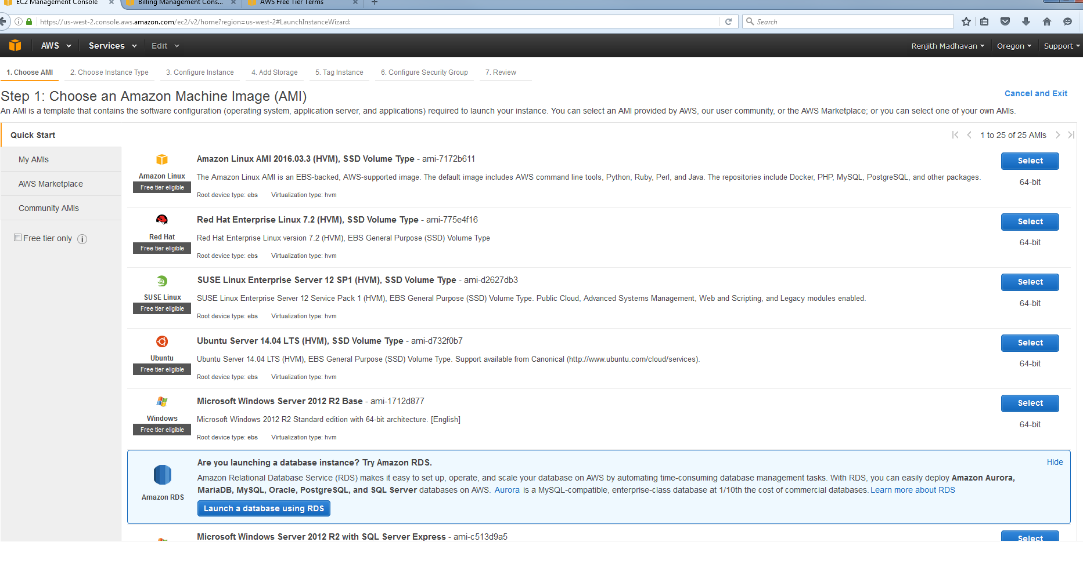

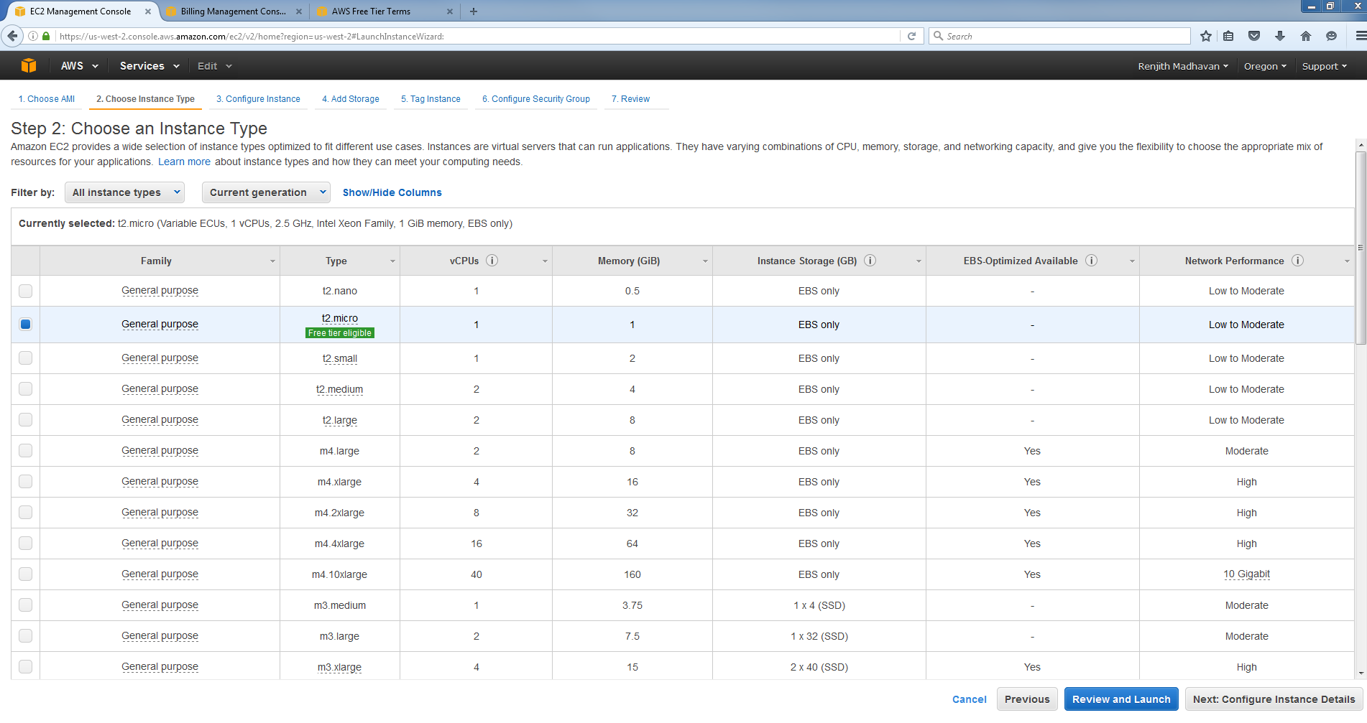

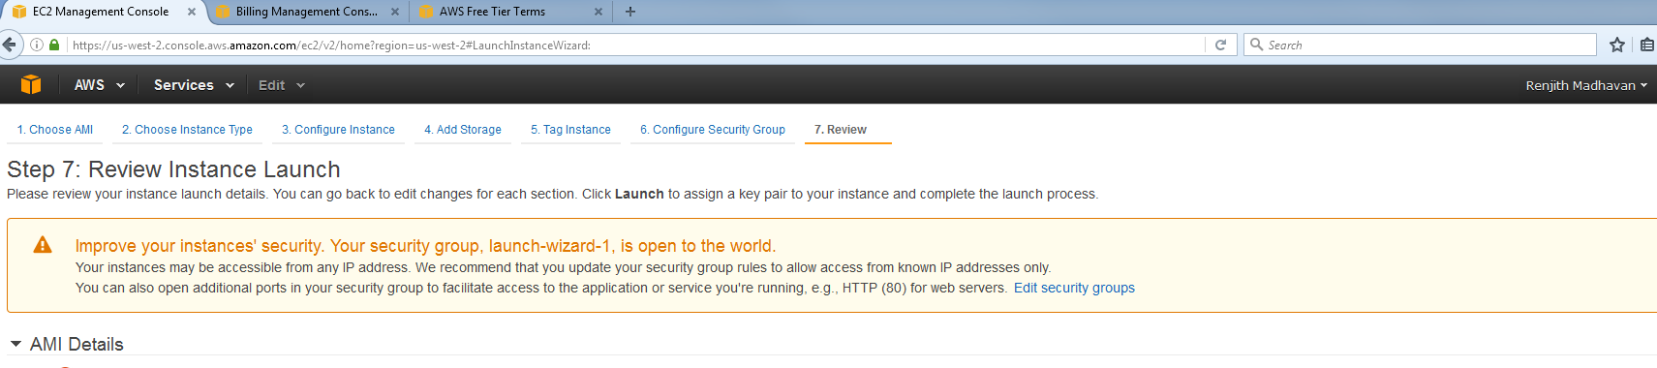

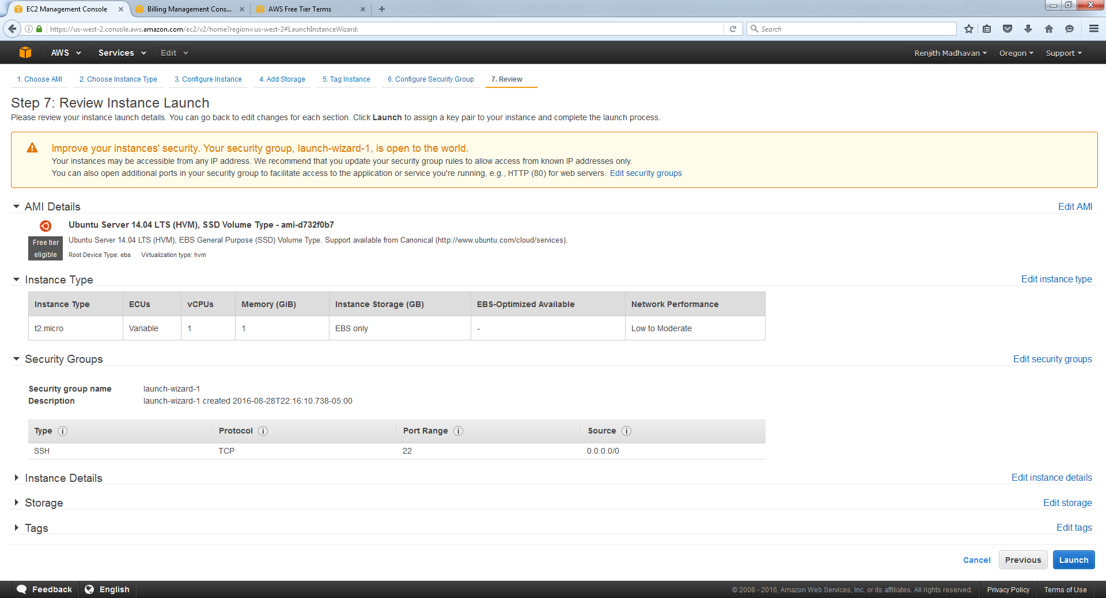

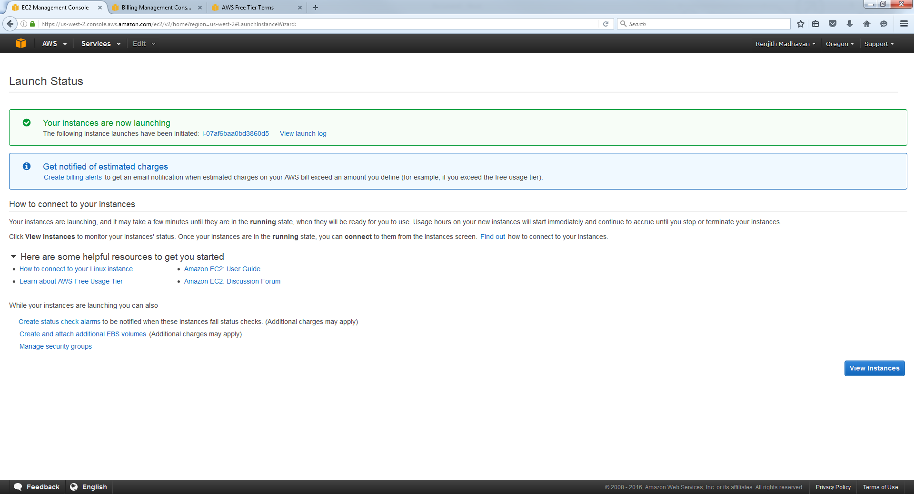

# AWS Management Console Screenshot

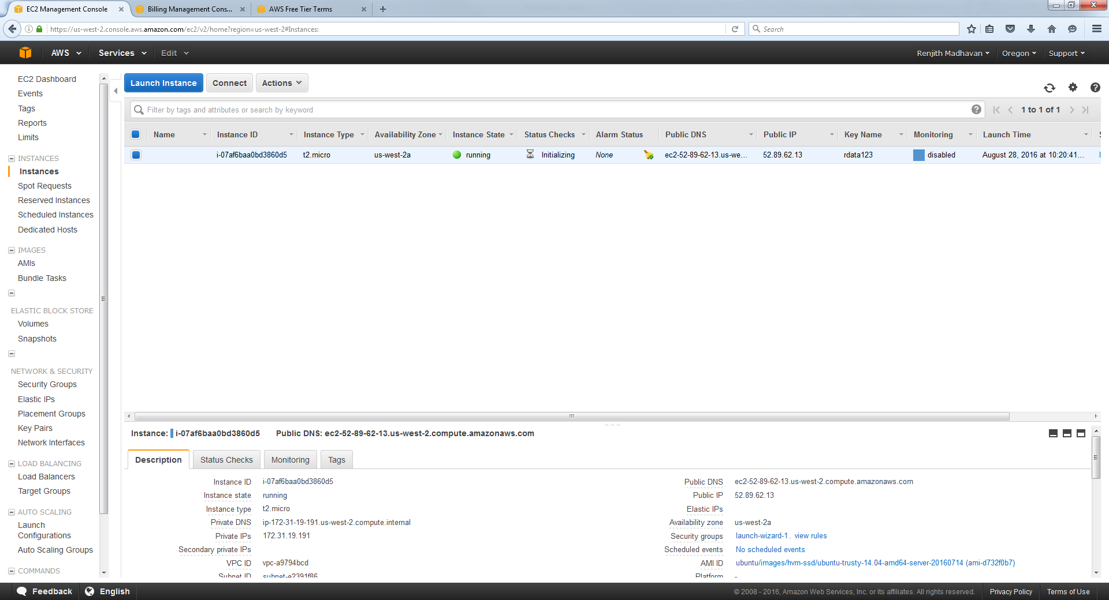

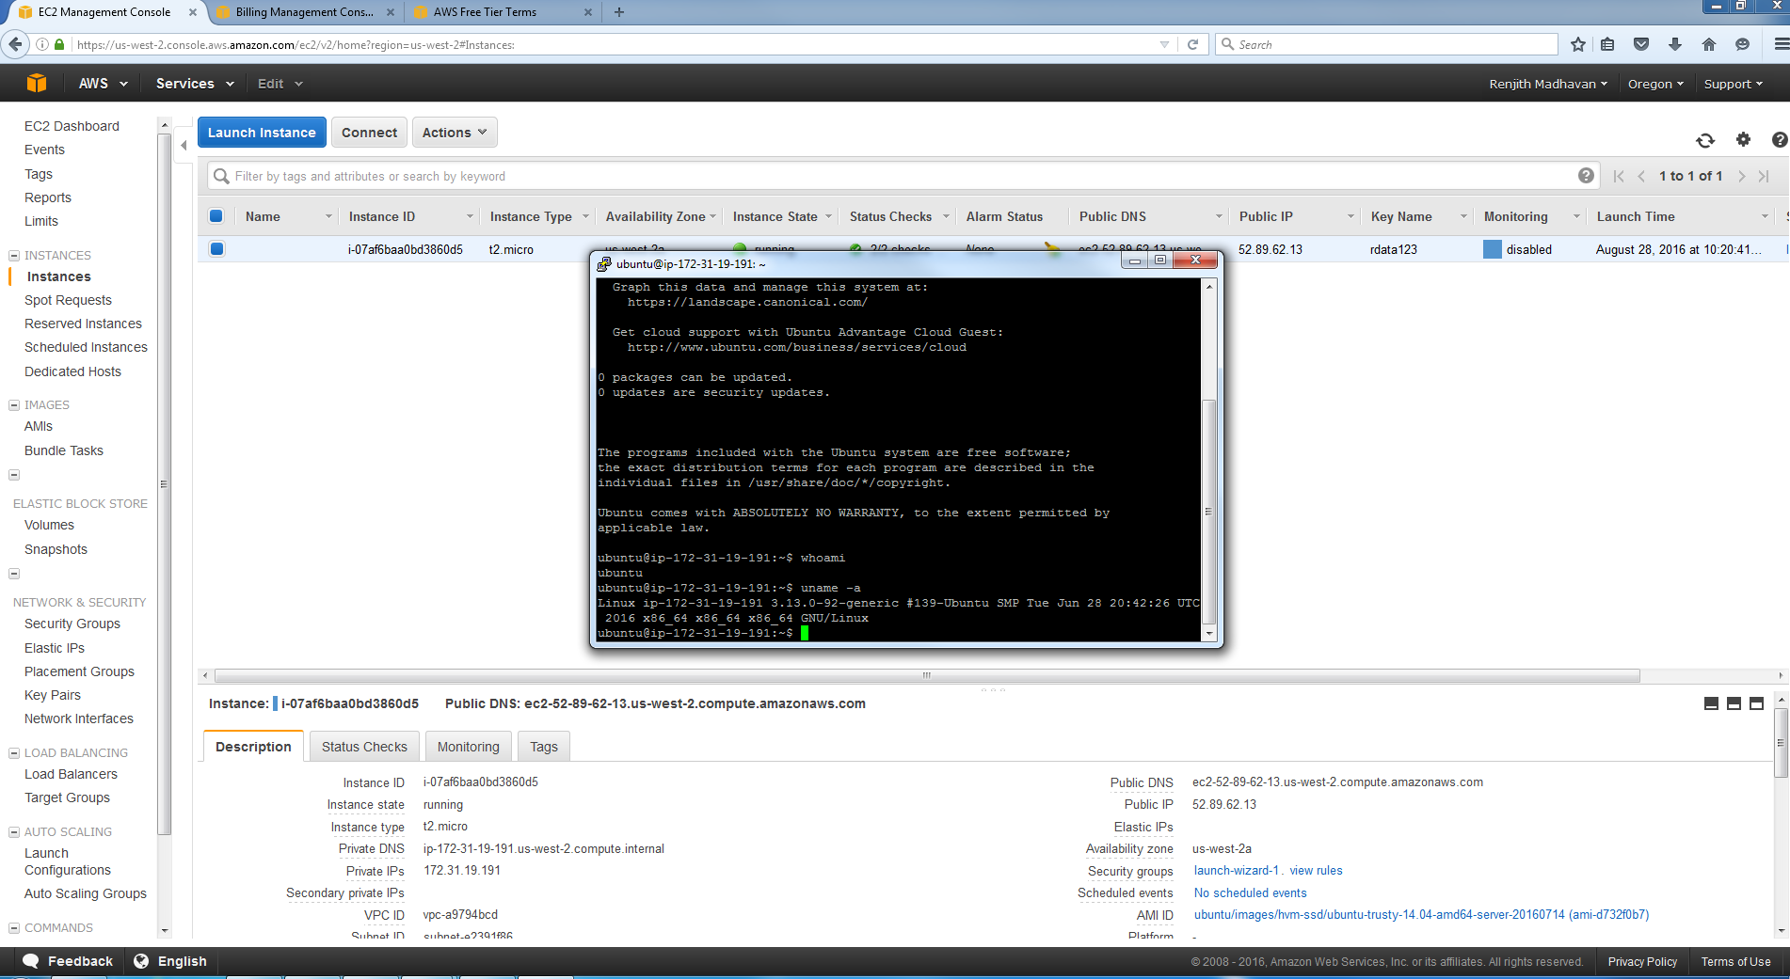

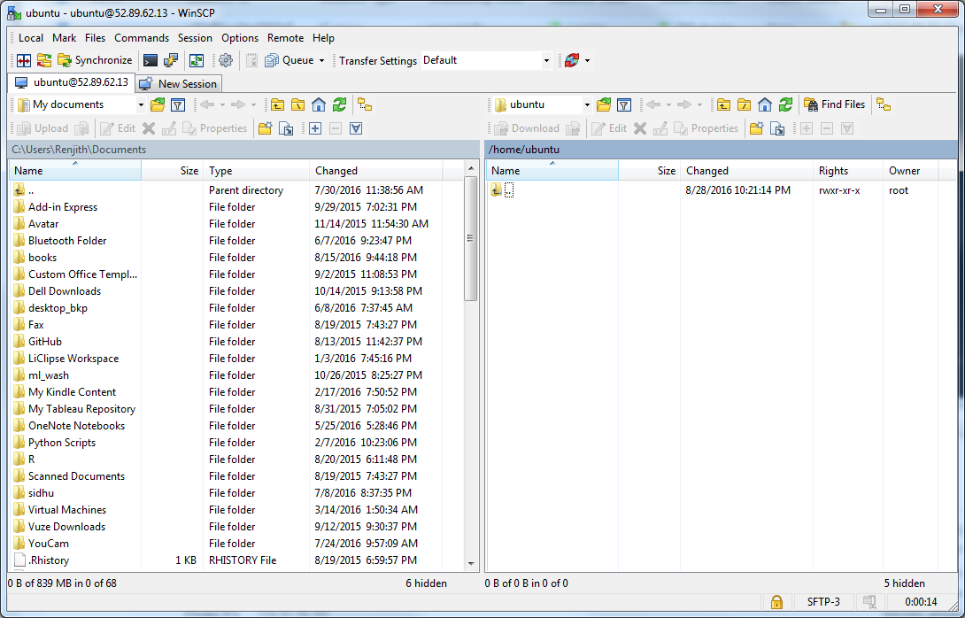

# Installing dos2unix

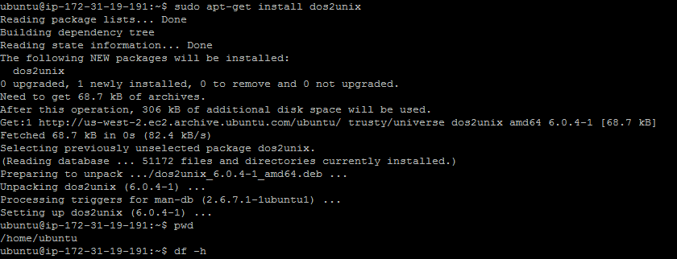

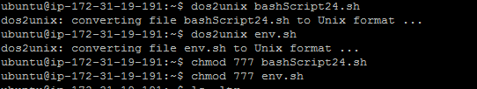

# Invoking “java”

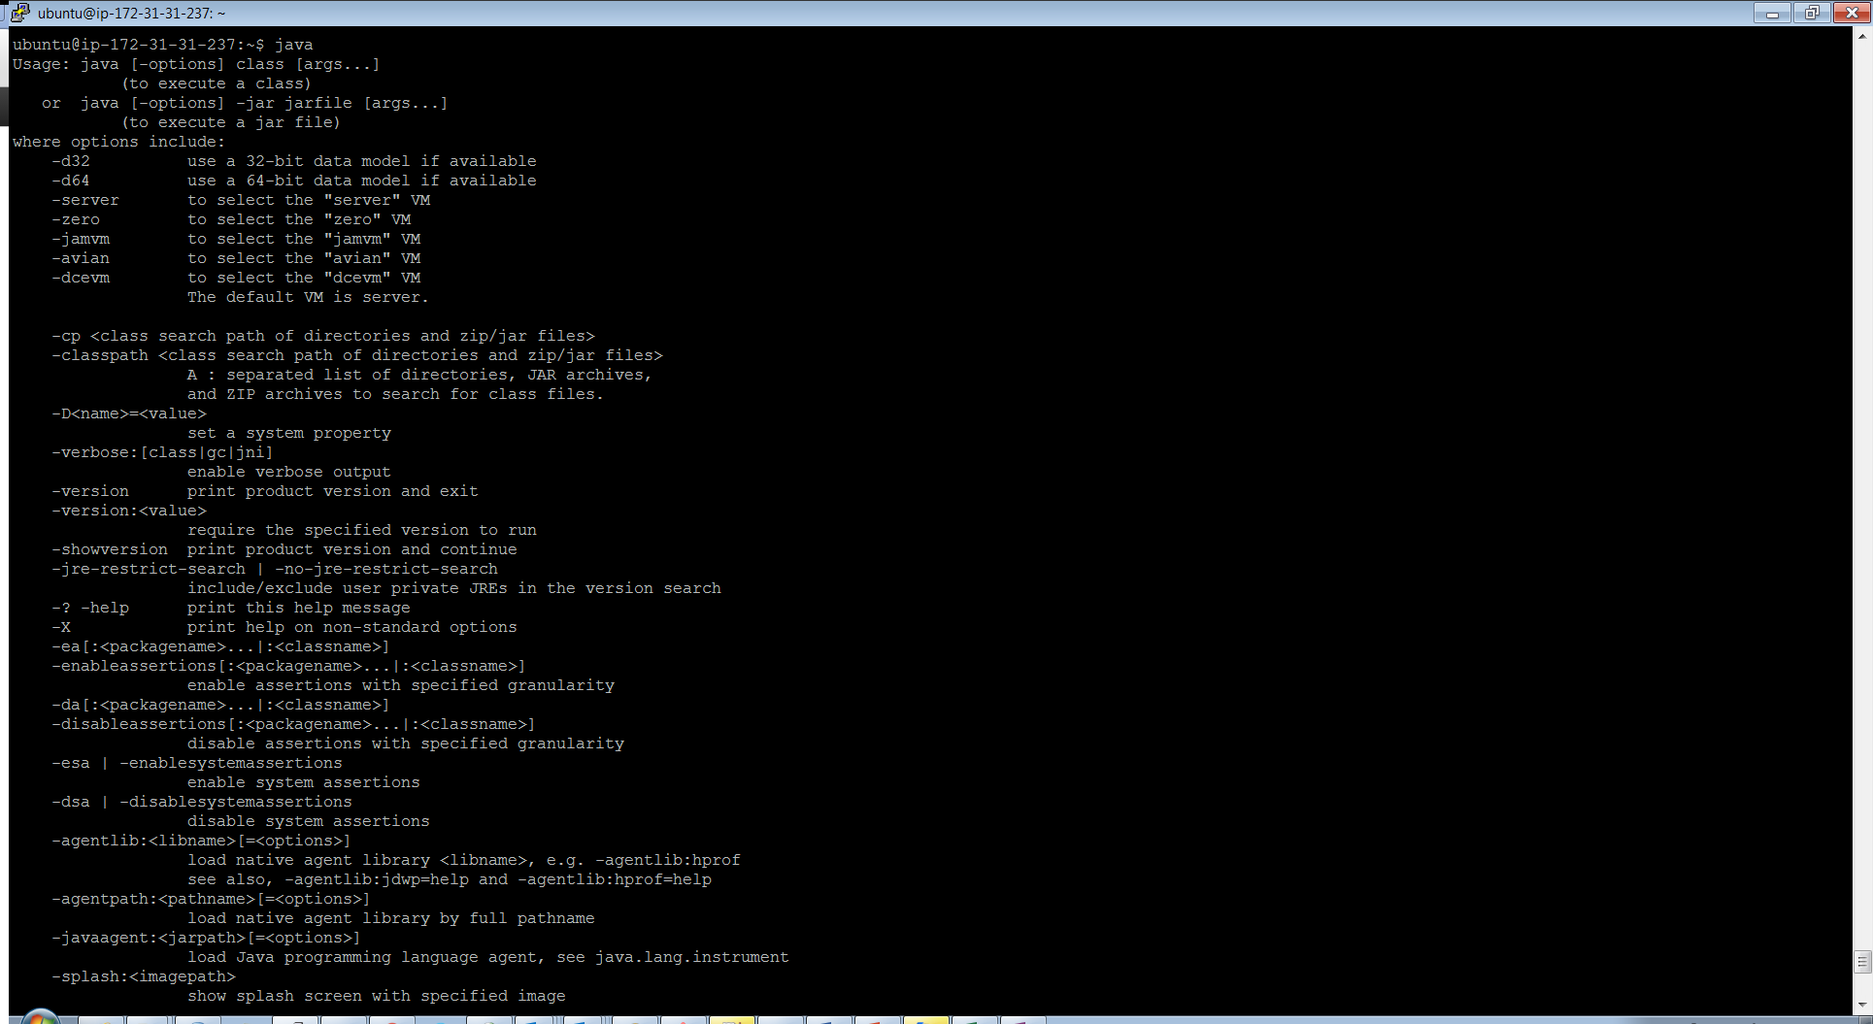

# Invoking “Hadoop”

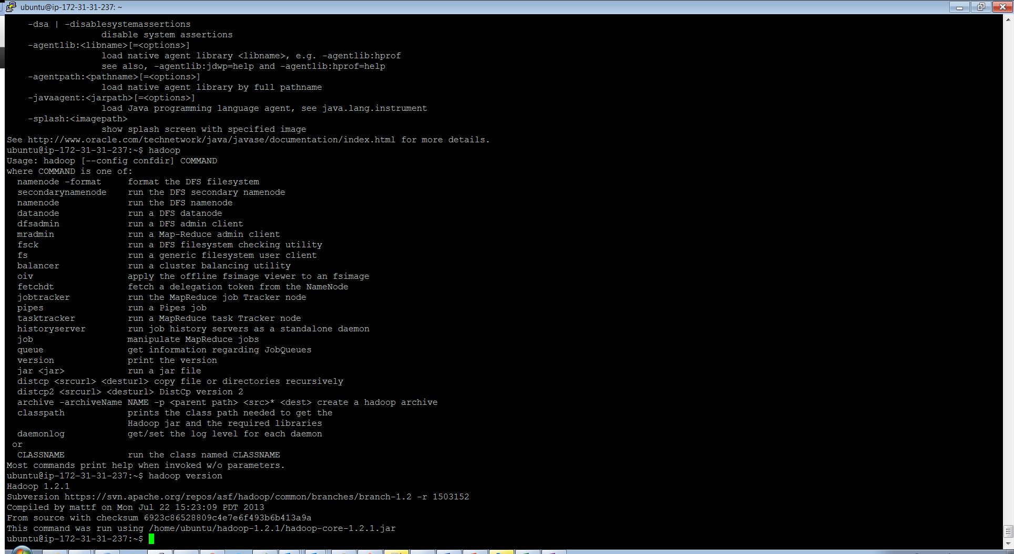

# Errors

File exists error while sourcing env.sh

Found that these directories are already created part of bashScript24.sh, hence can be ignored.

