Renjith Madhavan

MDS-535

Activity - 2

Contents

Hadoop Hello World Example (Java Based) 2

Input.txt content below: 2

Running wordcount on input.txt below: 2

Screenshot of output from output directory below: 3

Downloading the python files and changing permissions 4

Testing streaming using UNIX commands 4

Example 1 - Testing Hadoop Streaming using Python 4

Screenshot for the output below: 5

Example 2(dgrep.py) 6

Screenshot for the output (Example 2) 6

Example 3 ( logMapper.py) 7

Screenshot for output 3 7

# Hadoop Hello World Example (Java Based)

## Input.txt content below:

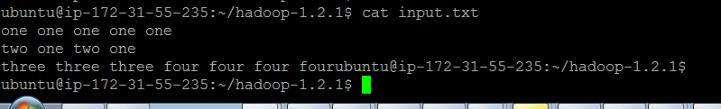

## Running wordcount on input.txt below:

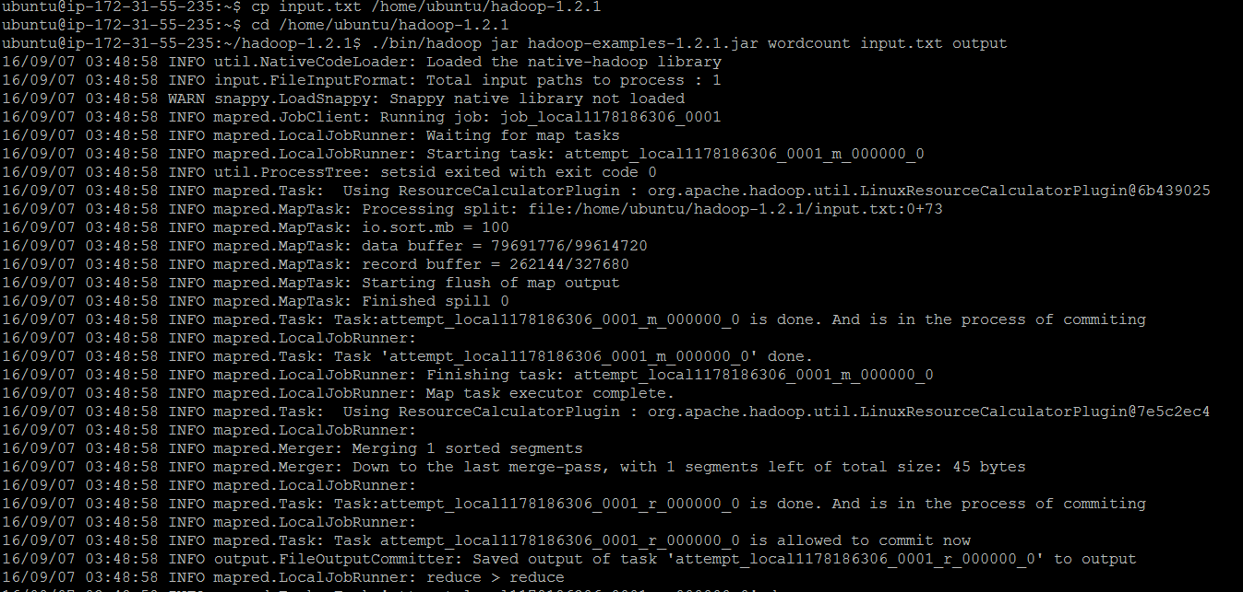

Screenshot continued from above...

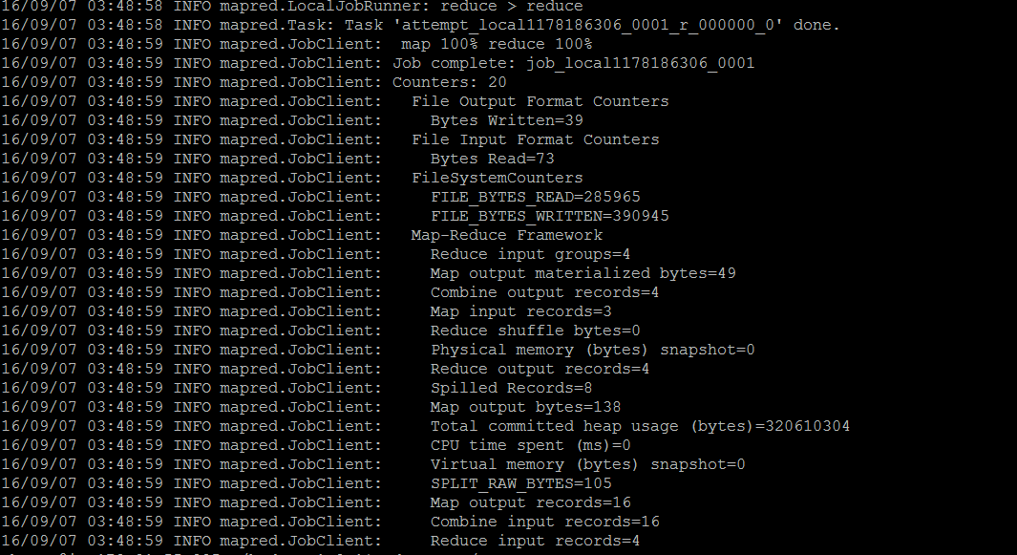

## Screenshot of output from output directory below:

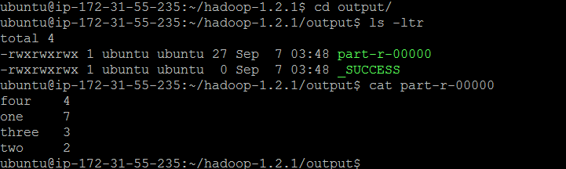

## Downloading the python files and changing permissions

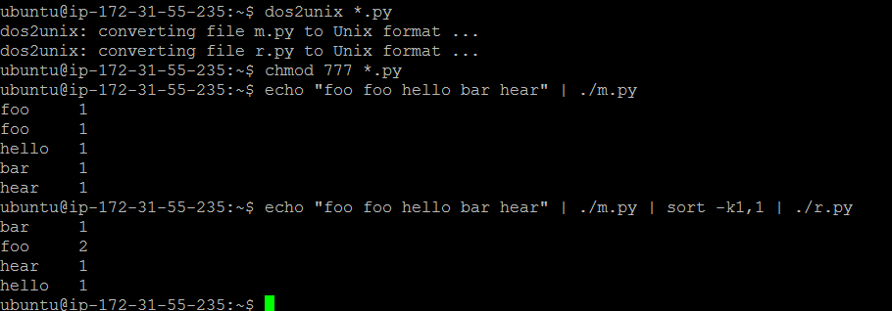

# Testing streaming using UNIX commands

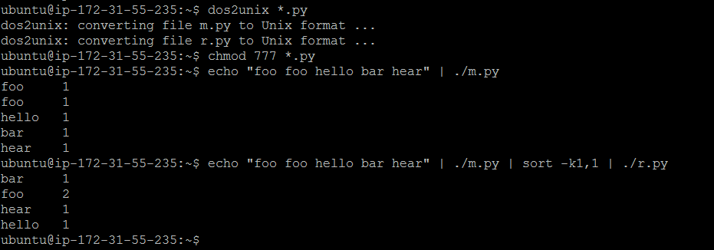

# Example 1 - Testing Hadoop Streaming using Python

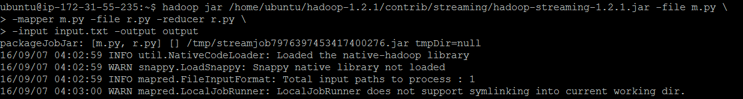

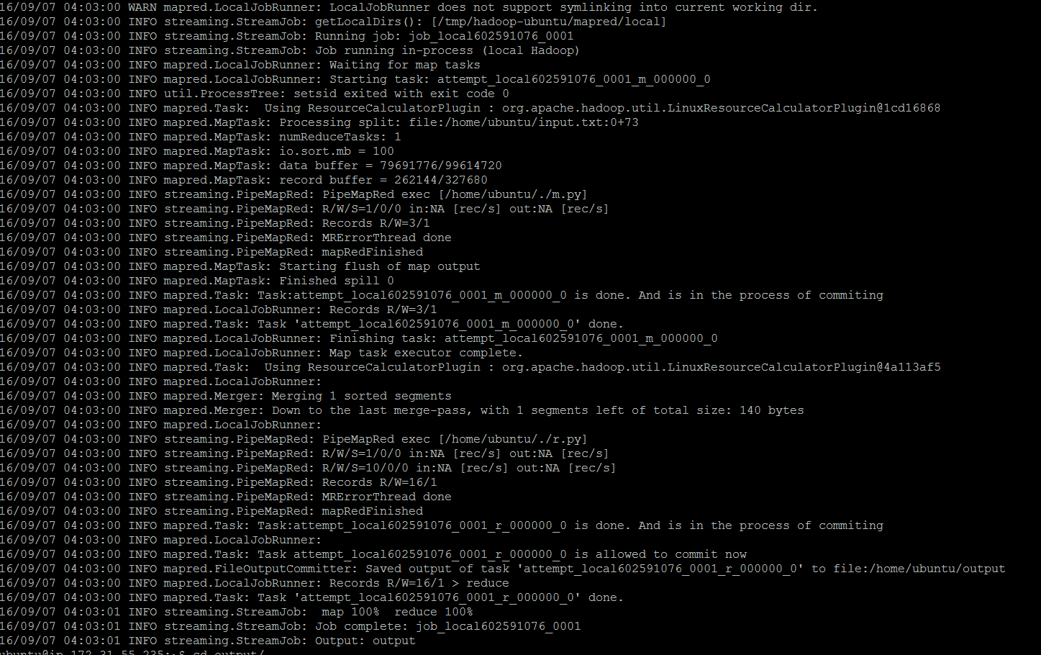

## Screenshot for the output below:

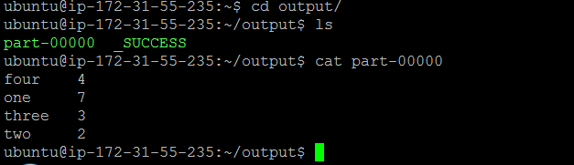

# Example 2(dgrep.py)

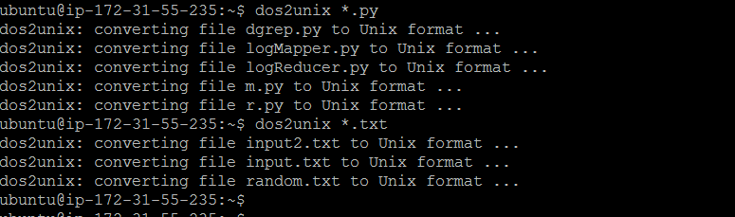

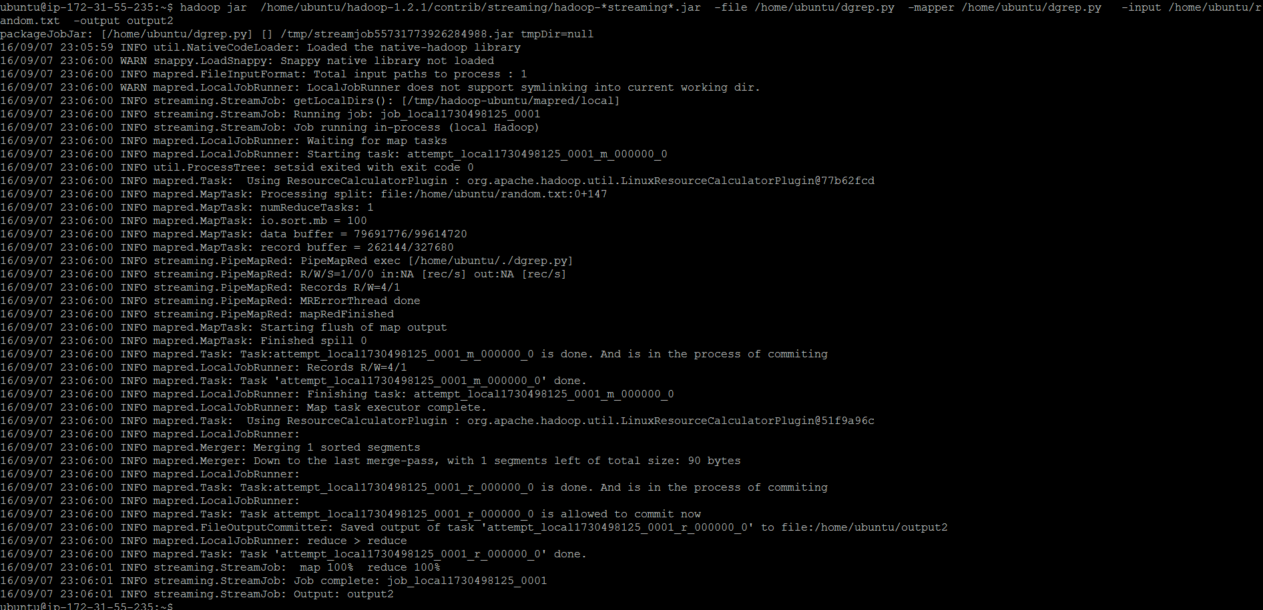

## Screenshot for the output (Example 2)

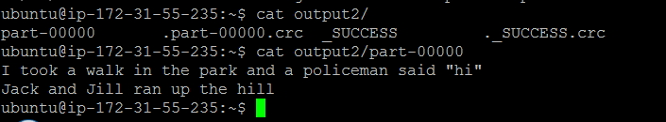

# Example 3 ( logMapper.py)

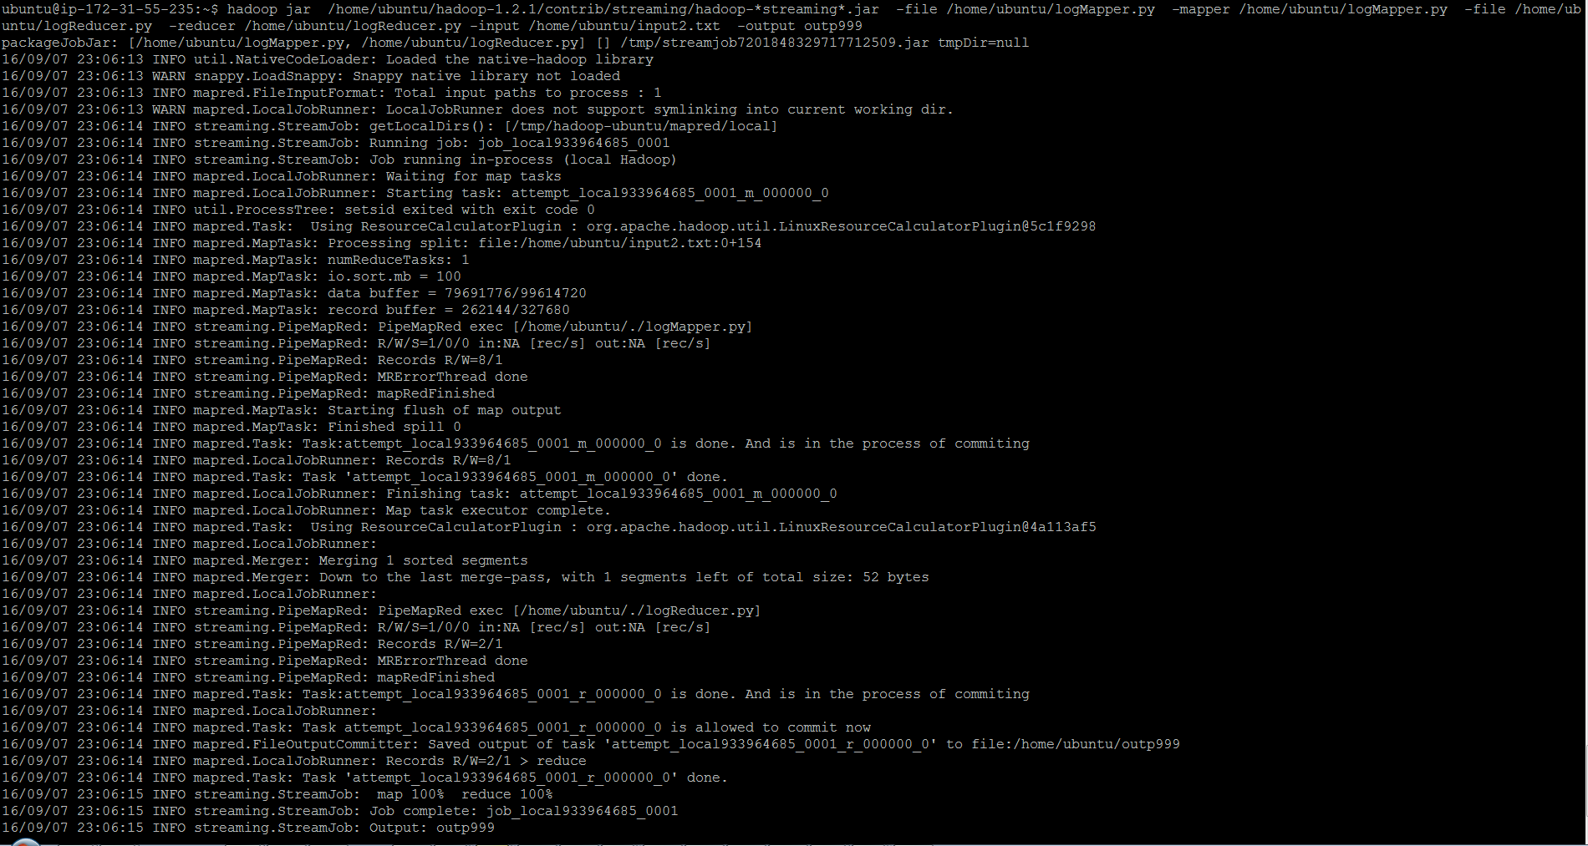

## Screenshot for output 3

