Renjith Madhavan

MDS-535

Activity - 3

Contents

MDS535_week_three_PIG_introduction 2

MDS535_week_three_PIG_introduction_v2_PART_TWO_V2 6

# MDS535_week_three_PIG_introduction

Pig –x local

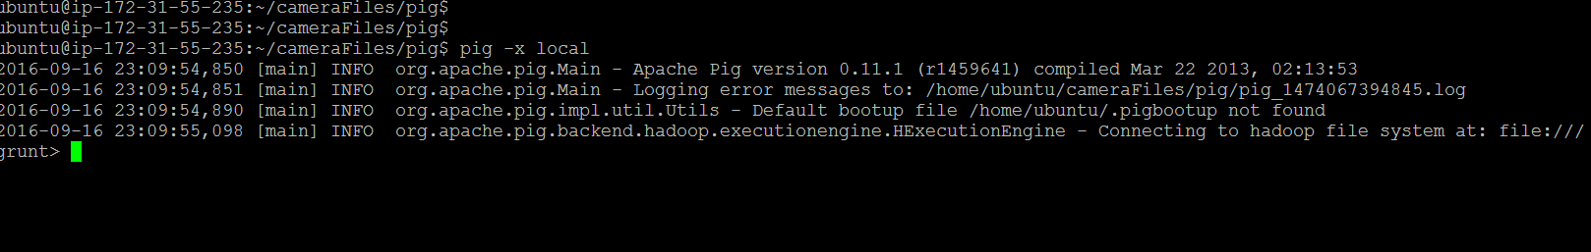

Grouping And Storing the results in a persistent file.

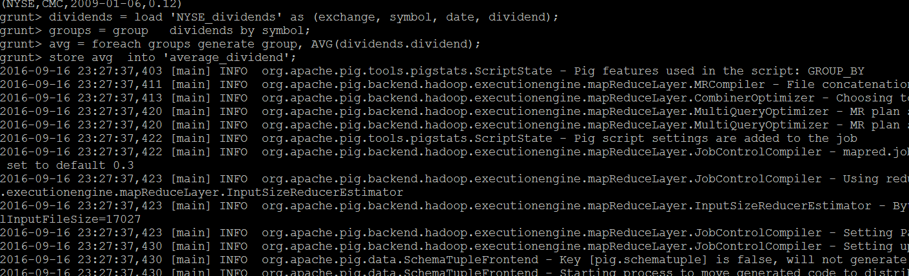

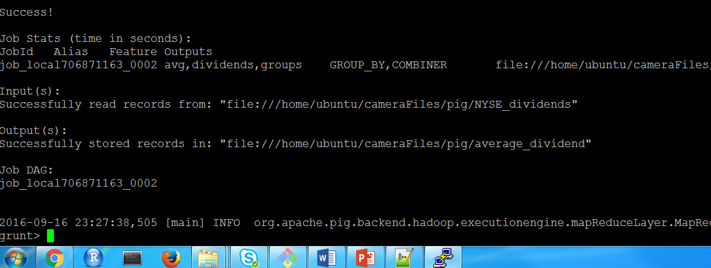

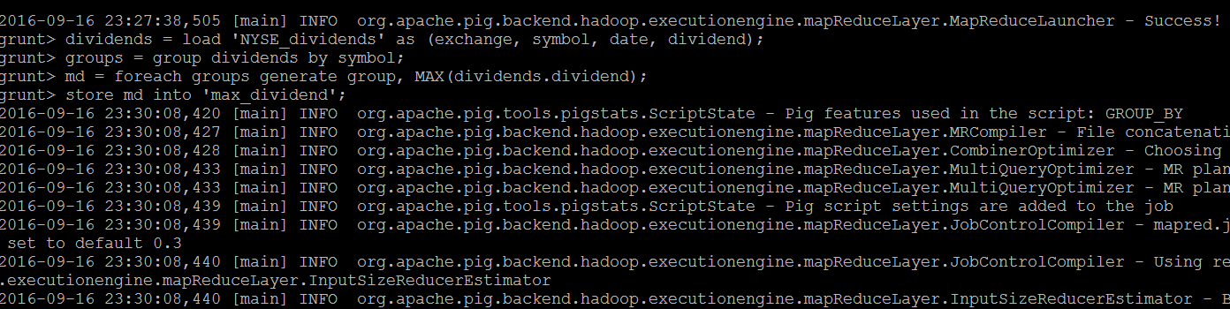

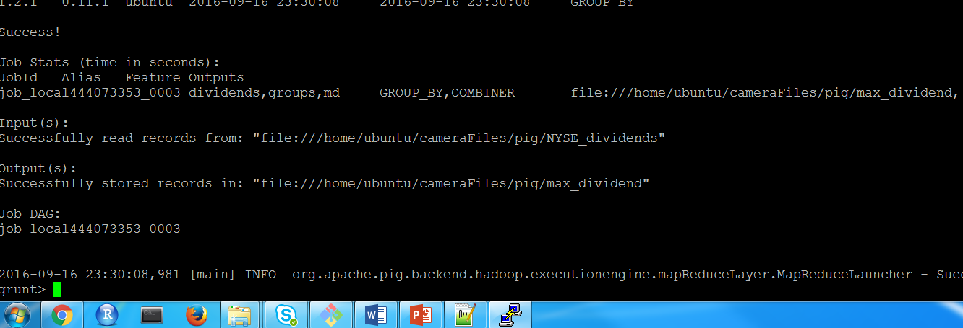

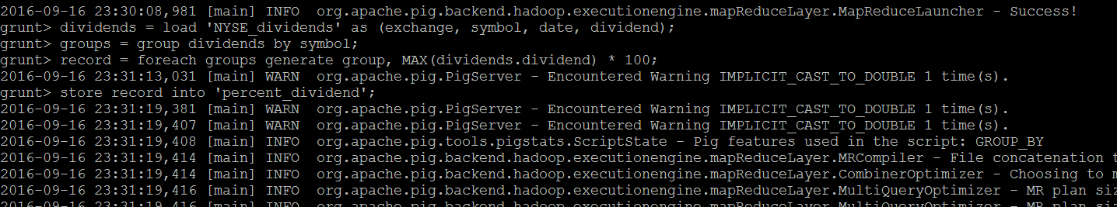

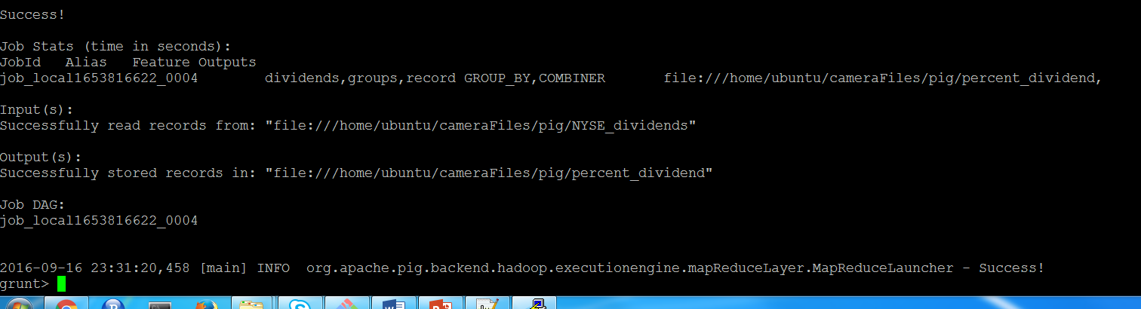

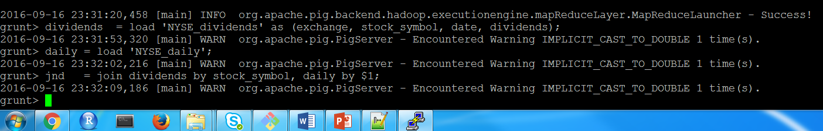

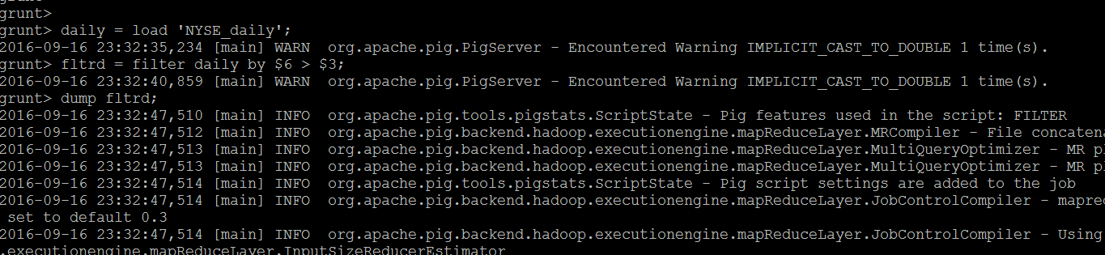

Dumping the First 10 results using “limit”

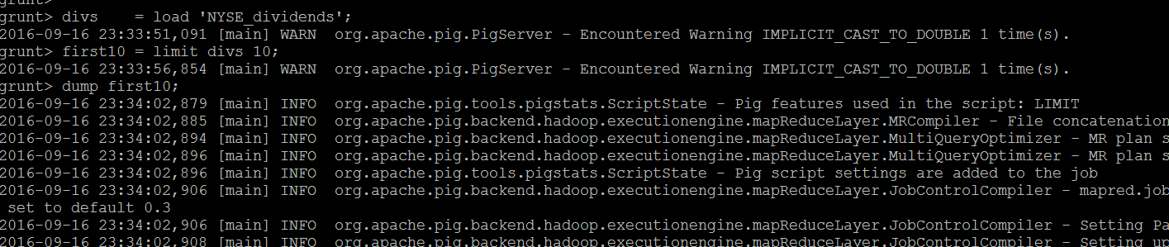

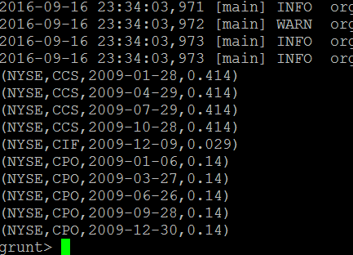

# MDS535_week_three_PIG_introduction_v2_PART_TWO_V2

Loading data from “small.log” file

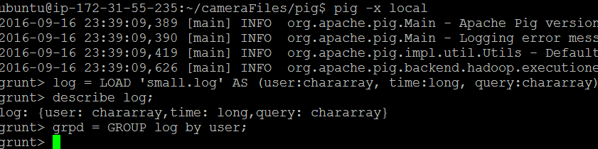

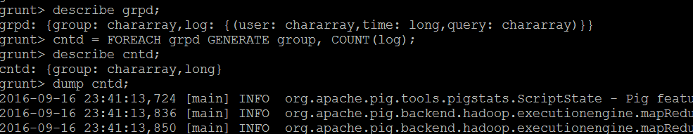

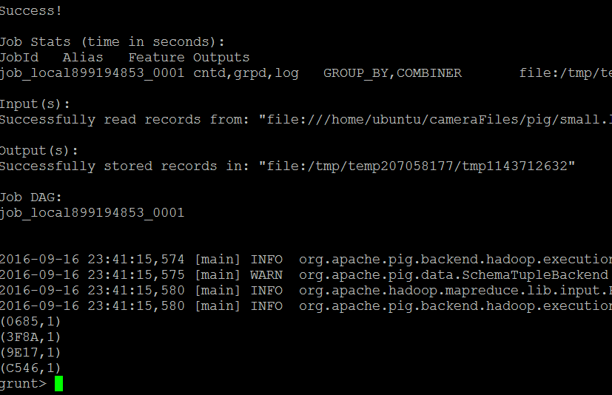

Loading Data from “Small2.log” file

