Renjith Madhavan

MDS-535

Activity - 4

Contents

Using Flatten 2

“foreach” noempty 4

Stock Data Analysis 5

Using distinct 6

Foreach and top 7

Foreach and count 8

Join using replicated 9

# Using Flatten

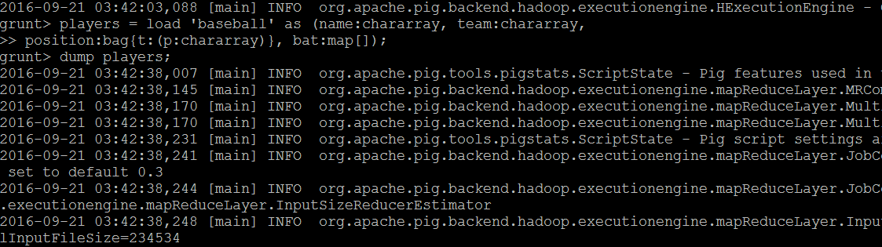

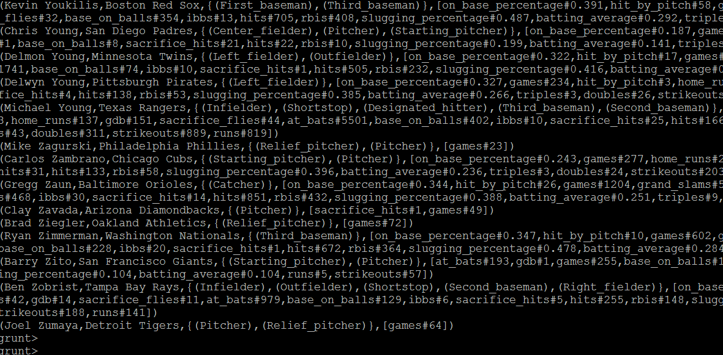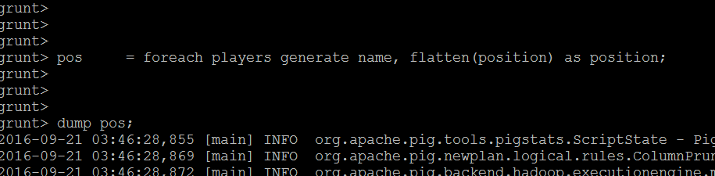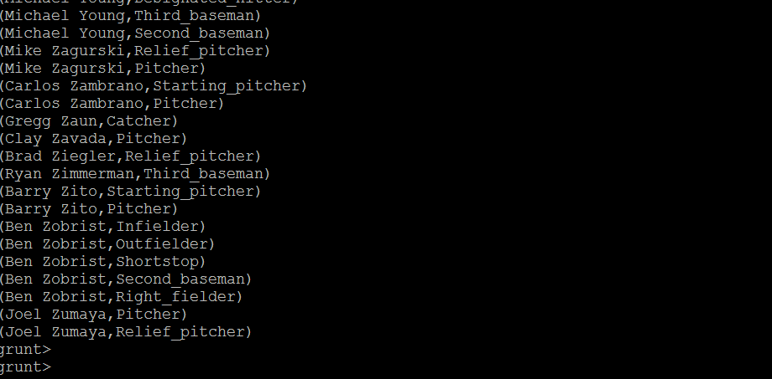

# “foreach” noempty

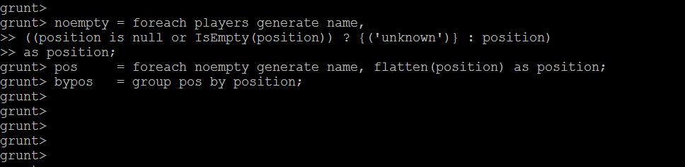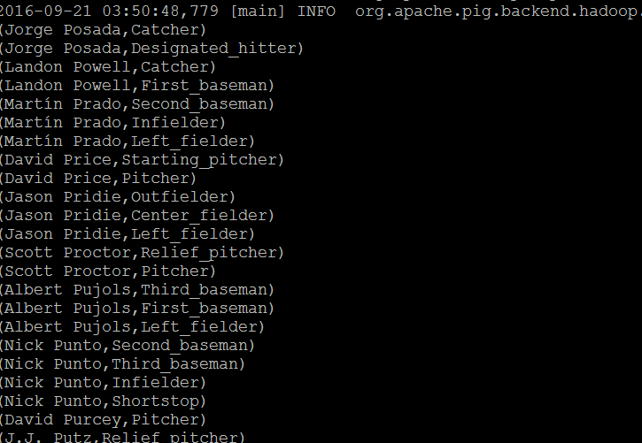

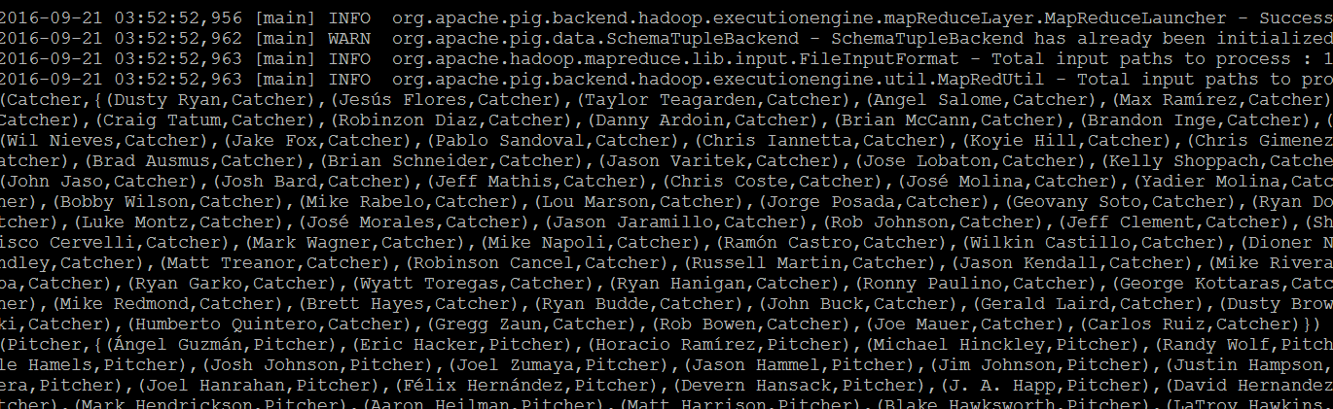

# Stock Data Analysis

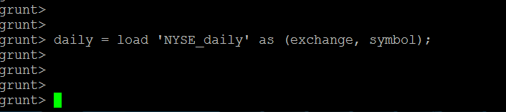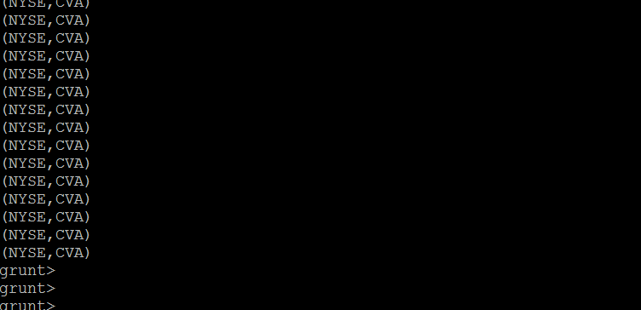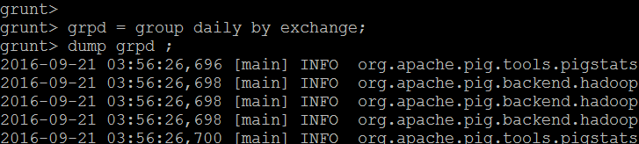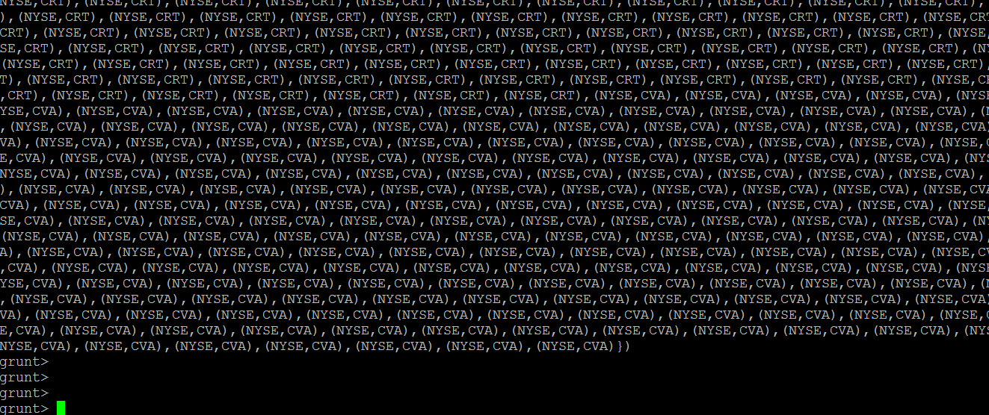

# Using distinct

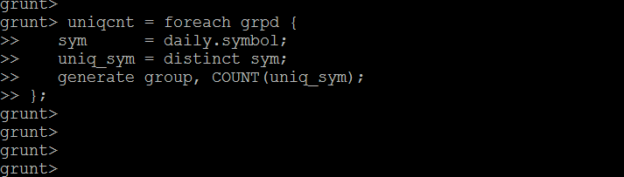

# Foreach and top

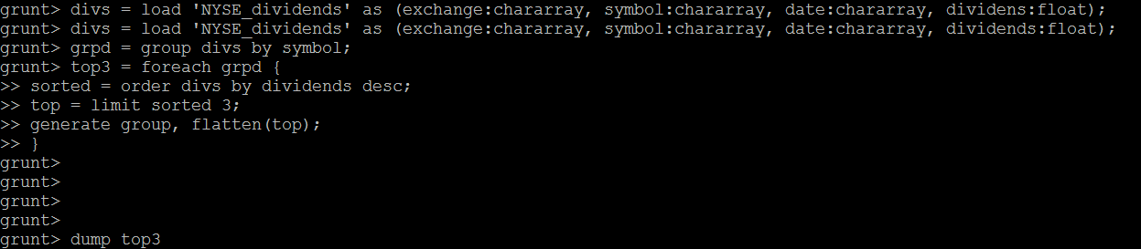

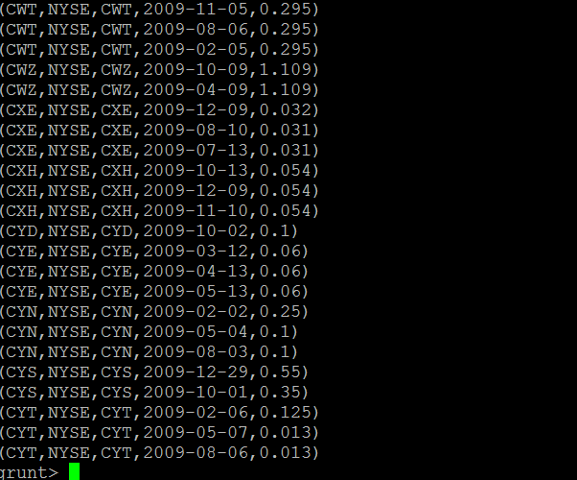

# Foreach and count

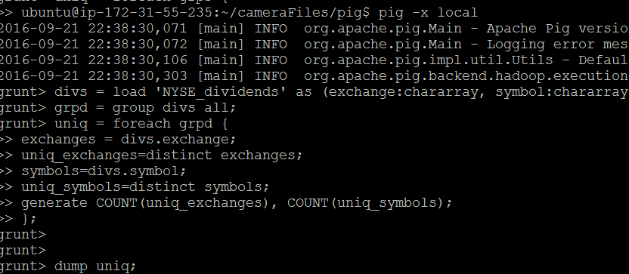

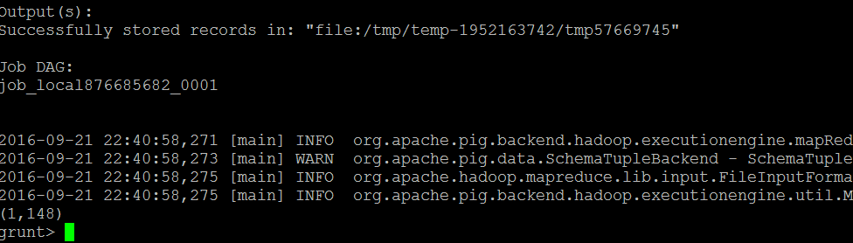

# Join using replicated

