Renjith Madhavan

MDS-535

Activity - 7

Contents

Reading a File 2

Collect and Count 2

Print the output 3

Parallelize 4

Estimating the value of “pi” 5

Spark SQL – Text File 6

SparkSQL – JSON File 8

# Reading a File

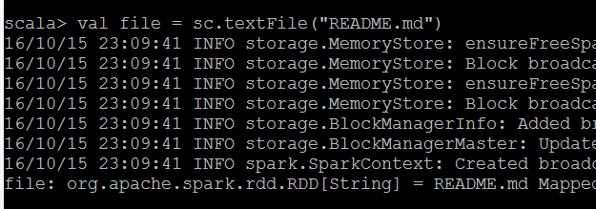

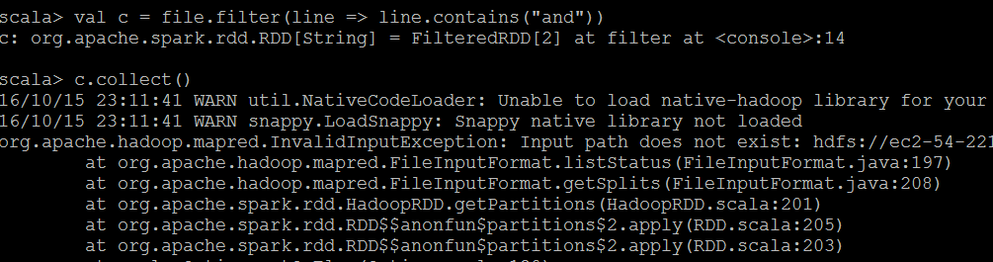

# Collect and Count

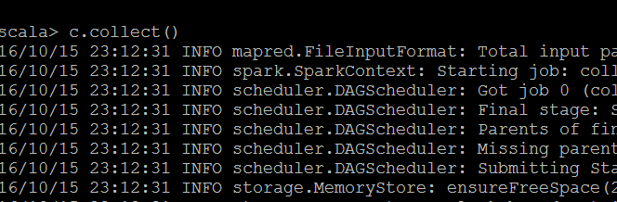

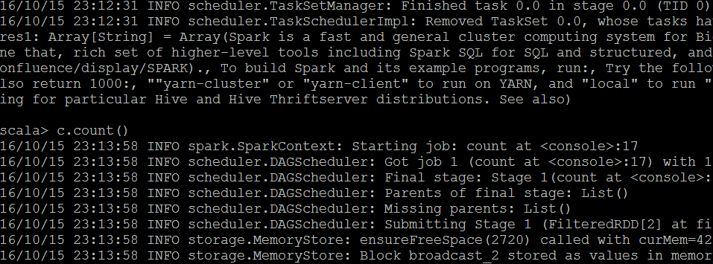

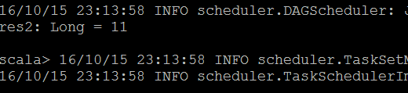

# Print the output

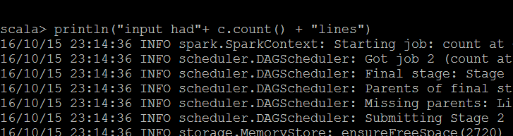

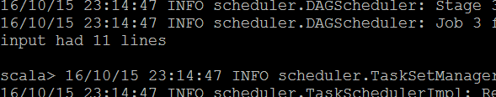

# Parallelize

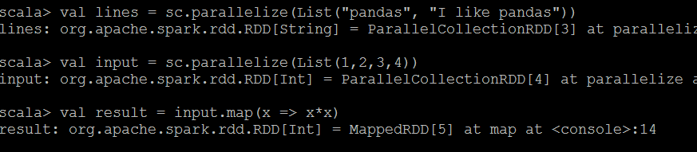

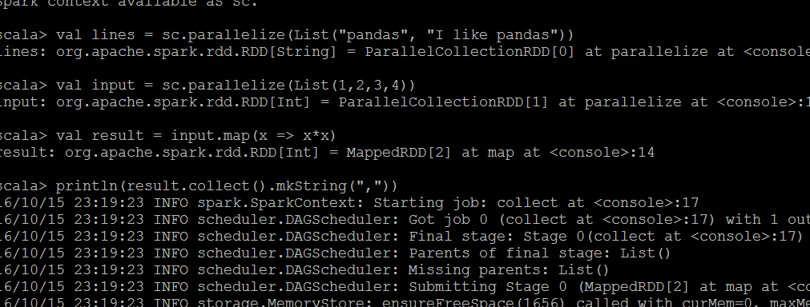

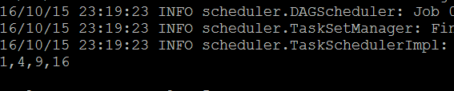

# Estimating the value of “pi”

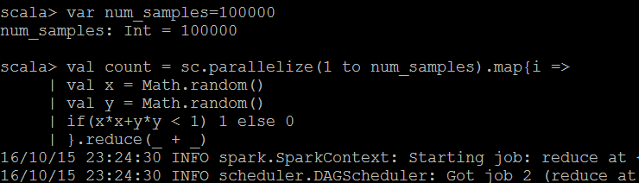

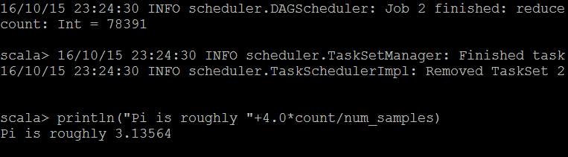

# Spark SQL – Text File

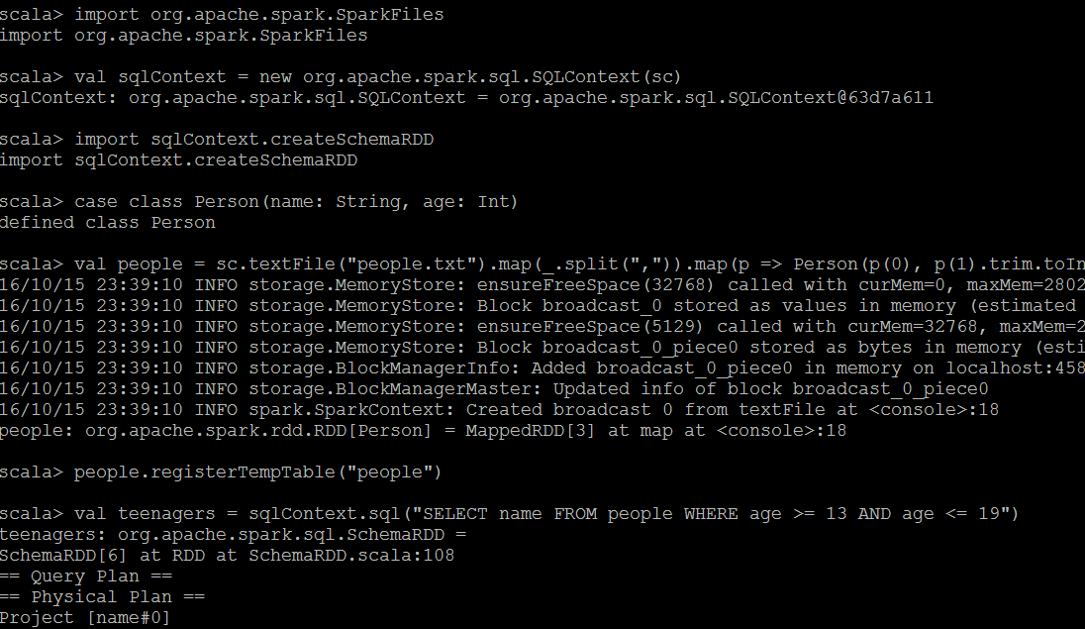

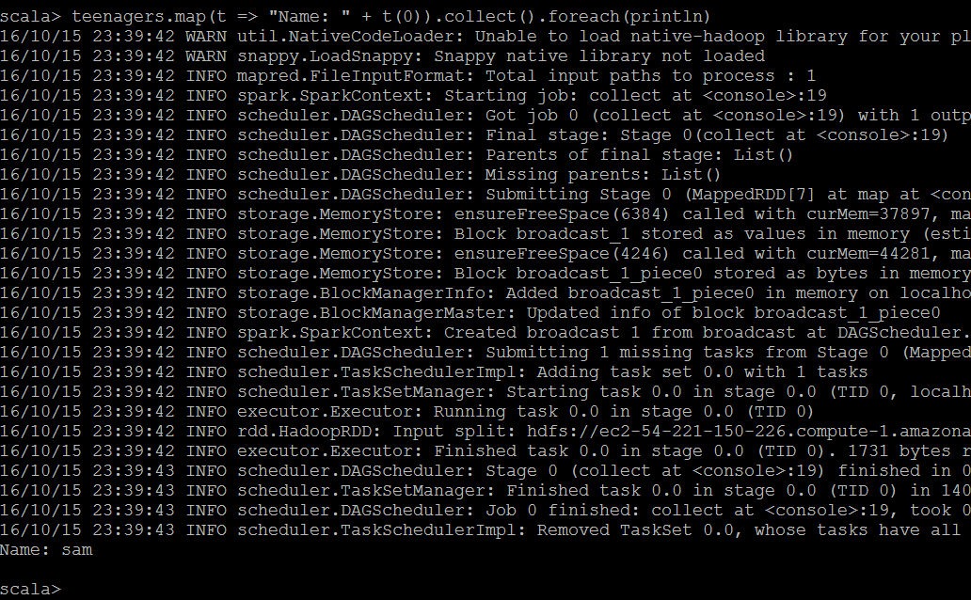

# SparkSQL – JSON File

