  - AOBP PLATFORM

Architecture, API &
Engineering Specification
Implementation contracts for independently deployed microfrontends, secure services and observable operations.
Version | 1.1
Date | 30 October 2026
Reference gateway | Spring Cloud Gateway; replaceable
Deployment | Kubernetes / Helm and Docker Compose
Status | Proposed implementation specification
  - Scope: React shell and remotes • Keycloak • BFF • Flight API • Business policies • WebSockets • Monitoring

Document guide
- 1. Design scope and delivery status
- 2. Architecture principles
- 3. Logical architecture
- 4. Microfrontend architecture
- 5. Gateway-neutral contract and Spring reference
- 6. Authentication and token lifecycle
- 7. Business authorization
- 8. WebSocket flow and scaling
- 9. API naming and resource modelling
- 10. Requests, responses and headers
- 11. Exceptions and error responses
- 12. Structured logging and audit
- 13. Reliability, security and event formats
- 14. Code structure, OpenAPI and quality gates
- 15. Standards reference register
- 16. Technology stack
- 17. Complete request tracing and error tracking
- 18. Kubernetes deployment and Helm specification
- 19. Docker and Docker Compose execution design
- 20. Data, audit and resilience
- 21. Acceptance and implementation sequence
- 22. Open decisions and provisional register
- 23. Official implementation references

1. Design scope and delivery status
This specification covers independently deployed React microfrontends, a replaceable API gateway, Spring Boot BFF, Keycloak identity federation, Flight Information API, backend business authorization, WebSocket updates, Kubernetes/Helm, Docker Compose and end-to-end observability.
Confirmed in this conversation: the UI is a separately deployed microfrontend application; Spring Cloud Gateway is the reference gateway but may be replaced; Keycloak, BFF, Flight API and business policies remain required. On-premises primary/AWS DR is a recorded working direction, not a validated recovery commitment. No source repository or running platform was inspected.
The API and engineering contracts below are normative platform proposals. The YAML fragments are design templates, not an executed deployment package. Container images, chart dependencies, certificates, DNS, secret provisioning and version-compatible configuration must be supplied during implementation. No throughput, HA or recovery claim is established by this document.

2. Architecture principles
Principle | Design consequence
Independent frontend deployment | Shell and remotes have separate images, pipelines, releases and rollback
Stable browser contracts | MFEs call relative BFF endpoints; they do not know internal service addresses
Replaceable gateway | Standard HTTP/WSS, OAuth/OIDC, OpenAPI and W3C trace context; proprietary routing stays at the edge
Separate session and edge concerns | BFF owns OAuth sessions; gateway owns routing and traffic protection
Identity-centric security | Keycloak authenticates; services authorize real business resources
Backend authority | UI capability checks improve UX but never grant access
Least privilege | Separate client identities, service accounts, secret access and namespace permissions
Durable state and audit | Transactional outbox for committed business changes; bounded asynchronous telemetry
Observable releases | Every request/event identifies service, release and deployment environment
Failure containment | Timeouts, bounded queues, concurrency limits and explicit degraded behaviour
Build once, promote unchanged | Images and manifests promoted by immutable digest
Evidence-based capacity | Resources, replicas, SLOs and DR targets validated against representative load

3. Logical architecture
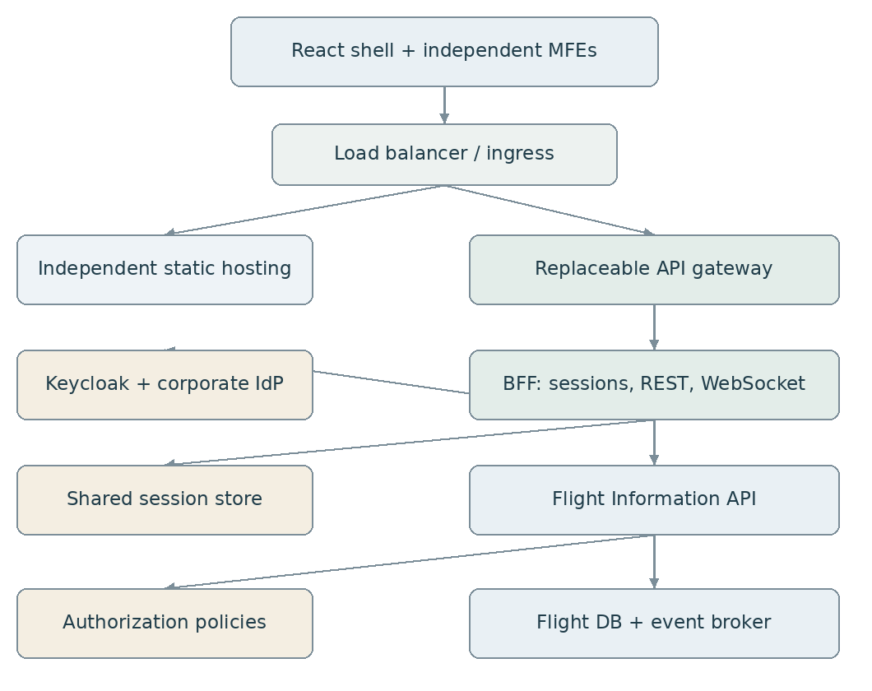
Logical architecture and trust boundaries
The entry point can be an ingress controller or external reverse proxy. It is a routing/TLS boundary, not a second application gateway with duplicate business policies. Static MFE traffic bypasses the application gateway in the reference topology, so gateway failure does not prevent downloading the shell; live functions still depend on the gateway/BFF. All browser application paths use one external origin. This does not imply a shared frontend deployment.
Keycloak uses a separate identity hostname and independently managed public authentication routes. Administration is private. The monitoring hostname is restricted to authorized operators.

4. Microfrontend architecture
Reference composition: React shell plus independently published flight and workflow remotes, using Module Federation or an equivalent runtime loader. Confirm the bundler and federation implementation before selecting packages. Route-based independently deployed applications are an alternative if runtime federation complexity is not justified.
Item | Ownership and contract
Shell | Navigation, layout, authentication state UX, design-system bootstrap, error boundaries, remote loader
Flight remote | Flight views and interactions; calls /bff/api/v1/flights/**
Workflow remote | Workflow/task views; calls its approved BFF contract
Shared browser SDK | Typed API client, CSRF handling, trace propagation, sanitized error reporting
Shared design system | Versioned UI contracts; defined compatible ranges
Session | One BFF session; no tokens stored by individual MFEs
Remote manifest | Maps remote name/version to immutable asset URL and compatible shell contract

Example external paths: /, /mfes/flight/1.4.0/remoteEntry.js, /mfes/workflow/2.1.0/remoteEntry.js, /bff/**. The ingress sends MFE prefixes to their own static services; the shell fallback must not swallow /bff, /mfes, OIDC callbacks or health endpoints.
Release process: publish immutable remote assets, run compatibility tests, update the environment remote manifest, then invalidate only the short-lived manifest cache. Hash-named assets receive long immutable caching; the remote manifest receives short caching/revalidation. Keep previous remote versions during rollback and existing browser sessions. Avoid overwriting one remoteEntry.js URL for every release.
Share React through a tested compatible version contract; do not force every remote dependency into a global singleton. Use per-remote error boundaries so a failed workflow remote does not blank the flight UI. Add a remote-loading availability metric and a controlled reload prompt for incompatible sessions.
Same-page MFEs share JavaScript execution privileges. They are not security isolation boundaries. Restrict who may publish remote code, protect asset integrity, review dependencies, and apply CSP. Use a sandboxed separate-origin iframe only when actual isolation is required, with its own integration constraints. Do not promise SRI support without validating the selected remote loader.

5. Gateway-neutral contract and Spring reference
Route class | Destination | Authentication responsibility
/bff/ws/v1 | BFF WebSocket endpoint | Session/origin at BFF; messages/subscriptions at BFF
/bff/** | BFF REST | Session and CSRF at BFF
/oauth2/authorization/** | BFF | Login initiation
/login/oauth2/code/** | BFF | OIDC callback validation
/api/v1/flights/** if enabled | Flight API | Bearer token at edge and API
Static assets | Independent UI services | No operational data in assets

Place the WebSocket route before the overlapping HTTP route and match the Upgrade header if the selected routing implementation requires it. Prefer native WebSocket transport initially. SockJS requires explicit additional HTTP routes and compatible load balancing.
Gateway configuration covers upstreams, methods, body/header limits, timeouts, quotas, trusted proxies, trace propagation and access logging. It does not contain flight object policies or OAuth browser session storage. BFF calls private API service addresses, avoiding an unnecessary external gateway loop.
Use declarative route configuration as the source of truth. Translate it to a replacement gateway during migration. Prove callback URI handling, cookie forwarding, WebSocket upgrade, quotas, trace context, failure responses and encoded-path behaviour before swapping implementations. Do not introduce a gateway-specific consumer database as the source of AOBP user permissions.
Spring reference dependencies: Gateway Server WebFlux starter, Actuator, Micrometer Prometheus registry, OAuth2 Resource Server for partner bearer routes, and a supported rate-limit implementation when required. Select a supported Spring Boot/Spring Cloud BOM combination together; do not mix examples from different release trains. Keep blocking DB or entitlement calls out of reactive gateway event loops.
A management UI is separate from monitoring. Grafana visualizes telemetry; production routes are changed through reviewed configuration and deployment. Expose Gateway Actuator inspection as read-only on a private management interface. Do not expose write/refresh/loggers/environment endpoints publicly.

6. Authentication and token lifecycle
Keycloak realm per agreed isolation boundary, with production separated from non-production. The BFF is the confidential OIDC client, using Authorization Code + PKCE and exact external callback URIs. React is not a separate OAuth client in this topology. Flight API has a controlled audience/resource identifier.
Corporate group mappings produce approved AOBP permissions. Avoid accepting arbitrary upstream group strings as application privileges. Use issuer plus subject as the stable identity; email is mutable. No application passwords. Minimal federated identity metadata and audit subjects are still required; this must be accepted under the no-local-accounts requirement.
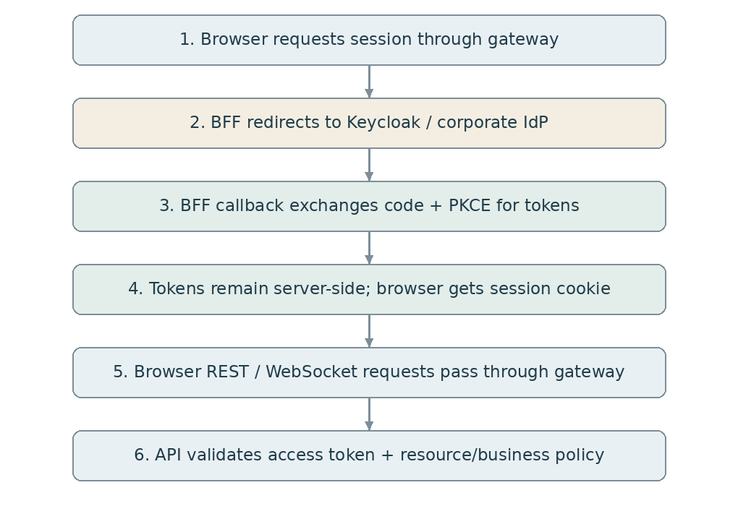
Authentication and authorized request flow
Cookies: Secure, HttpOnly, host-only, suitable path and SameSite for the actual OIDC response mode. Do not set broad parent-domain cookies. Keep tokens out of localStorage, frontend state, WebSocket URLs and logs. Protect unsafe methods with CSRF; use top-level navigation for login rather than expecting fetch to complete redirects.
BFF session state and authorized-client tokens must use a cluster-capable server-side repository; Spring Session alone does not guarantee every OAuth authorized-client implementation stores tokens in Redis. Verify the selected repository, protect token data at rest/in transit and coordinate refreshes for concurrent requests.
On refresh failure, invalidate the session and return 401 for API calls. Logout is CSRF-protected POST, invalidates the BFF session and closes associated sockets, then performs supported identity logout. Back-channel logout and account-disable propagation require explicit integration and tests.
Flight API validates issuer, signature, permitted algorithms, audience and times independently of the gateway. Configure the API audience explicitly. Cached signing keys support local JWT verification; key rotation and unknown-key handling must be tested. Short-lived JWTs still have a revocation window; agree a maximum revocation delay and implement current entitlement/revocation checks where required.

7. Business authorization
Layer | Checks
Edge | Network/request protections and coarse bearer scope for partner routes
BFF | Authenticated session, CSRF, approved routes and subscription controls
Flight API | Permission, object scope, field access and business invariant
Query layer | Authorized predicate before pagination/count/export
Workflow API | Current task eligibility, resource scope, claim/complete/reassign permissions

Example permissions: flight.read, flight.operational-time.update, flight.export, task.claim, task.complete. Designer/publisher permissions are independent from operational privileges. A studio manifest declares required permissions but cannot grant them to users.
ABAC input: validated subject, current entitlements, resource airport/terminal/airline from the database, requested action, session assurance where needed, and current flight/task state. Flight terminal and identity headers from the browser are never authoritative. Effective list scope is authorized scope intersected with requested filters. Deny by default.
Reference interface: FlightAuthorization.checkCanRead(subject, flight) and checkCanUpdate(subject, flight, requestedChanges). Implement initially with tested Spring policy classes or an OPA adapter. For polyglot reuse, distribute versioned policies to local evaluators. Supply dynamic resource data from the owning service. Define freshness bounds; deny protected actions if necessary policy/entitlement data is unavailable or stale.
Recheck update invariants under transaction/optimistic locking. A permission allow does not override an invalid business state. Use idempotency for retried commands. Do not automatically retry non-idempotent mutations at the gateway.

8. WebSocket flow and scaling
Browser connects to wss://aobp.example.com/bff/ws/v1 after login. The gateway proxies the upgrade; BFF authenticates the HTTP principal, validates Origin, and associates the connection with the session. With Spring STOMP security, send CSRF in CONNECT and authorize destinations/messages. Native WebSocket requires equivalent application controls.
On SUBSCRIBE, authorize the topic/resource against current scope. On event delivery, ensure recipients remain entitled, including role changes and changes to a flight's terminal/airline. Never broadcast all airport events and rely on React to hide them. Client-supplied destinations are not authorization evidence.
Flight API commits update + outbox record. Relay publishes a versioned event with event_id/business key. BFF receives it, finds authorized local subscriptions, and sends a minimal permitted payload. Use event ID and resource version to deduplicate and detect out-of-order changes. For complex payload security, send a scoped invalidation and let the browser re-fetch an authorized snapshot.
Multiple BFF replicas require fan-out to every replica holding relevant connections, or a broker relay/subscription architecture that accomplishes it. One Kafka consumer group delivers an event to one consumer, not every BFF. Do not use a single shared group as a broadcast design. Shared Redis sessions do not share live sockets or subscriptions.
Connections remain attached to their accepting instance. Native WebSocket generally needs no stickiness after upgrade; fallback transports may. Use graceful draining, connection/message limits, heartbeats, bounded buffers and slow-consumer disconnects. Reconnect with exponential backoff/jitter and obtain a fresh snapshot or replay cursor. Sockets are not a durable record of business state.
Map session expiry/logout to local socket closure across replicas; define bounded periodic checks because session notifications can be delayed. Server push/heartbeats must not keep a user logged in indefinitely. Define idle and absolute lifetime independently.

9. API naming and resource modelling
The rules in this chapter are AOBP platform conventions. They adopt HTTP, JSON, OpenAPI and Problem Details standards, but conventions such as URL versioning, camelCase fields and success envelopes are local choices, not universal industry mandates. MUST indicates an acceptance requirement; SHOULD allows a documented exception approved by the API owner and security/platform reviewer.

URI standard
Boundary | Canonical format | Example
Browser BFF API | /bff/api/v{major}/{resources} | /bff/api/v1/flights
Domain API, private or partner | /api/v{major}/{resources} | /api/v1/flights
Browser native WebSocket endpoint | /bff/ws/v{major} | /bff/ws/v1
BFF framework login endpoints | Framework-defined stable routes | /oauth2/authorization/keycloak
BFF framework callback | Exact registered redirect URI | /login/oauth2/code/keycloak
Health and telemetry | Private management endpoints | /actuator/health/readiness, /actuator/prometheus
Versioned MFE assets | /mfes/{name}/{release}/... | /mfes/flight/1.4.0/remoteEntry.js

Hostnames differ by environment; path contracts do not. Use https://aobp.example.com as the illustrative browser origin and https://identity.example.com as the issuer host. Partner APIs may use https://api.example.com while preserving /api/v1/.... Internal DNS names and ports never appear in browser contracts.
Paths MUST use lowercase plural resource nouns and kebab-case for compound segments. JSON/query/property names MUST use lowerCamelCase. OpenAPI path parameters use {flightId}; runtime requests contain an actual identifier, not braces. Avoid trailing slashes and ambiguous alternate spellings. IDs are opaque, immutable, non-PII references: a flight number plus date is not a reliable unique flight identifier. UUID is the reference representation; choose the UUID generation variant during implementation.
Do not include a service framework, deployment location, user identity, password, bearer token or action verb such as getFlights in the URI. Scope is enforced from trusted identity and resource data; a path airportId is not evidence of access. Keep nesting shallow and use nested paths only where ownership is real. URI versions identify breaking API contracts, not application releases. Additive compatible changes stay in v1; breaking changes need a new major contract and coexistence/migration plan.

Resource catalogue
Method and path | Meaning | Success
GET /api/v1/flights | Authorized filtered flight collection | 200
GET /api/v1/flights/{flightId} | One authorized flight representation | 200 + ETag
GET /api/v1/flights/{flightId}/operational-times | Read the operational-time subresource and concurrency token | 200 + ETag
PATCH /api/v1/flights/{flightId}/operational-times | Partial update of defined operational-time fields | 200 + new ETag
POST /api/v1/flight-change-requests | Create a governed operational change request | 201 + Location
POST /api/v1/flight-change-requests/{requestId}/approvals | Record an authorized approval | 201 + Location
POST /api/v1/flight-exports | Request an asynchronous export | 202 + Location
GET /api/v1/operations/{operationId} | Read asynchronous operation status | 200
GET /api/v1/flights/{flightId}/events | Authorized durable business history, if exposed | 200

These examples define the reference Flight API surface; each operation is implemented only if the business capability exists. POST does not imply blanket approval to create flight records. GET/HEAD MUST be safe; never use GET to update state or log out. PUT replaces the documented representation; PATCH updates explicitly permitted fields; DELETE means the documented deletion semantics, not a hidden arbitrary command. Use subordinate command resources for approvals/exports with lifecycle and audit needs.
BFF routes mirror or compose domain operations. One example mapping is /bff/api/v1/flights/{flightId} to /api/v1/flights/{flightId}. Do not blindly forward all HTTP paths/headers. Composition endpoints such as /bff/api/v1/flight-dashboard may combine responses while retaining explicit schemas and partial-failure semantics.

Filtering, pagination and sorting
Example: GET /api/v1/flights?airportId=BRU&terminalId=T1&airlineCode=SN&scheduledFrom=2026-10-30T00%3A00%3A00Z&scheduledTo=2026-10-31T00%3A00%3A00Z&limit=50&sort=scheduledTime,flightId.
Use RFC 3339 timestamps and a half-open time interval [scheduledFrom, scheduledTo). airportId=BRU is an illustrative configured airport key; distinguish it from airportIataCode or airportIcaoCode if those attributes are exposed. Validate named filters; never accept raw SQL, column names or arbitrary expressions. Sort keys are allowlisted; prefix descending keys with -. Always append a unique tie-breaker.
Cursor pagination is the reference for potentially large flight collections. limit defaults to 50 and is bounded at 200 as an initial platform convention; confirm against payload sizes and load. Cursor is opaque, integrity-protected, expires under a documented policy, and binds filters, sort and applicable authorization context. Reauthorize every page. Do not silently upgrade requested scope. Reject incompatible/tampered cursors with 400. Avoid mandatory total counts on large queries; use an optional separately budgeted count when needed.
Changing flight schedules can move records between pages. A normal cursor over live data is not a snapshot guarantee. For consistent exports, use a server-side snapshot/as-of strategy and a job. Restrict query ranges, export volume and execution cost.

10. Requests, responses and headers

Representation conventions
Use UTF-8 JSON with application/json for success responses; JSON Merge Patch uses application/merge-patch+json. Use a documented data envelope for business JSON responses. Errors MUST use the top-level Problem Details object and MUST NOT be wrapped in data or a second error envelope. Health probes, OIDC protocol responses, metrics, files, streams and 204/304 responses retain their protocol-defined representations.
Use lowerCamelCase fields, JSON booleans, numbers with documented bounds/precision, ISO dates and UTC RFC 3339 timestamps ending Z. Represent exact decimal monetary/measurement values as documented decimal strings when binary floating point would be unsafe; include units/currency. Enum values use UPPER_SNAKE_CASE and are explicitly documented. Define nullability per field: null means explicitly unknown/not available where allowed; absent means not included or not applicable according to that schema. Empty collections are [], not null. Do not serialize ORM entities or expose internal columns.
Reference single-flight response:
{
"data": {
"flightId": "f47ac10b-58cc-4372-a567-0e02b2c3d479",
"flightNumber": "SN1234",
"airportId": "BRU",
"terminalId": "T1",
"movementType": "DEPARTURE",
"operationalStatus": "SCHEDULED",
"scheduledTime": "2026-10-30T16:30:00Z",
"estimatedTime": "2026-10-30T16:40:00Z",
"actualTime": null,
"version": 17
}
}

Reference collection response:
{
"data": [
{
"flightId": "f47ac10b-58cc-4372-a567-0e02b2c3d479",
"flightNumber": "SN1234",
"scheduledTime": "2026-10-30T16:30:00Z"
}
],
"meta": {
"limit": 50,
"hasMore": true,
"nextCursor": "opaque-integrity-protected-cursor"
},
"links": {
"next": "/api/v1/flights?limit=50&cursor=opaque-integrity-protected-cursor"
}
}

Collection items use an explicit summary schema, not an accidentally truncated detail schema. BFF emits BFF-facing links and its own documented DTOs; do not leak internal URLs. At the last page use hasMore=false, nextCursor=null and omit links.next. Do not repeat HTTP status, success=true or generic messages in every successful body. Use headers for request correlation; do not add timestamps and trace metadata to all business payloads unnecessarily.

Headers
Header | Rule
Content-Type, Accept | Validate supported media types; 415/406 where appropriate
Authorization: Bearer ... | BFF-to-API and partner API only; redact everywhere
Cookie / Set-Cookie | BFF browser session only; redact everywhere
traceparent, tracestate | W3C trace propagation on allowlisted boundaries
X-Request-ID | Sanitized opaque HTTP interaction identifier returned to caller
Idempotency-Key | AOBP application contract for specified POST operations, not a guarantee supplied by HTTP itself
ETag / If-Match | Optimistic concurrency for versioned resources
Location | Newly created resource or asynchronous status URL
Retry-After | Applicable rate-limit/unavailable responses; honour before retry
Cache-Control | Sensitive/session responses default no-store; caching must be explicitly designed
WWW-Authenticate | Preserve appropriate bearer challenges on API 401

Generate/validate X-Request-ID at the trusted edge; internal spans may carry that value for a synchronous chain. A trace identifies distributed execution and may include retries; request ID identifies the interaction. Do not use either as user identity or an idempotency key. Do not expose arbitrary baggage fields. The BFF may return a correlation header but MUST NOT forward Set-Cookie/Authorization from unrelated downstream services.

Concurrency and PATCH
For the reference operational-times subresource, GET the subresource and receive a strong opaque ETag. PATCH requires If-Match and the documented merge-patch schema. Missing required precondition returns 428; stale If-Match returns 412. Return the new representation and new ETag on success. Never synthesize an ETag solely from a guessed client version. Authorize before exposing resource/version information.
The patch DTO allowlists fields such as estimatedTime. Explicitly reject forbidden and unknown input fields to prevent mass assignment. Define whether null clears a nullable field; reject null for fields that cannot be cleared. Use a transaction and version check so the conditional write and state invariants are atomic. Return 409 for genuine business-state conflicts, distinct from a failed HTTP precondition. GET flight detail may use its own representation ETag; do not assume it is interchangeable with a subresource ETag.

Asynchronous operations and idempotency
POST export returns 202 and Location /api/v1/operations/{operationId}. Status resource uses QUEUED/RUNNING/SUCCEEDED/FAILED/CANCELLED with createdAt/updatedAt and an authorized result reference when ready. A failed job's status GET can still return 200 because retrieving status succeeded; its documented error field describes the job failure. Result download rechecks authorization, expiry and data scope; private signed URLs are short-lived and never logged.
For selected POSTs, require an Idempotency-Key. Scope persistence by caller identity/organization, operation and key; store a canonical request hash and result in durable storage with a uniqueness constraint. Concurrent duplicate execution must be fenced. Same key/same request replays the documented original outcome; same key/different request returns 409. In-progress duplicates return the existing operation reference or a documented conflict. Start with a 24-hour retention proposal and agree it against client retry horizons. Do not claim idempotency after expiry. Never use pod memory as the only store. Reauthorize a replay and avoid storing secrets or unrestricted response bodies in the idempotency record.

11. Exceptions and error responses
Adopt RFC 9457 Problem Details for HTTP APIs, with Content-Type application/problem+json. Standard members are type, title, status, detail and instance. AOBP extensions are code, requestId, traceId and optional errors. Problem type URLs identify stable documentation, not internal stack traces. They should resolve to controlled API documentation. The public hostname below is illustrative.
{
"type": "https://api.example.com/problems/validation-failed",
"title": "Request validation failed",
"status": 400,
"detail": "One or more request fields are invalid.",
"instance": "urn:uuid:8e6699b3-5c73-4c72-9f56-1c68568b0918",
"code": "AOBP.VALIDATION_FAILED",
"requestId": "req_01J_EXAMPLE",
"traceId": "4bf92f3577b34da6a3ce929d0e0e4736",
"errors": [
{
"location": "body",
"pointer": "/estimatedTime",
"code": "INVALID_TIMESTAMP",
"message": "Use a valid RFC 3339 timestamp."
}
]
}

For query/path/header errors, use location plus parameter name instead of pretending there is a JSON Pointer. Do not include rejected secret/PII values. instance is a unique error occurrence identifier; it need not be a fetchable URL. traceId is present only when known and safe to disclose. Clients branch on code/type, never localized title/detail. Keep titles stable for a problem type.
HTTP | Code example | Trigger / handling
400 | AOBP.VALIDATION_FAILED | Malformed JSON, invalid fields, filters or cursor
401 | AOBP.AUTHENTICATION_REQUIRED | Missing/expired session or invalid bearer token
403 | AOBP.ACCESS_DENIED | Authenticated but lacks action/scope
404 | AOBP.RESOURCE_NOT_FOUND | Absent resource; also concealed inaccessible resource by agreed policy
405 | AOBP.METHOD_NOT_ALLOWED | Include Allow header
409 | FLIGHT.STATE_CONFLICT | Current business state disallows action
412 | AOBP.PRECONDITION_FAILED | Stale If-Match
413 | AOBP.PAYLOAD_TOO_LARGE | Request exceeds documented size
415 | AOBP.UNSUPPORTED_MEDIA_TYPE | Unsupported request representation
428 | AOBP.PRECONDITION_REQUIRED | Required If-Match absent
429 | AOBP.RATE_LIMIT_EXCEEDED | Include Retry-After where known
500 | AOBP.INTERNAL_ERROR | Unexpected application defect; safe generic detail
502 | AOBP.UPSTREAM_RESPONSE_INVALID | Gateway/BFF receives invalid upstream response
503 | AOBP.SERVICE_UNAVAILABLE | Necessary dependency unavailable/circuit open
504 | AOBP.UPSTREAM_TIMEOUT | Proxy deadline exceeded waiting for upstream

These are platform mappings, not proof all failures have one universal status. A domain invariant outside the current state may use a separately defined 422 contract; do not use 400/409/422 inconsistently for the same condition. Preserve actual HTTP status; never return 200 with success=false for an HTTP operation failure.

Spring implementation pattern
Component | Implementation responsibility
Controller | Validated request DTOs, ResponseEntity, documented headers and status
Application service | Use-case orchestration and transaction boundary
Domain | Typed business exceptions with stable codes, not raw HTTP coupling
Policy adapter | Typed authorization decision; trusted attributes
REST exception handler | @RestControllerAdvice, ResponseEntityExceptionHandler, Spring ProblemDetail
Security entry/deny handlers | Same JSON contract for filter-chain 401/403
Gateway handler | Reactive error handler for routing/timeouts; separate security handlers
BFF downstream mapper | Preserve approved domain errors; transform unsafe/unknown payloads
WebSocket layer | Message-level error contract after upgrade

MVC advice alone does not handle gateway reactive errors, security-filter failures or post-upgrade WebSocket errors. Implement those boundaries explicitly. Unexpected exceptions are logged once at the owning error boundary with the stack trace and returned as sanitized 500. Upstream layers record the dependency failure without repeating the full stack trace. Expected validation/business denials do not require ERROR stack traces. Do not catch Exception and return null or success.
ProblemDetail example for a business conflict (illustrative Spring code):
@ExceptionHandler(FlightStateConflictException.class)
ResponseEntity<ProblemDetail> handleConflict(
FlightStateConflictException ex) {
ProblemDetail p = ProblemDetail.forStatusAndDetail(
HttpStatus.CONFLICT,
"The flight cannot be changed in its current state.");
p.setType(URI.create(
"https://api.example.com/problems/flight-state-conflict"));
p.setTitle("Flight state conflict");
p.setProperty("code", "FLIGHT.STATE_CONFLICT");
// Common factory adds instance, requestId and current traceId.
return ResponseEntity.status(HttpStatus.CONFLICT).body(p);
}

Use a shared ProblemFactory and catalogue, with independent implementations for MVC and reactive stacks. Do not pass ex.getMessage() through to the caller without an explicit safe-message contract. Make framework-generated body parse, validation, unknown route, 401/403 and method errors conform too. A proxy/load balancer may still emit a generic transport error; frontend clients must tolerate non-JSON failures safely rather than crashing during JSON parsing.

12. Structured logging and audit

Canonical JSON log schema
Emit one JSON object per line to stdout/stderr, not multi-line text. Stack traces are escaped strings inside the JSON object. The following schema is an AOBP JSON export representation; OTel collectors map it to the OTel LogRecord's Timestamp, SeverityText, Body, TraceId, SpanId, Resource and Attributes. Dotted keys below are literal flat JSON keys. Do not mix a flat field and nested object with the same name in the backend index.
{
"timestamp": "2026-10-30T16:30:12.345Z",
"severity": "INFO",
"message": "Flight operational times updated",
"event.name": "flight.operational_times.updated",
"service.name": "flight-api",
"service.version": "1.4.0",
"deployment.environment.name": "production",
"site.id": "onprem-primary",
"trace_id": "4bf92f3577b34da6a3ce929d0e0e4736",
"span_id": "00f067aa0ba902b7",
"request.id": "req_01J_EXAMPLE",
"http.request.method": "PATCH",
"http.route": "/api/v1/flights/{flightId}/operational-times",
"http.response.status_code": 200,
"duration_ms": 43,
"business.action": "flight.operational-time.update",
"business.outcome": "SUCCESS",
"resource.type": "flight",
"resource.id": "f47ac10b-58cc-4372-a567-0e02b2c3d479",
"airport.id": "BRU",
"terminal.id": "T1",
"policy.version": "flight-policy-7"
}

Always include timestamp, severity, message, event.name, service.name/version and environment. Include trace_id/span_id only when an active trace exists; never invent placeholder IDs. Include workflow.instance.id, task.id, event.id and causation.id when relevant. Actor reference is pseudonymous and restricted to justified events; never log email/name routinely. Business identifiers and terminal details also need access/retention review.
Use an allowlist for logged HTTP headers; exclude Authorization, Cookie, Set-Cookie, CSRF tokens, credentials and signed URLs. Do not log complete query strings, SQL parameters, raw request bodies, process variables or upstream payloads by default. Normalize untrusted strings, enforce length limits and prevent log injection. Schema validation should detect accidental field-type changes. Redact at source, then enforce collector/index controls.
Severity | Use
DEBUG | Controlled diagnostics, off by default in production
INFO | Meaningful lifecycle/completion events; normal request summaries at selected boundaries
WARN | Recoverable degradation, exhausted client quota or notable expected failure by policy
ERROR | Unexpected defect or failed required operation needing investigation

Avoid logging every method entry/exit and every normal authorization permit at INFO. Expected 4xx events are tracked through structured access/security metrics without treating them as application defects. A denied privileged action is always security-audited; it need not contain a stack trace. Add error.code, error.type and exception.stacktrace for unexpected faults only at the owner. Sampling diagnostics does not authorize sampling required audit events.

Audit versus technical logs
Audit event fields: auditEventId, occurredAt, actor subject+issuer reference, executing service, action, resource reference, authorized airport/terminal scope, outcome/reason, policy version, application release, requestId/traceId and redacted change summary. Keep a named schema and version. Separate business effective time from audit recording time. Capture failed attempts separately from transactionally committed outbox records.
Audit writer privileges are append-oriented; readers are separately authorized. Protect retention, archival, integrity and privileged administration. Define legal/data-owner retention periods rather than inventing one retention duration for all datasets. Diagnostic log backend availability must not decide whether a transaction's required audit record is durable.

Logging implementation
Provide language-specific adapters to the common schema: Logback JSON encoder/structured logging for supported Spring versions; standard JSON log adapters for Node/Python/Quarkus. Common standards do not require every service to depend on a Java library. Propagate correlation through instrumentation, MDC/context and asynchronous/reactive context; clear context after request completion to prevent cross-user contamination. Test Reactor and executor propagation explicitly; a thread-local-only approach is insufficient.

13. Reliability, security and event formats

Timeout and retry budget
Reference starting budget for a normal interactive read: API response objective below 2 seconds under agreed load; API dependency budget below 2 seconds; BFF overall deadline 3 seconds; gateway deadline 4 seconds; browser deadline 6 seconds. These are initial proposals to validate, not established SLOs. Set specific connect/read/pool-acquisition deadlines inside that budget, reserve overhead and use separate budgets for exports/long-running actions. Never use a retry that exceeds the caller's remaining deadline.
Retry only documented transient failures for safe/idempotent operations, with bounded attempts, exponential backoff and jitter. Respect Retry-After. Do not retry validation, authorization, state conflict or stale preconditions automatically. Choose one retry owner to prevent gateway x BFF x API multiplicative attempts. No transparent replay of partial WebSocket messages. Use bulkheads and bounded pools/queues; a circuit breaker is for dependency failures, not ordinary business rejection.

Request security controls
Validate body/header sizes, JSON nesting, collection limits, date ranges and upload/download limits. Use parameterized database queries; allowlist sort and patch fields. Never deserialize arbitrary polymorphic types from untrusted JSON. Restrict outbound hosts to prevent SSRF. Use exact CORS/origin policies only where necessary; common browser origin simplifies but does not replace CSRF. Return no-store on session/operational responses by default, and avoid user-specific shared-cache leakage. Reauthorize exports and event subscriptions. Threat-model XSS in shared-privilege MFEs, CSRF, object-level authorization, replay and injection.

Event and WebSocket contracts
Use CloudEvents-style metadata when adopting CloudEvents, with specversion, id, source, type, subject, time, datacontenttype and data; do not call a custom envelope CloudEvents-compliant without validating the chosen transport binding. Reference event type com.aobp.flight.operational-times.updated.v1. Include resourceVersion and approved airport scope in data, plus correlation/causation metadata as defined extensions. Schemas are versioned and registered; consumers tolerate compatible additions and unknown optional attributes.
WebSocket message envelopes define protocolVersion, messageId, type, occurredAt and data. A message-level rejection contains code, safe message, relatedMessageId and request/trace reference where available; it is not an HTTP 400 after the connection has upgraded. STOMP ERROR framing/connection semantics must be followed rather than assuming every error can retain the connection. For application-level recoverable errors, use an authorized private error destination. Use standard close codes such as 1008 for policy violation, 1009 for oversized messages and 1011 for server failure as applicable; do not leak exception details. Define resynchronization after disconnect.

14. Code structure, OpenAPI and quality gates
Reference Java package boundaries:
com.aobp.flight
api # controllers, request/response DTOs, exception advice
application # use cases and transaction orchestration
domain # flight rules, domain types and typed exceptions
infrastructure # repositories, outbox, external adapters
security # authorization facade and policy adapter
observability # schema adapter and business metrics

Keep the gateway reactive and independent; BFF can use the Spring web stack selected for session/WebSocket needs; Flight API can use Spring MVC/JPA. Do not add both servlet and reactive web starters casually. Shared dependencies supply contracts, error factories and telemetry conventions; they must not contain flight domain logic or centralize all services in one release cycle.
Maintain an OpenAPI document per BFF/domain API and AsyncAPI or equivalent schemas for event/WebSocket contracts. Pin a supported OpenAPI version in tooling (3.1 is the reference if all generators/validators support it). Document security, operationId, permissions, query bounds, DTOs, nullability, headers, all status codes, Problem Details and examples. Gate breaking changes in CI and generate TypeScript clients after contract approval. JWT bearer security applies to domain APIs; BFF declares cookie-session security and documents CSRF, with custom UI handling where tooling lacks support. Publishing OpenAPI does not authorize operations.
Example operationId names: listFlights, getFlight, updateFlightOperationalTimes, createFlightExport. Specify read-only fields and additionalProperties rules in schemas. Unknown input fields are rejected for security-sensitive commands; clients tolerate additive response properties. Enum additions may break exhaustive clients, so classify them explicitly in compatibility rules. Do not change units, timestamp meaning, default sort or authorization semantics silently.
Gate | Evidence
URI/schema lint | Naming, version, operationId and examples conform
Contract compatibility | No unapproved breaking change; generated client integration passes
Negative API tests | Cross-terminal/object/field access denied; no mass assignment
Error consistency | Parse/security/gateway/domain failures follow correct contract
Concurrency | Two updates with one ETag cannot silently overwrite
Idempotency | Duplicate concurrent POST does not execute twice
Telemetry | Trace continuity, requestId and sanitized logs verified
WebSocket | Unauthorized subscribe/delivery, expiry, reconnect and fan-out tested
Capacity/reliability | Representative throughput, tail latency, timeout and outage behaviour measured
Deployment | Helm schema/security checks, migration compatibility and rollback verified

Definition of done: OpenAPI updated, contract and negative tests passed, policies approved, bounded dependencies configured, dashboards/alerts/runbook provisioned, audit delivery verified, image scanned/signed with SBOM, and deployment/recovery evidence retained. No claim of enterprise readiness is based solely on using a named product or pattern.

15. Standards reference register
Reference | Applied purpose
RFC 9110 HTTP Semantics | Methods, status, conditional requests and headers
RFC 9457 Problem Details | Standard HTTP API error representation
RFC 3339 timestamps | Interoperable date/time strings
RFC 7396 JSON Merge Patch | Documented partial-update representation
RFC 6585 | Additional statuses including 428 and 429
W3C Trace Context | Cross-service trace propagation
OpenTelemetry Logs Data Model | Trace-correlated structured telemetry
OpenAPI | Machine-readable synchronous API contract
CloudEvents / AsyncAPI | Optional governed event/async contracts

Official sources: https://www.rfc-editor.org/rfc/rfc9110 ; https://www.rfc-editor.org/rfc/rfc9457 ; https://www.rfc-editor.org/rfc/rfc3339 ; https://www.rfc-editor.org/rfc/rfc7396 ; https://www.rfc-editor.org/rfc/rfc6585 ; https://www.w3.org/TR/trace-context/ ; https://opentelemetry.io/docs/specs/otel/logs/data-model/ ; https://spec.openapis.org/oas/ ; https://cloudevents.io/ . These standards guide the design; AOBP-specific choices are explicitly identified above.

16. Technology stack
Capability | Reference stack | Selection note
UI | React + TypeScript, independently built shell/remotes | Federation implementation depends on bundler
Static hosting | Nginx or equivalent static service | Separate image per frontend
Gateway | Spring Cloud Gateway Server WebFlux | Replaceable through standard contracts
BFF/API | Supported Spring Boot + Spring Security | Separate services and dependency sets
Identity | Keycloak + dedicated PostgreSQL | Corporate OIDC/SAML federation
Sessions | Redis-compatible store | Verify client compatibility, support and exact selected distribution's licence
Flight state/audit outbox | PostgreSQL | Independent roles and schemas; audit archive separate
Business events | Kafka or RabbitMQ | Choose one based on replay/fan-out needs; not both by default
Policy | Spring classes; OPA adapter where shared governance needed | Version and test policies
Metrics | Micrometer, Prometheus, Alertmanager | Private scrape endpoints
Traces | OpenTelemetry Collector + Tempo | Alternative Jaeger possible
Logs | Structured JSON, collector + Loki | OpenSearch alternative for richer search
Dashboard | Grafana | OIDC login, scoped operational access
Packaging | Docker, Compose for development; Helm for Kubernetes | Immutable images
Delivery | CI plus Argo CD or equivalent GitOps | Build once, digest promotion

Open source is not the same as permissive licensing for every component. Review pinned component/image/plugin licences, including Grafana/Loki/Tempo distribution choices and the selected session store. Community software does not include a contractual support SLA. Produce an SBOM and licence inventory during delivery.

17. Complete request tracing and error tracking
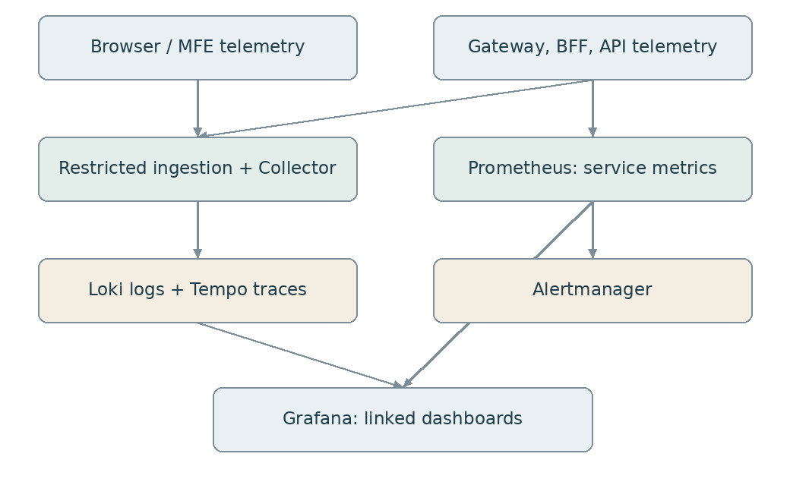
Telemetry collection and dashboard relationships
Use one documented instrumentation strategy per service. Avoid simultaneously enabling overlapping agents and Spring instrumentation that create duplicate server spans. Trace ingress/gateway, BFF and API separately and propagate traceparent/tracestate over approved boundaries. Enable sampling, exporters and log correlation explicitly; propagation alone does not export spans.
Browser SDK creates spans for navigation, remote load and approved API calls, tags MFE name/version, and reports sanitized JS errors/unhandled rejections and performance measurements. It is an implementation task, not an automatic capability of React. Initial navigation can precede SDK initialization; use navigation/resource timing rather than promising one browser trace covers every bootstrap request.
Browser telemetry credentials must not be secrets embedded in JS. Expose a restricted ingestion proxy with origin checks, rate/body limits, schema filtering and abuse controls. Do not expose a generic Collector receiver publicly. Propagate traces only to allowlisted destinations. Scrub query strings, user input and source-map payloads; protect private source maps used for symbolication. Treat browser-provided trace identifiers as untrusted correlation data, never authorization.
Structured fields: timestamp UTC, severity, service.name, service.version, deployment.environment, site, namespace, pod, route_id, MFE version where known, trace_id, span_id, request_id, event_id, workflow_instance_id, flight resource reference where permitted, error.code, outcome and duration. Avoid personal details and secrets. Gateway owns a sanitized request ID; client correlation values are length/format checked. No tokens/cookies/bodies by default.
HTTP spans capture transport status; domain events capture business outcomes. A 200 response can contain a business rejection and a 403 is not necessarily a software defect. Standard error response: stable error code, safe message, request/trace reference; detailed stack traces remain private. Track error fingerprints to group repeated defects.
Async events carry trace metadata plus event ID, causation ID and correlation/business-process ID. For fan-out or long delays, use trace links/new consumer traces rather than one unbounded trace. Metrics use bounded labels: service, route, operation, outcome. Never label by user/flight/trace/request ID or raw URL.
Telemetry has a defined loss policy. Sample traces; never present sampled traces as complete audit evidence. Tail/error sampling requires collector capacity and correct trace routing. Maintain durable audit independently. Bounded collector queues and retry storage prevent observability outages from exhausting application memory; monitor dropped telemetry.

Dashboard provisioning specification
Version-control data sources, dashboard JSON, alert rules and permissions. Use stable data-source UIDs (prometheus, loki, tempo). Configure trace-to-log links using trace_id; log-to-trace derived fields; metric exemplars where instrumentation and backend support them. Use dashboard variables environment/site/service/route/release. Do not expose broad data-source query access merely because a dashboard has filters.
Dashboard | Panels and drill-down
Platform overview | Service health, traffic, errors, p95/p99, deployment versions, saturation
Gateway | Per-route rate/latency/status, throttles, upstream failures, connections, event-loop pressure
BFF and identity | Session/login/refresh failures, session-store latency, revocation processing
Flight API | Endpoint latency, error codes, DB pool/waits, policy decisions, update conflicts
WebSocket | Active sessions, handshake failures, connection lifetime, messages/sec, delivery lag, disconnect reason, queue pressure
Browser/MFEs | Remote-load failures, JS errors, navigation/Web Vitals, API failures by release
Business operations | Flight-event freshness, overdue tasks, rejected updates, integration backlog
Audit/security | Denied actions, privilege/config changes and audit outbox age

WebSocket connection duration is not message latency. Add application metrics/spans for message processing and delivery. In a microfrontend page, Web Vitals are page-level; attribute remote actions/errors separately rather than claiming every page metric belongs exclusively to one remote.
Starter PromQL templates (verify actual exported metric/label names):
sum by (routeId) (rate(spring_cloud_gateway_requests_seconds_count[5m]))

histogram_quantile(0.95,
sum by (le, routeId) (rate(spring_cloud_gateway_requests_seconds_bucket[5m])))

sum(rate(http_server_requests_seconds_count{service="flight-api",status=~"5.."}[5m]))
/
clamp_min(sum(rate(http_server_requests_seconds_count{service="flight-api"}[5m])), 0.001)

Histogram buckets must be enabled. Prometheus scrape labels such as service must be configured consistently. Set low-traffic conditions for ratio alerts. Example triggers: sustained elevated 5xx with minimum traffic; p95 above agreed SLO; zero ready replicas; oldest outbox event over agreed threshold; rising event lag; dropped telemetry; certificate expiry; authorization service unavailable. Numerical thresholds are open decisions based on the workload. Route alerts to the correct support owner, with dashboard/log/trace links and runbooks.

18. Kubernetes deployment and Helm specification
Namespaces: aobp-edge, aobp-apps, aobp-identity, aobp-observability; data services in dedicated namespaces or managed/external services. NetworkPolicy requires a supporting CNI. Permit only intended ingress, egress, DNS, identity, telemetry and data-service flows. Do not rely on namespace separation alone.
Chart structure:
charts/
aobp-edge/ # gateway, Service, HPA, PDB, management access
aobp-shell/ # shell static deployment
aobp-flight-mfe/ # independent remote deployment
aobp-workflow-mfe/ # independent remote deployment
aobp-bff/ # session-aware BFF and WS service
aobp-flight-api/ # API, policy adapter, migration job reference
aobp-observability-config/ # dashboards, rules, collectors, data sources
environments/
dev/ staging/ prod-onprem/ dr-aws/

Keep charts independently releasable. An environment orchestration layer may order releases but must not force a shell deployment for every remote change. Pin upstream identity/observability chart versions and verify chart/image licences. Stateful production services need tested operators/managed services or explicit operational ownership; a Deployment plus PVC is not a complete HA database design.
Illustrative component values, not universal sizing:
image:
repository: registry.example.com/aobp/flight-api
digest: "sha256:REPLACE_WITH_VALIDATED_DIGEST"
replicaCount: 2
service:
port: 8080
management:
port: 9090
resources:
requests: {cpu: 250m, memory: 512Mi}
limits: {memory: 1Gi}
autoscaling:
enabled: true
minReplicas: 2
maxReplicas: 6
targetCPUUtilizationPercentage: 65
podDisruptionBudget:
minAvailable: 1
terminationGracePeriodSeconds: 60
secrets:
existingSecret: flight-api-runtime
telemetry:
serviceName: flight-api
otlpEndpoint: http://otel-collector.aobp-observability.svc:4318

Render digest as repository@digest; validate required fields using values.schema.json. Avoid replica fights: omit Deployment replicas when HPA owns scaling. CPU requests enable CPU-based HPA; CPU limits are an environment decision because throttling can affect latency. BFF/gateway connection-heavy workloads require additional connection/queue metrics, not CPU alone.
Every application chart specifies: ServiceAccount with automount disabled unless required; non-root identity; read-only root filesystem with explicit writable tmp volume; dropped capabilities; seccomp RuntimeDefault; startup/readiness/liveness probes; resource requests/limits; graceful shutdown; topology spread; PDB; private management port; service selectors; NetworkPolicy and secret references. Validate compatibility of restrictive filesystem settings with the actual image.
Startup probe permits initialization. Liveness checks process health rather than all downstream dependencies to prevent restart storms. Readiness reflects safe serving capacity without turning one optional dependency outage into whole-platform failure. Management port binds to the pod network and is protected by policy; do not bind only to localhost if Prometheus must scrape it.
Ingress routes separately hosted shell/remotes and gateway paths. Native WebSocket timeout/upgrade behaviour is configured in the selected ingress/LB as well as gateway. Terminate external TLS and re-encrypt internal sensitive paths according to trust policy. If a mesh is used, document TLS termination/mTLS identities and avoid conflicting retry policies.
Secrets are provisioned from an approved secret manager via an operator/CSI or controlled mechanism. Do not put credentials in Helm values, ConfigMaps or Git. Configure Keycloak hostname, broker credentials, signing-key lifecycle and TLS separately. Backup secret/key recovery is part of DR.
Migrations: dedicated controlled job, backward-compatible expand/contract schema changes, advisory/execution locking, preflight backup and explicit rollback strategy. Helm rollback does not undo database migrations. Set connection pools so max replicas multiplied by pool size does not exhaust PostgreSQL.
CI: lint, unit/contract/security tests, secret/dependency scans, image scan/SBOM/signature, helm lint/template, schema validation, policy checks and representative deployment tests. Promote identical digests. Run end-to-end login, cross-terminal denial, MFE compatibility and WS reconnect tests before production.

19. Docker and Docker Compose execution design
Each backend produces one non-root image. Build Java artifacts in a builder stage with pinned toolchain; copy only the artifact into a supported pinned JRE runtime. Frontends use a Node builder and a static web runtime; no frontend dev server in production. Supply frontend environment/remote manifest at runtime using an external configuration endpoint/file, not baked secrets.
Dockerfile outline (replace placeholders with selected pinned images/artifact):
FROM company-approved-jre@sha256:REPLACE AS runtime
WORKDIR /app
COPY --chown=10001:10001 app.jar /app/app.jar
USER 10001:10001
EXPOSE 8080 9090
ENTRYPOINT ["java", "-jar", "/app/app.jar"]

Compose is for local integration and single-host demonstration, not production HA. Use the same images and external route contracts as Kubernetes. A local edge proxy routes static hosts/paths, gateway and identity without coupling UI images to gateway. Set local DNS/hosts entries, trusted development TLS and reachable OIDC issuer names first. Browser and containers must resolve the same configured issuer correctly; localhost inside a container is not the host or Keycloak.
Service inventory:
Compose service | Dependencies
edge | shell, remotes, gateway, keycloak
shell, flight-mfe, workflow-mfe | Their independent static images
gateway | BFF; private management metrics
bff | keycloak, sessions, flight-api, event broker
flight-api | flight-db, policy if external, event broker
keycloak | identity-db
outbox-relay | flight-db and event broker
prometheus, grafana, collector, tempo, loki | Provisioned monitoring configuration

Compose skeleton illustrating contracts (not a runnable complete file):
services:
gateway:
image: ${GATEWAY_IMAGE:?Set an immutable image reference}
env_file: ./config/gateway.env
networks: [app]
restart: unless-stopped
bff:
image: ${BFF_IMAGE:?Set an immutable image reference}
env_file: ./config/bff.env
secrets: [bff_oidc_secret]
networks: [app, data]
restart: unless-stopped
flight-api:
image: ${FLIGHT_API_IMAGE:?Set an immutable image reference}
env_file: ./config/flight-api.env
secrets: [flight_db_password]
networks: [app, data]
restart: unless-stopped
flight-mfe:
image: ${FLIGHT_MFE_IMAGE:?Set an immutable image reference}
networks: [app]
grafana:
image: ${GRAFANA_IMAGE:?Set a pinned approved image}
volumes:
- ./observability/grafana/provisioning:/etc/grafana/provisioning:ro
- grafana-data:/var/lib/grafana
networks: [app]
networks:
app: {}
data:
internal: true
volumes:
grafana-data: {}
secrets:
bff_oidc_secret:
file: ./local-secrets/bff_oidc_secret
flight_db_password:
file: ./local-secrets/flight_db_password

Applications must explicitly consume mounted secrets, e.g. via supported Spring configtree import and correctly named files. Compose secrets are file delivery, not a production secret manager. Keep local-secrets excluded from source control. Define healthchecks with tooling actually present in images; add health-based depends_on for startup convenience, but retain application retries because dependency failure occurs after startup too. Publish only local edge/required operator ports; keep DB/Redis/broker/admin interfaces private. Supply persistent volumes and backup/reset commands. Never use down -v when data must be retained.
Execution contract after implementing the complete package:
docker compose --env-file .env.local config --quiet
docker compose --env-file .env.local up -d
docker compose --env-file .env.local ps
docker compose --env-file .env.local logs -f gateway bff flight-api
docker compose --env-file .env.local down

Kubernetes execution contract after charts, dependencies and secret provisioning are complete:
helm lint charts/aobp-flight-api
helm template flight-api charts/aobp-flight-api -f environments/dev/flight-api.yaml
helm upgrade --install flight-api charts/aobp-flight-api --namespace aobp-apps --create-
namespace -f environments/dev/flight-api.yaml --wait

20. Data, audit and resilience
Flight API owns flight state and trusted object attributes. Keycloak owns identity state in an independently protected database. Sessions are transient but contain sensitive material. Business history, security audit and diagnostic telemetry have separate retention/access policies.
Transactionally persist flight changes plus outbox records. Consumers deduplicate, observe event ordering/resource versions and reconcile after downtime. Capture denied requests and failed authentication through a separate security-event path. Protected immutable archive provides stronger audit assurance than an append-only SQL table alone.
On observability outage, bounded buffers and a documented loss policy protect business operations. On audit persistence failure, critical audited mutations fail according to approved business policy. On policy outage, fail closed for protected actions. On session-store outage, return controlled unavailable responses rather than creating anonymous/partial sessions. On IdP outage, new login fails; existing sessions follow expiry/refresh rules with no hidden local-password fallback.
On-prem/AWS DR: independent entry and gateway capability, same approved application/configuration digests, replicated/backed-up business/identity data, recoverable signing keys/secrets, explicit fencing of primary writers, DNS/routing cutover and partner routing. Do not stretch a session/quota/database quorum across sites casually. Prefer an explicitly tested active/passive design until latency and consistency requirements justify more. Reauthentication after failover is an acceptable proposed simplification, subject to business agreement. Recovery targets remain to be approved per service.

21. Acceptance and implementation sequence
- Establish external routes, DNS/TLS, issuer, permission catalogue and OpenAPI contracts.
- Deliver shell plus one independent flight remote; demonstrate remote-only deployment and rollback.
- Implement login/BFF session/Flight API authorization with negative cross-terminal tests.
- Add authorized WebSocket updates and multi-replica event delivery, logout/expiry and reconnect recovery.
- Provision observability, dashboards and alerts; demonstrate browser error to API trace/log drill-down and metric exemplar where supported.
- Implement Docker Compose integration environment and independent Helm releases.
- Run capacity, dependency outage, security and DR exercises before approving production sizing.
Acceptance scenario | Required evidence
Independent remote deployment | Shell/gateway/BFF unchanged; old/new browser compatibility shown
Gateway replacement | Login callbacks, cookies, REST, WS and tracing contracts pass
Cross-terminal request/subscription/export | Denial at backend and no event/data leakage
Account disabled with open socket | Access removed within agreed revocation bound
BFF replica terminated | Client reconnects and recovers correct authorized snapshot
Multi-replica event delivery | Authorized users on different BFFs receive updates
Token/session inspection | No secrets in browser storage/logs/telemetry
Tracing drill-down | Request connects gateway/BFF/API spans and relevant logs
Slow DB/event broker | Bounded resources, useful error and operator alert
Telemetry backend outage | Business service remains bounded; loss/backlog visible
Outbox replay | No duplicate business mutation; history reconciles
DR exercise | Fenced writes, identity recovery and audited cutover/failback

22. Open decisions and provisional register
ID | Proposed decision | Owner / outstanding validation
D01 | Independent React shell/remotes behind common-origin routing | Frontend lead: bundler, loader and compatibility contract
D02 | Gateway-neutral contracts; Spring Cloud Gateway reference | Platform lead: release train and replacement tests
D03 | BFF session authentication with server-side tokens | IAM lead: repository, revocation and assurance requirements
D04 | Keycloak corporate federation | IAM lead: upstream provider, metadata policy and recovery
D05 | Backend RBAC/ABAC, query scoping and current task checks | Domain/security leads: entitlement source and freshness
D06 | Event-backed authorized WebSocket delivery | Integration lead: Kafka vs RabbitMQ and fan-out design
D07 | Prometheus/Grafana plus OTEL/Tempo/Loki | Operations lead: volume, retention, access and licensing
D08 | Independent Helm charts and digest promotion | DevSecOps lead: GitOps tooling and admission controls
D09 | On-prem primary, AWS active/passive recovery | Continuity lead: service-specific RTO/RPO and test evidence

All IDs are provisional for this document. Prior alternatives: directly exposed SPA OAuth, combined gateway/BFF, frontend assets embedded in the gateway, and global gateway-only business authorization. They are not selected because they conflict with the requested independent UI deployments, token boundary or backend resource enforcement.

23. Official implementation references
These are implementation references, not evidence of deployed AOBP capabilities. Verify documentation against the pinned release.
- Spring Cloud Gateway: https://docs.spring.io/spring-cloud-gateway/reference/
- Gateway Actuator API: https://docs.spring.io/spring-cloud-gateway/reference/spring-cloud-gateway-server-webflux/actuator-api.html
- Spring Security OAuth2 client: https://docs.spring.io/spring-security/reference/servlet/oauth2/client/index.html
- Spring Security Resource Server JWT: https://docs.spring.io/spring-security/reference/servlet/oauth2/resource-server/jwt.html
- Spring Security WebSocket: https://docs.spring.io/spring-security/reference/servlet/integrations/websocket.html
- Spring Session WebSocket: https://docs.spring.io/spring-session/reference/guides/boot-websocket.html
- Keycloak production: https://www.keycloak.org/server/configuration-production
- Keycloak HA: https://www.keycloak.org/high-availability/introduction
- OpenTelemetry sensitive data: https://opentelemetry.io/docs/security/handling-sensitive-data/
- OPA external data: https://www.openpolicyagent.org/docs/external-data
- Kubernetes documentation: https://kubernetes.io/docs/
- Helm chart best practices: https://helm.sh/docs/chart_best_practices/
- Docker Compose: https://docs.docker.com/compose/
- Grafana documentation: https://grafana.com/docs/grafana/latest/

