Take Flight

Inspired by the simplicity and timeless appeal of a paper plane, “Take Flight” embarks takes on a journey of exploration and creativity as a multimedia representation. The paper plane serves as a metaphor for ideas taking flight, symbolizing the journey of imagination and creativity through visual graphics, auditory experiences, and interactive components

However, much like life’s journey or a design process, navigating through challenges is not so easy. This challenge is portrayed through encounters with obstacles of the bee and the wind blowing actions. Yet, in overcoming these obstacles, all it takes is a gentle push to be back on your feet again. By harnessing the dynamic capabilities of multimedia elements in Adobe Animate, including visual, auditory, and interactive components “Take Flight” fosters a compelling story telling experience that invites the audience to reflect their own experiences and imagination and inspire audiences to dream, explore and create ultimately creating their own paths.

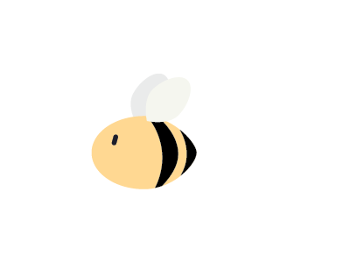**Reference**

Karen Shichida (2024)*. Bumble Bee* [Drawing]. Created 5/3/24 for BENV1043 Multimedia in Design Presentation, T1 2024 with Adobe Illustrator.

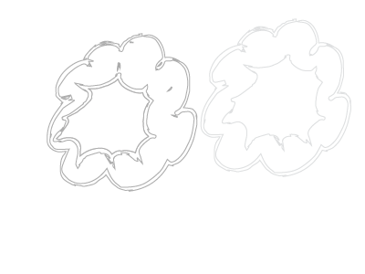

Karen Shichida (2024)*. Cloud Rings* [Drawing]. Created 5/3/24 for BENV1043 Multimedia in Design Presentation, T1 2024 with Adobe Illustrator.

**

Karen Shichida (2024)*. Cloud_1* [Drawing]. Created 5/3/24 for BENV1043 Multimedia in Design Presentation, T1 2024 with Adobe Illustrator.



Karen Shichida (2024)*. Cloud_2* [Drawing]. Created 5/3/24 for BENV1043 Multimedia in Design Presentation, T1 2024 with Adobe Illustrator.

Karen Shichida (2024)*. Cloud_2* [Gen AI Image]. Created 5/3/24 for BENV1043 Multimedia in Design Presentation, T1 2024 with Adobe Illustrator. Prompt: Grass Line Art Graphics Background

UNIVERSFIELD, *Interface* [Audio]. Pixabay.com. Accessed 9/10/24**.** <https://pixabay.com/sound-effects/search/achievement/>

Florianreichelt, *Woosh* (2023) [Audio]. Freesound.org. Accessed 9/10/24. <https://freesound.org/people/florianreichelt/sounds/683096/>