### Battery Model ([1])

The following model represents the battery as a third-order electrical circuit. It is nearly equivalent to that in [1], but it was modified so that current was an internal state of the model and the source current was replaced with a source voltage. These changes were made to easily account for the thermal losses across .

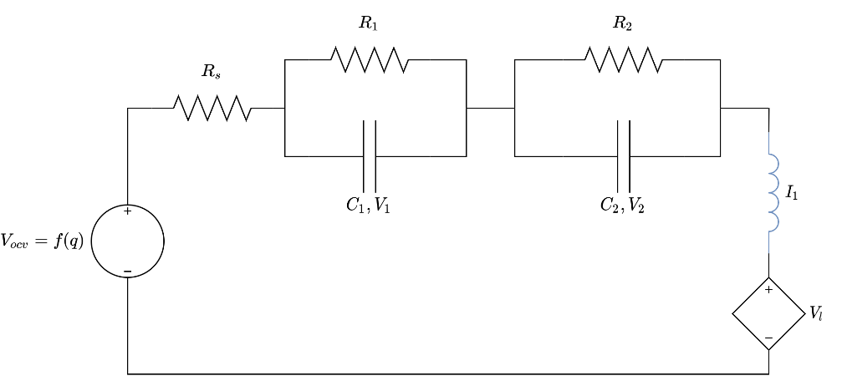

Figure : Battery Component Model



In Equation 1.4, are capacitances and resistances found from experimental parameter identification,  is the battery capacity (Amp-hours or equivalent), is the battery state of charge (SOC), is the open circuit voltage (OCV), and is the pack’s current demand [1]. is the voltage of the load connected to the battery.

Figure : Battery Graph Model



## Appendix:

[1] C. T. Aksland, “MODULAR MODELING AND CONTROL OF A HYBRID UNMANNED AERIAL VEHICLE’S POWERTRAIN,” M.S., University of Illinois at Urbana-Champaign.