**DC Bus Graph Model (Identical to that in** [1]**)**

The following DC bus graph model builds on work from WeeklyReport_09292020. After adding virtual inductances to support graph-modelling and switches to disconnect voltage sources and current loads, the component model becomes identical to that in [1]:

Figure : DC Bus Component Model

For each virtual inductance element,



Looking at the state of the bus capacitor,



From these equations, we can construct the following graph model,

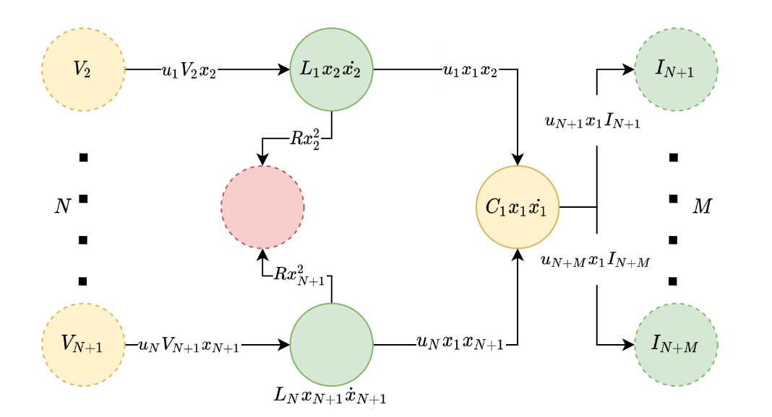

Figure : DC Bus Graph Model



## Appendix:

[1] C. T. Aksland, “MODULAR MODELING AND CONTROL OF A HYBRID UNMANNED AERIAL VEHICLE’S POWERTRAIN,” M.S., University of Illinois at Urbana-Champaign.