### DC-DC Converter Graph Model

The following model was largely derived from [1], with some changes made so that it can be controlled as a sort of variable transformer (i.e. architecture of the DC-DC converter is more abstract).

### 

Figure 1: DC-DC Converter Component Model (virtual components shown in blue)

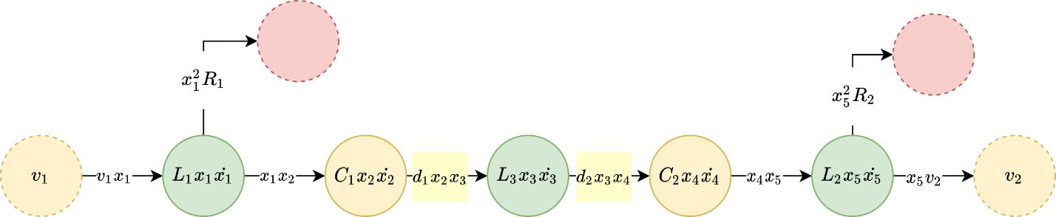

Figure 2: DC-DC Converter Graph Model



are gains that can be configured to control voltage or current in the following way:



Update: Removed final state so that model could connect to current source on side 2

## Appendix:

[1] D. J. Docimo, H. C. Pangborn, and A. G. Alleyne, “Hierarchical Control for Electro-Thermal Power Management of an Electric Vehicle Powertrain,” presented at the ASME 2018 Dynamic Systems and Control Conference, Nov. 2018, doi: 10.1115/DSCC2018-9215.