### DQ-Frame Inverter Graph Model

This time, we’ll employ the power invariant DQ-Transform  with initial a-phase to q-axis alignment,

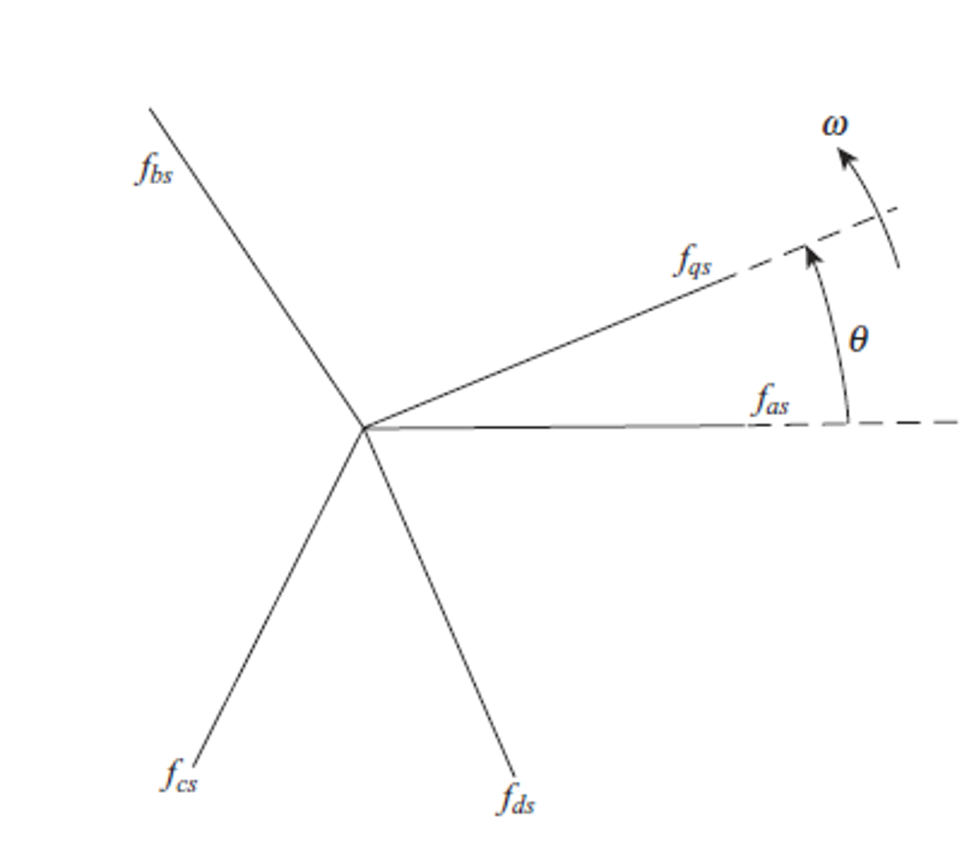



Where . The power invariance gives,



With an input waveform,



where is the amplitude of the source voltage,



The combined results of 1.6 and 1.4 show that we can treat a PMSM inverter similar to the DC-DC Converter model with the following adjustments.



are gains that can be configured to control voltage or current in the following way:



Updated for compatibility with other graph models, see draw.io file.

## Appendix:

[1] D. J. Docimo, H. C. Pangborn, and A. G. Alleyne, “Hierarchical Control for Electro-Thermal Power Management of an Electric Vehicle Powertrain,” presented at the ASME 2018 Dynamic Systems and Control Conference, Nov. 2018, doi: 10.1115/DSCC2018-9215.

[2] C. T. Aksland, “MODULAR MODELING AND CONTROL OF A HYBRID UNMANNED AERIAL VEHICLE’S POWERTRAIN,” M.S., University of Illinois at Urbana-Champaign.