**Permanent-Magnet Synchronous Machine Model:**

The following derivation is based on the Park transformation given in [1]. Note that the q-axis is initially aligned with phase a of motor. Also, this version of the Park transform is invariant for voltage, current, and electric charge but not for power.

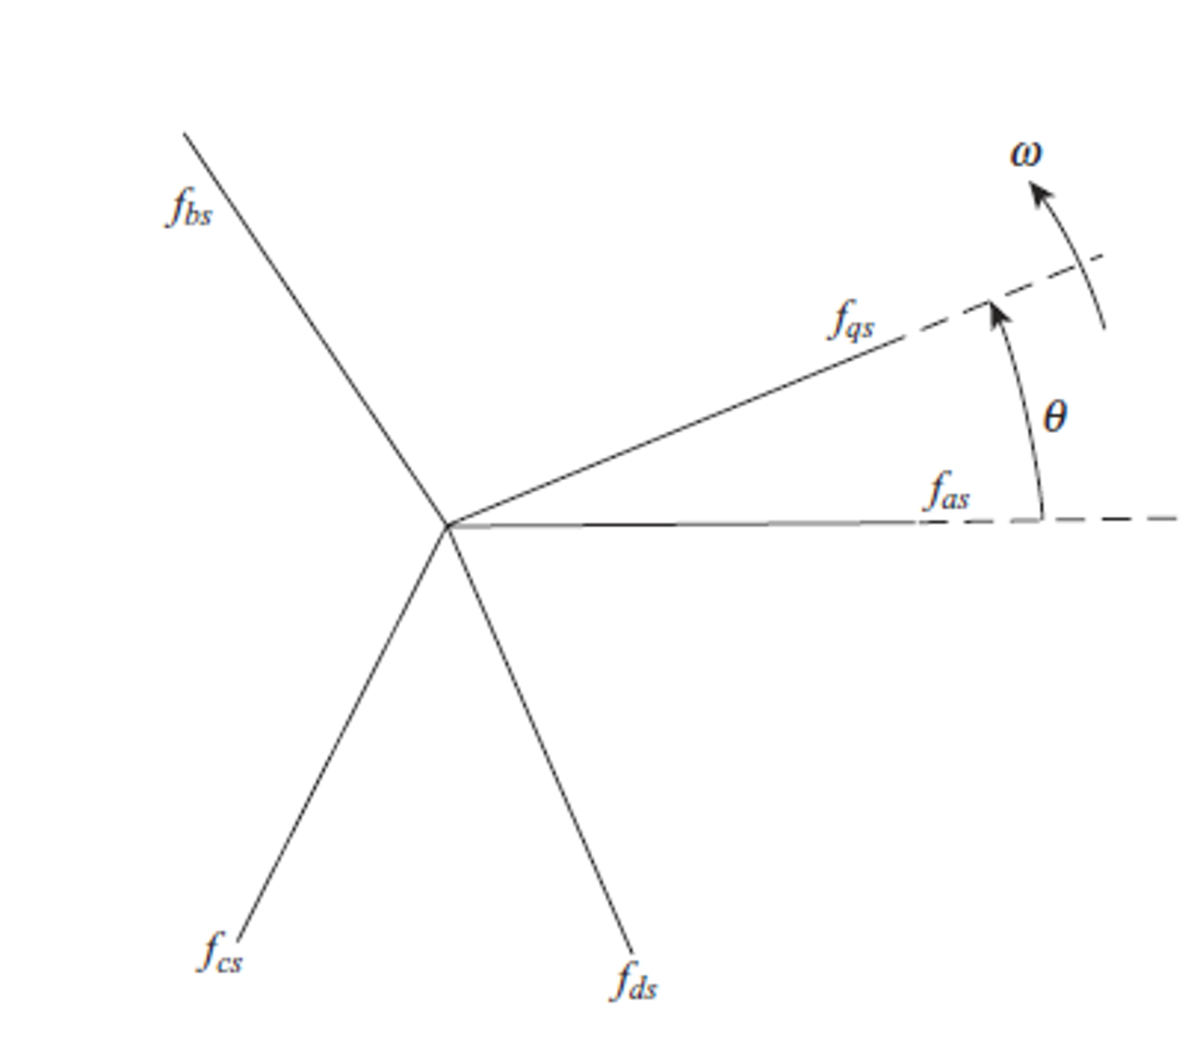

Figure 1: Park transform with q-axis aligned with phase a at



For the transformation that gives circuit variables referred to a reference frame fixed on the rotor,



Where is the mechanical speed of the rotor and is the number of poles.

For a PMSM motor assuming:

* Stator currents and voltages are sinusoidal and balanced with the same angular velocity as the rotor speed [1]
* Stator windings are balanced and sinusoidally distributed [1]
* An equal number of rotor and stator poles [1]
* Smooth air gap model: neglects cogging torque between permanent magnet and stator teeth. [2]
* Linear magnetics model which neglects magnetic saturation [2]
* Core losses in magnetic materials of machine are neglected [2].
* Frequency and temperature dependence of stator resistance is neglected [2].

Chapman [3] and Kraus [1] give







Where are constant inductances derived from motor geometry, (given in Volt*seconds or equivalent) is the peak strength of the flux linkage due to the magnets [3], and is the torque due to the magnetic field acting on the rotor.

With the following assumptions, the model can be simplified:

* “For a surface-mounted machine, because the stator inductances are independent of rotor position” [3].
* When motor phases are wye-connected, , so and [3].







Notice how in this case, only depends on quadrature phase current . If a field-oriented control (FOC) scheme is employed, torque control is achieved by controlling and driving to zero [4]. To increase maximum motor speed, a field-weakening technique can be use. This technique reverses the direction of to reduce the motor’s back EMF [4].

Making one final assumption,

* due to FOC techniques

We can further simplify the model:







With this FOC control scheme, the dynamics of the model are identical to that of a DC motor with a voltage constant . This result is very similar to the model Chris Aksland used in his master’s thesis [5].

Mechanical dynamics are given by



Where is motor inertia, is a load torque with an orientation opposing , is a viscous friction factor, and is a constant opposing torque from Coulomb or “dry” friction.

The motor’s power balance can be written as follows:







Where is the motor efficiency.

**PMSM for VTOL Applications**

Electric motors for aircraft applications are held to very high reliability, efficiency, and power density standards [6]. PMSM and BLDC motors appear to be a good fit, being “characterized with high power density and efficiency, high torque/inertia and torque/volume ratios, and improved reliability” [6]. These motor types also have a fast transient response, which is critical when the rotors are used to control flight dynamics [7]. Fault tolerance, however, is more complicated in PMSM designs [6]. Though VTOL designs are far from uniform, PMSM motors (and mechanically similar BLDC motors) are popular in conceptual and prototype designs. Examples include Volocopter’s VC200 air taxi, Leonardo’s Project Zero, and the XV-24A LightningStrike [7].

To minimize harsh current surges and cogging torque, distributed windings and sinusoidal control waveforms are preferred [7]. This justifies the initial assumptions for equations 1.3-5. The surface-mount and wye-connected assumptions lead to equations 1.6-8. Surface mount machines are popular for simple construction and control, small rotor diameter, and low inertia; however, they limit one’s ability to use the field weakening technique for operation above base speed [3],[6]. Finally, the FOC assumption made for equations 1.9-11 allows for precise torque control but further limits use of the field weakening technique. Therefore, the rotor and/or gearbox would need to be selected such that the field weakening technique needn’t be employed.

### **Permanent-Magnet Synchronous Machine Graph Model**

Recalling the simplified PMSM model, based on the power-variant Park Transform:







Where . To modify these equations for use with the power-invariant Park transform, we’ll try a change of variables from the variant form to the invariant form .





We can then substitute these into equations 1.8 and 1.9,





Simplifying and replacing with ,







These equations can now be put in the following graph form. To avoid numerical issues near , the sign function can be replaced by a sigmoid function  as suggested in [5].

Figure 2: PMSM Graph Model



## Note on Speed/Torque Constants K­_emf and K_t

The motor is not parametrized with the parameter, where



## Appendix:

[1] Paul Krause, Oleg Wasynczuk, Scott Sudhoff, and Steven Pekarek, *Analysis of Electric Machinery and Drive Systems*, 1st ed. John Wiley & Sons, Ltd, 2013.

[2] Brad Hieb and Heath Hofmann, “Parameterizing and Verifying a Permanent Magnet Synchronous Motor Model - Video.” https://www.mathworks.com/videos/parameterizing-and-verifying-a-permanent-magnet-synchronous-motor-model-92982.html (accessed Sep. 22, 2020).

[3] Patrick L. Chapman, “Permanent-Magnet Synchronous Machine Drives,” in *Power Electronics Handbook*, .

[4] V. M. Bida, D. V. Samokhvalov, and F. Sh. Al-Mahturi, “PMSM vector control techniques — A survey,” in *2018 IEEE Conference of Russian Young Researchers in Electrical and Electronic Engineering (EIConRus)*, Jan. 2018, pp. 577–581, doi: 10.1109/EIConRus.2018.8317164.

[5] C. T. Aksland, “MODULAR MODELING AND CONTROL OF A HYBRID UNMANNED AERIAL VEHICLE’S POWERTRAIN,” M.S., University of Illinois at Urbana-Champaign.

[6] W. Cao, B. C. Mecrow, G. J. Atkinson, J. W. Bennett, and D. J. Atkinson, “Overview of Electric Motor Technologies Used for More Electric Aircraft (MEA),” *IEEE Trans. Ind. Electron.*, vol. 59, no. 9, pp. 3523–3531, Sep. 2012, doi: 10.1109/TIE.2011.2165453.

[7] F. Colucci, “Turning Volts into VTOL,” p. 4, 2018.