### Propeller Graph Model [1],[2]

From the model described in WeeklyReport_0915020, we have,





where is input torque from the motor, is air density, is propeller diameter, is the rotational inertia of the propeller, is the drag coefficient, is rotor speed, and is the thrust coefficient. and are generally function of the propeller design, Reynolds number, and the advance ratio [2].

We can rewrite Equation 1.1 as,



Which gives the following graph form,

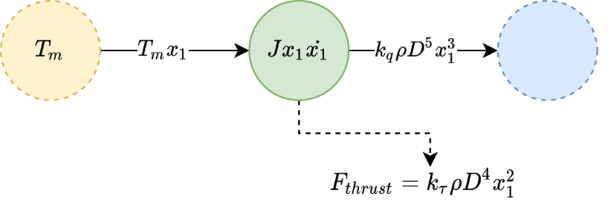



## Appendix:

[1] A. F. El-Sayed, “Piston Engines and Propellers,” in *Fundamentals of Aircraft and Rocket Propulsion*, A. F. El-Sayed, Ed. London: Springer, 2016, pp. 219–314.

[2] “11.7 Performance of Propellers.” https://web.mit.edu/16.unified/www/FALL/thermodynamics/notes/node86.html (accessed Sep. 08, 2020).