GROUP 5 PROJECT
1. Abdoulaye DIEYE
2. Awadi Abalo KATANGA
3. Mikhael Presley KIBINDA MOUKENGUE
4. Fatou Sene DIENG
5. Bolaji Rolayo BAMIRO
6. Nokeme MEITE
7. Thierno Bassirou BALDE
8. Idrissou HEL HADJE SOUNON ALIDOU

Group 5 chose the community and crime data set for analysis. The communities are within the United States. The data combines socio-economic data from the 1990 US Census, law enforcement data from the 1990 US LEMAS survey, and crime data from the 1995 FBI UCR.

We want to predict the per community violent crime per 100k population in a community which is the response variable. This was calculated using population and sum of crime variables considered as violent crimes in the U.S which are assualt, murder, rape and robbery.

These 19 predictors were selected from 126 predictors on our dataset to analyse any plausible connection to violent crimes.

1. -- population: population for community: (numeric - decimal)
2. -- householdsize: mean people per household (numeric - decimal)
3. -- racepctblack: percentage of population that is african american (numeric - decimal)
4. -- racePctWhite: percentage of population that is caucasian (numeric - decimal)
5. -- racePctHisp: percentage of population that is of hispanic heritage (numeric - decimal)
6. -- agePct12t29: percentage of population that is 12-29 in age (numeric - decimal)

7. -- pctWWage: percentage of households with wage or salary income in 1989 (numeric - decimal)

8. -- PctPopUnderPov: percentage of people under the poverty level (numeric - decimal)
9. -- PctNotHSGrad: percentage of people 25 and over that are not high school graduates (numeric - decimal)
10. -- PctBSorMore: percentage of people 25 and over with a bachelors degree or higher education (numeric - decimal)
11. -- PctUnemployed: percentage of people 16 and over, in the labor force, and unemployed (numeric - decimal)
12. -- PctEmploy: percentage of people 16 and over who are employed (numeric - decimal)
13. -- TotalPctDiv: percentage of population who are divorced (numeric - decimal)
14. -- PctImmigRecent: percentage of _immigrants_ who immigated within last 3 years (numeric - decimal)
15. -- PctImmigRec10: percentage of _immigrants_ who immigated within last 10 years (numeric - decimal)
16. -- PctSpeakEnglOnly: percent of people who speak only English (numeric - decimal)
17. -- PctNotSpeakEnglWell: percent of people who do not speak English well (numeric - decimal)
18. -- HouseVacant: number of vacant households (numeric - decimal)
19. -- PctVacMore6Mos: percent of vacant housing that has been vacant more than 6 months (numeric - decimal)
Y=ViolentCrimesPerPop: total number of violent crimes per 100K popuation (numeric - decimal) GOAL attribute (to be predicted)

Using PCA, we performed an SVD and achieve this result
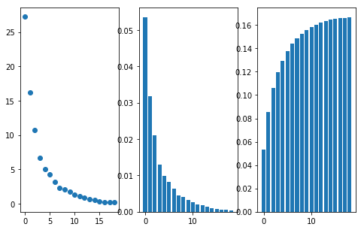

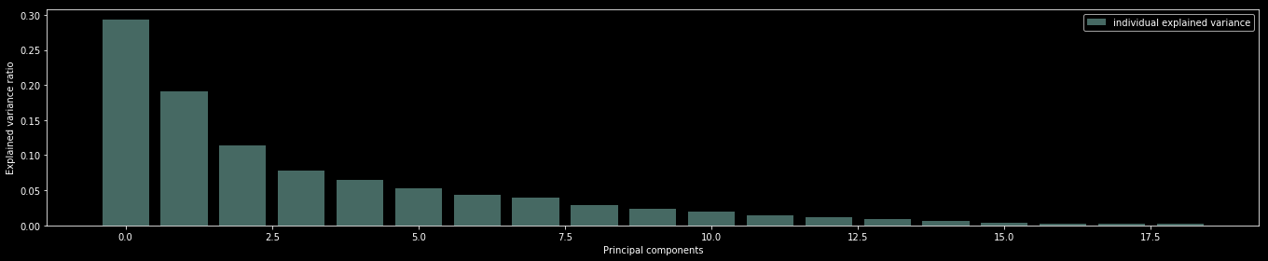

we can see from the above plots that first two components constitute almost 50% of the variance. The third to fifth components has 39% of the data spread. The next ones have component has less than 5% of the variance. Hence we can drop from the fifth component.

We computed the beta least squares because the data had a full rank and was invertible. They are array([[ 0.14614507],[ 0.06659244],[ 0.35132529],[-0.12540451],[-0.00776718],[ 0.01377758],
[-0.15944306],[-0.00978902],[ 0.04334829],[ 0.02418924],[ 0.03890242],[ 0.04860601],[ 0.24556376], [ 0.02604453], [-0.02511422], [-0.07142245], [ 0.09441266], [-0.07306555],
[-0.04897254]] with shape 19x1. The mean square error was 0.44311.
We performed a PC, Ridge and Lasso regression. We first split into data set into 80% train and 20% test to compute or Mean square errors on the test data.
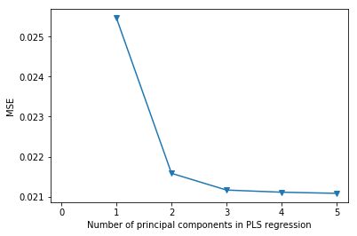

The mean square error for the five PCs are ;[0.025466864238096795, 0.021581970845643804, 0.02116355595814939, 0.02110971521452798, 0.021081340292745557] using 10 fold cross-validation. The graph shows the trend of MSE wrt each principal components.
Using the Ridge regression, we had a mean square error the test set and got a value of 0.4284 with best gamma at 0.1002. No graph was generated for this because ridge coefficients were in 3 dimensions.

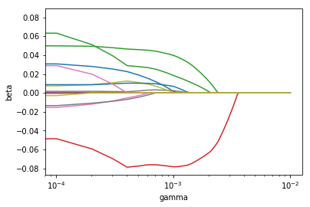

Using the Lasso regression, we had a mean square error of the test set and got a value of 0.4696
We select the PC regression model as the best model because it has the lowest mean square error.

