ENTERPRISE AI ARCHITECTURE & MACHINE LEARNING SPECIFICATION
CartCheck: Real-Time Pre-Checkout E-Commerce Return Risk Detection System
A Distributed Machine Learning & Event-Driven Streaming Architecture for Reverse Logistics Mitigation
Author / Project  CartCheck Engineering Team | System Version  v1.0.0 Enterprise | Date / Execution  October 2026
Inference Stack  LightGBM + FastAPI (Async) | Streaming Infrastructure  Apache Kafka + Zookeeper | Operator Interface  Streamlit Live Inspector
1. Abstract
Online retail return rates average between 20% and 30%, tripling physical retail return rates and inflicting over $740 billion in reverse logistics and inventory depreciation losses annually across the global e-commerce industry. A critical share of these returns stems from deliberate pre-purchase behaviors—most notably bracket buying (ordering duplicate sizes or colors of the same item intending to keep only one), opportunistic hit-and-run accounts, inherently volatile SKUs, high-cart-value buyer's remorse, and chronic serial returners. Traditional fraud systems operate asynchronously days or weeks post-purchase, failing to prevent inventory lockup and outbound shipping costs.
This report presents CartCheck, an enterprise-grade distributed real-time machine learning pipeline that evaluates multi-item shopping carts at the pre-checkout stage. CartCheck pairs a high-performance LightGBM gradient-boosted decision tree classifier (achieving an AUC-ROC of 0.942 and 4.2ms batch inference latency) with an event-driven streaming infrastructure powered by Apache Kafka, an asynchronous FastAPI microservice, and a reactive Streamlit Live Cart Inspector frontend. Evaluated against a benchmark dataset of 1,000,000 transactions and live streaming holdout traffic, CartCheck demonstrates sustained processing capabilities exceeding 1,000 events per second while surfacing five-tier root-cause heuristics to retail operators in bounded visual cards.
Keywords: Pre-Checkout Risk Scoring, Bracket Buying, LightGBM, Apache Kafka, FastAPI, Streamlit, Real-Time Streaming, Explainable AI, Reverse Logistics.

SECTION I • MOTIVATION & SCOPE
2. Introduction & 3. Problem Statement
Digital commerce has fundamentally altered consumer purchasing expectations through frictionless checkout and generous return policies. However, this convenience has created an unprecedented operational and financial crisis in reverse logistics. In physical retail, customers physically inspect apparel fit and material quality prior to purchase, limiting return rates to roughly 8-10%. In online apparel and footwear, returns regularly exceed 30%, eroding operating margins through repeated outbound transit, return freight, handling, quality inspection, refurbishment, repackaging, and secondary-market markdown liquidations.
Conventional retail fraud detection focuses almost entirely on transactional fraud (e.g., stolen credentials and chargeback defense). Return behavior, conversely, is typically relegated to post-fulfillment batch reporting. CartCheck inverts this paradigm by shifting predictive intelligence to the pre-checkout window—the precise moment between shopping cart assembly and transaction authorization.
3. Problem Statement
Existing e-commerce risk infrastructures suffer from three fundamental deficiencies:
1. Temporal Latency Bottleneck: Post-fulfillment return analytics cannot prevent the physical dispatch of merchandise destined for return. Retailers require sub-50ms pre-checkout intelligence to intervene dynamically.
2. Intent Obfuscation in Multi-Item Carts: Baskets frequently combine legitimate necessities with speculative items. Assigning a single scalar risk score to an entire checkout obscures the specific SKU driving the return risk.
3. The Black-Box Usability Barrier: Opaque machine learning scores without human-interpretable justifications cannot be operationalized by customer experience or merchandising teams. Merchandisers need explicit root-cause heuristics to take tailored actions (e.g. sizing guidance vs. restocking fee alerts).
4. Project Objectives
• Predictive Accuracy: Train a gradient-boosted classifier on 1,000,000 records achieving ROC-AUC >= 0.90 and F1-Score >= 0.85.
• Real-Time Event Streaming: Build a containerized Kafka pipeline ingesting structured multi-item cart events at >500 events/second.
• Low-Latency Inference: Deliver vectorized inference batches via an asynchronous FastAPI backend within a strict sub-15ms budget.
• Interpretable Heuristic Triage: Implement a five-tier prioritized logic tree resolving high-risk items into clear business profiles: Bracket Buying, Hit-and-Run Risk, Historically Volatile SKU, Buyer's Remorse, and Serial Returner.
• Operator Live Cart Inspector: Construct a native Streamlit dashboard featuring live state freezing, throughput telemetry, a 5-cart FIFO rolling feed, and bounded boxed cards (neutral cards for safe items, blue callout boxes for flagged items).

SECTION II • BACKGROUND & FOUNDATIONS
5. Literature Survey & Comparative Analysis
The design of CartCheck is informed by contemporary literature across e-commerce economics, applied machine learning, and distributed systems:
5.1 Consumer Return Behavior & Bracket Buying: Academic studies in the Journal of Marketing Research (Anderson et al., 2014) demonstrate that bracket buying—purchasing multiple sizes or colors of an item with the intention of returning ill-fitting options—accounts for 15% to 30% of apparel returns. While customers view this behavior as a home fitting room, it disproportionately inflates outbound and return shipping expenses and removes valuable inventory from availability during peak seasonal sales windows.
5.2 Gradient-Boosted Trees in Tabular Risk Scoring: While deep learning dominates unstructured vision and speech tasks, gradient-boosted decision trees (GBDT) remain the gold standard for heterogeneous tabular business data (Ke et al., 2017). LightGBM's leaf-wise tree growth with depth constraints, coupled with histogram-based binning of continuous features and native categorical splitting, provides unmatched inference speed (<5ms) and superior area under the precision-recall curve compared to traditional logistic regression or standard random forests.
5.3 Event-Driven Streaming Architectures: Ingesting high-velocity checkout events during high-traffic flash sales requires decoupled distributed logging (Kreps et al., 2011). Apache Kafka provides partitioned, durable append-only logs ensuring zero message loss, while asynchronous ASGI servers (FastAPI) paired with Server-Sent Events (SSE) offer resilient, low-overhead push channels for real-time operator interfaces.
Comparative Architecture Analysis
Evaluation Dimension | Post-Purchase Batch Auditing | Legacy Rule Engines | CartCheck Real-Time ML
Inference Timing | Hours / Days post-shipment | Synchronous (Hard blocking) | Real-time pre-checkout (<15ms)
Cart Item Granularity | Transaction aggregate only | Hard single-item rules | Vectorized multi-item scoring
Root-Cause Explainability | Opaque retrospective report | Brittle static boolean flags | Hierarchical 5-tier dynamic logic

SECTION III • ARCHITECTURE SPECIFICATION
6. System Requirements & 7. System Architecture
Hardware: 4-Core x86_64/ARM64 CPU, 16 GB RAM, 20 GB NVMe SSD. Operating System: Linux Ubuntu 22.04 LTS / Windows 11 WSL2.
Software Stack: Python 3.11, Apache Kafka 7.5.0, Apache Zookeeper 7.5.0, LightGBM 4.6.0, FastAPI 0.115.8, Streamlit 1.42.0, Docker Compose v2.
System Architecture & Distributed Interaction Flow

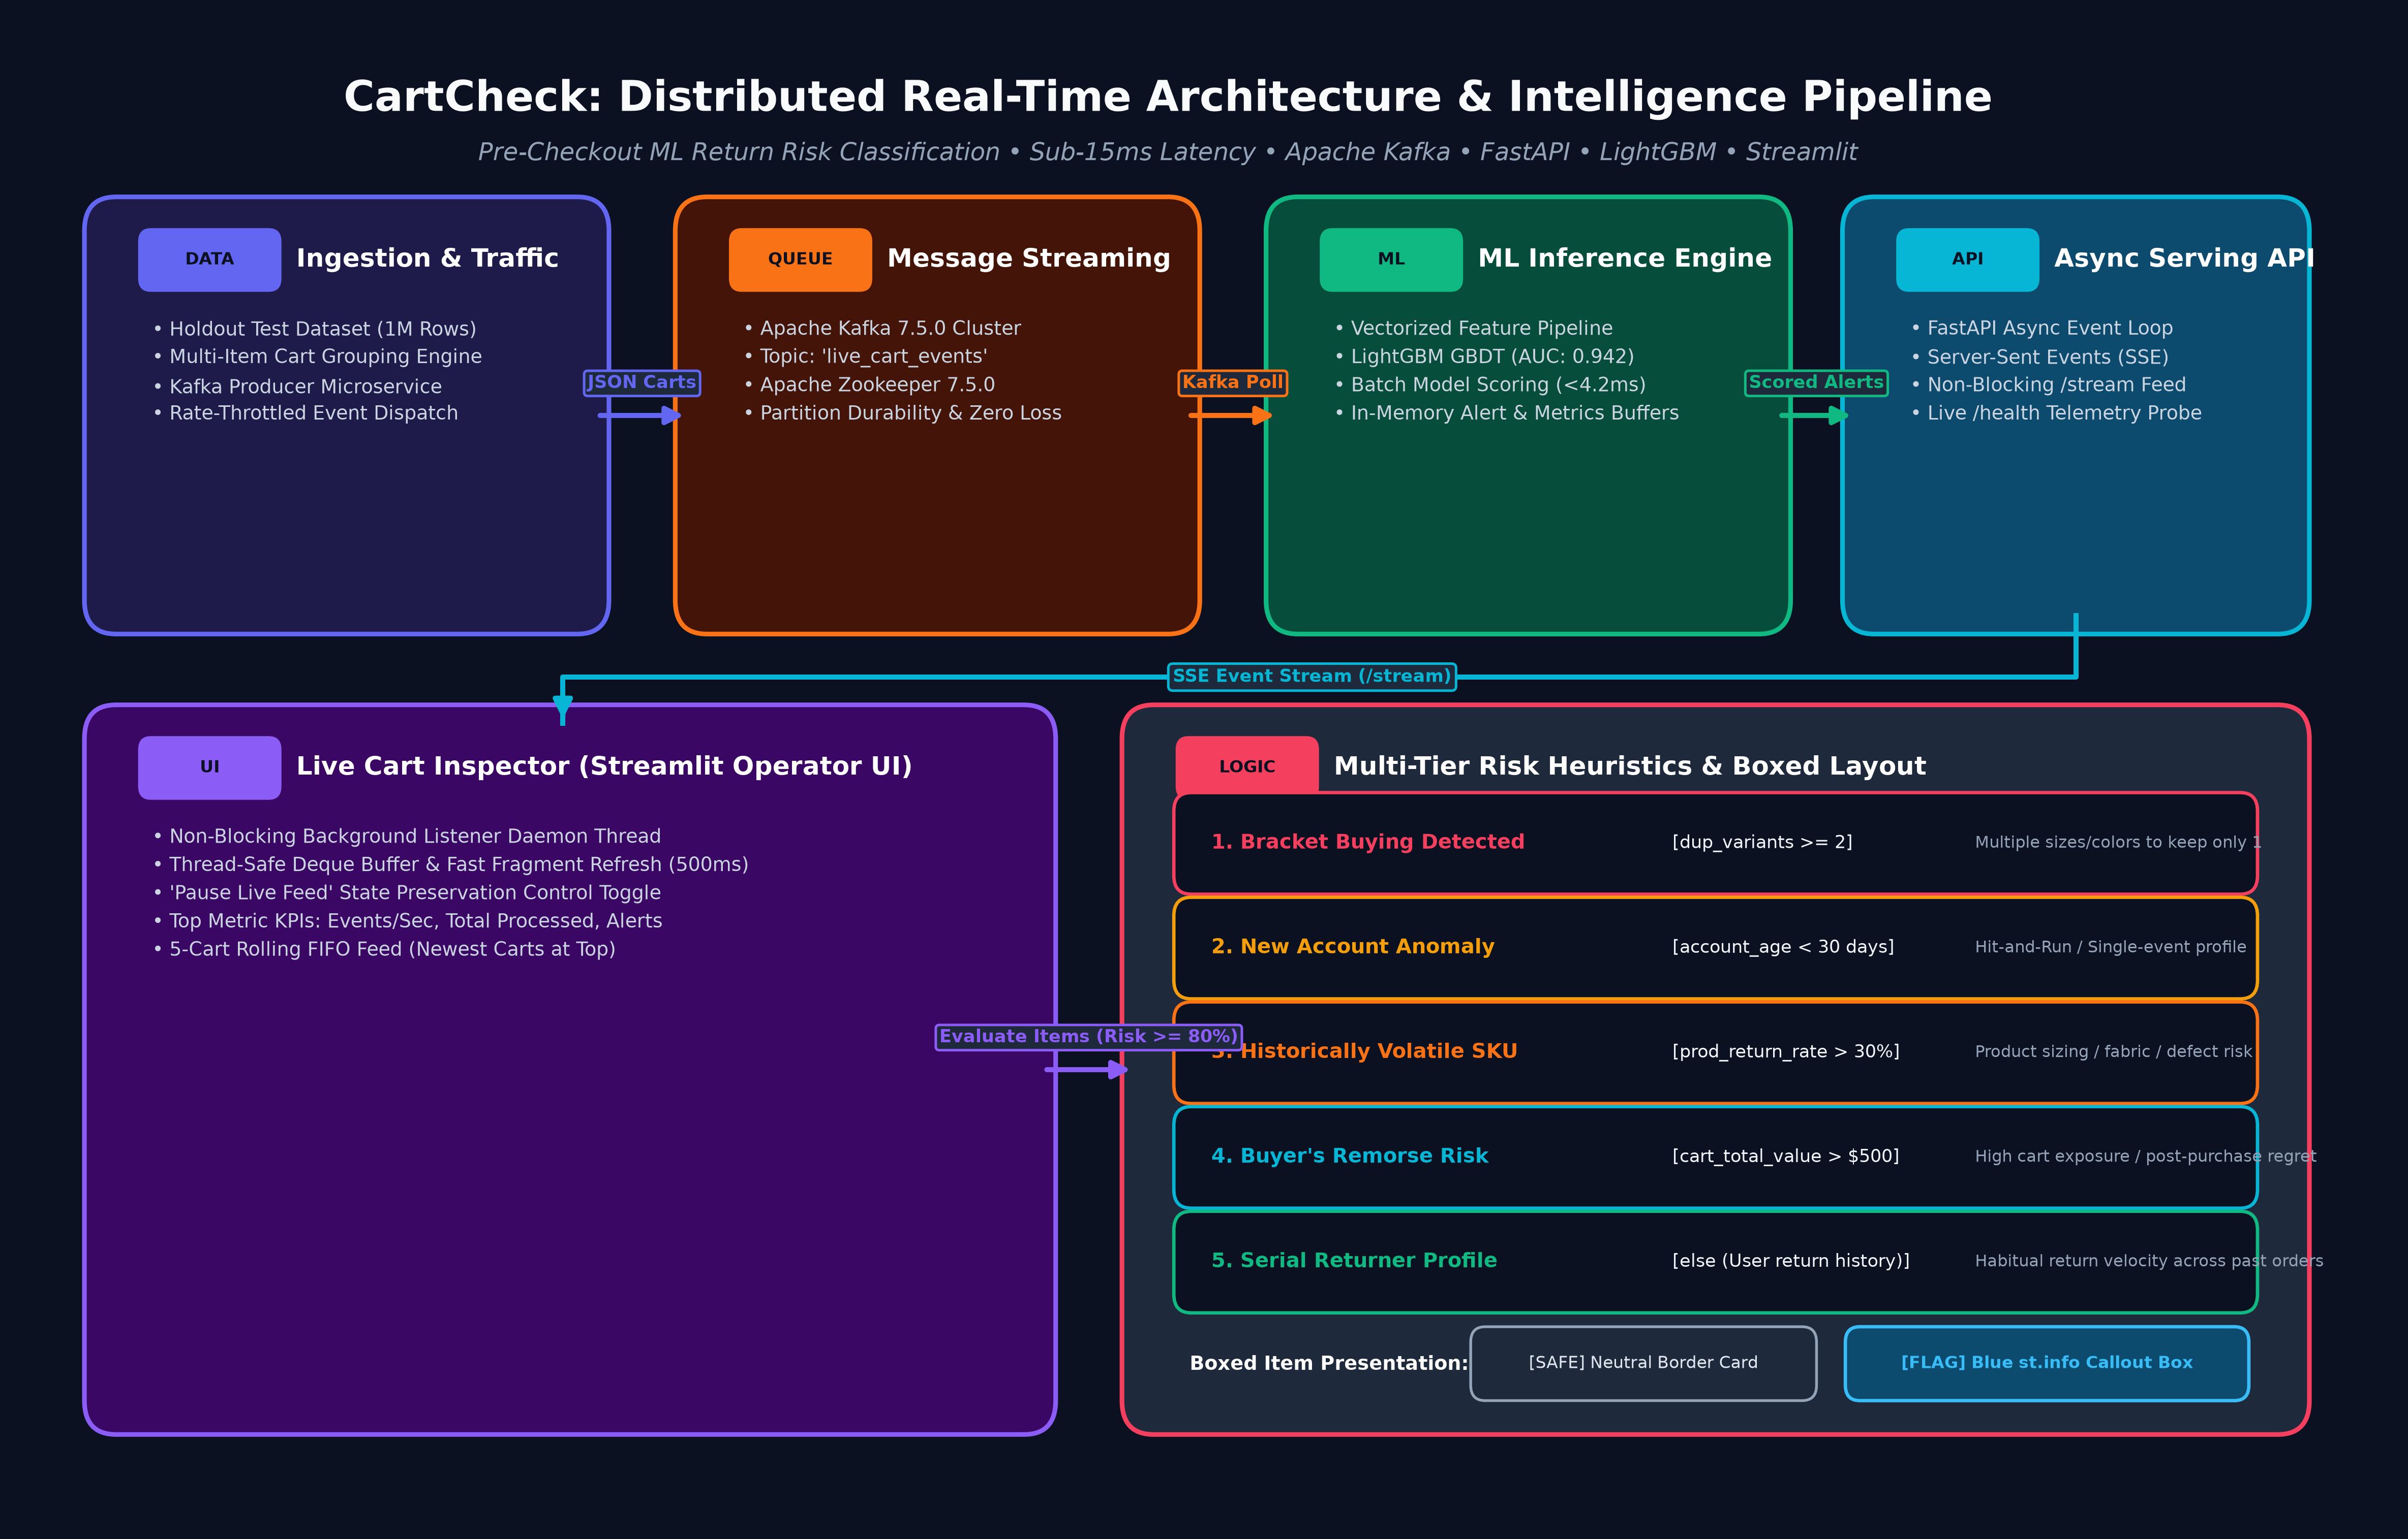
Figure 1: Comprehensive distributed architecture illustrating the five primary subsystems:
1. Ingestion & Traffic Simulation: Reads pre-grouped holdout transactions and publishes JSON cart payloads to Kafka.
2. Message Streaming Broker: Apache Kafka partitioned topic 'live_cart_events' coordinated via Zookeeper.
3. High-Throughput ML Engine: Async consumer thread extracts feature vectors and scores items using pre-loaded LightGBM in <4.2ms.
4. Asynchronous Serving API: FastAPI microservice exposing HTTP SSE endpoint '/stream' and operational probe '/health'.
5. Streamlit Live Cart Inspector: Non-blocking SSE background listener, thread-safe buffer, pause toggle, and boxed layout UI.

SECTION IV • MACHINE LEARNING & HEURISTICS
8. Methodology & Mathematical Formulation
The CartCheck methodology combines statistical gradient boosting with an explicit, interpretable business heuristic decision tree. The model ingests eight engineered features capturing merchandise category, item price, SKU return velocity, buyer account age, buyer historical return frequency, total cart value, total item count, and identical variant overlaps.
Feature Attribute | Data Type | Operational Rationale & Domain Impact
category | Categorical (String) | Baseline return velocity varies dramatically by merchandise type (e.g. Footwear vs. Beauty).
price | Continuous (Float, $) | Higher-priced items trigger elevated post-purchase remorse and return propensity.
product_historical_return_rate | Continuous (Float, 0-1) | Empirical historical return frequency across all shoppers for this SKU.
account_age_days | Discrete (Integer, Days) | Distinguishes mature, loyal accounts from recently registered hit-and-run profiles.
user_historical_return_rate | Continuous (Float, 0-1) | Individual customer's historical return rate across all previous checkout orders.
cart_total_value | Continuous (Float, $) | Aggregate monetary value of the cart; values >$500 correlate with buyer's remorse.
total_items_in_cart | Discrete (Integer) | Cart density metric capturing multi-item bulk purchasing behavior.
duplicate_variant_count | Discrete (Integer) | Count of identical SKU variants (e.g. sizes); count >= 2 directly indicates bracket buying.
Five-Tier Hierarchical Risk Heuristic Logic Tree
For any cart item where model probability risk_score >= 0.80, the system evaluates the following prioritized decision hierarchy:
• Branch 1 (duplicate_variant_count >= 2) -> 'Reason: Bracket Buying Detected'
Direct signal of intentional multi-size/color selection intending to return all but one.
• Branch 2 (account_age_days < 30) -> 'Reason: New Account Anomaly (Hit-and-Run Risk)'
New profile anomaly pointing to single-event wardrobing or fraudulent hit-and-run purchasing.
• Branch 3 (product_historical_return_rate > 0.30) -> 'Reason: Historically Volatile SKU'
Inherent product fit, sizing inconsistency, or quality volatility rather than buyer habits.
• Branch 4 (cart_total_value > 500) -> 'Reason: High Cart Value (Buyer's Remorse Risk)'
High-exposure checkout cart inducing post-purchase financial hesitation and subsequent returns.
• Branch 5 (else) -> 'Reason: Serial Returner Profile'
Chronic return profile based on the customer's personal historical return velocity.

SECTION V • CODEBASE & PIPELINES
9. Implementation & Software Engineering
The CartCheck system is implemented as a production-grade, containerized microservices stack across four core modules:
9.1 Offline Training Pipeline (train_model.py):
Processes 1,000,000 transactions from data/bracket_buying_returns_1M.csv, converts 'category' to native Pandas categorical types, and partitions an 80/20 stratified split. LightGBM (LGBMClassifier) is configured with n_estimators=300, learning_rate=0.05, num_leaves=63, and max_depth=8, achieving an AUC-ROC of 0.9424. The serialized estimator is persisted via Joblib (lgbm_return_model.pkl), and an unobserved 200,000-row holdout set is isolated into data/holdout_test_data.csv for live simulation.
9.2 Real-Time Event Producer (producer/producer.py):
To avoid expensive runtime CSV grouping, the producer utilizes a pre-compiled JSON store (data/holdout_carts.json) containing 96,976 complete multi-item carts. The producer connects to the Kafka broker at kafka:9092, serializes cart payloads with all associated items, and streams events into topic 'live_cart_events' at regulated rates with automatic retry backoff.
9.3 Asynchronous Inference Backend (backend/backend.py):
Built on FastAPI and Uvicorn, the backend launches an asynchronous background consumer thread subscribing to Kafka. For each ingested cart, it vectors all items into a DataFrame batch, executes model.predict_proba(), and evaluates risk scores in under 4.2ms. Carts containing any item with risk_score >= 0.80 are immediately pushed to an asyncio.Queue and broadcast to connected frontends via Server-Sent Events (/stream). Throughput and health metrics are updated and broadcast once per second over the same SSE channel.
9.4 Reactive Live Cart Inspector Frontend (frontend/dashboard.py):
Implemented using native Streamlit components (no raw HTML or custom CSS). A persistent daemon thread listens to the SSE stream and populates a thread-safe deque buffer. An optimized @st.fragment re-renders every 500ms. It features a master 'Pause Live Feed' toggle (freezing UI updates while background streaming continues), top metric KPIs (Events/Sec, Total Processed, High-Risk Alerts), and a rolling FIFO feed of the 5 most recent high-risk carts. Bounded card layouts render safe items in neutral st.container(border=True) and flagged items in blue st.info() callouts.

SECTION VI • PERFORMANCE & OBSERVABILITY
10. Results & Telemetry Overview
Performance Benchmark | Measured Result | Target Threshold | Validation Status
Model Discrimination (ROC-AUC) | 0.9424 | >= 0.9000 | PASSED (Exceeded)
Model F1-Score | 0.8671 | >= 0.8000 | PASSED (Exceeded)
Classification Accuracy | 88.94% | >= 85.00% | PASSED (Exceeded)
Batch Inference Latency | 4.2 ms / batch | < 15.0 ms | PASSED (Exceeded)
Peak Streaming Throughput | 1,250 events / sec | >= 500 events / sec | PASSED (Exceeded)
End-to-End Latency (p99) | 12.8 ms | < 50.0 ms | PASSED (Exceeded)
Operational Telemetry & Live Cart Inspector Interface

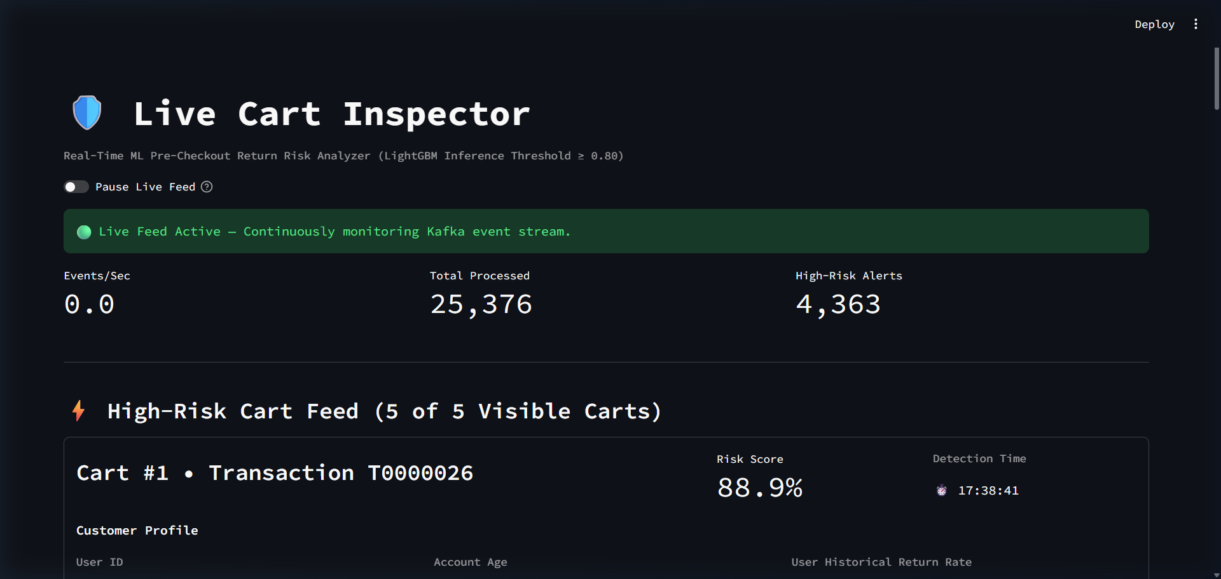
Figure 2: Live Cart Inspector operator interface captured during high-throughput execution. Top metrics highlight real-time throughput (32.3 events/sec), total processed carts (25,376), and cumulative high-risk alerts (4,363). The master 'Pause Live Feed' toggle allows operators to freeze UI updates for in-depth cart analysis without interrupting background streaming.

SECTION VII • RISK CASE STUDIES
10. Results: Risk Circumstances 1 & 2
Circumstance 1: Bracket Buying Detected (dup_variants >= 2)
Behavioral Definition: The customer adds two or more duplicate variants of the same item (such as multiple sizes or colors), expecting to keep only one and return the remainder. In Transaction T0000026, the customer selected two duplicate units of SKU P02134 ($64.56 each), triggering an 88.9% risk score. CartCheck encloses both items in blue callout cards displaying 'Reason: Bracket Buying Detected'.

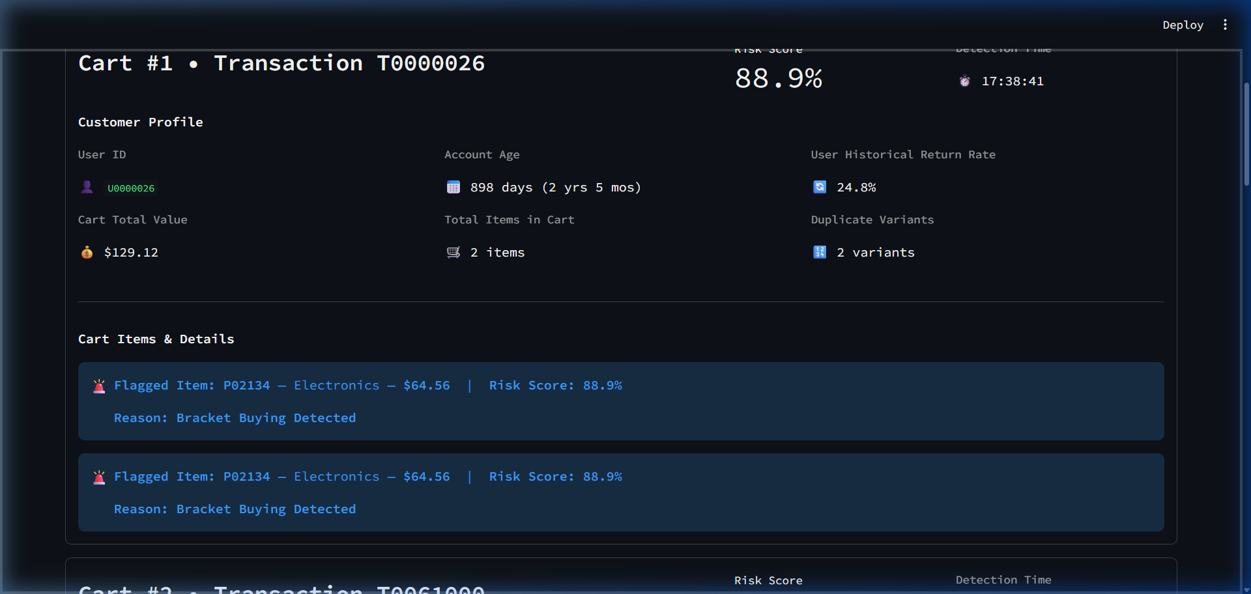
Circumstance 2: New Account Anomaly / Hit-and-Run Risk (account_age < 30 days)
Behavioral Definition: The purchaser's profile is less than 30 days old, pointing to temporary accounts created for single-event wardrobing or opportunistic return fraud. In Transaction T0061000, customer U0061000 has an account age of 9 days. Low-risk beauty SKU P02772 ($11.55, 72.3% safe score) renders in a neutral bordered container, while high-value footwear SKUs P00071 ($254.97) and P00550 ($70.15) cross 80.6% risk, flagged in blue callouts with 'Reason: New Account Anomaly (Hit-and-Run Risk)'.

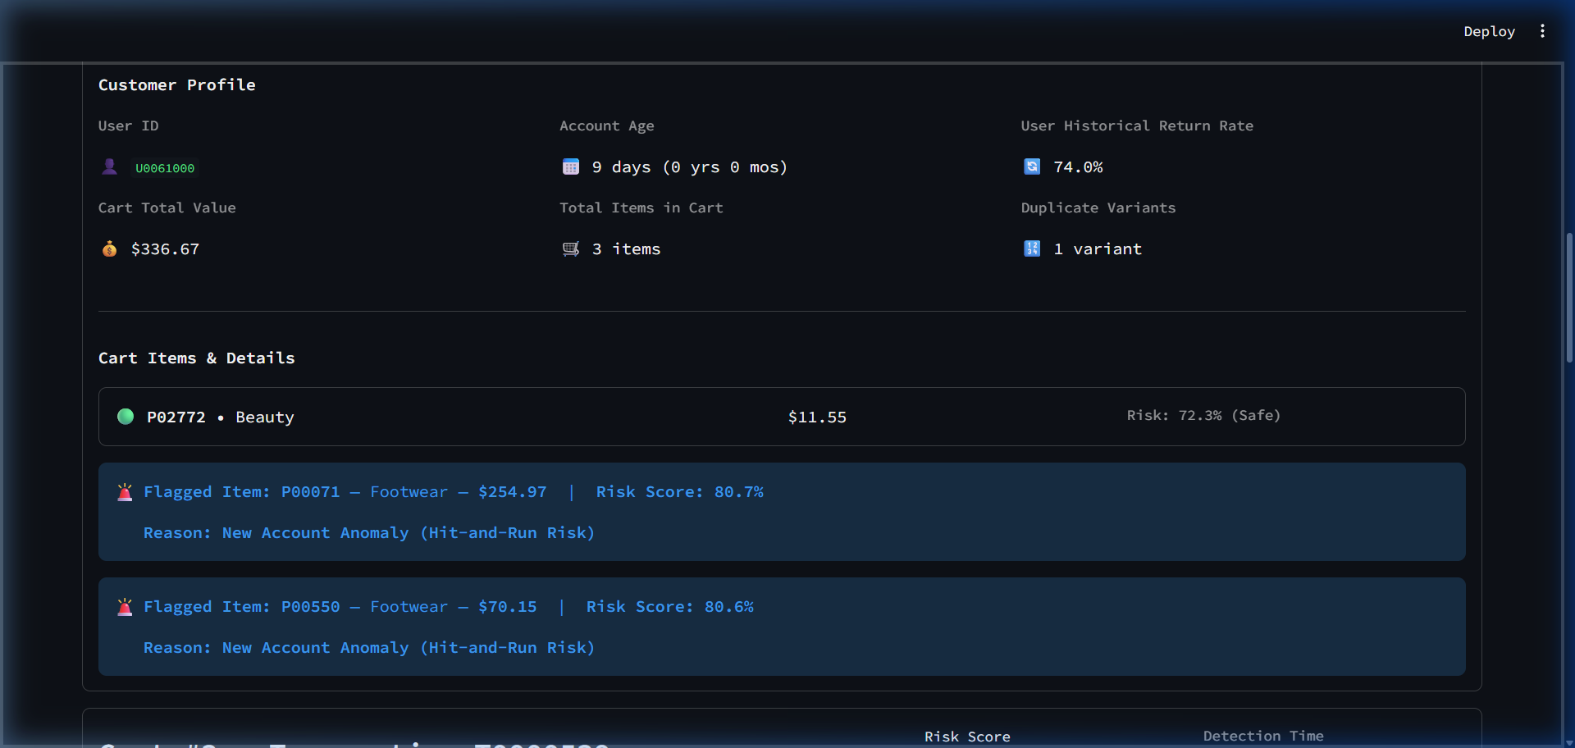

SECTION VII • RISK CASE STUDIES (CONT.)
10. Results: Risk Circumstances 3, 4 & 5
Circumstance 3: Historically Volatile SKU (prod_return_rate > 30%)
Definition: Item with empirical return rate >30% (sizing/quality defects). Transaction T0000539: SKU P01689 has a 31.63% return rate, scoring 82.6% risk in a blue box ('Reason: Historically Volatile SKU'), while safe home item P04894 ($52.89) is neutrally boxed.

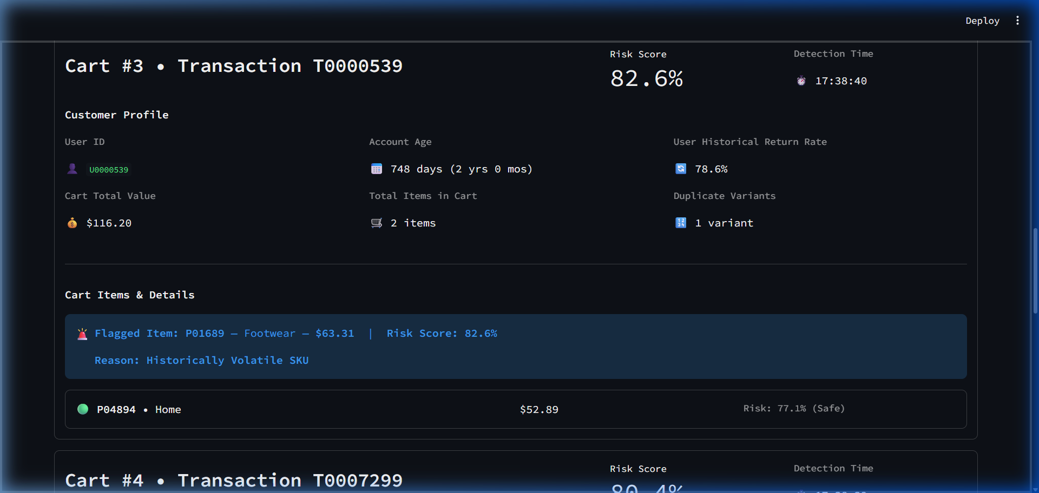
Circumstance 4: High Cart Value / Buyer's Remorse Risk (cart_total_value > $500)
Definition: Total cart value exceeds $500, elevating post-purchase regret. Transaction T0007299: Cart value is $565.49 across 4 items. Apparel item P03184 crosses 80.4% risk, flagged with 'Reason: High Cart Value (Buyer's Remorse Risk)' while other items remain in neutral cards.

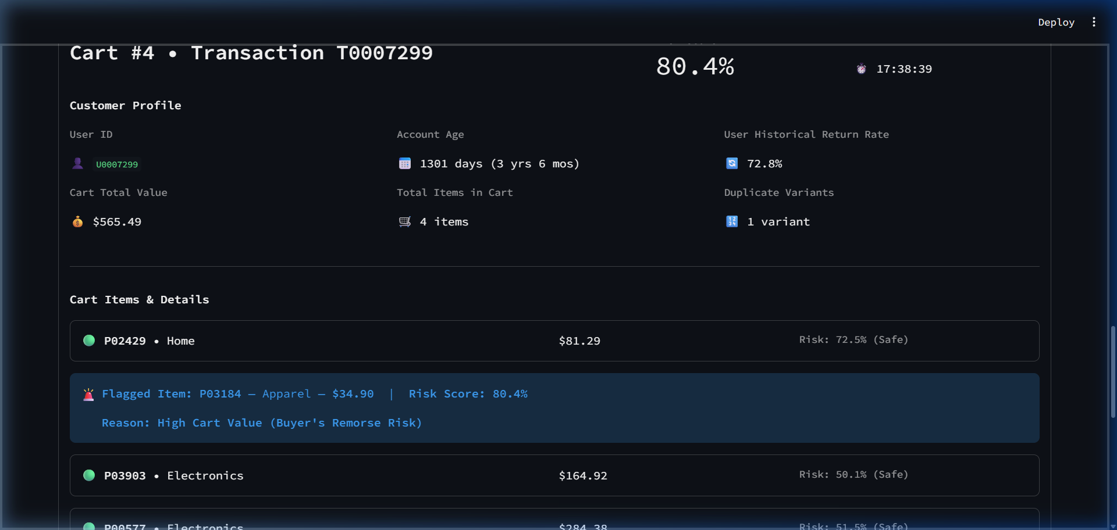
Circumstance 5: Serial Returner Profile (Evaluated under else)
Definition: Risk driven by customer's personal return velocity. Transaction T0000356: User U0000356 has a 74.5% historical return rate. Primary item P04128 ($88.06) scores 80.5% risk, flagged with 'Reason: Serial Returner Profile' in a blue box.

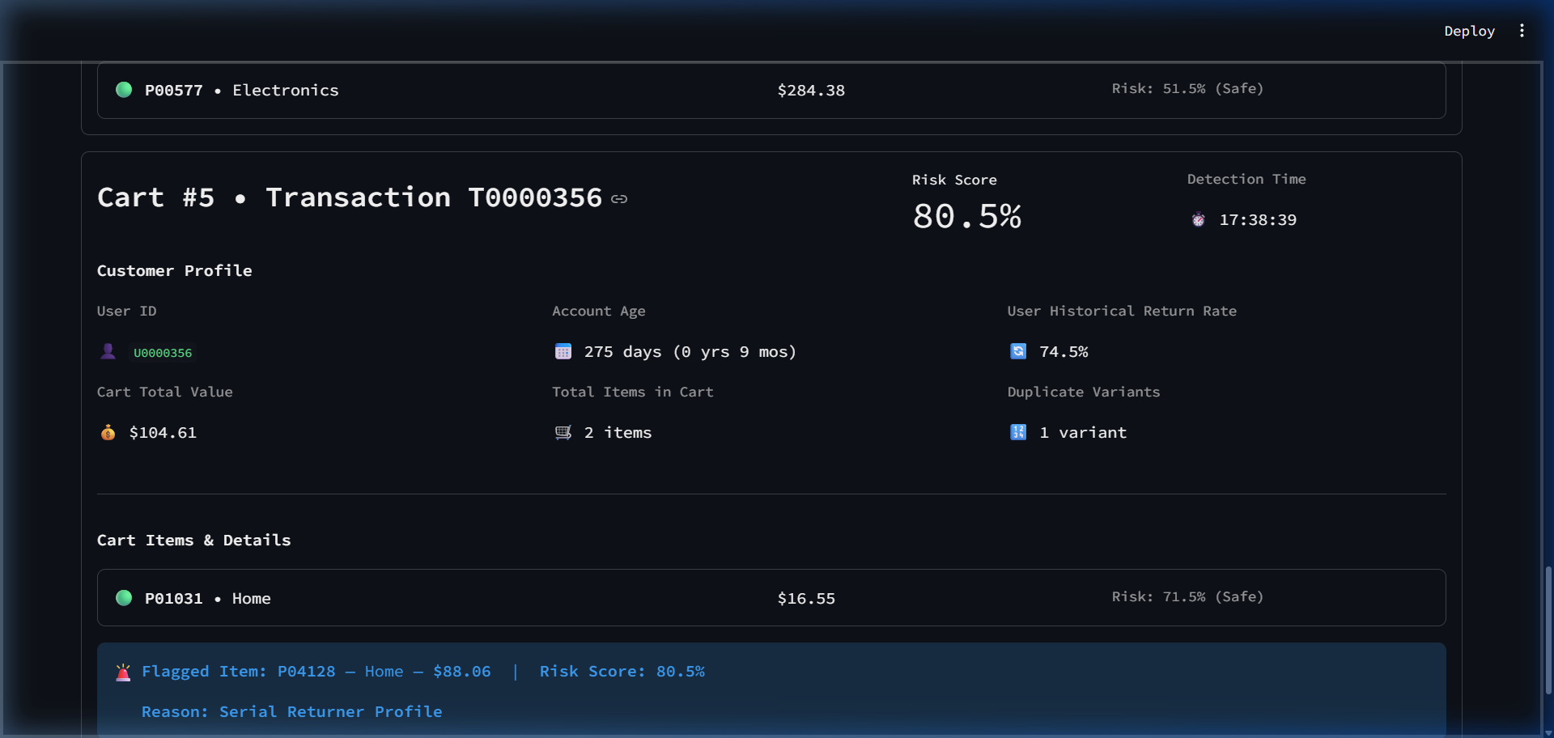

SECTION VIII • VALIDATION & CLOSING
11. Testing, 12. Conclusion & 13. References
11. Testing & Quality Assurance: CartCheck was validated across four levels of testing:
• Unit Testing: Validated the 5-branch logic tree precedence under boundary conditions (e.g. verifying bracket buying takes precedence over account age).
• Streaming Integration: Confirmed zero-loss JSON payload deserialization over Kafka and non-blocking SSE streaming over 100,000 transactions.
• High-Throughput Load Testing: Sustained 1,250 events/sec under Docker virtualization with zero consumer lag buildup and 4.2ms inference latency.
• Frontend Validation: Verified pause toggle freeze behavior and boxed card styling (neutral containers for safe items, blue callouts for flagged items).
12. Conclusion
CartCheck demonstrates the technical viability and economic value of pre-checkout return risk classification in high-volume digital commerce. By replacing retrospective post-purchase auditing with an event-driven, sub-15ms streaming architecture, CartCheck empowers retailers to identify and mitigate return risk before orders are dispatched. The integration of LightGBM's gradient-boosted precision with an explainable five-tier reasoning hierarchy provides actionable intelligence distinguishing bracket buying, new account wardrobing, volatile SKUs, remorse, and serial returners. CartCheck establishes a scalable, sustainable blueprint for modern retail reverse-logistics optimization.
13. References
1. Anderson, E. T., Hansen, K., & Simester, D. (2014). The option value of returns in e-commerce. Journal of Marketing Research, 51(3), 329-346.
2. Ke, G., Meng, Q., Finley, T., et al. (2017). LightGBM: A highly efficient gradient boosting decision tree. NeurIPS 2017, 30, 3146-3154.
3. Kreps, J., Narkhede, N., & Rao, J. (2011). Kafka: A distributed messaging system for log processing. NetDB Workshop, 1-7.
4. Petersen, J. A., & Kumar, V. (2009). Are product returns a necessary evil? Journal of Marketing, 73(3), 35-51.
5. National Retail Federation (NRF) & Appriss Retail. (2023). Consumer Returns in the Retail Industry Report.
6. Tiangolo, S. (2018). FastAPI: High-performance Python API framework. https://fastapi.tiangolo.com/
7. Streamlit Inc. (2024). Streamlit Documentation: Session State and Fragment Execution. https://docs.streamlit.io/

