Coursera (MOOC)

Coursera is a Massive Open Online Courses (MOOC) portal that you can use to take an impressive number of specialized courses offered by a number of Universities such as Stanford, Pen State, Jon Hopkins and the rest.

“Coursera provides universal access to the world’s best education, partnering with top universities and organizations to offer courses online.” -- <https://www.coursera.org/>

Java specialization

<https://www.coursera.org/specializations/java-programming>

<https://www.coursera.org/specializations/java-object-oriented>

Our interest will be on “**Java Programming: Solving Problems with Software**” (<https://www.coursera.org/learn/java-programming> ) course that is part of the java specialization, and “**Java Programming: Arrays, Lists, and Structured Data**” (<https://www.coursera.org/learn/java-programming-arrays-lists-data> ) course.

In order to enlist for “**Java Programming: Solving Problems with Software**”, follow the steps below: -

# Steps:

1. Start your browser of choice (hopefully not I.E)
2. Navigate to <https://www.coursera.org/learn/java-programming>. You should land on a page similar to the one below.

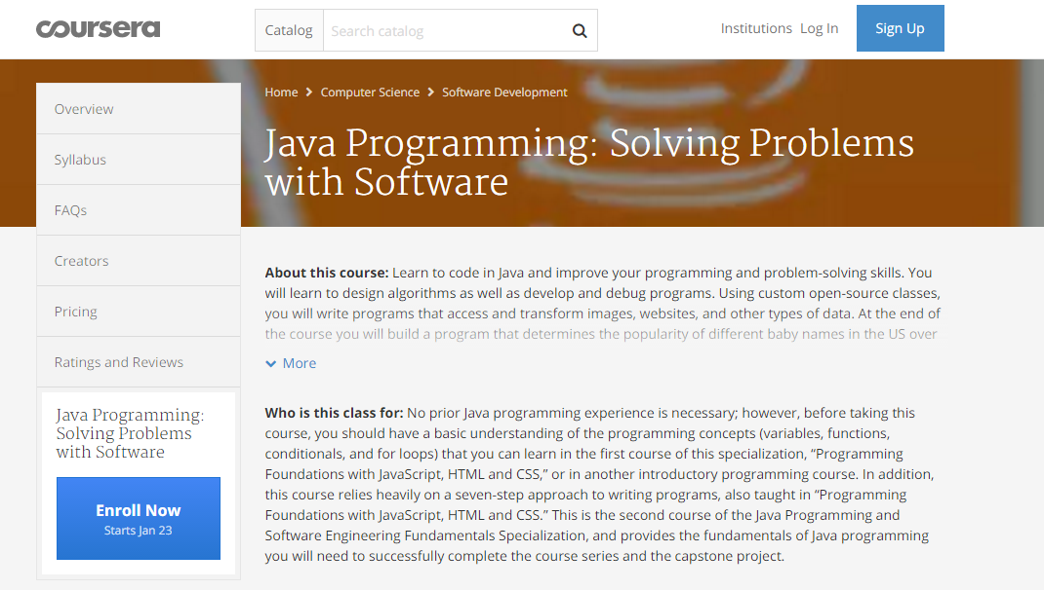

1. If you haven’t signed up, please go ahead and do that, otherwise log in.
2. On the lowermost left corner, there is “Enroll Now” button. Click it.

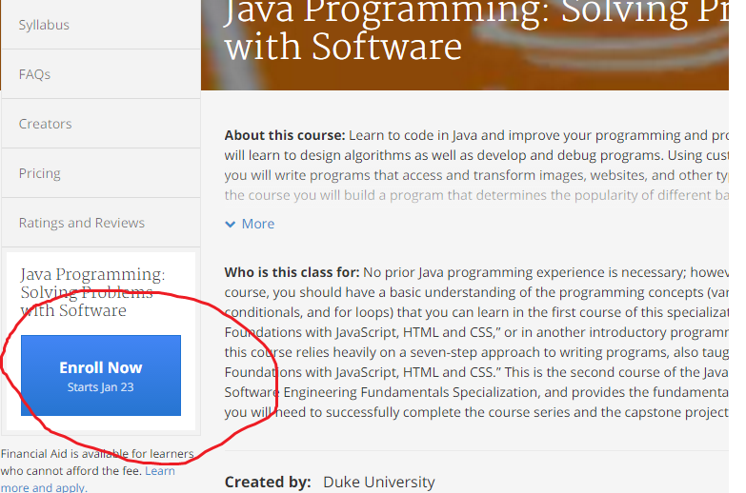

1. A dialog for making fee payment will appear as below. Please click “Audit” in order to enjoy the course at no cost.

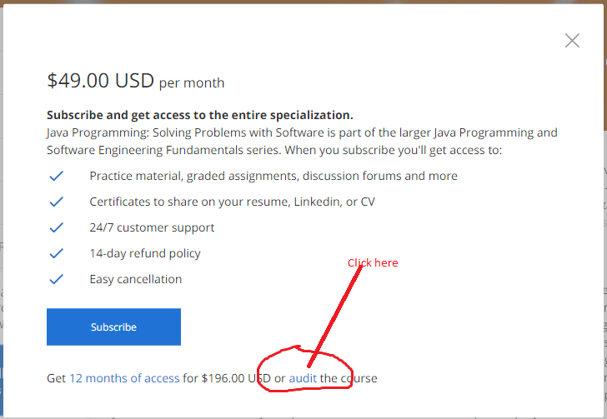

1. NB: You will get access to all the materials as concerns the course, you will be able to access quiz, but you will **NOT** be able to submit assignments for quiz. Instead, we will be doing the quizzes on a weekly basis counting towards your CAT’s

You will need to dedicate at least 3 hours a week for these courses. At the end of each week are assignments.