Proomahan

System Design

STATUS  Implementation baseline |  | OWNER  Project owner |  | LAST UPDATED  7 November 2026

Authors | Codex with requirements from the project owner
Reviewers | Neighborhood and implementation reviewers to be assigned
Related docs | Repository planning pack in README.md and docs/00 through docs/05
Scope | Architecture for the neighborhood management MVP

1. Abstract
Proomahan is a responsive neighborhood management platform for administrators and residents. One Next.js application uses Supabase PostgreSQL, Auth and Storage to manage people, units, dynamic fees, invoices, manually verified payments, news and resident services. The MVP serves one neighborhood while enforcing tenant boundaries from the first migration.
Administrators create accounts and manage password resets manually. Residents sign in with a phone number or email address and a password, without email or SMS verification. Fees and amounts are configurable. Ownership, occupancy, billing responsibility and account access remain separate; pending payment submissions never reduce an outstanding balance.

2. Goals and Non-Goals
Goals | Non-goals
Manage dated unit ownership and occupancy without losing history. | Rental contracts and property-title processing.
Configure fee items and amounts without code changes; settle invoices only after verification. | Payment gateways, automatic refunds and full treasury accounting.
Provide private resident letters, service requests, guest reports and audience-scoped news. | Electronic gate operation, QR passes and automatic WhatsApp delivery.
Support one neighborhood now with tenant-aware access and staged rollout. | Native mobile apps, SaaS subscriptions and customer self-onboarding.

3. Background and Problem Statement
The project requires a shared record of units, residents, financial obligations and neighborhood services. Current spreadsheets, unit counts and production workloads have not been established. Development can proceed using configurable rules and synthetic fixtures; actual import volume and operational targets are launch inputs.
The application owns workflows and authorization; Supabase owns authentication credentials and persistent storage. Physical gate opening, bank transfers, cash handover and letter signing remain external manual activities. The key invariant is that a resident can access only explicitly authorized records, including after ownership or occupancy changes.

4. Proposed Architecture

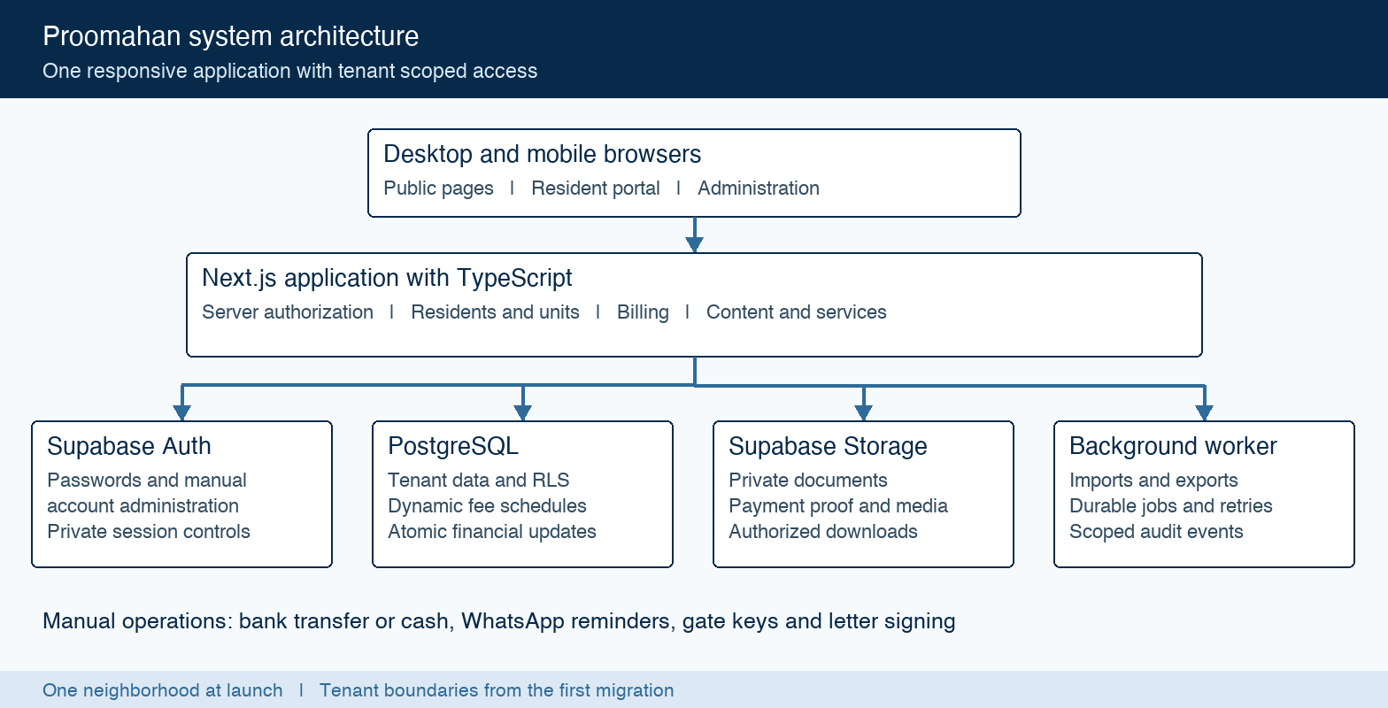
Figure 1. Proomahan application and Supabase boundaries.

Core components

Component | Responsibility | Primary storage | Failure behavior
Next.js application | Pages, workspaces and validated server actions. | User-scoped clients | Deny if identity or access checks fail.
Supabase Auth | Password sign-in and manual account operations. | Auth and private session controls | Block incomplete provisioning or resets.
PostgreSQL domain layer | Dated records, fees, invoices and allocations. | Tenant-scoped tables | Roll back failure; reject conflicts and duplicates.
Supabase Storage | Evidence, letters and news media. | Private buckets | Keep failed uploads unattached; check downloads.
Background worker | Imports, exports and durable follow-up work. | PostgreSQL jobs and audit | Bound retries; show failures to staff.

5. Request Lifecycle
- A resident submits payment details for authorized invoices, or an administrator invokes a protected action. Inputs include the unit, affected record IDs and an idempotency key.
- The server validates the session, password-change gate, current membership, tenant and role. It normalizes identifiers and rejects inaccessible records before loading sensitive data.
- Processing loads the relevant invoice balances or effective fee settings, responsibility, vacancy rules and evidence metadata. Client totals and role claims are never authoritative.
- A payment submission remains pending. Billing administrators compare bank or cash evidence, then verify or reject it with a reason. Invoice previews resolve charges before issuance.
- Verification locks payment and invoice rows, applies allocations once, and commits the decision, audit event and follow-up job in one database transaction.
- Workers process durable jobs with deduplication and bounded retries. Failed notifications do not undo financial changes. WhatsApp reminders are previewed and opened manually.
- The portal returns the current status, outstanding balance and receipt after verification. Errors distinguish validation, conflict and retryable infrastructure failure without exposing private data.

6. API and Data Contracts

Primary data contract for an issued invoice

Field | Type | Required | Description
id / invoice_number | UUID / text | Yes at issue | Opaque identity and tenant-unique official number.
tenant_id / unit_id | UUID | Yes | Neighborhood and physical unit; composite references prevent cross-tenant links.
bill_to_person_id | UUID | Yes | Responsible person resolved for the billing reference date.
period_start / period_end | date | Yes | Billing interval, with start inclusive and end exclusive.
items | Related rows | Yes | Configured fee item, labels, quantity, rate and amount snapshots.
total_amount / currency | Decimal / code | Yes | Sum of issued lines; IDR in the pilot; no floating-point money.
status / due_date | Enum / date | Yes | Draft, issued or void; unpaid/partially paid/paid is derived separately.

Contract guarantees

- Amounts use exact decimals. Invoice lines and total agree; verified, unreversed allocations determine settlement. Pending submissions remain separate.
- A generated occurrence is unique per tenant, unit, fee item and period or one-time charge date. Submission keys prevent repeat effects; official numbering is allocated atomically.
- Issued records snapshot item/category labels, quantities, rates, bill-to details and unit labels. Configuration changes never rewrite an issued invoice.
- An invoice is the source of debt; a verified payment is evidence of settlement. Collections are not the available bank or cash balance.
Detailed schema definitions and access rules are maintained in the repository specification:
docs/05-mvp-implementation-specification.md
Core relationships and administrator configuration
Domain | Records | Rule
Identity | Auth users, profiles, memberships and roles | Accounts and people are separate; staff access is neighborhood-scoped.
Residents and units | Clusters, units, ownership and occupancy periods | One physical unit; dated links preserve history and control access.
Dynamic fees | Categories, items, effective schedules and responsibility | Monthly/one-time charges; unit overrides cluster overrides neighborhood.
Finance | Invoices, items, payments, allocations and reversals | Issued/verified records are immutable; pending evidence is not settlement.
Content and services | Posts/media, letters, requests, guest reports and contacts | Published audiences and private applicant/host visibility apply to files too.
Server actions are implementation contracts; they are not deployed public APIs. Each checks actor, tenant, permission, inputs and current record state.
Action | Inputs | Result and authorization
Create or reset account | Person, approved identifier and assigned roles | Neighborhood administrator only; temporary credential shown once; audited.
Change ownership or occupancy | Unit, people and effective dates | Validate periods; update relationship history and current access atomically.
Save fee schedule | Item, amount, scope, dates, due rule, payer and vacancy rule | Billing administrator; reject ambiguous settings and preserve prior versions.
Preview and issue invoices | Billing period and selected scope | Resolve item rates/liability; missing configuration blocks issue.
Submit payment | Authorized invoices, amount, method, handover/payment date and evidence | Resident permission required; pending submission with stable retry key.
Verify or reject payment | Payment ID, decision, reason and allocations | Billing administrator; one transactional decision; receipt only after verification.
Issue letter or publish post | Approved request/file/reference or content/audience | Service/content administrator; validate document purpose and visibility.

7. Consistency, Idempotency, and Replay

Financial effects and relationship changes are transactional. Retries may repeat computation, but must not duplicate a charge, allocation or official reference. Batch invoice issuance reports results per invoice and resumes failed items without leaving a partially issued invoice.
Scenario | Expected behavior | Reasoning
Repeat generation or submission | Return or resume the original operation; no duplicate financial effect. | Unique occurrence/submission keys survive retries.
Concurrent payment verification | Only one transition applies; lock and recheck affected balances. | Transactions prevent double allocation.
Auth, file or worker failure | Keep provisioning blocked, uploads unattached or jobs retryable. | Partial external work cannot silently activate access or settle debt.
Configuration changes | Revalidate draft preview; preserve issued snapshots. | Versioned schedules separate future rates from existing debt.

8. Security and Privacy Considerations

- Supabase Auth handles passwords. Neighborhood administrators provision accounts, approve identifiers and reset temporary passwords manually. Public registration and automated email/SMS recovery are disabled. First sign-in after creation or reset requires a password change.
- Every protected query checks active membership, tenant, role and row access through server authorization and Row Level Security. Database-controlled account/session gates block disabled accounts and stale sessions. User-editable metadata never grants authority.
- Supabase privileged credentials remain server-only. Payment verification and issuance use restricted transactional operations. Files are private, purpose-scoped and inspected; downloads require parent-record permission and short-lived links.
- Owners, occupants and non-login people are distinct from accounts. New occupants do not inherit old invoices or identity files. Billing, content, service and security roles receive only their scoped permissions; document review is an explicit capability.
- Audit records exclude passwords and document bodies. Internal service notes remain private. Production retention, region and recovery settings require recorded ownership before launch; database and file restoration must be verified together.

9. Operational Readiness
Signal | SLO or alert | Owner | Launch gate
Financial integrity | No duplicate charges/allocations in concurrency and replay tests. | Implementation owner | Required
Tenant isolation | No cross-tenant or private-file access in the acceptance suite. | Implementation owner | Required
Job and review queues | Failures/retry exhaustion visible; numeric alert thresholds set before launch. | Operator to assign | Required
Latency and capacity | Measure real import volume and core journeys; agree targets before launch. | Operator to assign | Required
Recovery and drift | Database/file restore and reviewed migration consistency demonstrated. | Operator to assign | Required
Rollout constraint: dry-run imports, reconcile opening balances, pilot selected households, verify rollback and restore, then promote. No SLO measurements or production validation have been completed yet.

10. Alternatives Considered

Alternative | Reason to consider | MVP tradeoff
Separate backend service | Independent service scaling and deployment. | One application and transactional database cover the initial workflows with less operational overhead.
Separate native mobile apps | Dedicated device experiences. | Responsive web serves the requested desktop/mobile scope with one interface system.
Immediate messaging/payment automation | Reduce repeated staff actions. | Manual reminders and verification match the MVP; provider integrations are later work.
Single-neighborhood schema without tenant keys | Fewer initial access dimensions. | Future customers would require data restructuring; tenant boundaries are included now.

11. Open Questions
- Deployment inputs: select the Supabase region, application host, production domain and responsible operator. No production environment or deployment date is assigned by this design.
- Neighborhood setup: enter actual fee items, amounts, payer/vacancy rules, due dates, bank instructions and cash collectors. These are configuration inputs, not hardcoded product rules.
- Resident services: configure approved letter types, evidence, numbering, authorized signatories, contact hours and guest-report recipients before activating those services.
- Operations: establish import volume, retention, recovery targets, performance thresholds and support ownership. These must be recorded before production rollout.

12. Decision and Next Steps
Proceed with the modular Next.js and Supabase baseline. Build account/tenant access and the directory first, then dynamic billing, payment verification, content and services. Pilot selected households before wider onboarding. Promotion requires reconciled imports, tested isolation, successful restore and administrator acceptance.
Milestone | Deliverable | Exit criteria
M1 Foundation | Project, migrations, Auth, account/session gates and private storage. | Manual provisioning/reset works; stale sessions and cross-tenant reads fail.
M2 Directory | Units, people, dated history, account links and CSV preview. | Owner/renter/move-out examples pass; invalid overlaps are blocked.
M3 Billing setup | Dynamic fee catalog, schedules, liability and invoice preview. | New items and unit/cluster overrides work without deployment.
M4 Settlement | Issue, submit, verify, reverse, receipt, reports and reminders. | Concurrent retries apply once; partial/excess payments reconcile.
M5 Services | News, contacts, resident letters, service requests and guest reports. | Audience/private-file checks pass; issued letters require reference and signed file.
M6 Pilot | Import reconciliation, device checks, staff guide and restore drill. | Representative residents finish tasks; data and files recover; launch inputs complete.

A tenant is an isolated neighborhood customer. A renter is a person renting a residential unit.

