MatchResolution User Manual
Version: v2.0.0
Audience: RF Engineer only.
Document date: 2026-08-15

What this app does ?

MatchResolution converts EVC RF matching network Smap datasets into analysis views and charts. We could analysis resolution, efficiency and plot impedance of desired load and tune position on Smith Chart.
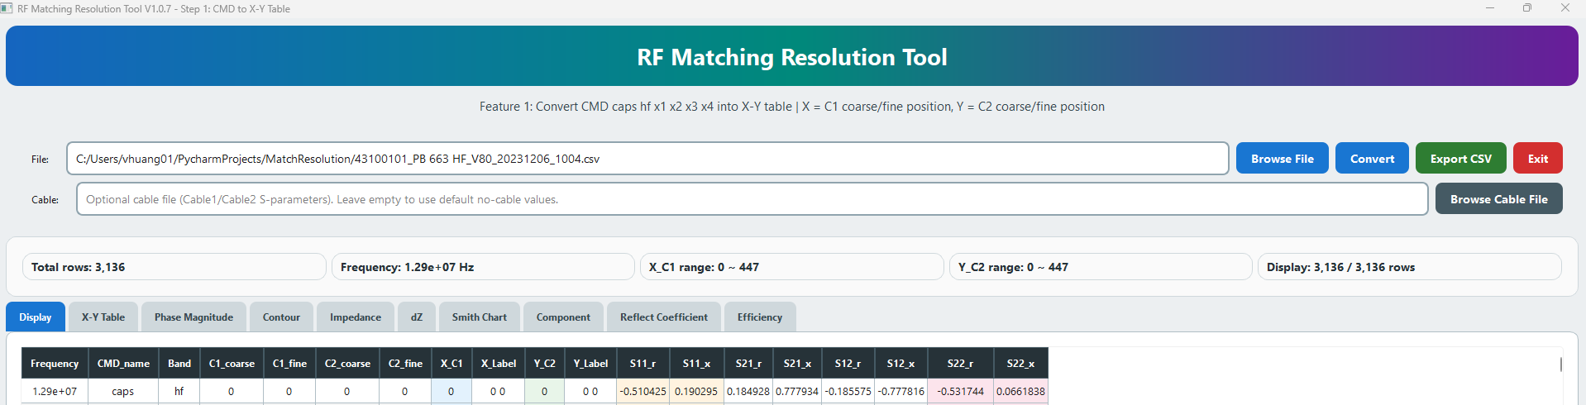

1. Start the App
- Double-click `MatchResolution_V1.0.9.exe` or latest version.
- A splash screen appears, shows the program name and version, and stays on screen while the app loads.
- The main window opens maximized after startup finishes.

2. Quick Workflow
- Click "Browse File" and select your Smap file (.csv; reduced Smap, full Smap). 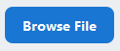
- Optional: click "Browse Cable File" and select a cable S-parameter file. 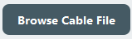
- Click "Convert". 
- Review results in the tabs.
- Click "Export CSV" to export the current tab data. 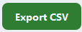

3. Cable File (Optional)
- If no cable file is selected, the app uses built-in no-cable defaults.
- The cable file must contain both Cable1 and Cable2 rows.
- Required columns: cable, S11R, S11X, S21R, S21X, S12R, S12X, S22R, S22X

4. What Convert Does
- Converts measured S parameters to T parameters.
- Removes cable effects in the T domain.
- Converts the final T parameters back to S parameters.
- All tables and plots use the de-embedded results.

5. Tab Guide
Tab | Description
Display | Row-based converted/de-embedded S-parameter table.
X-Y Table | Grid view for the selected S-parameter (S11/S21/S12/S22).
Phase Magnitude | Magnitude/phase table with 0 to 360 degree rotation.
Contour | Edge-only grid view and contour Smith mode.
Impedance | Converted impedance view for the selected parameter.
dZ | Delta impedance resolution maps.
Reflect Coefficient | Delta-Gamma resolution views.
Efficiency | |S21|^2 or η(eta)overall = (1 - |S11|^2) x |S21|^2.
Smith Chart | Modes: X-Y, dZ, dGamma(Reflect Coefficient), Efficiency, Contour, and P/M.
Component | Capacitor and resolution component plots.

6. Smith Chart Controls
- Parameter selector chooses which S-parameter to plot. 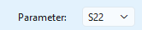
- Conjugate toggles the plotted reflection data.
- Save Image exports the current Smith chart as PNG.
- Rotation is on the Smith Chart tab under Save Image. This rotate Phase Magnitude data.
- X-Y Table shows Smap data on Smith Chart.
- 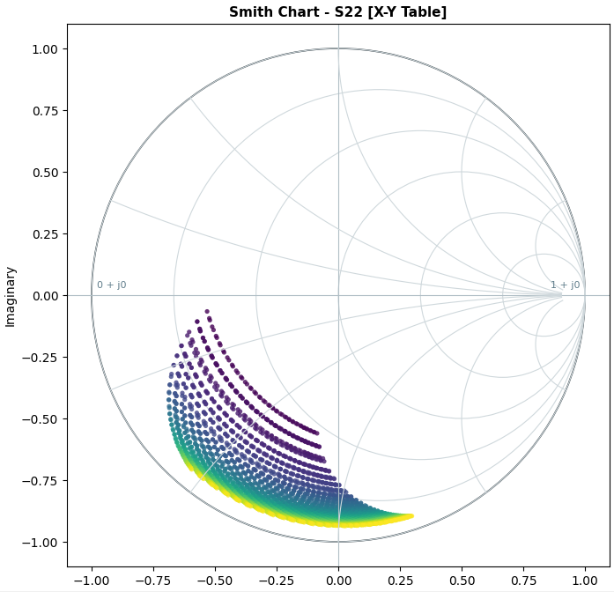
- dZ showed deviation from next position to current position.
- Horizontal : dZ = (0 1 0 0) – (0 0 0 0)
- Vertical : dZ = (0 0 0 1) – (0 0 0 0)
- 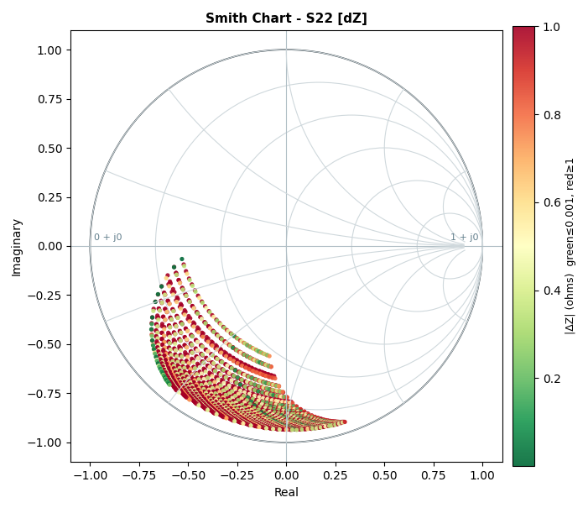
- dΓ shows deviation from next reflect coefficient to current reflect coefficient.
- Horizontal : dΓ = (0 1 0 0) – (0 0 0 0)
- Vertical : dΓ = (0 0 0 1) – (0 0 0 0)
- 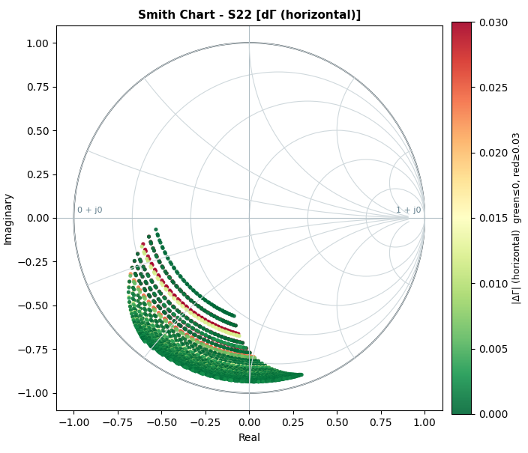
- Efficiency shows efficiency from S parameter.
- `|S21|²`
- Only consider Zo as 50 ohm.
- `ηoverall = (1 - |S11|²) × |S21|²`.
- Where:
- - **η** (eta) = Power transmission efficiency (dimensionless, range [0, 1])
- - **|S11|²** = Magnitude squared of S11 parameter (reflection coefficient)
- - **|S21|²** = Magnitude squared of S21 parameter (forward transmission coefficient)
- `|S21|²`*(1 - |S22|²) / |1 - S22²|²`. (default selection)
- Consider perfect match conditions
- 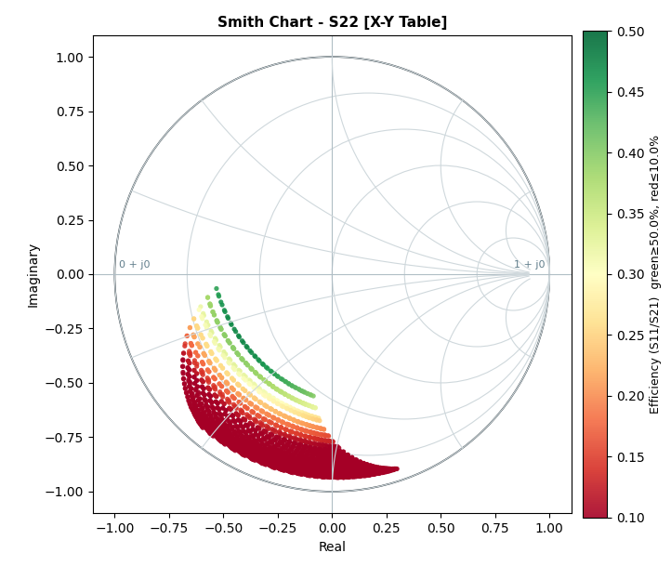
- P/M mode shows phase-magnitude data on the Smith chart.
- Contour mode shows the outer edge points only. 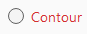
- 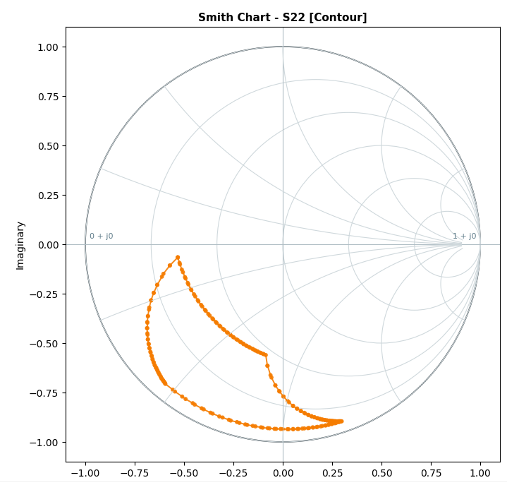

7. Manual Impedance point
- Manually add impedance point on Smith Chart. 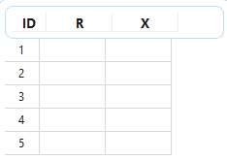
- Plot Points add manual impedance point on Smith Chart.
- Add Row to add more manual impedance point on the table.
- Clear to erase manual impedance point on the table.
- Import impedance point from csv file.

8. Smith Chart Search and Carry Over
- Enter C1% and C2%. 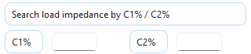
- Click "Search ZL".
- Click "Carry Over" to place the result into the manual impedance table. 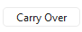

9. Export CSV
- Export CSV saves the current tab view.
- Phase Magnitude and Contour tabs export their grid tables.
- If no tab-specific export exists, the main converted table is saved.

10. Component
- Input RF Cavity design
- 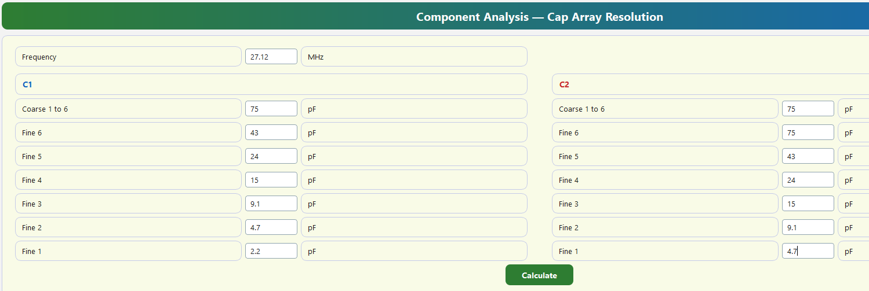
- Display Resolution heatmap result
- 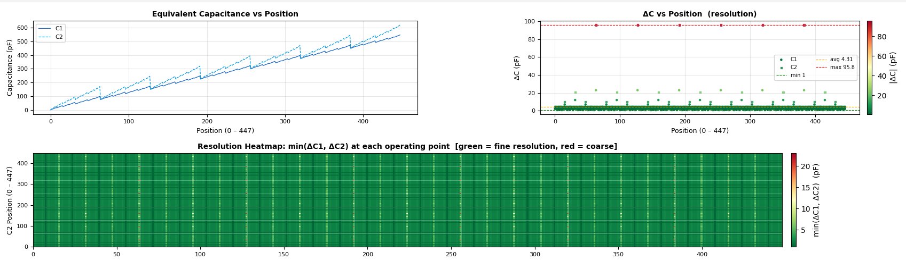
- Tykon0527 RF cavity sample
- 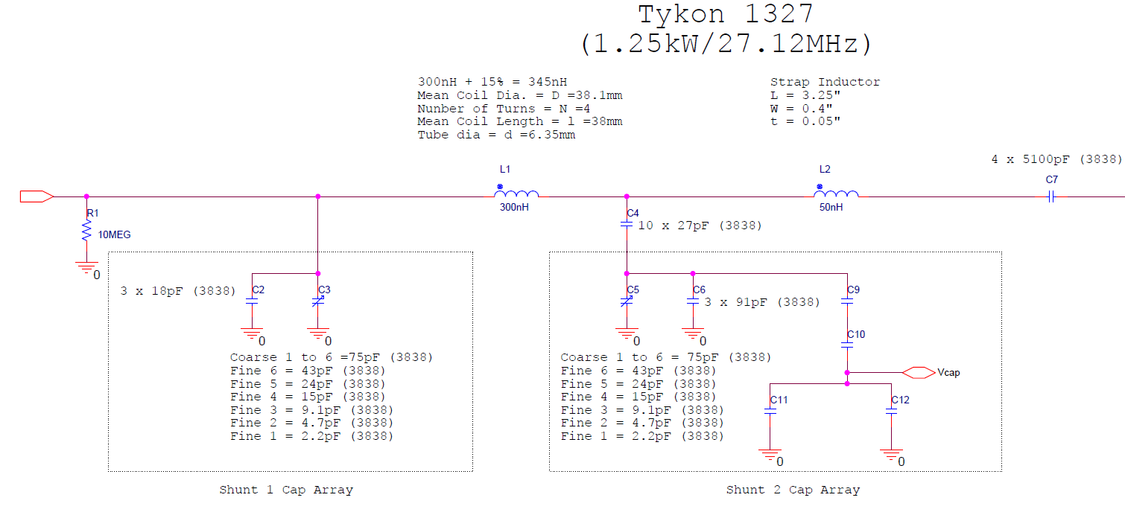
- Tykon1213 RF Cavity sample for model 524
- 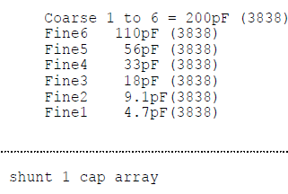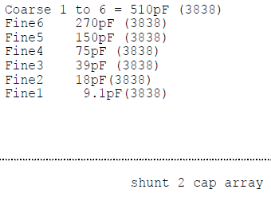

11. Troubleshooting
- No data after Convert: confirm the file contains valid Frequency/CMD/S-parameter data.
- Cable file error: confirm the required columns and both Cable1/Cable2 rows are present.
- Slow startup: the splash screen should appear first and the libraries load in the background.

12. Best Practices
- Keep original measurement files unchanged.
- Use a cable file only when measurements include front/back cable effects.
- Use Export CSV for reporting individual tab results.

