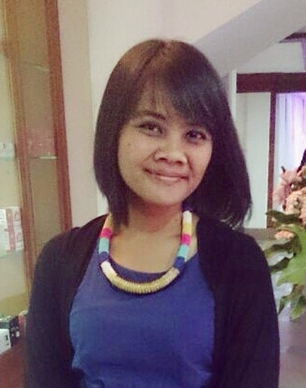
Dessy Syahniar M.Psi.,Psikolog
Jl. Raya Tapos Gg. H Sara Rt 03/05 No. 56
Cimanggis - Depok 16959
Phone: 081311334183
Email: dessy.syahniar@gmail.com

PERSONAL DATA
Place / Date of Birth : Jakarta / August 5th 1988
Age : 25 Years old
Religion : Moslem
Gender : Female
Marital Status : Single

Job Experience
1. Magister Psychologist Students at Clinical Psychologist University of Indonesia (2009-2011)
- Learn and conduct psychological assesment and intervention under supervision by licensed psychologists, manage variety of clinical cases in various institutions, including:
- Panti Sosial Karya Wanita Mulyajaya, Ps.Rebo
- Panti Werdha Budi Mulia
- Puskesmas Sukmajaya, Depok
- Klinik Terpadu Psikologi UI, Depok
- Panti Rehabilitasi NAPZA Yakita, Ciawi (Bogor)
- Rumah Sakit Marzoeki Mahdi, Bogor
- Rumah Sehat Masjid Agung Sunda Kelapa
- Panti Sosial Handayani, Cipayung
- Yayasan Ginjal Diatrans Indonesia, Jatiwaringin
- Polres Depok, Depok
2. HR Analyst at PT Indocement Tunggal Prakarsa Tbk.
(October 2011 – February 2014)
- Recruitment planning in accordance with company requirements
- Doing employee recruitment process : testing, create psychological report, interviewing, selecting and hiring new employee
- Building relationship, making coordination and corporate with 2nd party (school, university, etc) as a source of employee
- Counseling the employees
3. Private Psychologist (2011 – Current)
- Manage variety of clinical cases and conduct psychological assesment and intervention by private
4. Associate Psychologist PT Galenium Pharmasia (June 2013 – Current)
- Create psychological report for prospective employee

FORMAL EDUCATION
Degree | Institution | Major | School Year
Master Degree | University of Indonesia | Profesi Psikolog Klinis Dewasa (PSYCHOLOGIST) | 2009 – 2011
Bachelor Degree | Paramadina University | Psychology | 2005 – 2009
Senior High School | SMAN 1 Cibinong | Science | 2002 – 2005

Training/ Course
Course Type | Institution | Year
English Course | IEC | 2003 - 2004
Training “Bringing the HR Revolution to Indonesia with social media” | HRD Forum | 2013
Training “psychoassessment : Belbin Method with Philip Merry” | PT Indocement Tunggal Prakarsa Tbk. | 2013
Training “Personal Development and Attitude Excellente for high Performance with Synergis training & Consulting” | Synergis Training Center | 2013

CERTIFICATION
Activity | Institution | Position | Year
Temu Ilmiah psikologi | Psychology Faculty, University of Indonesia Indonesia | Speakers and Participant | 2010

ABILITY
- Adult Clinical of Psychologist : Administration and Interpretation psychological test, psychological examination. psychological intervention (therapy).
- Recruitment process in Industry & organization setting
- Administration, scoring, interpretation for variety of psychological testing then create psychological report in clinical, Industry & organization, and educational setting
- Computer Ability: MS. Office (Word, Excel, Powerpoint), SPSS for Windows, Photoshop CS3.

STRENGHT
Highly motivation, easy going, humble, able to learn and work hard, able to work as part of team or individual.

REFERENCE
1. Dra. Yudiana Ratna Sari, M.Si (Psikolog)
Job: Psychlogist, Lecture in Psychology Majoring at University of Indonesia
Relation: College Lecture
Phone Number: 08174975760
2. Dudy Gandjar
Current Job: HR Manager PT Pionir Beton Indonesia
Relation: Former Boss in Recruitment & Specialist section PT Indocement Tunggal Prakarsa Tbk.
Phone Number: 0856894900233
3. M. Nur Sahabuddin
Current Job: Section head of Recruitment and Specialist Section of PT Indocement Tunggal Prakarsa Tbk.
Relation: Section Head
Phone Number: 0811847099

