**Introduction**

The task is to write a Scissor Paper Rock game using TDD in Python. The code has been used and addressed all the comments of flake8

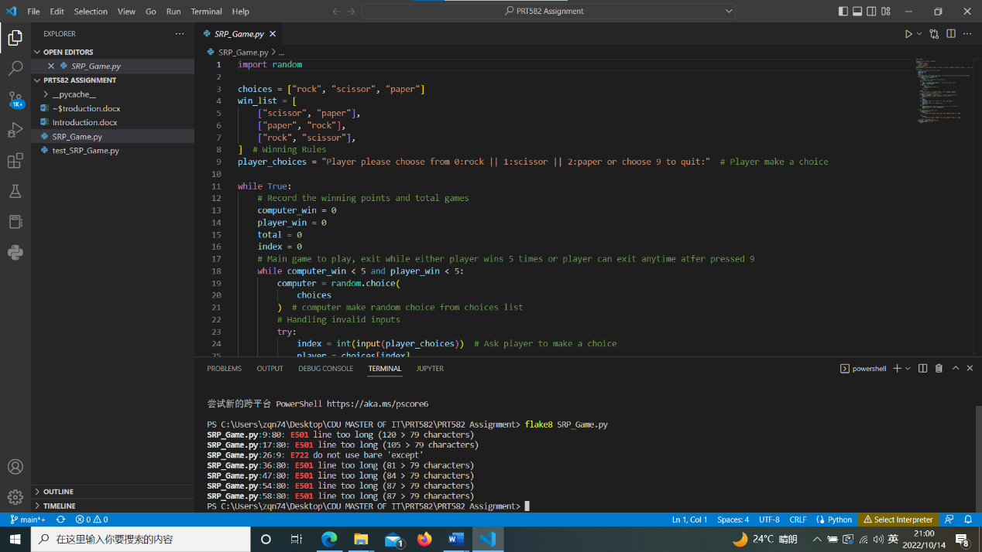

Winning rules are as follows:

* rock vs paper -> paper wins
* rock vs scissor -> rock wins
* paper vs scissor -> scissor wins.

The basic game requirements are:

* + 1. The computer randomly picks one of the options of scissor, paper and rock.
    2. Player is then given the option to pick/type one of the options of scissor, paper and rock.
    3. One point is given to the winner.
    4. The first to get five points wins the game. The total number of rounds played in total will also be displayed.
    5. Once the winner is determined, the player is asked to quit or restart the game
    6. Player can also quit the game at any time.

I did not follow exactly the TDD process to do this project as I am not familiar with this method. I try to use some automation to run the project, but still cannot figure it out.

**Process**

1. Import random function from Python build-in function as computer randomly picks one from three options.
2. Set ‘rock’, paper’, ‘scissor’ as the random options. Test the random function. This screenshot shows at least one choice has been selected from the random option.

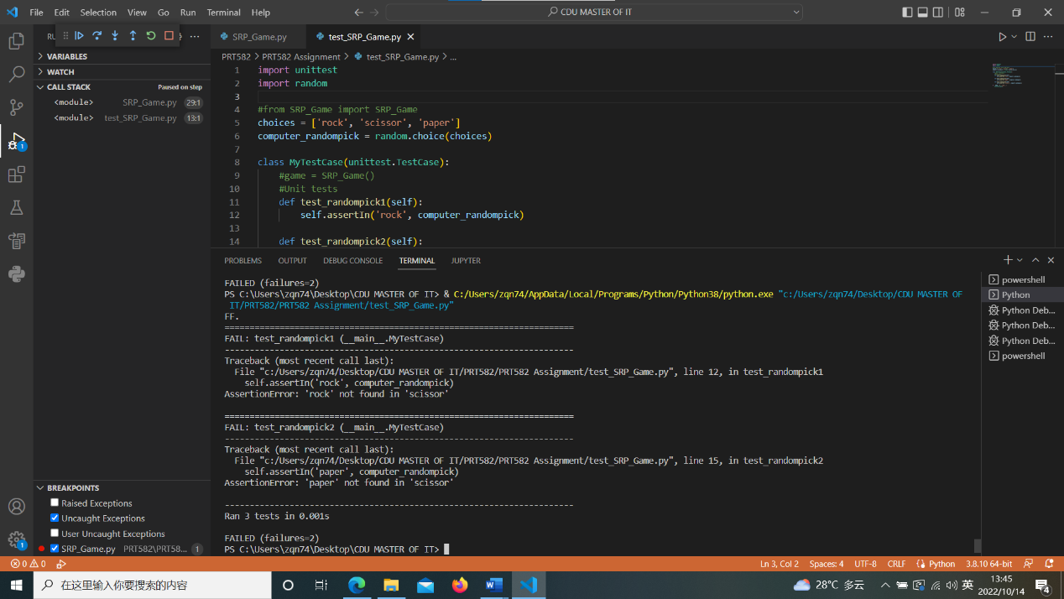

1. Follow the winning rules to setup the win_list.
2. Program the main function:

* Use While loop, stop when either player or computer wins 5 games (<5)
* Computer make random choice
* Ask player to make the choice from 0/1/2 or choose 9 to quit the game
* Handling the player’s input error
* Compare both player and computer’s choice, one point is given to the winner
* Print out the winner
* Create another while loop to ask player play again or not

1. Tested the quit option by input 9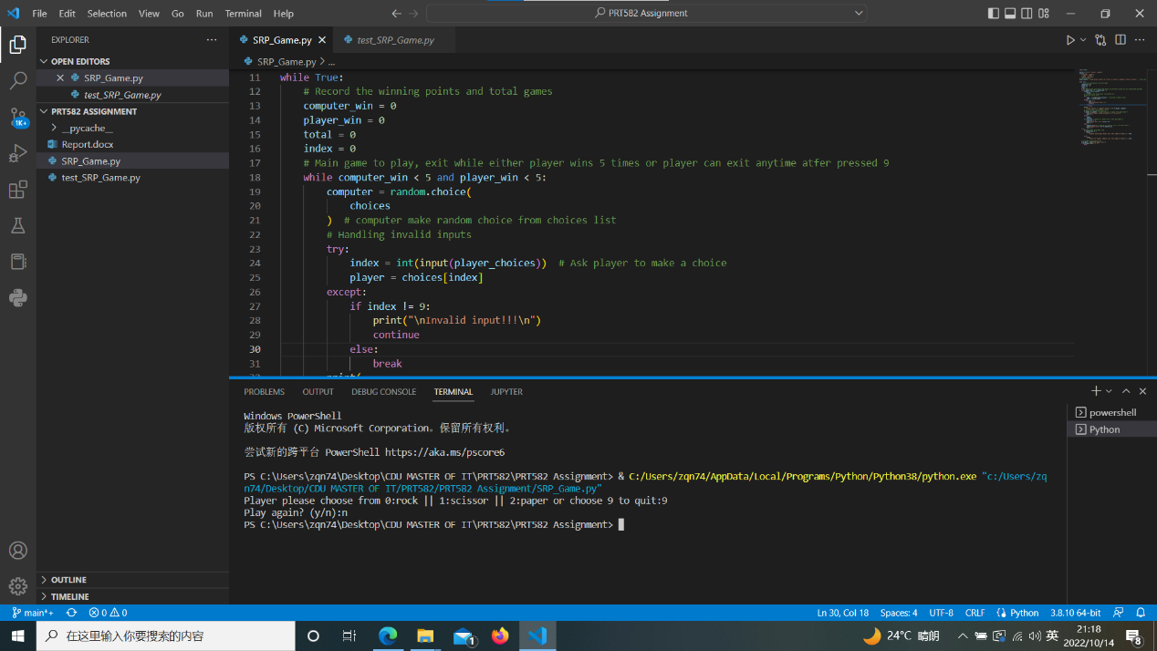
2. Tested player wins 5 games and game stops ask player to play again or not

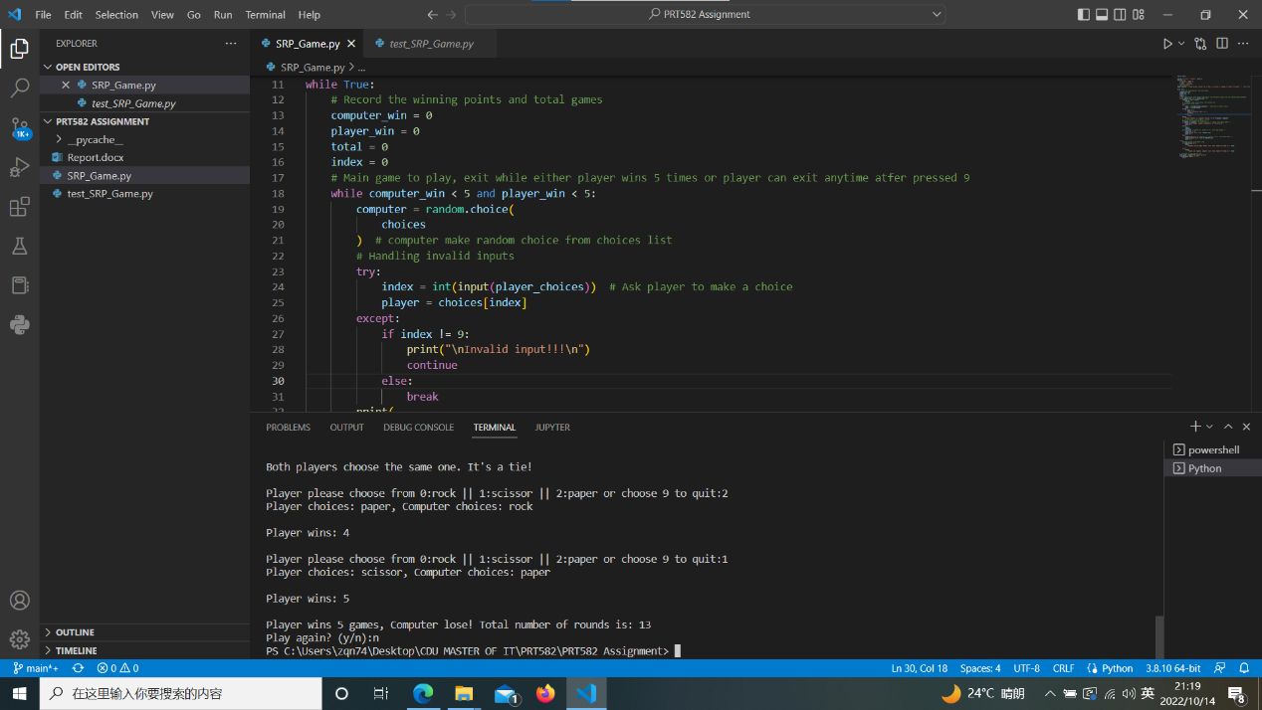

1. Tested computer wins 5 games and game stops ask player to play again or not

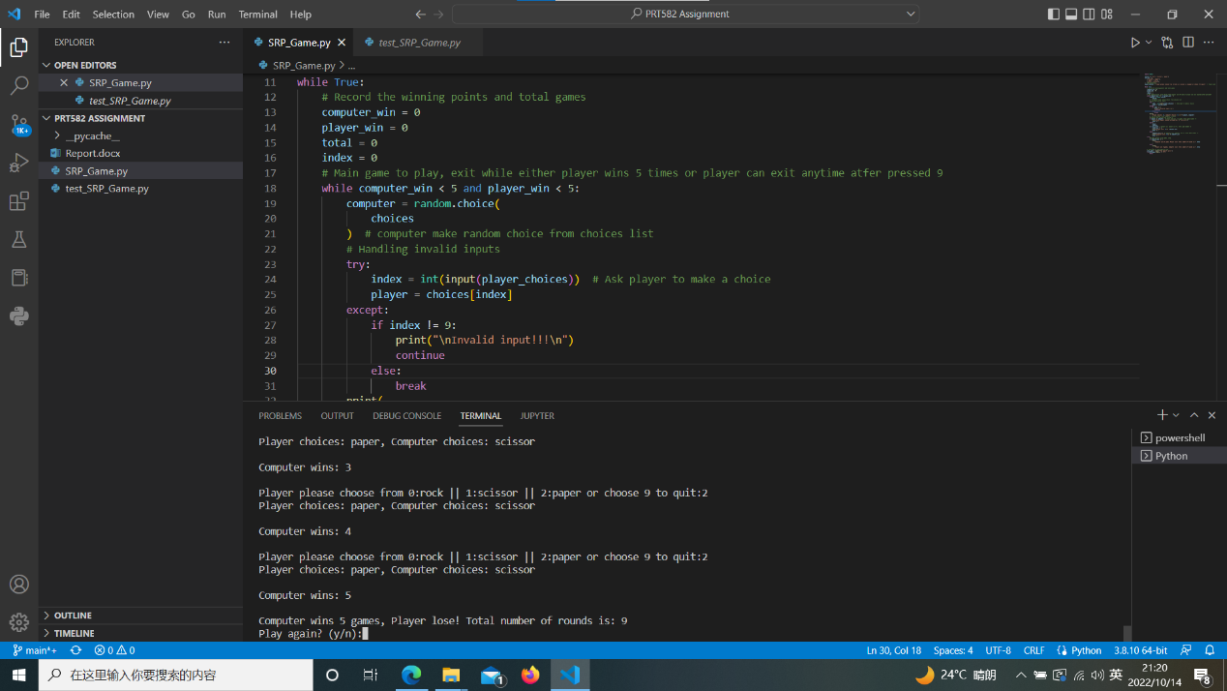

1. Tested handling the invalid input from the player

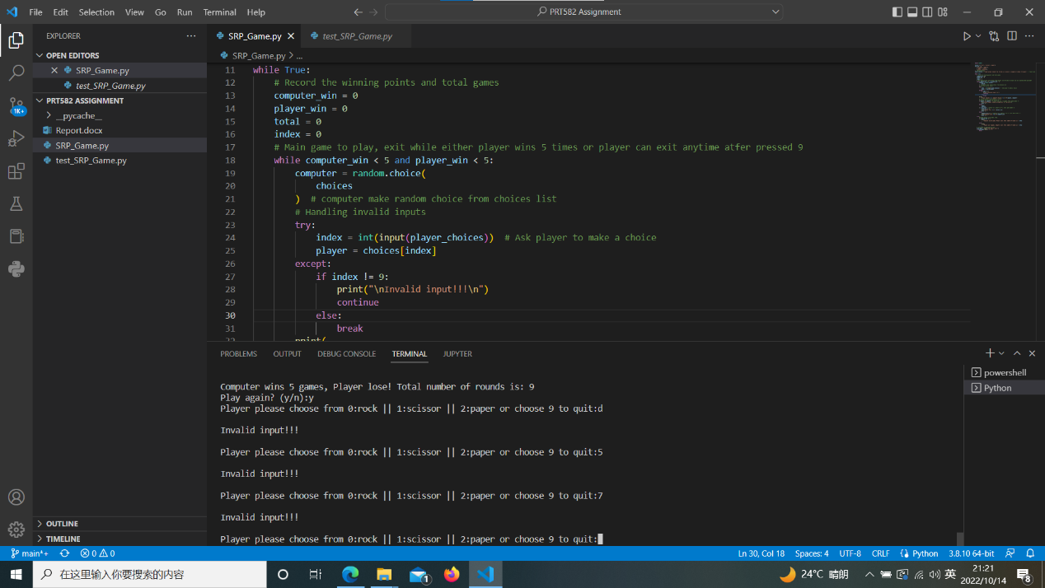

**Conclusion**

I need to get familiar with Python and practice more. Struggle with the TDD method, especially using the Unittest function. The coding format has to improve and will use flake8 to check the formatting.

The Github link for this assignment is [renozhu/PRT-582-Assignment (github.com)](https://github.com/renozhu/PRT-582-Assignment/tree/main)