**Final Hand-In:**

Team: Simple Habits (Alarmclock)

* René Penkert ([rene.penkert@gmail.com](mailto:rene.penkert@gmail.com) )
* Benedikt Bosshammer([benedikt.bosshammer@gmx.de)](mailto:benedikt.bosshammer@gmx.de))

Overall Usecase Diagram:

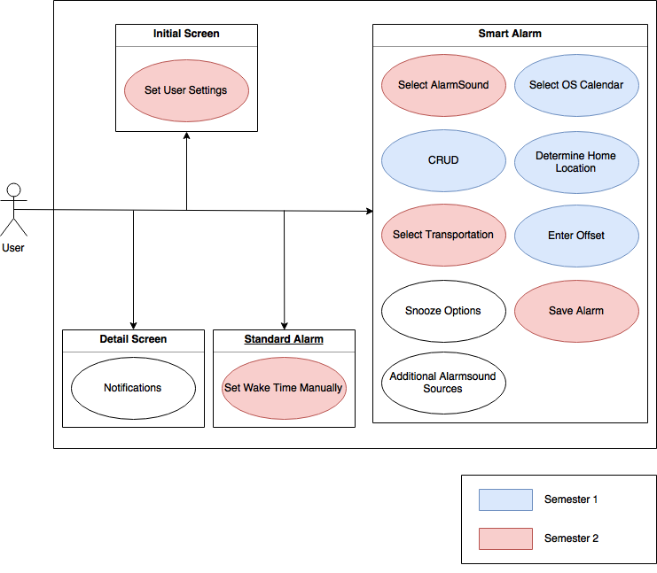

Time spent:

Benedikt Bosshammer -> time spent 236:

René Maximilian Penkert -> time spent: 221:

Jira Sprints -> Overall Time Spent 457 hours.