Simple Habits

Version 1.0

Revision History

|  |  |  |  |
| --- | --- | --- | --- |
| **Date** | **Version** | **Description** | **Author** |
| 31/10/16 | 1.0 | Initial Creation | Benedikt Bosshammer |
| 31/11/16 | 1.1 | Inserted Feature Files | Benedikt Bosshammer |

Table of Contents

1. Use-Case Name **Fehler! Textmarke nicht definiert.**

1.1 Brief Description 4

2. Flow of Events 4

2.1 Basic Flow 5

2.2 Alternative Flows 5

3. Special Requirements 5

4. Preconditions 5

5. Postconditions 5

6. Extension Points 5

ound

# Select alarm sound

## Brief Description

This Use Case provides the possibility for the users to select a sound from different sources for the alarm clock.

# Flow of Events

Within the Initialization of the Smart Alarm the User is asked to select an alarm sound to wake him up in the morning.

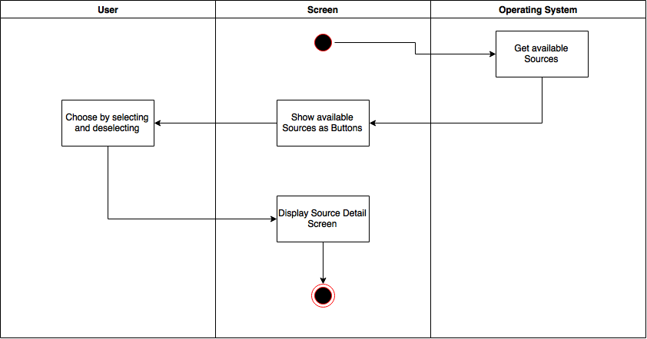

iOS Mock Up:

../../../../../Desktop/First%20UI%20Prototype%20(verschob

Feature File:

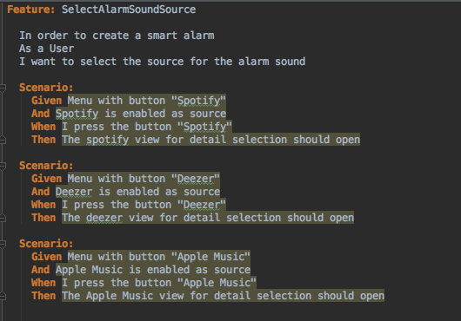

## Basic Flow

## Alternative Flows

# Special Requirements

# Preconditions

# Postconditions

# Extension Points