Simple Habits

Version 1.4

Revision History

|  |  |  |  |
| --- | --- | --- | --- |
| **Date** | **Version** | **Description** | **Author** |
| 31/10/16 | 1.0 | Initial Creation | Benedikt Bosshammer |
| 06/11/16 | 1.1 | Activity Diagram | Benedikt Bosshammer |
| 08/11/16 | 1.2 | Mockups | Benedikt Bosshammer |
| 14/11/16 | 1.3 | Feature Files | Benedikt Bosshammer |
| 15/05/17 | 1.4 | Added Function Points | René Penkert |

Table of Contents

1. Select Calendar 4

1.1 Brief Description 4

2. Flow of Events 4

2.1 Basic Flow 6

2.2 Alternative Flows 6

3. Special Requirements 6

4. Preconditions 6

5. Postconditions 6

6. Extension Points 6

7. Function Points 6

8. Testing 6

# Select Calendar

## Brief Description

This Use Case provides the possibility for the users to select the OS calendars containing the appointments for wake up time calculation.

# Flow of Events

Within the Initialization of the Smart Alarm the User is asked to select all his OS Calendars he wants the app to calculate in. It is confirmed by continuing to the next page.

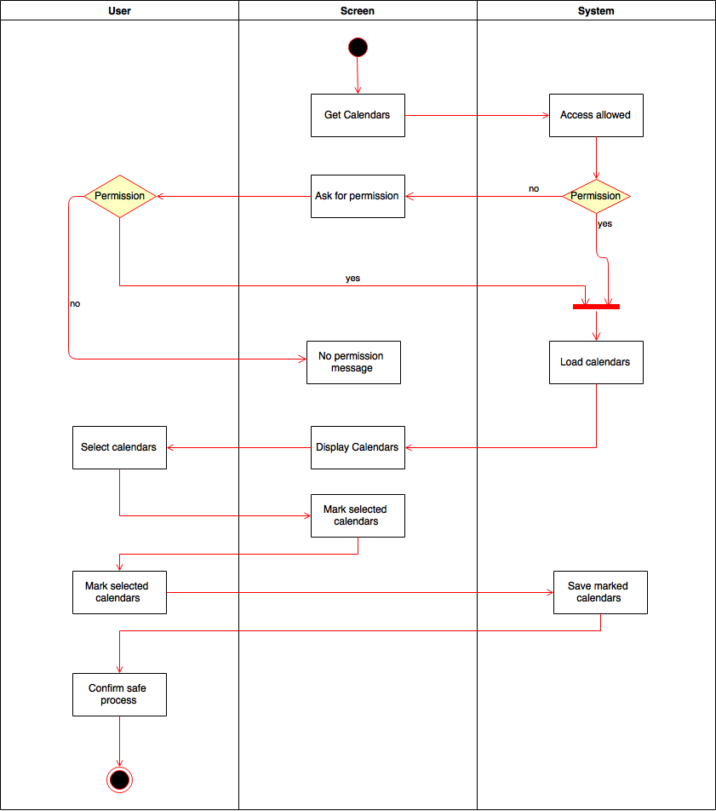

iOS Mock Up:

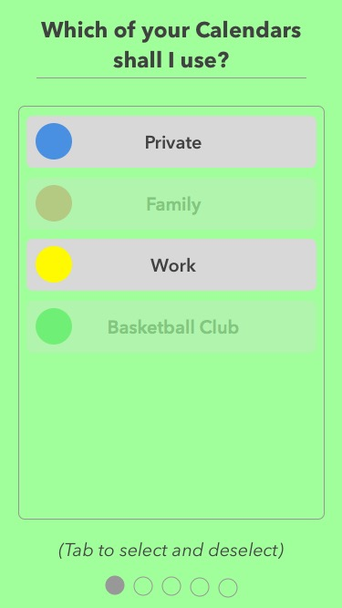

Mockup 1 Computer Design from Sketch

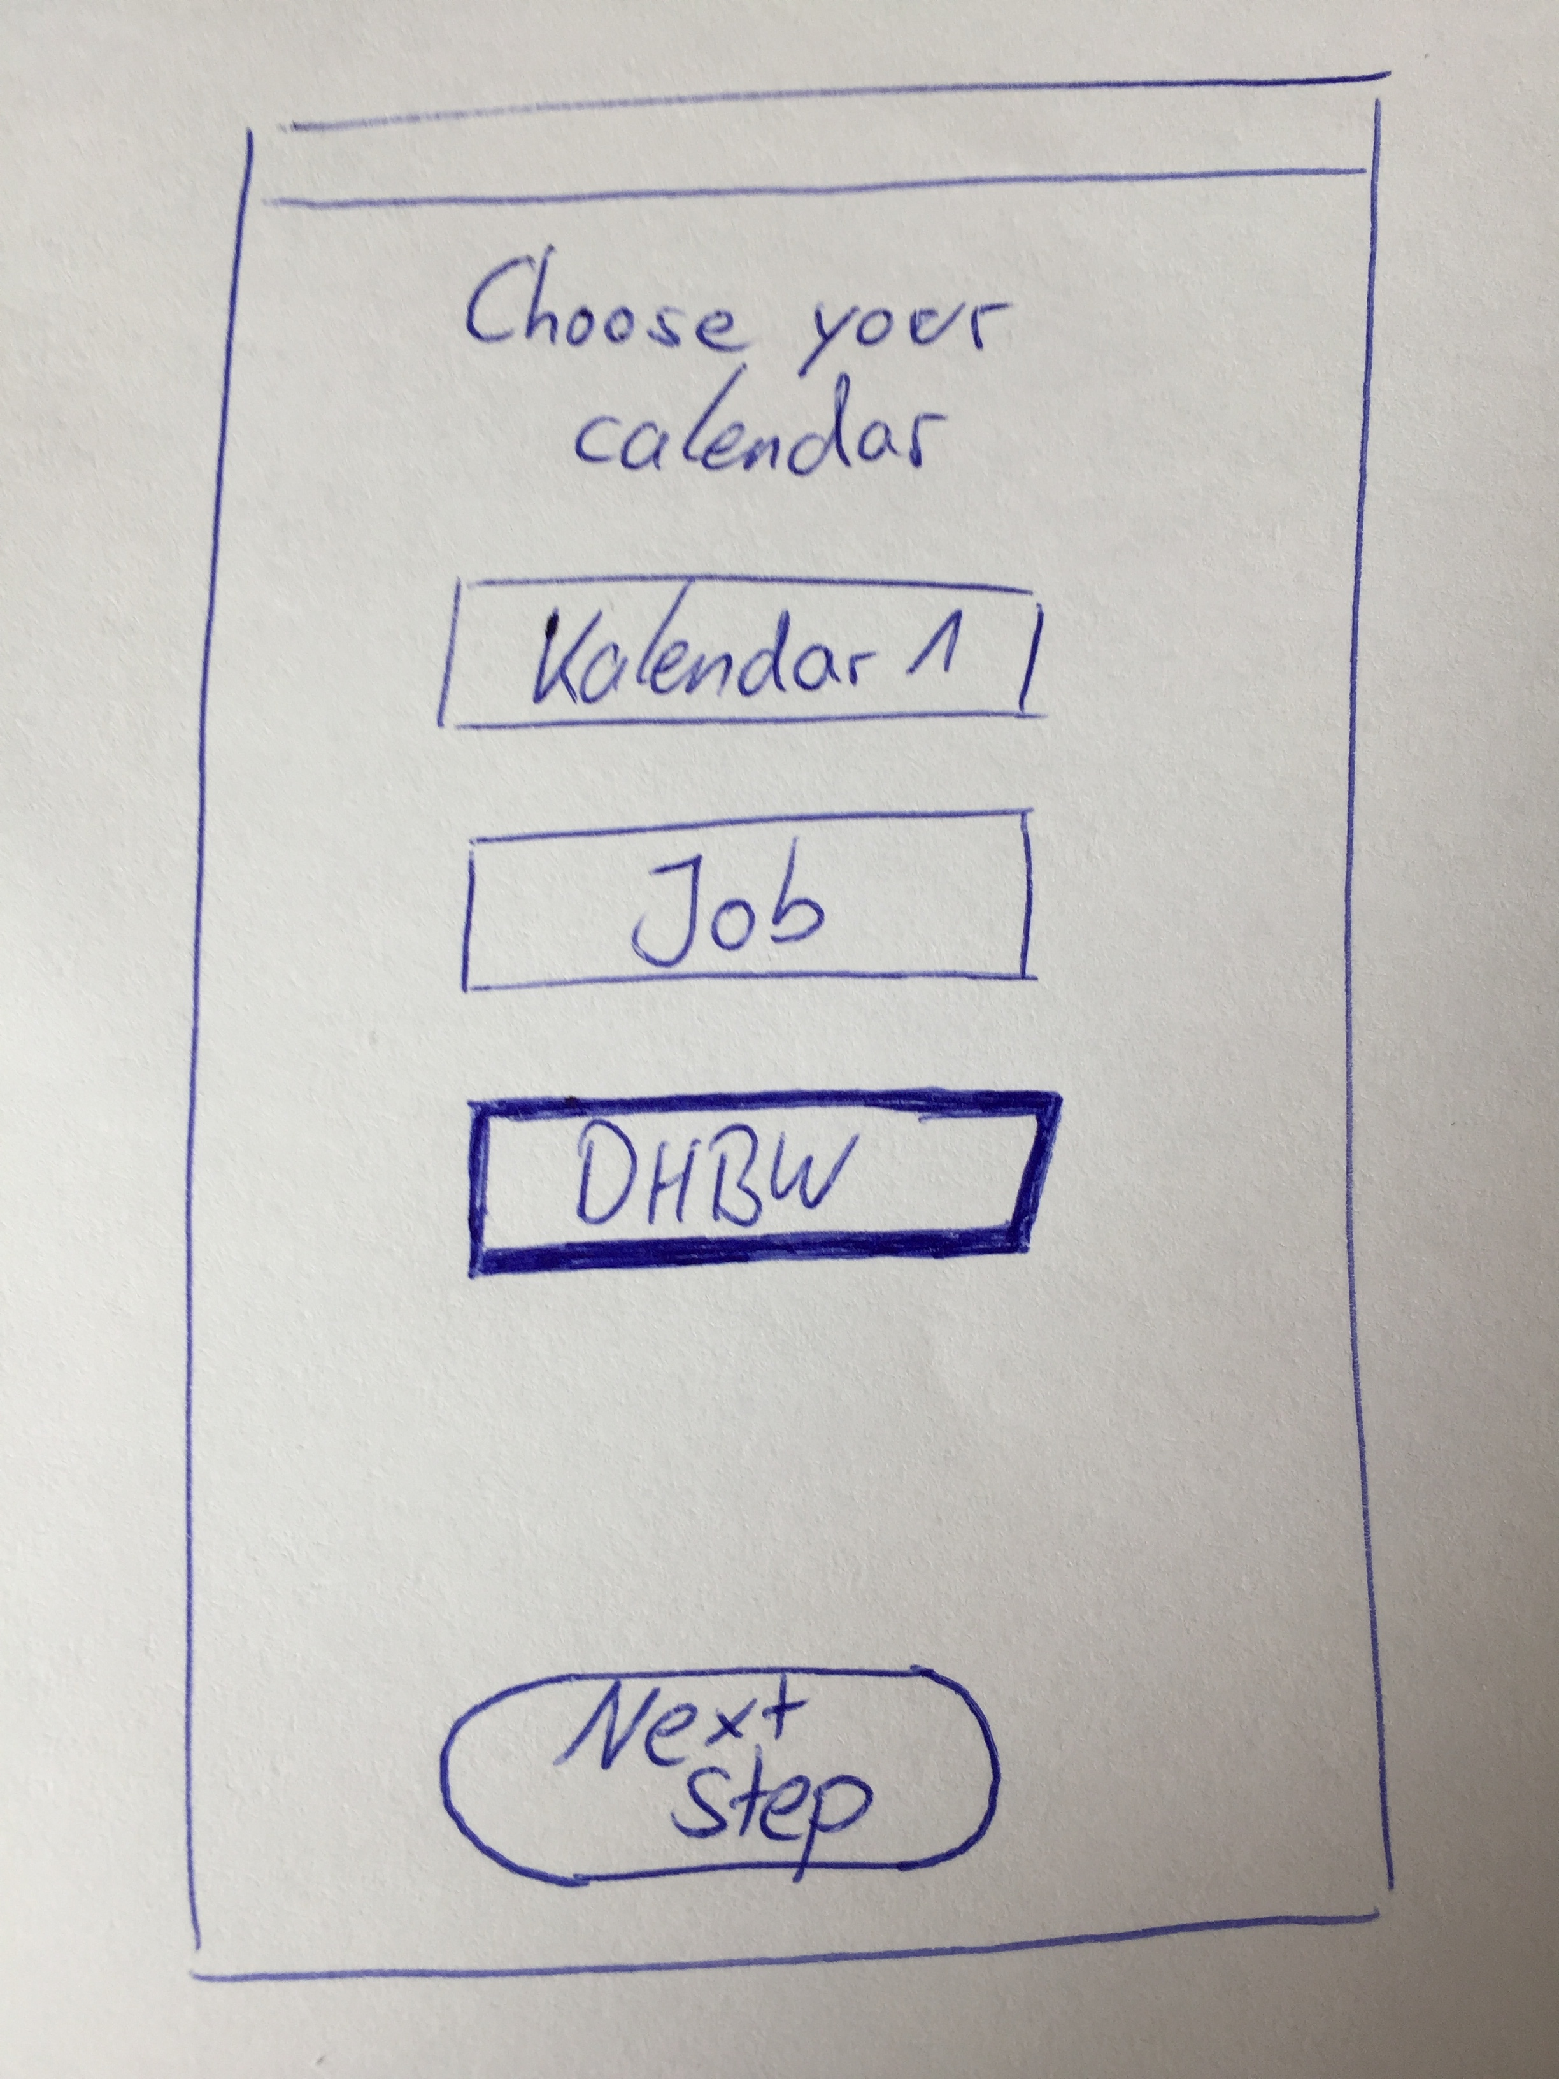

Mockup 2 Hand drawn Design

Feature Files:

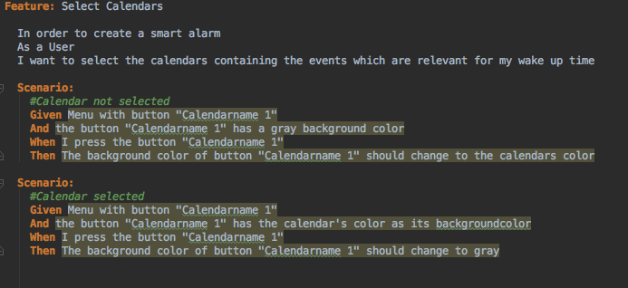

## Basic Flow

The user selects one calendar which the SmartAlarm than is based on

## Alternative Flows

# Special Requirements

The User needs to grant the Application access to their Calendars.

# Preconditions

Obviously there needs to be a calendar on which the Smart alarm can be based.

# Postconditions

After the Calendar is selected, the alarm needs to be changed when the calendar changes. There needs to be a direct correlation between the calendar and the alarm

# Extension Points

# Function Points

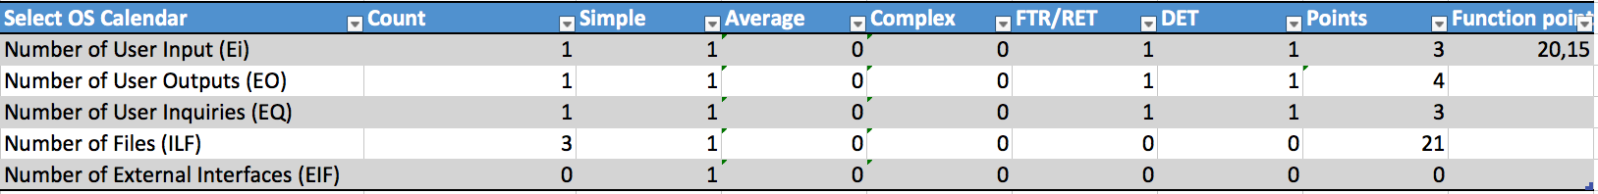

# Testing

[UI-Test](https://github.com/renpen/SimpleHabits/blob/dfe92bb596b6932b511eaf21bdc3fdd9118f9551/xCodeProject/AlarmClockUITests/UITestSelectOSCalendar.swift)