Simple Habits

Use-Case Specification: Select calendars

Version 1.0

Revision History

|  |  |  |  |
| --- | --- | --- | --- |
| **Date** | **Version** | **Description** | **Author** |
| 31/10/16 | 1.0 | Initial Creation | Benedikt Bosshammer |

Table of Contents

1. Use-Case Name 4

1.1 Brief Description 4

2. Flow of Events 4

2.1 Basic Flow 4

2.2 Alternative Flows 4

3. Special Requirements 4

4. Preconditions 4

5. Postconditions 4

6. Extension Points 4

Use-Case Specification: Select Calendars

# Select Calendar

## Brief Description

This Use Case provides the possibility for the users to select the OS calendars containing the appointments for wake up time calculation.

# Flow of Events

Within the Initialization of the Smart Alarm the User is asked to select all his OS Calendars he wants the app to calculate in. It is confirmed by continuing to the next page.

iOS Mock Up:

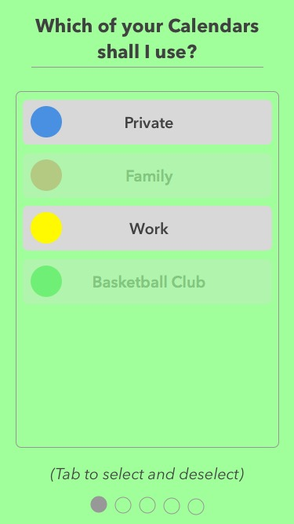

## Basic Flow

## Alternative Flows

# Special Requirements

# Preconditions

# Postconditions

# Extension Points