UN Votes

Ted Smith

## Introduction

How do various countries vote in the United Nations General Assembly, how have their voting patterns evolved throughout time, and how similarly or differently do they view certain issues? Answering these questions (at a high level) is the focus of this analysis.

### Getting Started

Open up your RStudio instance in Posit Cloud.

Create a new workspace.

Create a new project.

Create a new R script (*e.g.* ae-00.R)

Copy the code bits into the window.

### Packages

We will use the **tidyverse**, **lubridate**, and **scales** packages for data wrangling and visualization, and the **DT** package for interactive display of tabular output, and the **unvotes** package for the data.

Some of these packages will need to be installed the first time you run this. RStudio will prompt you to install them. You should not need to install these packages again for the current Posit Cloud Workspace.

library(tidyverse)  
library(lubridate)  
library(scales)  
library(DT)  
library(unvotes)

### Data

The data we’re using originally come from the **unvotes** package. In the chunk below we modify the data by joining the various data frames provided in the package to help you get started with the analysis.

unvotes <- un_votes |>  
 inner_join(un_roll_calls, by = "rcid") |>  
 inner_join(un_roll_call_issues, by = "rcid", relationship =  
 "many-to-many")

## UN voting patterns

Let’s create a data visualisation that displays how the voting record of Canada changed over time on a variety of issues, and compares it to three other countries: United Kingdom, USA, and Turkey.

We can easily change which countries are being plotted by changing which countries the code above filters for. Note that the country name should be spelled and capitalized exactly the same way as it appears in the data. See the Appendix for a list of the countries in the data.

# Canada added by Glen Armstrong  
  
unvotes |>  
 filter(country %in% c("United Kingdom", "United States", "Turkey")) |>  
 mutate(year = year(date)) |>  
 group_by(country, year, issue) |>  
 summarize(percent_yes = mean(vote == "yes")) |>  
 ggplot(mapping = aes(x = year, y = percent_yes, color = country)) +  
 geom_point(alpha = 0.4) +  
 geom_smooth(method = "loess", se = FALSE) +  
 facet_wrap(~issue) +  
 scale_y_continuous(labels = percent) +  
 labs(  
 title = "Percentage of 'Yes' votes in the UN General Assembly",  
 subtitle = "1946 to 2019",  
 y = "% Yes",  
 x = "Year",  
 color = "Country"  
 )

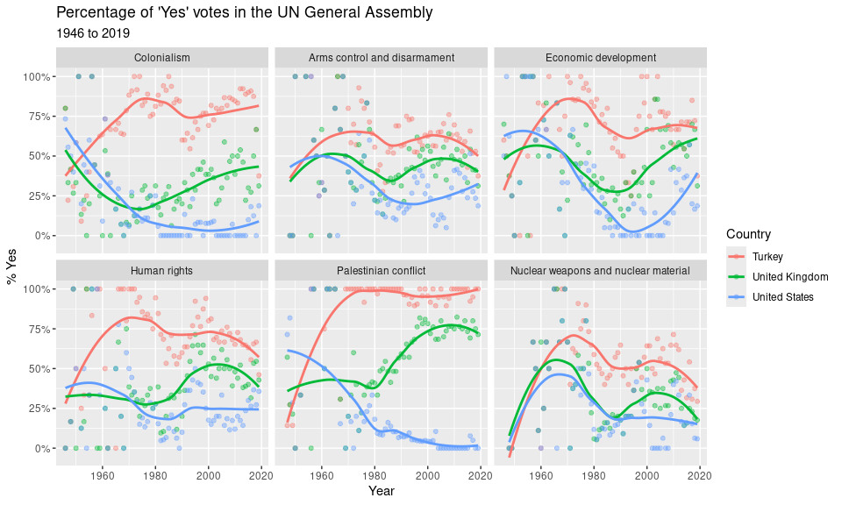

## References

1. David Robinson (2017). [unvotes](https://CRAN.R-project.org/package=unvotes): United Nations General Assembly Voting Data. R package version 0.2.0.
2. Erik Voeten “Data and Analyses of Voting in the UN General Assembly” Routledge Handbook of International Organization, edited by Bob Reinalda (published May 27, 2013).
3. Much of the analysis has been modeled on the examples presented in the [unvotes package vignette](https://cran.r-project.org/web/packages/unvotes/vignettes/unvotes.html).