## Complexity Drivers

|  |  |  |
| --- | --- | --- |
| Attribute |  | Complexity |
| Team Size | 3 | 3 |
| Mission Critical | Speculative | 1 |
|  |  |  |
| Team Location | Within driving distance | 5 |
| Team Capacity | Team with limited experience and a few experts | 7 |
| Domain knowledge gaps | Developers require some domain assistance | 5 |
| Dependencies | No dependencies | 1 |
|  |  | 22 |

Tabel 1: Complexity Attributes, with range from low (left) to highly complex (right)

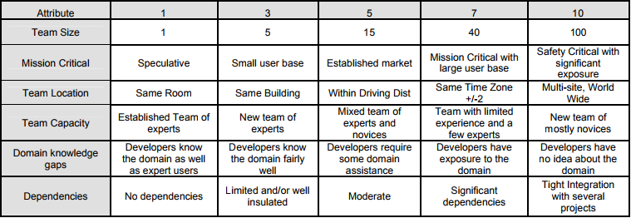

## Uncertainty Drivers

|  |  |  |
| --- | --- | --- |
| Attribute |  | Complexity |
| Market Uncertainty | Known deliverable possibly defined contractual obligation. | 1 |
| Technical Uncertainty | We think we know how to build it😊 | 3 |
| Project Duration | Between 4 weeks and 6 months | 2 |
| Dependents/Scope Flexibility | Scope is not very flexible | 3 |
|  |  | 9 |

$${Complexity=2}^{\sum{{\log_{10}{x}}_{i}}}$$

$${Uncertanity=2}^{\sum{{\log_{10}{y}}_{i}}}$$

Tabel 2: Uncertainty Attributes, with range from low (left) to high uncertainty (right)

