Snake Species Identification & Recognition

In this project we are using pre-trained DenseNet169 CNN based algorithm to recognized Snake Species. We use AI-Crowd Snake Species dataset to train DenseNet169 algorithm. We have trained algorithm with 32 different species of snakes and this dataset has many more species but training model was taking more time so we restrict model to get trained 32 species.

Below screen showing dataset details used in this project

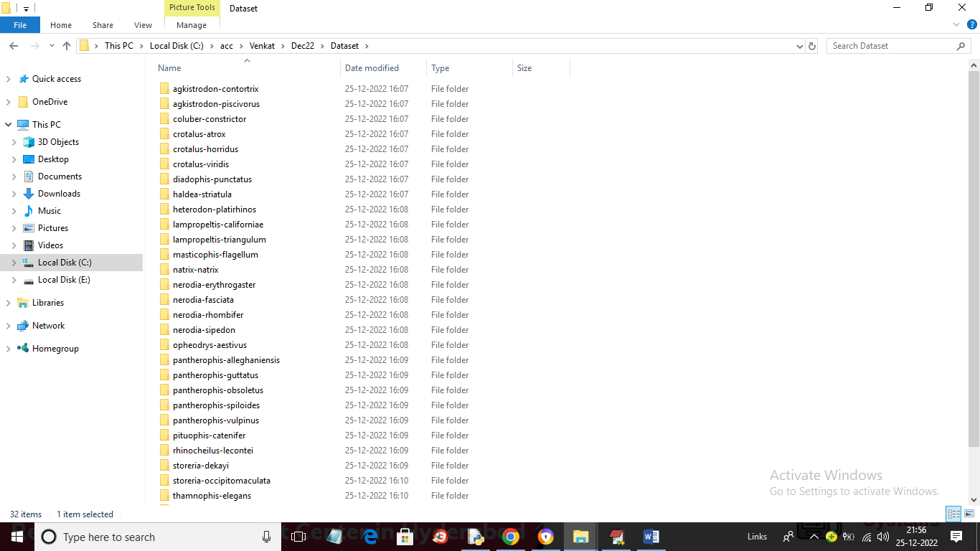

In above dataset screen we have 32 different folders and each folder contains one species of snake images and just go inside any folder to view images

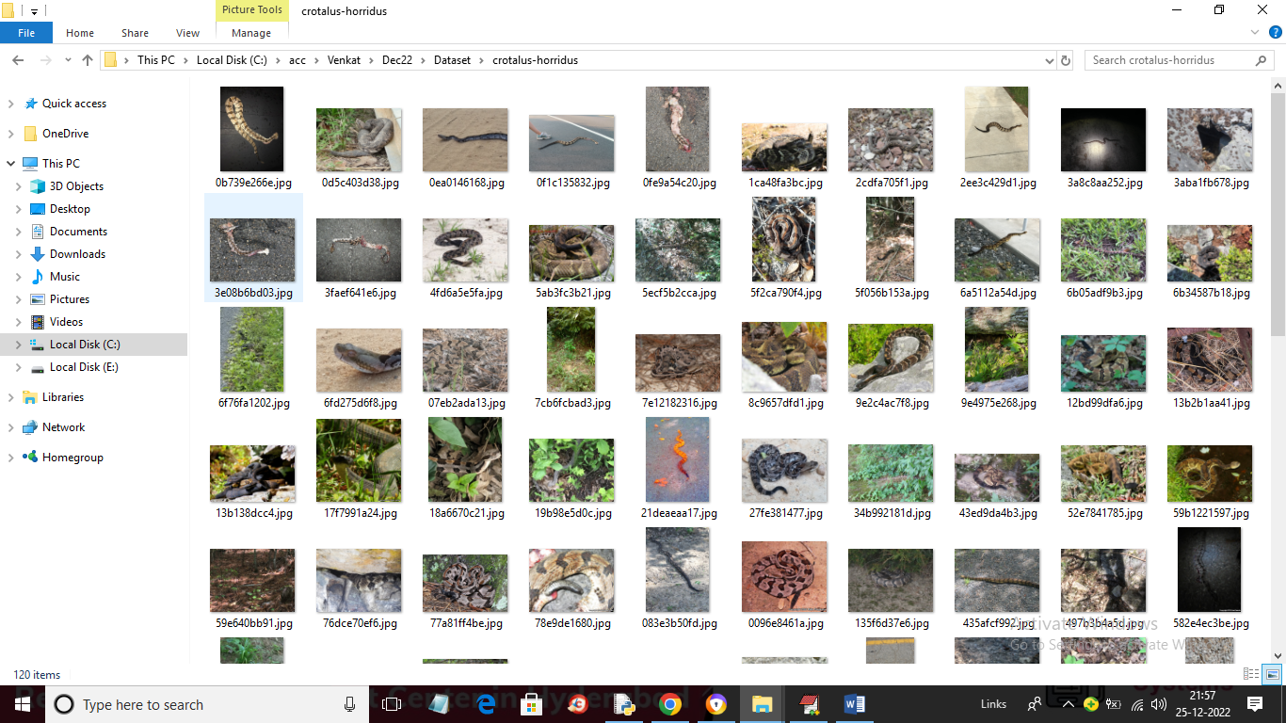

So by using above dataset we are training DenseNet169 algorithm.

To implement this project we have designed following modules

1. Upload Snake Species Dataset: using this module we can upload dataset to application and then find different species found in dataset
2. Preprocess Dataset: using this module we will read each image and then resize images to equal sizes and then normalized pixel values and then split dataset into train and test where application used 80% images for training and 20% for testing
3. Train DenseNet169 Algorithm: using this module we will input 80% images to train DenseNet169 model and then apply 20% test images on trained model to calculate prediction accuracy.
4. DenseNet169 Training Graph: using this module we will plot DenseNet169 training accuracy and loss graph
5. Snake Species Classification: using this module we can upload test images and then DenseNet169 will analyse image and then recognized species.

SCREEN SHOTS

To run project double click on ‘run.bat’ file to get below output

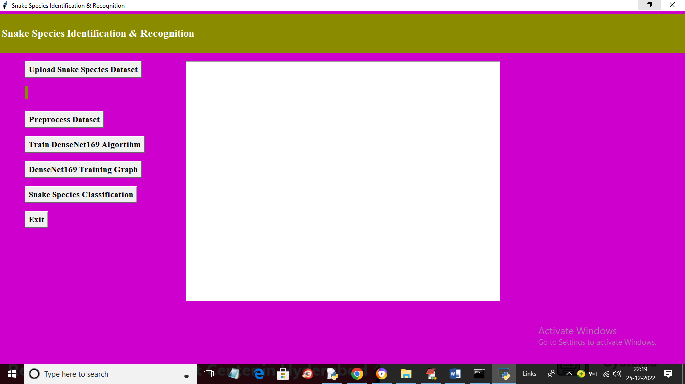

In above screen click on ‘Upload Snake Species Dataset’ button to upload dataset and get below output

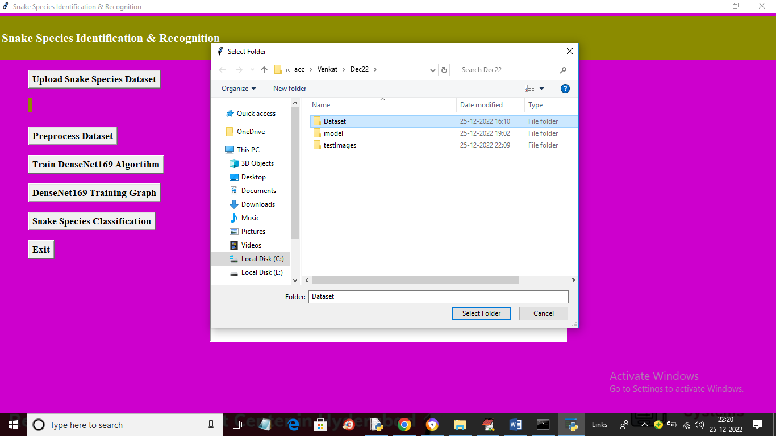

In above screen selecting and uploading entire ‘Dataset’ folder and then click on ‘Select Folder’ button to load dataset and get below output

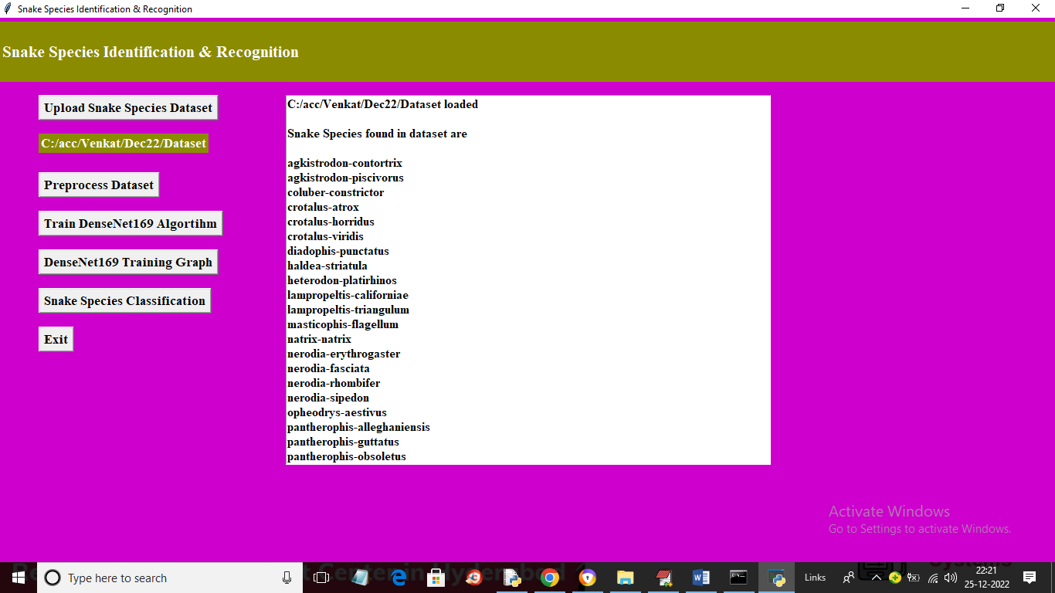

In above screen dataset loaded and then displaying names of each species. Now click on ‘Preprocess Dataset’ button to read each image and then normalize image pixel values and then split dataset into train and test

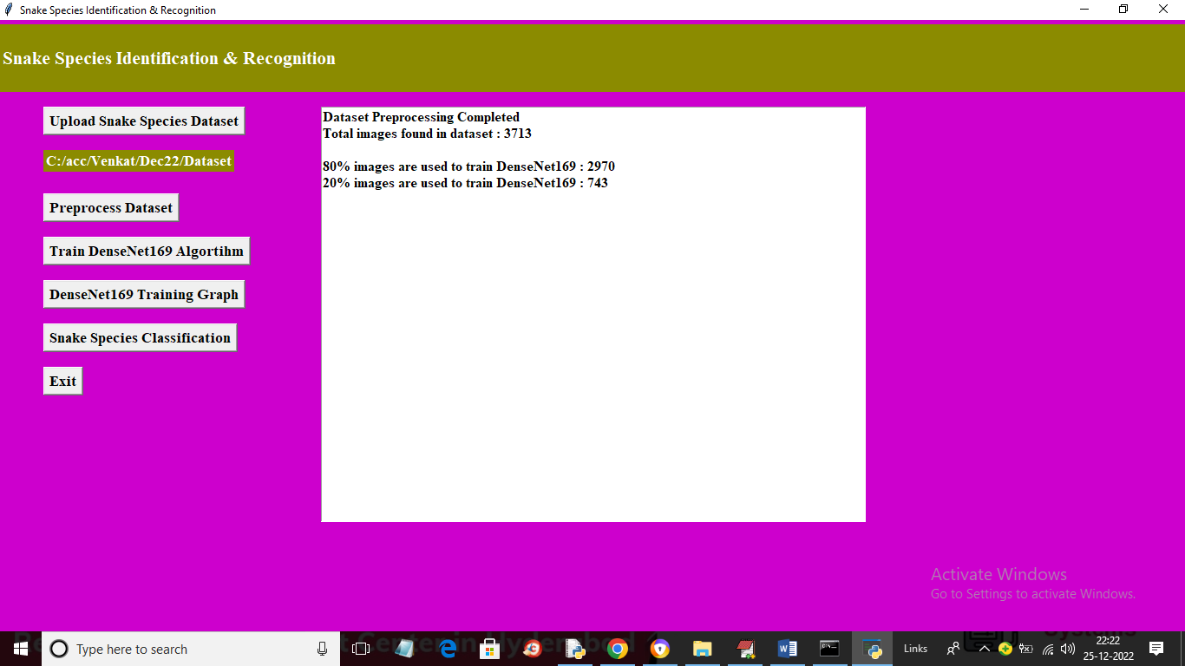

In above screen all images are processed and total images found in dataset is 3713 and application using 2970 (80%) images for training and 743 (20%) images for testing and now click on ‘Train DenseNet169 Algorithm’ button to train DenseNet169 model and get below output

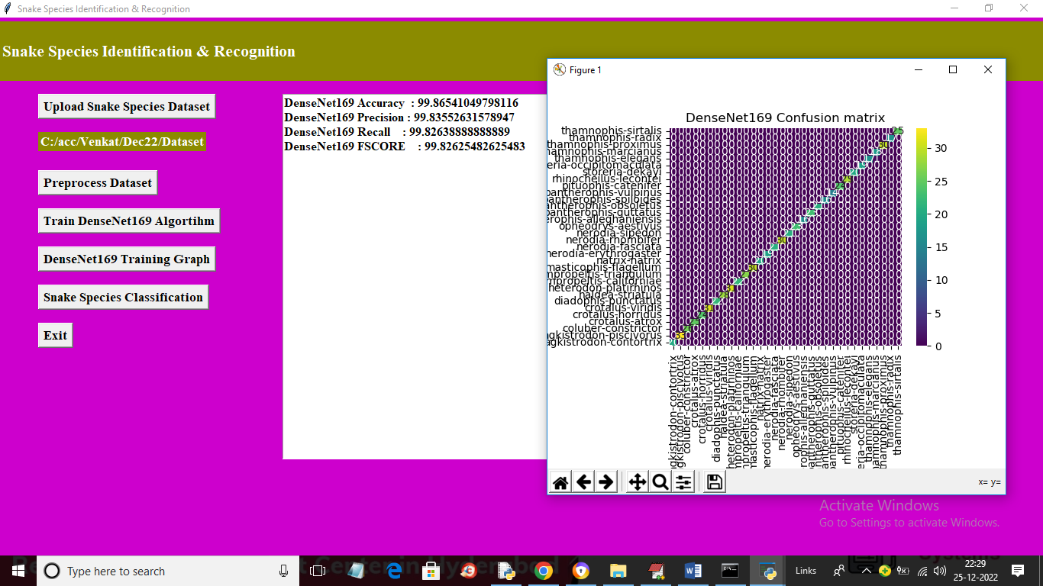

In above screen with Densenet169 we got accuracy and precision as 99% and in confusion matrix graph x-axis represents Predicted Labels and y-axis represents True classes and count in Diagnol represents correct prediction count and other boxes contains incorrect prediction count. Now close above graph and then click on ‘DenseNet169 Training Graph’ button to get below DenseNet169 training graph.

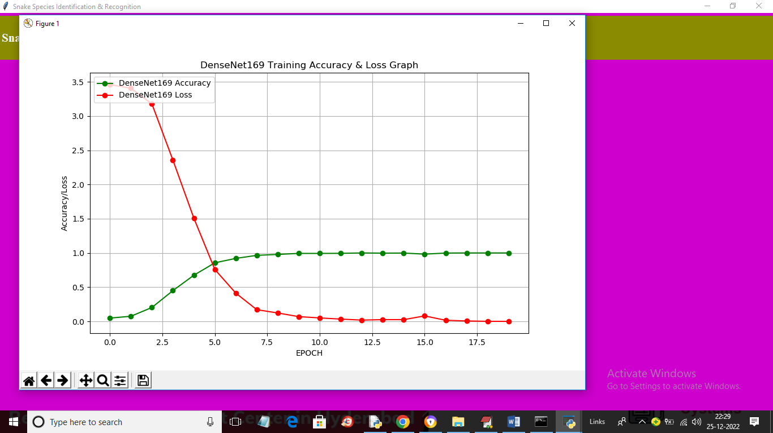

In above graph x-axis represents training epoch and y-axis represents accuracy and red line represents LOSS values and green line represents accuracy and with each increasing epoch accuracy got increased and loss got decreased. Now close above graph and then click on ‘Snake Species Classification’ button to upload test images and get below output

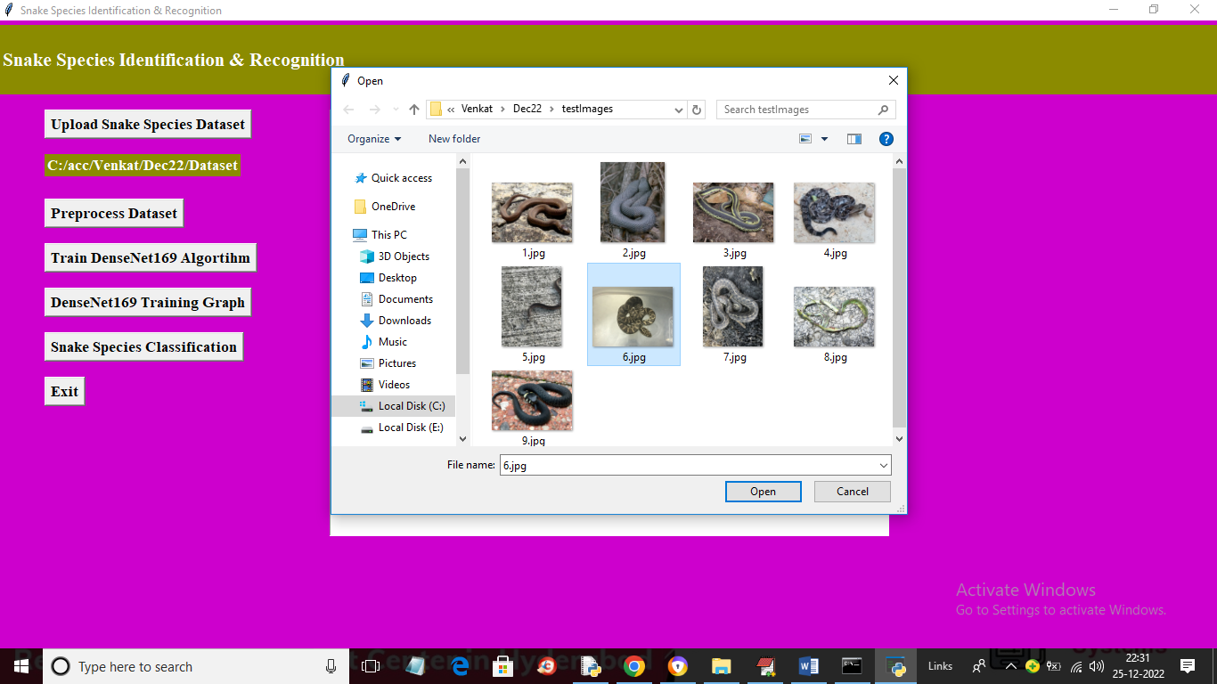

In above screen selecting and uploading ‘6.jpg’ and then click on ‘Open’ button to load image and get below recognition output

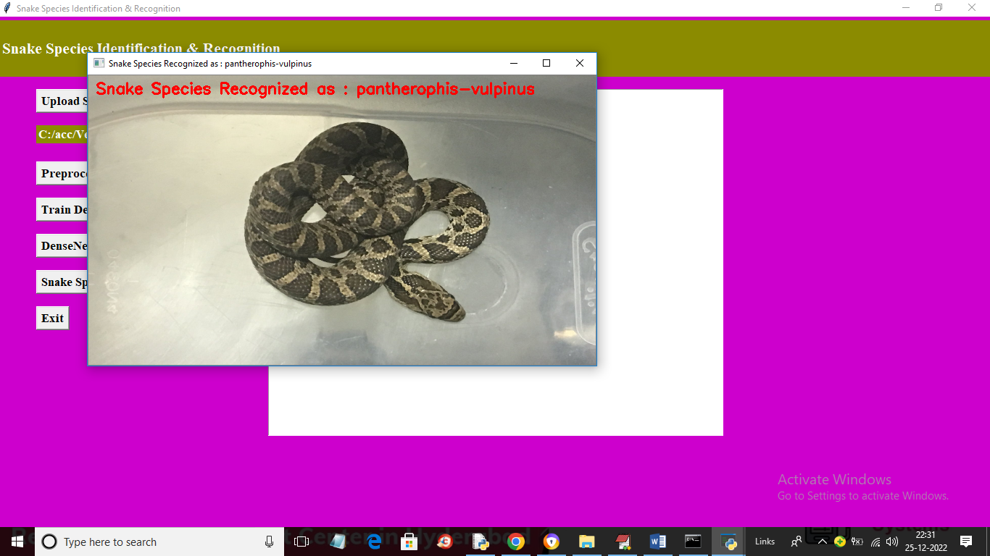

In above screen in red colour text we can see prediction of recognized snake species and similarly you can upload and test other images

