Title | Administration
Meta Description
— Page content begins below. Please do not edit the table above. —

Executive Cabinet Members
This administrative team serves in an advisory capacity to the president.

President
Dr. John L. Hoffman
Email: john.hoffman@bemidjistate.edu
Office: Deputy Hall 304

[[IMAGE REF 0000]] Image reference -- not directly editable; the original page reference is preserved automatically. Source: https://www.bemidjistate.edu/offices/president/wp-content/uploads/sites/86/2024/08/John-Hoffman.jpg

Provost & Vice President for Academic Affairs
Dr. Marah Jacobson
Email: marah.jacobson@bemidjistate.edu
Office: Deputy Hall 305

[[IMAGE REF 0001]] Image reference -- not directly editable; the original page reference is preserved automatically. Source: https://www.bemidjistate.edu/offices/president/wp-content/uploads/sites/86/2025/11/Marah-Jacobson-scaled.jpg

Executive Vice President & Senior Academic Officer, Northwest Technical College
Dr. Ketmani Kouanchao
Email: ketmani.kouanchao@ntcmn.edu
Office: Northwest Technical College Campus 105

[[IMAGE REF 0002]] Image reference -- not directly editable; the original page reference is preserved automatically. Source: https://www.bemidjistate.edu/offices/president/wp-content/uploads/sites/86/2025/01/23NTC_Ketmani_Kouanchao_0018.jpg

Vice President for American Indian Student Success & Campus Diversity Officer
Chrissy Downwind
Email: chrissy.downwind@bemidjistate.edu
Office: American Indian Resource Center 114

[[IMAGE REF 0003]] Image reference -- not directly editable; the original page reference is preserved automatically. Source: https://www.bemidjistate.edu/offices/president/wp-content/uploads/sites/86/2024/08/Chrissy-Downwind.jpg

Interim Vice President for Finance & Administration
Dr. Jeff Ueland
Email: jeffrey.ueland@bemidjistate.edu
Office: Deputy Hall 347

Vice President of Enrollment Management
Ben Hoffman
Email: benjamin.hoffman@bemidjistate.edu
Office: Deputy Hall 311

[[IMAGE REF 0004]] Image reference -- not directly editable; the original page reference is preserved automatically. Source: https://www.bemidjistate.edu/offices/president/wp-content/uploads/sites/86/2024/08/020A7912_2.jpg

Vice President of University Advancement
Allyssa Joseph
Email: allyssa.joseph@bemidjistate.edu
Office: David Park House
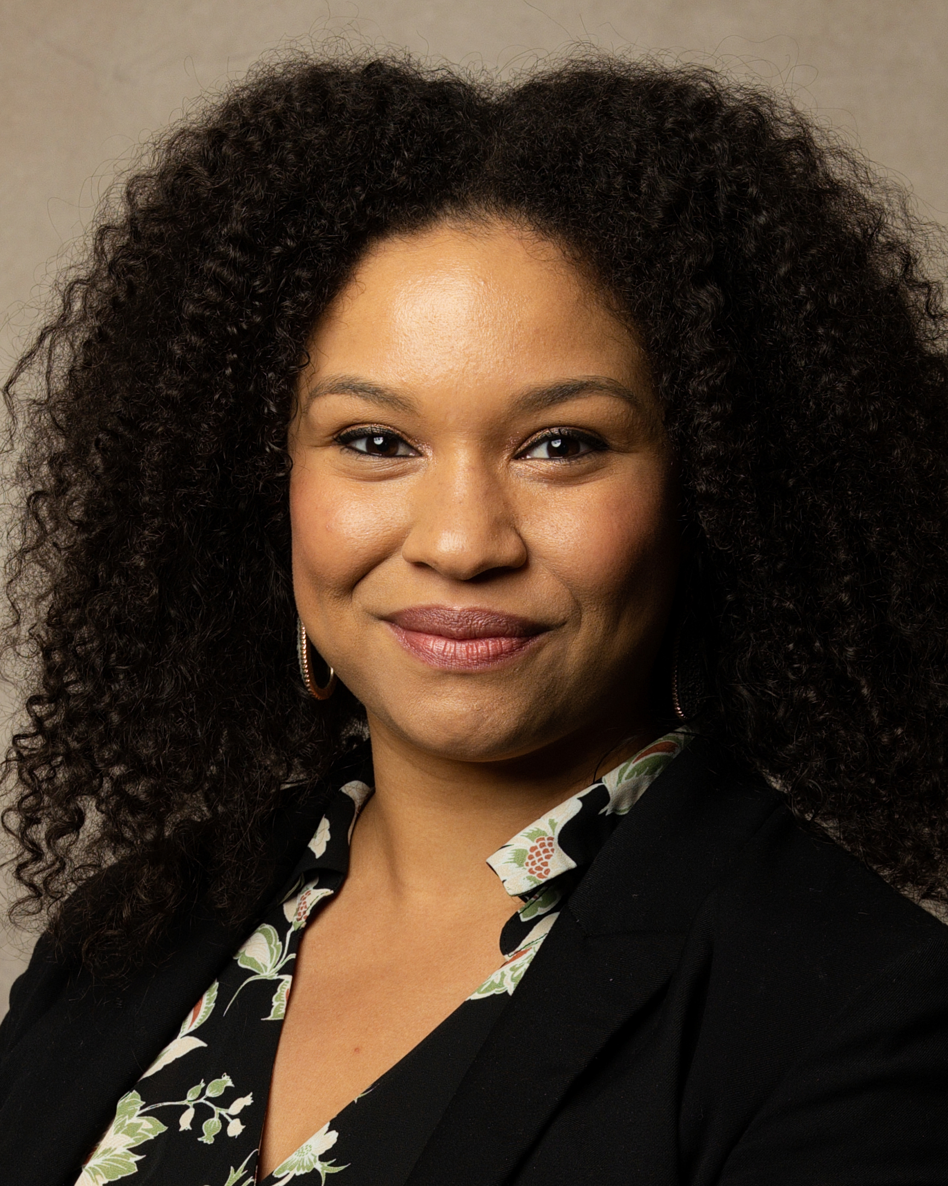
[[IMAGE REF 0005]] Image reference -- not directly editable; the original page reference is preserved automatically. Source: https://www.bemidjistate.edu/offices/president/wp-content/uploads/sites/86/2024/08/020A7869_2.jpg

Director of Athletics
Britt Lauritsen, J.D.
Email: brittany.lauritsen@bemidjistate.edu
Office: Physical Education Complex 200

[[IMAGE REF 0006]] Image reference -- not directly editable; the original page reference is preserved automatically. Source: https://www.bemidjistate.edu/offices/president/wp-content/uploads/sites/86/2024/08/020A7823_2.jpg

Head of Staff
Henoc Preciado
Email: henoc.preciado@bemidjistate.edu
Office: Deputy Hall 304

[[IMAGE REF 0007]] Image reference -- not directly editable; the original page reference is preserved automatically. Source: https://www.bemidjistate.edu/offices/president/wp-content/uploads/sites/86/2024/08/020A7898_2.jpg

Vice President for Student Affairs
Dr. Kevin Stensberg
Email: kevin.stensberg@bemidjistate.edu

[[IMAGE REF 0008]] Image reference -- not directly editable; the original page reference is preserved automatically. Source: https://www.bemidjistate.edu/offices/president/wp-content/uploads/sites/86/2025/11/Kevin-Stensberg-BSU-scaled.jpg

Campus Human Resources Officer & Title IX Coordinator
Megan Zothman
Email: megan.zothman@bemidjistate.edu
Office: Deputy Hall 335

Other Administrative Units
Bemidji State University is a member of the Minnesota State system of colleges and universities. In addition to the Office of the President, Bemidji State University has administrative units designed to lead academic and student services, innovation and operational aspects of the university.

Administrative Units
- President
- Academic Affairs
- Athletics
- Diversity, Equity & Inclusion
- Enrollment Management
- Finance & Administration
- Human Resources
- Northwest Technical College
- Student Life & Success
The Bemidji State University Alumni & Foundation also provides leadership through its “friend-raising” and fundraising functions.

